Annex (iv) – SSSI Assessment Form
SSSI Assessment for permit/licence and deployment applications | 
To be completed by Permitting Officers for any applications for a permission which Natural Resources Wales has considered under S28I duty to notify SNCB and take their advice into account. This applies to all proposed permissions within a SSSI, and to operations outside the SSSI boundary which are likely to damage its special features.
NRW as a Section 28G authority has, when exercising its functions, a general duty to take reasonable steps, consistent with the proper exercise of its functions, to further the conservation and enhancement of the flora, fauna or geological or physiological features by reason of which the site is of special interest’

Part 1 – SSSI Assessment
Part 2 – Formal notification to SNCB (to be completed if part 1 assessment concludes likely damage, not likely to damage because of conditions or you cannot conclude no likely damage)
Part 3 – Decision

Part 1 – SSSI Assessment

- Permitting officer/team | Liz Cole water resources permitting
- Permit application reference and site name | RWE Pembrokeshire abstraction licence renewal  PAN-025790
- a. SSSI name(s) b. location  c. NRW Operational Area/Environment Team | a. Milford Haven Waterway SSSI  b. Milford Haven, Pembrokeshire  c. South West Wales Ops/Pembrokeshire Environment Team
- Brief description of proposal

Renewal application of abstraction licence 22-61-6-0156 which was issued in 2008 and expired 31 March 2025. The application is currently subject to Licence Extension Validity (LEV): under the Water Resources Act 1991 section 46A allows for a licensed abstraction to continue past its expiry date until the determination of the valid renewal application. The current licence authorises abstraction of up to 40m³/s, and 144,000 m³/hr, 3,456,000m³/day, 1,200,000,000m³/yr from ‘point A’ located at NGR SM 93654 02652, located in the Daugleddau estuary, Pembroke.
Water is abstracted from a structure 54 metres in length fed by ten pumps. The intake structure at the point of water entry is screened by 50mm bar trash screen and also fitted with an acoustic fish deterrent and strobe lighting sytem . Within the intake works there are a further four drum screens with mesh size of 6mm which include a backwash and fish return system.
The applicant wishes to renew the licence on the same terms, to the next common catchment end date, which for the The Cleddau and Pembrokeshire Coastal Rivers Abstraction Licensing Strategy is 31 March 2037.

The power station is currently operated under EPR permit, current version (a variation) issued 16/10/2020: EPR/DP3333TA

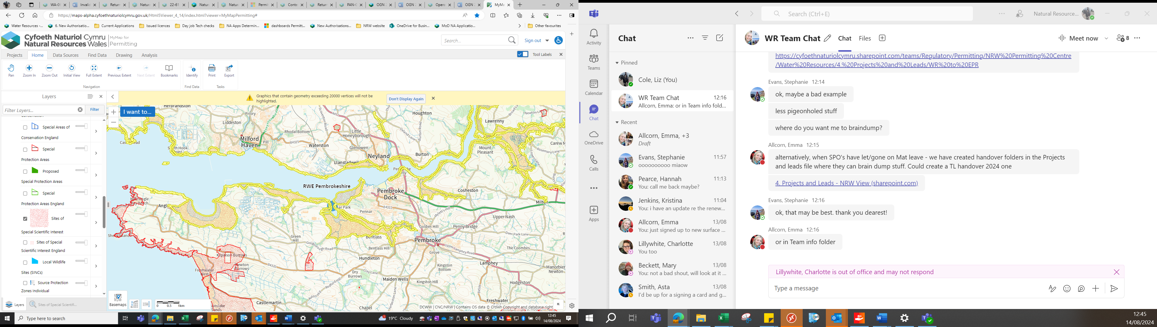
Yellow highlighted area denotes Milford Haven Waterway SSSI area

- What aspects of the proposed permission are likely to damage the SSSI features of special interest?

The following activities are likely to cause damage:

‘10. Killing, injuring, taking or removal of any wild animal, or the eggs/nests of any wild animal or the disturbing, taking, damaging or destroying of any wild animal in its place of shelter excluding pest control.’

‘14. Alterations to water levels and tables and water utilisation including irrigation, storage and abstraction from existing water bodies and through boreholes.’

The following SSSI(s) features and potential impacts have been considered to assess the likelihood of damage:

Over-wintering wildfowl and waders, otter. In addition fish populations may be considered as part of general marine/esturaine biology. Fish prey species (wildfowl include little grebe, shelduck, widgeon, teal, dunlin and curlew, as well as otter) may consume fish species in the Haven as part/all of their diet. Fish populations could decreased due to the abstraction which can cause entrapment of adult and juvenilie fish as well entrainment of their eggs and larvae. A decrease in prey availability could adversely impact upon wildfowl survival and population numbers as well as potential impact to overall marine biology.

- Summary of any informal advice received from internal experts (if required and including pre-app advice)

Advice from the Marine Area Management & Advice team 05/05/2023, updated 18/07/2023 as part of renewal reminder letter consultation:

‘We advise that any potential effects on the bird features of Milford Haven Waterway SSSI should be considered, as well as any potential effects on priority bird species listed in section 7 of the Environment Act (Wales). Potential considerations may include (but not be limited to) changes to prey availability, food web dynamics or habitat changes and effects this could have on bird populations.
The features of Milford Haven Waterway SSSI are Wintering Teal, Wigeon, Dunlin, Curlew, Shelduck & Little grebe. These species have a mixed diet including aquatic plants, grasses, roots, invertebrates (including aquatic invertebrates), small fish and amphibians depending on the species in question and the time of year. Although fish are not typically consumed by some of these species (such as Teal and Wigeon), Little grebe for example, are almost exclusively carnivorous and will take small fish and amphibians. Waders and some wildfowl species also need invertebrates such as crustaceans, insects, molluscs and worms. There is also a potential impact pathway through changes to vegetation (e.g. aquatic plants) that affect the diet of these species.
We therefore need to rule out changes to flora and fauna of Milford Haven Waterway SSSI which could affect its bird features.
Surveys and/or an analysis of existing data therefore may be required to understand potential impacts on these features. It may be that there is existing data available for this area (e.g. WeBs) but they would need to check.

Recommendations for application
The applicant should submit an assessment on the effects on the marine/coastal bird features of Milford Haven Waterway SSSI. These are Wintering Teal, Wigeon, Dunlin, Curlew, Shelduck & Little grebe. Surveys and/or an analysis of existing data may be required to understand potential impacts on these features.’
In addition, this advice note highlights a risk to Pembrokeshire Marine SAC, West Wales Marine SAC and Afon Cleddau SAC, in addition to the Milford Haven Water SSSI. The risks include potential impacts to estuarine and migratory fish (including sea and river lamprey) who access Mildford Haven waterway as part of their lifecycle.
Marine advice 11/02/2025
This advice highlighted concerns following receipt and review of the entrapment data, final documents submitted by RWE in December 2024.

- Recommendation

The proposed permission is not likely to damage any of the flora, fauna or geological or physiological features which are of special interest because of conditions. The current/expired abstraction licence currently contains conditions so that the abstraction intake is screened and also includes a fish deterrent system. There are two sets of screens, coarse screen with 50mm bar spacing at entrance to intake, then rotating drum screens with 6mm mesh. The site uses an acoustic fish deterrent (ADF) as well as strobe lighting to deter fish away from the intake. There is also a fish recovery and backwash return system which discharges at certain states of tide to avoid re-entrapment. The renewed abstraction licence will also include the same conditions to ensure continued screening/fish deterrence. An environmental monitoring program has been in place to fulfil pre-construction, construction and operational permitting of the power station; since 2006. The monitoring is in place in order to meet the EPR permit requirements (reference EPR/DP3333TA). The sampling program covers the following aspects:

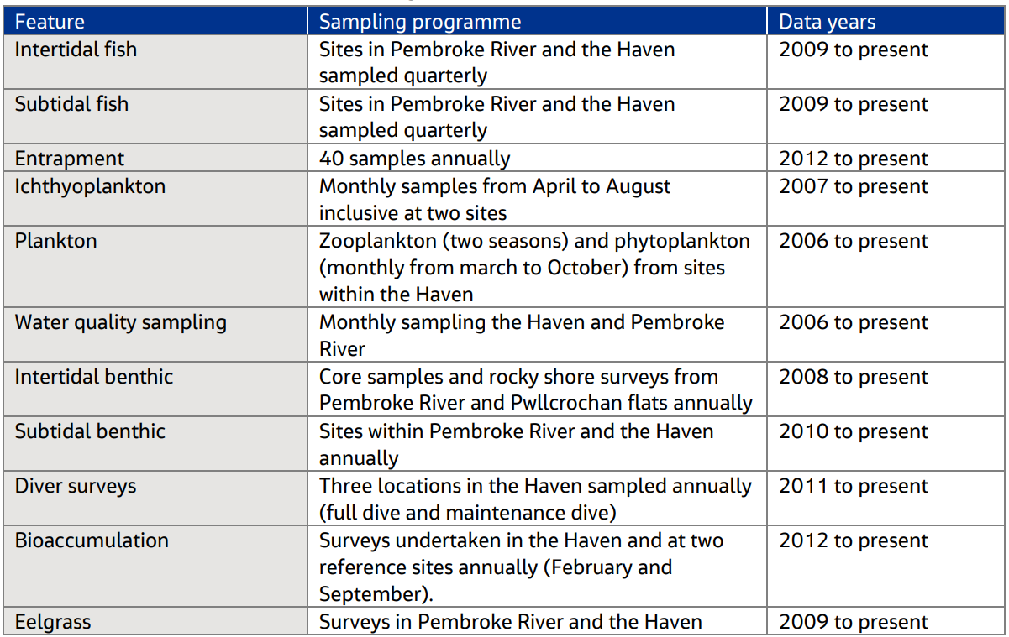

The details of the sampling program have been agreed in consultation with NRW and are continually reviewed and agreed.

RWE submit the results of sampling program to NRW on an annual basis, the reports being accepted by NRW. It is acknowledged that there have been observed fluctuations in fish abundance and community structure at a local level, likely to be within expected natural variations of a highly dynamic fish community. The Milford Haven Waterway covers a large area of coastline and any impacts from the powerstation will be very localised, and only could affect two out of the eleven management units (Pembroke River and Milford Haven south sections). As impact to fish has been minimised through the mitigation measures implemented/conditioned within the licence, and any impacts will be localised, fish populations are maintained (subject to expected annual fluctuations) and therefore prey availability throughout the entire SSSI area will not be significantly affected. The over-wintering bird species are highly mobile and can access across the different elements of the SSSi area. The locality of the intake structure is in a relatively industrialised area, whilst there are large expanses within the wider estuary of low disturbance likely to be favourable for over-wintering species and otters.
The following conditions as included in the current licence and will be included within the renewed licence:

- Before any abstraction takes place the Licence Holder shall install to the satisfaction of the NRW at the point specified in condition 2 above:
• Four drum screens with a mesh size of 6 millimetres or less at the intake structure. The drum screens will incorporate a back wash and fish return system.
• An acoustic fish deterrent at the intake structure.
• A strobe light at the intake structure.

- The Licence Holder shall maintain the four drum screens and fish return system, acoustic fish deterrent and strobe light specified in condition 9.2 above, and record any maintenance carried out to the satisfaction of the NRW.

The design of the intake is so that velocity of abstraction is minimised (to accord with best practice) which reduces impacts to local sediments rather than wider estuarine impacts.
The applicant has produced their own assessment regarding impacts to the Milford Haven Waterway SSSI, ‘Pembroke Abstraction SSSi assessment’. Although fish eggs/species are entrapped as will pass through the initial intake trash screening, the significance of this upon fish populations is not known to be significant and therefore evidence to date demonstrates that the abstraction has not adversely impacted fish populatons and subsequently prey availability.

- Signature and date assessment made | Liz Cole  20/05/2025
- Officers name and job title | Liz Cole  Water resources senior permitting officer

Permitting
Formal Notification under Section 28I of the Wildlife and Countryside Act 1981

Part 2 Formal notification under S28I – To be completed for all permit applications assessed as: not likely to damage because of conditions, likely to damage SSSI and those where we are unable to conclude no likely damage.

- Date Notice of intention to permit activity likely to damage SSSI sent to NRW (SCNB) | 21/05/2025  We have assessed that RWE Pembroke power station abstraction licence renewal is likely to damage Milford Haven Waterway SSSI and request your formal advice. We have assessed that this damage could be mitigated by including conditions as detailed above.  Information on the permit application can be found in Part 1 of this form and within the DMS under the Licence Renewal category.
- Advice received from NRW (SNCB)

Marine advice 27/06/2025 including Goby & Herring entrapment analysis which contains comments from Marine Mammals, Ornithology, and Marine Fish advisory.
F26- section 4: updated decription of abstraction intake as per advice.
F27 – section 5: ‘We advise that PDO 10. Killing, injuring, taking or removal of any wild animal, or the eggs/nests of any wild animal or the disturbing, taking, damaging or destroying of any wild animal in its place of shelter excluding pest control should be included in the assessment. We also advise that this section appears to have omitted assessment of otters and estuaries/estuarine communities. These identified species have now been included within assessment.
F28 – section 6: reference/append previous advice received 11/02/2025 which is now attached
F29 -,section 7: further assessment required: ‘We advise that our comments on Section 4.1 estuaries of the HRA also apply to this section.’ Section 7 has been updated, although not in agreement with the advisory comments.
MO2- agree with conclusion of assessment that proposal not likely to damage wintering waterbird features of SSSI.

- Name and job title of conservation/marine officer (sign and date) | Adam Cooper, Marine Area Management and Advice Team  27/06/2025
Part 3 – To record NRW decision following SNCB Advice
- DECISION
The proposed permission is not likely to damage any of the flora, fauna or geological or physiological features which are of special interest because of conditions.

The advice received from SNCB has been considered, as outlined in section 7 above. Some amendments have been made in line with this advice, however the conclusion of the assessment does not align with SNCB advice. The decision to proceed on issuing a licence has been escalated to the Head of Regulation and Permitting.

- Natural Resources Wales (Section 28G Authority) (permitting service) is minded to | Issue the permission with conditions to ensure no damage to SSSI  A finalised escalation paper has been drafted outlining NRW’s decision to issue the abstraction. It has been concluded that
- Is decision in line with advice from SNCB | No  The commencement of the escalation process on 19/08/2025 meets the requirements of OGN 231 to make notification 21 days prior to issue of licence
- Signature and date assessment completed | Liz Cole 05/08/2025
- Officers name and job title | Water resources senior permitting officer

