Annex (iv) – SSSI Assessment Form
SSSI Assessment for permit/licence and deployment applications | 
To be completed by Permitting Officers for any applications for a permission which Natural Resources Wales has considered under S28I duty to notify SNCB and take their advice into account. This applies to all proposed permissions within a SSSI, and to operations outside the SSSI boundary which are likely to damage its special features.
NRW as a Section 28G authority has, when exercising its functions, a general duty to take reasonable steps, consistent with the proper exercise of its functions, to further the conservation and enhancement of the flora, fauna or geological or physiological features by reason of which the site is of special interest’

Part 1 – SSSI Assessment
Part 2 – Formal notification to SNCB (to be completed if part 1 assessment concludes likely damage, not likely to damage because of conditions or you cannot conclude no likely damage)
Part 3 – Decision

Part 1 – SSSI Assessment

- Permitting officer/team | Liz Cole water resources permitting
- Permit application reference and site name | RWE Pembrokeshire abstraction licence renewal  PAN-025790
- a. SSSI name(s) b. location  c. NRW Operational Area/Environment Team | a. Western Cleddau River  Eastern Cleddau River  b. Pembrokeshire  c. South West Wales Ops/Pembrokeshire Environment Team
- Brief description of proposal

Renewal application of abstraction licence 22-61-6-0156 which was issued in 2008 and expired 31 March 2025. The application is currently subject to Licence Extension Validity (LEV): under the Water Resources Act 1991 section 46A allows for a licensed abstraction to continue past its expiry date until the determination of the valid renewal application. The current licence authorises abstraction of up to 40 m³/s, and 144,000 m³/hr, 3,456,000m³/day, 1,200,000,000m³/yr from ‘point A’ located at NGR SM 93654 02652, located in the Daugleddau estuary, Pembroke.
Water is abstracted from a structure 54 metres in length fed by ten pumps. The intake structure at the point of water entry is screened by 50mm bar trash screen and also fitted with an acoustic fish deterrent and strobe lighting sytem . Within the intake works there are a further four drum screens with mesh size of 6mm which include a backwash and fish return system. The abstracted water is used for non-evaporative cooling in the combined cycle gas turbine at the power station.

The applicant wishes to renew the licence on the same terms, to the next common catchment end date, which for the The Cleddau and Pembrokeshire Coastal Rivers Abstraction Licensing Strategy is 31 March 2037.

The power station is currently operated under EPR permit, current version (a variation) issued 16/10/2020: EPR/DP3333TA

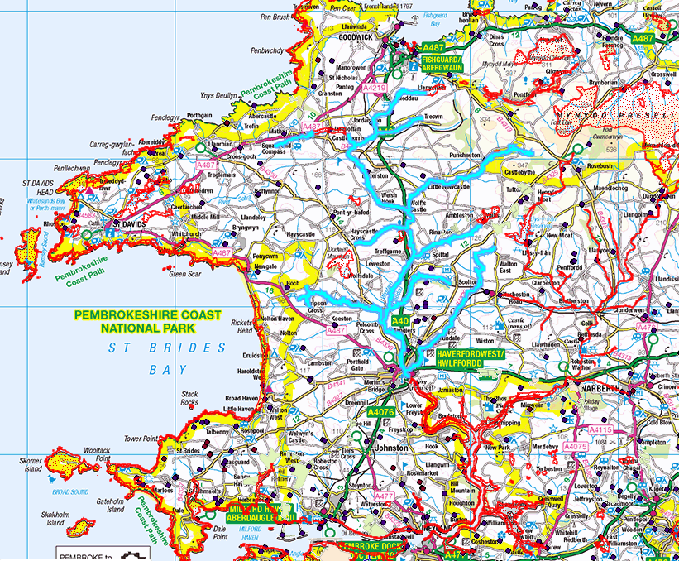
Map showing Western Cleddau River SSSI boundary outlined in blue. The area included is the main river and its tributaries running from Fishguard to Haverford West

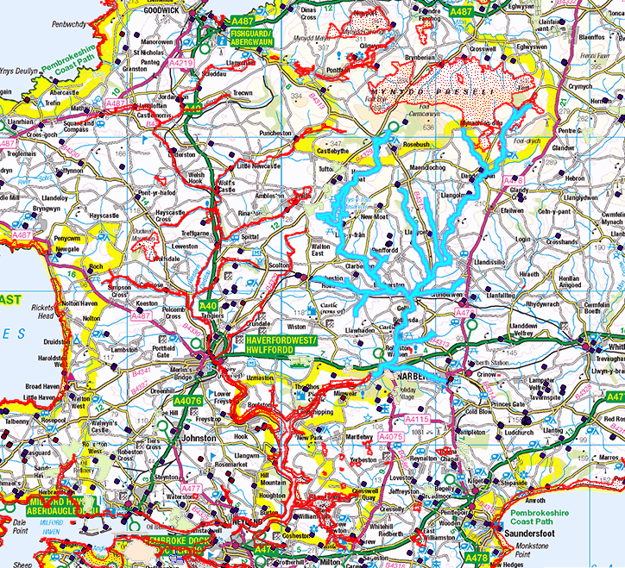
Map showing Easter Cleddau River SSSI boundary denoted in blue. Area designated stretches from south of Preseli Mountains to Narbeth.

- What aspects of the proposed permission are likely to damage the SSSI features of special interest?

The following activities are likely to cause damage:

‘10. Killing, injuring, taking or removal of any wild animal, or the eggs/nests of any wild animal or the disturbing, taking, damaging or destroying of any wild animal in its place of shelter excluding pest control.’

’14. Alterations to water levels and tables and water utilisation including irrigation, storage and abstraction from existing water bodies and through boreholes. Also the modification of current drainage regime, (eg through the installation of new pumps).’

The following SSSI(s) features and potential impacts have been considered to assess the likelihood of damage:

Otter, Fish species (bull head, river/sea/brook lamprey), aquatic plants and breeding birds. Entrapment of fish species by the cooling water abstraction intake located in the Milford Haven waterway has the potential to entrain larval fish and impinge fish species. Migratory fish species include the river and sea lamprey which occupy the estuary as part of their lifecycle and are at risk of becoming entrapped. These species pass through the estuary and travel up through both the Western and Eastern Cleddau to spawn. Entrapment may lead to mortality/injury and impact population numbers and ability of these migratory species to access the Cleddau rivers. There is subsequent risk of impact to Otter species and breeding birds who may feed upon these species fish species.

- Summary of any informal advice received from internal experts (if required and including pre-app advice)

Advice from the Marine Area Management & Advice team 05/05/2023, updated 18/07/2023 as part of renewal reminder letter consultation
This advice note highlights a risk to Pembrokeshire Marine SAC, West Wales Marine SAC and Afon Cleddau SAC, in addition to the Milford Haven Water SSSI. The risks include potential impacts to estuarine and migratory fish (including sea and river lamprey) who access Mildford Haven waterway as part of their lifecycle.

Marine advice 11/02/2025
This advice highlighted concerns following receipt and review of the entrapment data, final documents submitted by RWE in December 2024.

- Recommendation

The proposed permission is not likely to damage any of the flora, fauna or geological or physiological features which are of special interest because of conditions. The current/expired abstraction licence currently contains conditions so that the abstraction intake is screened and also includes a fish deterrent system. There are two sets of screens, coarse screen with 50mm bar spacing at the intake location and then rotating drum screens with 6mm mesh. The site uses an acoustic fish deterrent (ADF) as well as strobe lighting to deter fish away from the intake. There is also a fish recovery and backwash return system which discharges at certain states of tide to avoid re-entrapment. The renewed abstraction licence will also include the same conditions to ensure continued screening/fish deterrence. An environmental monitoring program has been in place to fulfil pre-construction, construction and operational permitting of the power station; since 2006. The monitoring is in place in order to meet the EPR permit requirements (reference EPR/DP3333TA). The sampling program covers the following aspects:

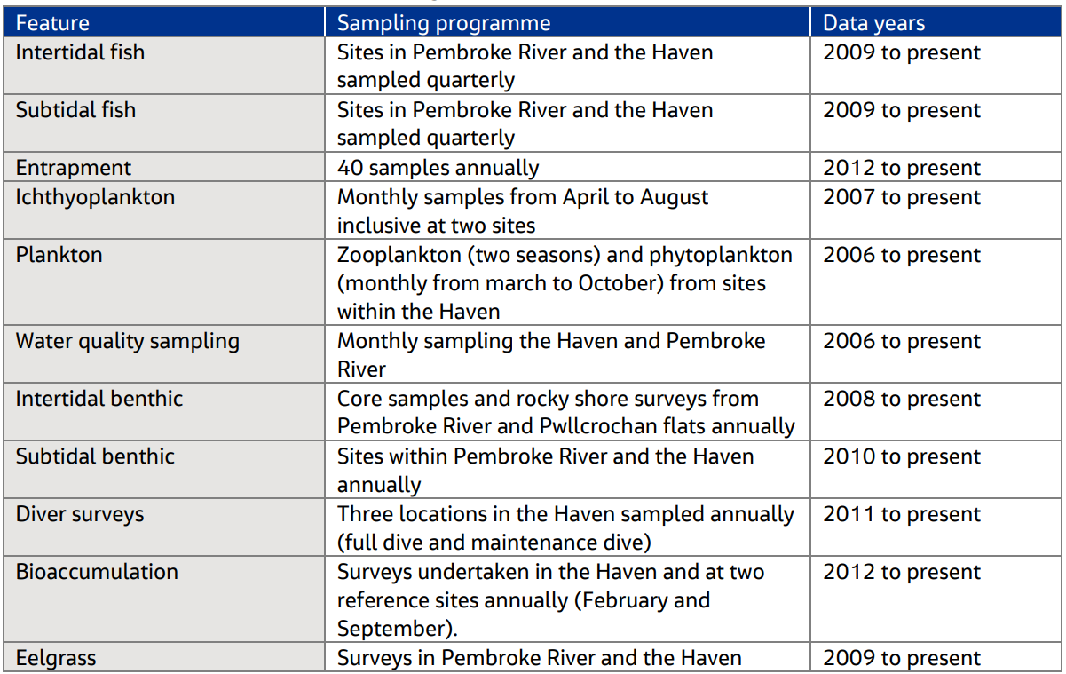

The details of the sampling program have been agreed in consultation with NRW and are continually reviewed and agreed and include impingement monitoring 40 days throughout a year as well as entrainment monitoring.
No recording of river lamprey impingement has been identified as part of the sampling program. The species however are believed to exist within the estuary as part of their lifecycle and reside in the estuary prior to spawning in the River Cleddau. The entrainment monitoring currently taking place does not cover the outward river lamprey migration period when juvenile fish would be small enough to become entrained.

Very low numbers of Sea lamprey being impinged have been recorded from the impingement surveys carried out as part of the sampling program. No sea lamprey were recorded as part of the entrainment sampling. This may be due to the sampling period not occurring during the most likely period where lamprey of juvenile size able to become entrained would be migrating from the Cleddau into the estuary.
The SILAS system in place is not specifically designed to deter lamprey, however the fish recovery and return system in place is designed to return fish in a viable condition. Bespoke survival rate studies undertaken at Pembroke power station indicate that lamprey have a 50% survival rate following impingement and therefore not all impinged lamprey will be lost
Due to the inclusion of fish screens and deterrent system at the abstraction intake the impact to Sea and River lamprey populations are not considered significant. Impacts from impingement and entrainment have been minimalised as best as possible with the use of specific technology designed for this location to initially deter fish from entering the abstraction system and for impinged fish to be returned to the estuary. The abstraction is unlikely to affect the conservation objectives for Sea and River lamprey being met in the future. Both lamprey species are considered to be in un-favourable conservation status. It should be noted that following the second report cycle of the condition status of River Lamprey they are now considered to be in an unfavourable- recovering status. At this second reporting cycle this species passed targets for population density, distribution and age structure; but failed on the river flows. This indicates that river lamprey populations are recovering. The reporting cycle highlighted concerns form water quality within the Cleddau catchment from pollution incidents, rather than any impact from RWE Pembrokeshire affecting lamprey populations.
The following conditions as included in the current licence and will be included within the renewed licence:

- Before any abstraction takes place the Licence Holder shall install to the satisfaction of the NRW at the point specified in condition 2 above:
• Four drum screens with a mesh size of 6 millimetres or less at the intake structure. The drum screens will incorporate a back wash and fish return system.
• An acoustic fish deterrent at the intake structure.
• A strobe light at the intake structure.

- The Licence Holder shall maintain the four drum screens and fish return system, acoustic fish deterrent and strobe light specified in condition 9.2 above, and record any maintenance carried out to the satisfaction of the NRW.

By minimising impacts to fish species, this will subsequently reduce/null impact to mammals such as otter and birds who may predate on these migratory fish species. Although fish eggs/species are entrapped as will pass through the initial intake trash screening, the significance of this upon fish populations is not known to be significant and therefore evidence to date demonstrates that the abstraction has not adversely impacted fish populatons and subsequently prey availability.

- Signature and date assessment made | Liz Cole  01/05/2025
- Officers name and job title | Liz Cole  Water resources senior permitting officer

Permitting
Formal Notification under Section 28I of the Wildlife and Countryside Act 1981

Part 2 Formal notification under S28I – To be completed for all permit applications assessed as: not likely to damage because of conditions, likely to damage SSSI and those where we are unable to conclude no likely damage.

- Date Notice of intention to permit activity likely to damage SSSI sent to NRW (SCNB) | 21/05/2025  We have assessed that RWE Pembroke power station abstraction licence renewal is likely to damage Western Cleddau and Eastern Cleddau SSSIs and request your formal advice. We have assessed that this damage could be mitigated by including conditions as detailed above.  Information on the permit application can be found in Part 1 of this form and within the DMS under the Licence Renewal category.
- Advice received from NRW (SNCB)

See Marine Area Management And Advice Team (MAMAT) memo received 27/06/2025 which contains comment from Marine Mammels, Marine Ornithology and Marine Fish advisory:

F22- section 4: updated decription of abstraction intake as per advice.
F23 – section 5: ‘We advise that PDO 10. Killing, injuring, taking or removal of any wild animal, or the eggs/nests of any wild animal or the disturbing, taking, damaging or destroying of any wild animal in its place of shelter excluding pest control. should be included in the assessment. This section has been updated
F24 – section 6: reference/append previous advice received 11/02/2025 which is now attached
F25 -,section 7: further assessment required: ‘We advise that our comments on Section 4.1 sea lamprey and river lamprey of the HRA also apply to this section.’ Section 7 of this assessment has been updated although not in agreement with the advisory comments received.

- Name and job title of conservation/marine officer (sign and date) | Adam Cooper, Marine Area Management and Advice Team  27/06/2025

Part 3 – To record NRW decision following SNCB Advice
- DECISION

The proposed permission is not likely to damage any of the flora, fauna or geological or physiological features which are of special interest because of conditions.

The advice received from SNCB has been considered, as outlined in section 7 above. Some amendments have been made in line with this advice, however the conclusion of the assessment does not align with SNCB advice. The decision to proceed on issuing a licence has been escalated to the Head of Regulation and Permitting.
- Natural Resources Wales (Section 28G Authority) (permitting service) is minded to | Issue the permission with conditions to ensure no damage to SSSI  A finalised escalation paper has been drafted outlining NRW’s decision to issue the abstraction. It has been concluded that
- Is decision in line with advice from SNCB | No  The commencement of the escalation process on 19/08/2025 meets the requirements of OGN 231 to make notification 21 days prior to issue of licence.
- Signature and date assessment completed | Liz Cole 05/08/2025
- Officers name and job title | Water resources senior permitting officer

