Annex (iv) – SSSI Assessment Form
SSSI Assessment for permit/licence and deployment applications | 
To be completed by Permitting Officers for any applications for a permission which Natural Resources Wales has considered under S28I duty to notify SNCB and take their advice into account. This applies to all proposed permissions within a SSSI, and to operations outside the SSSI boundary which are likely to damage its special features.
NRW as a Section 28G authority has, when exercising its functions, a general duty to take reasonable steps, consistent with the proper exercise of its functions, to further the conservation and enhancement of the flora, fauna or geological or physiological features by reason of which the site is of special interest.

Part 1 – SSSI Assessment
Part 2 – Formal notification to SNCB (to be completed if part 1 assessment concludes likely damage, not likely to damage because of conditions or you cannot conclude no likely damage)
Part 3 – Decision
Pink text – drafting notes, to be deleted before completion/consultation.
Blue text – examples, to be replaced with permission-specific information and text turned to black.

Part 1 – SSSI Assessment

- Permitting officer/team | Bryan Burn, Waste Permitting
- Permit application reference and site name | PAN-030459  Cefn Naw Clawdd Farm, Dolgellau, Gwynedd. LL40 2SG for fields 1416, 9846, 0865.  Glyn Farm, Dolgellau, Gwynedd. LL40 1YA for fields 9216, 1113.  The application also includes Tan Y Coed Uchaf, Bryncrug, Tywyn. LL36 9UP for fields 0264, 2585 although these are not in range of SSSI.
- a. SSSI name(s)  b. location  c. NRW Operational Area/Environment Team | a. Cadair Idris  b. Dolgellau, Gwynedd  c. North West  a. Llwyn-iarth  b. Dolgellau and Penmaenpool, Gwynedd  c. North West  a. Bryn y Gwin Isaf  b. 1.5 km west of Dolgellau, Gwynedd  c. North West  a. Mawddach Estuary  b. Meirionnydd, Gwynedd  c. North West
- Brief description of proposal | Landspreading deployment under standard rules permit SR2010 No4  The activity is not wholly or partly within the SSSI boundaries.  A land spreading application to spread a total of 10 non stackable waste streams coded EWC 19 09 02 at 3 farm addresses Cefn Naw Clawdd, Dolgellau, Glyn Farm, Dolgellau, Tan Y Coed Uchaf, Bryncrug. The fields are within a 10-mile radius of the main farm address. The wastes will be spread on grass fields. The maximum application rate is 250 tonnes per ha, with a total tonnage to spread of 4425 tonnes.  The waste will be spread over 21.3 ha hectares of land within the listed fields at Cefn Naw Clawdd, Glyn Farm and Tan Y Coed Uchaf farm. The wastes may be stored in a lagoon, above ground store or spread on delivery. The wastes will be spread via dribble bar which is an appropriate application method for the waste type.  Targeted periods of spreading on grass fields include early spring (late February – May), after cutting of silage, and prior to grazing through summer and autumn (September).  The wastes may be applied separately or in combination. If the wastes are applied in combination the total combined amount applied will not exceed 250t/ha, the total nitrogen loading will be less than 250kg/ha, and the amount of available nitrogen and total or available phosphate and potash (whichever is appropriate) will not exceed the fertiliser recommendation or the amount removed in crop offtake, whichever is the greater.  Suitable no spread buffers are in place where steeply sloping ground is apparent.  The landspreading activity will comply with CoGAP.
- What aspects of the proposed permission are likely to damage the SSSI features of special interest?

The following activities are likely to cause damage:

Mawddach Estuary SSSI

5. Application of manure, slurry, silage liquor, fertilisers, and lime.

7 Dumping, spreading, or discharging of any materials.

22. Storage of materials.

26. Use of vehicles or craft.

Bryn y Gwin Isaf SSSI

26. Use of vehicles, machinery, or other devices likely to produce noise, fumes and heat.

Llwyn-iarth SSSI

5. Application of manure, slurry, silage liquor, fertilisers, and lime.

7. Dumping, spreading, or discharging of any materials.

22. Storage of materials.

26. Use of vehicles.

Cadair Idris SSSI

5. Application of manure, slurry, silage liquor, fertilisers, and lime.

7. Dumping, spreading, or discharging of any materials.

22. Storage of materials.

The following SSSI(s) features and potential impacts have been considered to assess the likelihood of damage:

Mawddach Estuary SSSI

Habitats

- Estuary
- Intertidal muddy gullies
- Bog
- Salt marsh
- Coastal fen
- Swamp
- Wet woodland

Rare plants

- Rare dwarf spike-rush,
- Lax-flowered sea lavender
- Perennial glasswort
- sharp rush,
- marshwort
- lesser bulrush
- brown beak-sedge
- bog rosemary,
- great sundew
- Wavy St John’s-wort,
- moor-grass tussocks.
- greater spearwort
- rare cyperus sedge
- scarce narrow-leaved helleborine
- small adder’s tongue
- smooth cat’s-ear

Birds

- Skylark
- Barn owl
- Song thrush
- Redshank
- Snipe

Mammals

- Otter
Fish

- Sea lamprey and non-spawning
- Allis shad
- Twaite shad.
- Mullet.

River shingle invertebrates

- Four rove beetles
- Two ground beetles
- Money spider
- Wolf spider
- Scavenger water
- Grimmia arenaria
- Pallavicinia lyellii

Fish

- Atlantic Salmon

Other special features

- Neutral and marshy grassland & bracken
- Woodland, and linear features such as hedgerows and lines of trees along the riverbanks
- Lempholemma polyanthus (Lichen)
- Fairbourne spit
- Reed bunting
- Grasshopper warbler
- Reed warbler
- Kingfisher
- Water rail goosander
- Chough
- Wintering wildfowl and Waders include wigeon, teal, oystercatcher, curlew and shelduck.

Bryn y Gwin Isaf SSSI

- Lesser horseshoe bats

Llwyn-iarth SSSI

- Lowland neutral grassland
- Flushes
- Fen
- Population of wood bitter-vetch
- A mosaic of habitats including marshy grassland, wet dwarf shrub heath, acid grassland, scrub and woodland

Cadair Idris SSSI

Geological

- Ordovician igneous and sedimentary succession exposed in natural rock outcrops. Pleistocene/Quaternary landform assemblage comprising cirques, protalus ramparts, moraines, landslides, alluvial fans, stratified screes, blockstreams, and associated deposits.

Habitat

- Blanket bog
- Wet and dry heaths
- Lichen/bryophyte heath
- Marshy grassland
- Tall herb and fern ledges
- Vegetated natural rock exposures
- Lakes (nutrient-poor lakes)
- Broadleaved woodland
- Flush and spring
- Calcareous and species-rich acid grassland

Plants

- Hairy greenweed
- Welsh eyebright. Nationally scarce mosses,
- liverworts and lichens including the liverwort Radula voluta,
- Slender green feather moss and an edge of range lichen.
- Nationally rare and scarce invertebrates
- Population of lesser horseshoe bats
- Summary of any informal advice received from internal experts (if required and including pre-app advice) | None required
- Recommendation | The proposed permission is not likely to damage any of the flora, fauna or geological or physiological features which are of special interest  There are no impact pathway for features to be affected due to the distance the fields are from the SSSI sites.  A possible impact pathway was identified where a water issue is within 50metres of field 1113. A no spread buffer is in place and the issue is beyond a built environment.  Multiple watercourses within fields 0865, 9846 and 1416 and the Afon Clwdog borders the fields to the East. No spread buffers are in place to the borders and watercourses.  Fields that have highly sloping ground have no spread buffers to mitigate the risk of surface runoff.  Wastes will be spread via low-trajectory splash plate / dribble bar trailing shoe or similar. These application methods are appropriate for the waste types and apply the wastes directly to the ground to reduce the risk of surface runoff.  Spreading will only be undertaken when weather conditions are suitable within restrictions outlined in CoGAP  No more than 50t/ha of waste will be spread on a field in any 3-week period in accordance with CoGAP, and no more than 250t/ha will be spread within any 12-month period.  Spreading machinery will be turned off and lifted away from the soil prior to turning at the end of each run.  Machinery will be checked daily when in use, regularly serviced and spreading equipment calibrated. Umbilical hoses will be regularly checked for damage to prevent leaks  Machinery turns will not be executed in no spread buffers.  All spillages will be reported immediately to NRW
- Signature and date assessment made | Bryan Burn, 01/10/25
- Officers name and job title | Bryan Burn, Permitting Officer

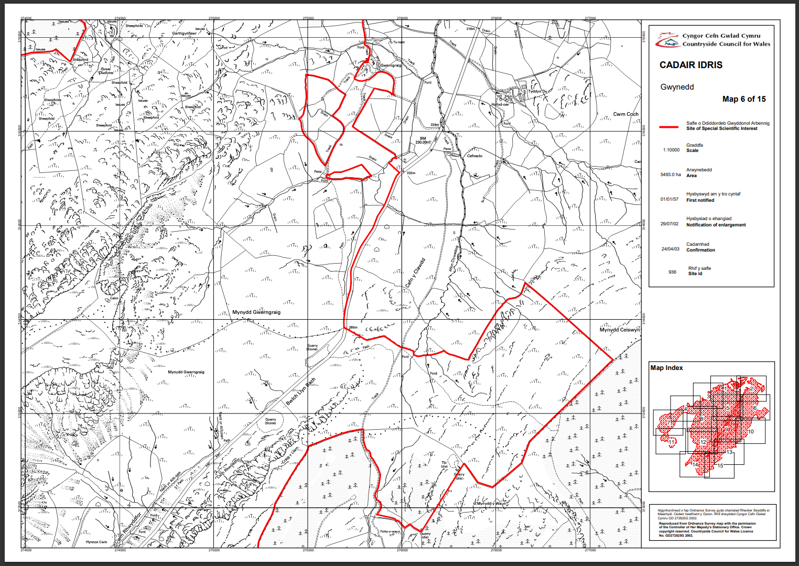
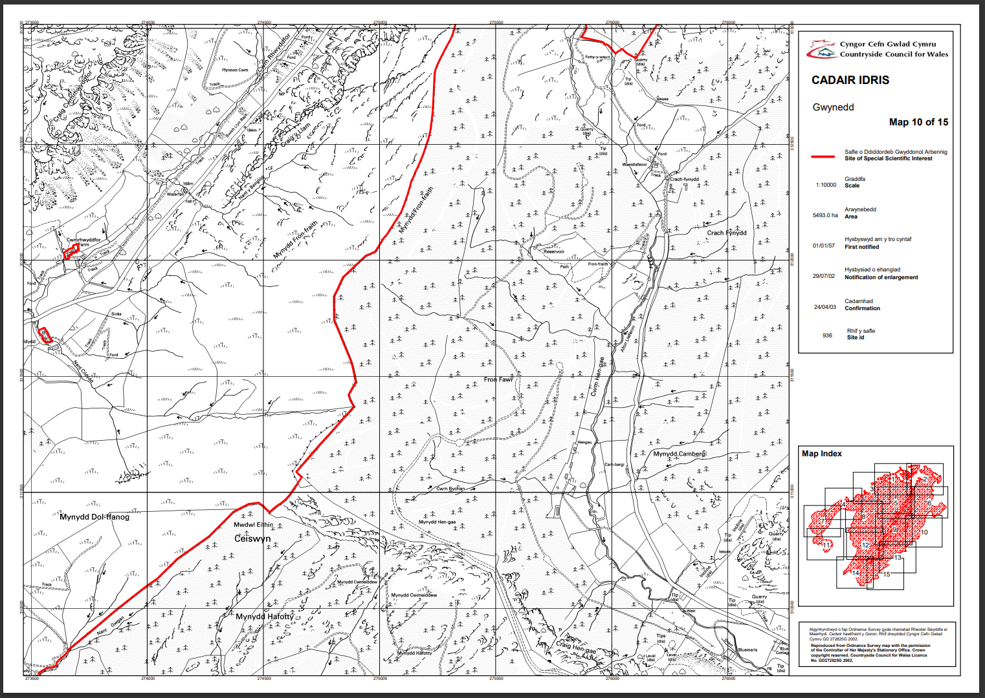
Cadair Idris is North and West of fields 0865, 9846 and 1416.
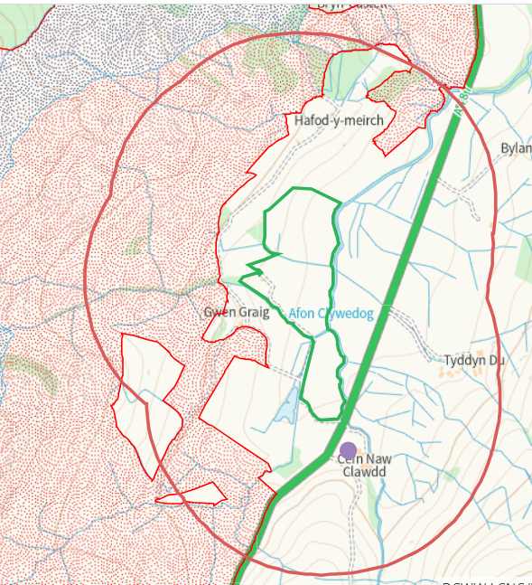

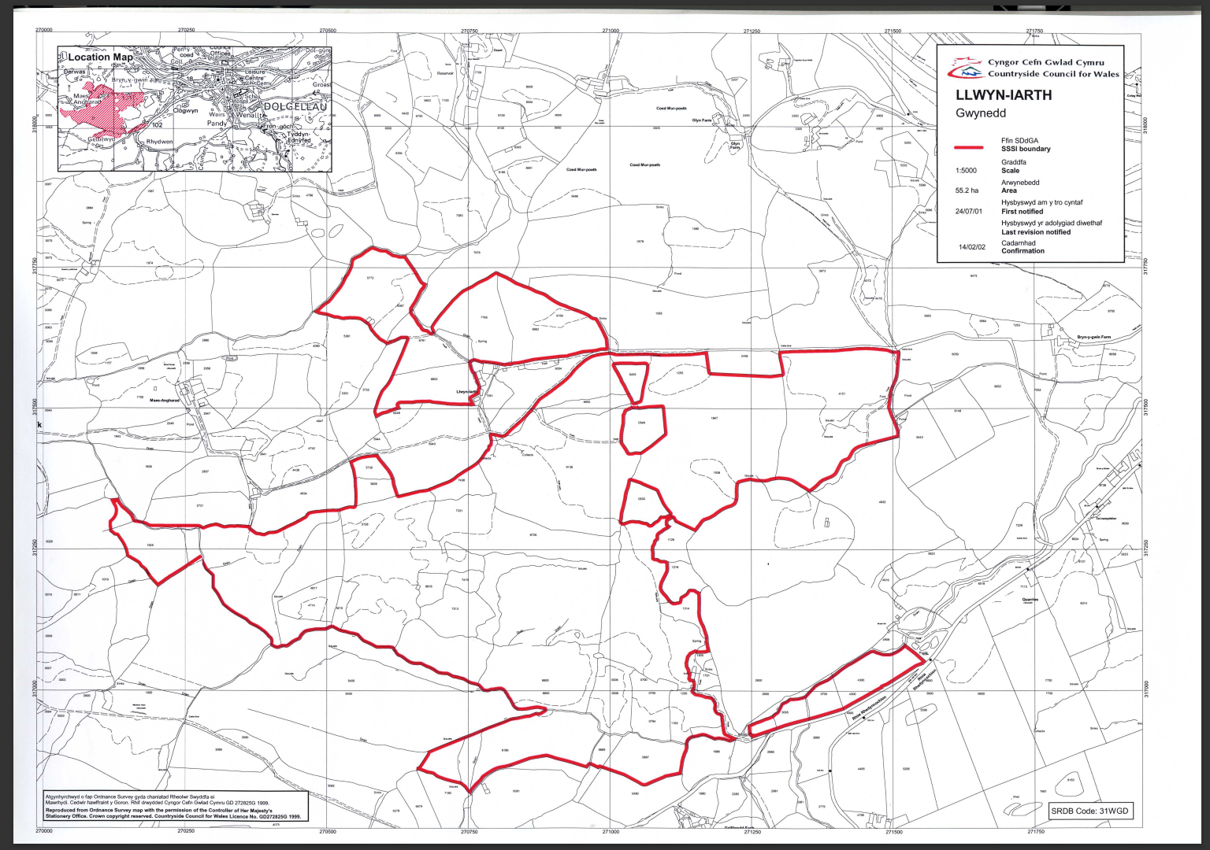
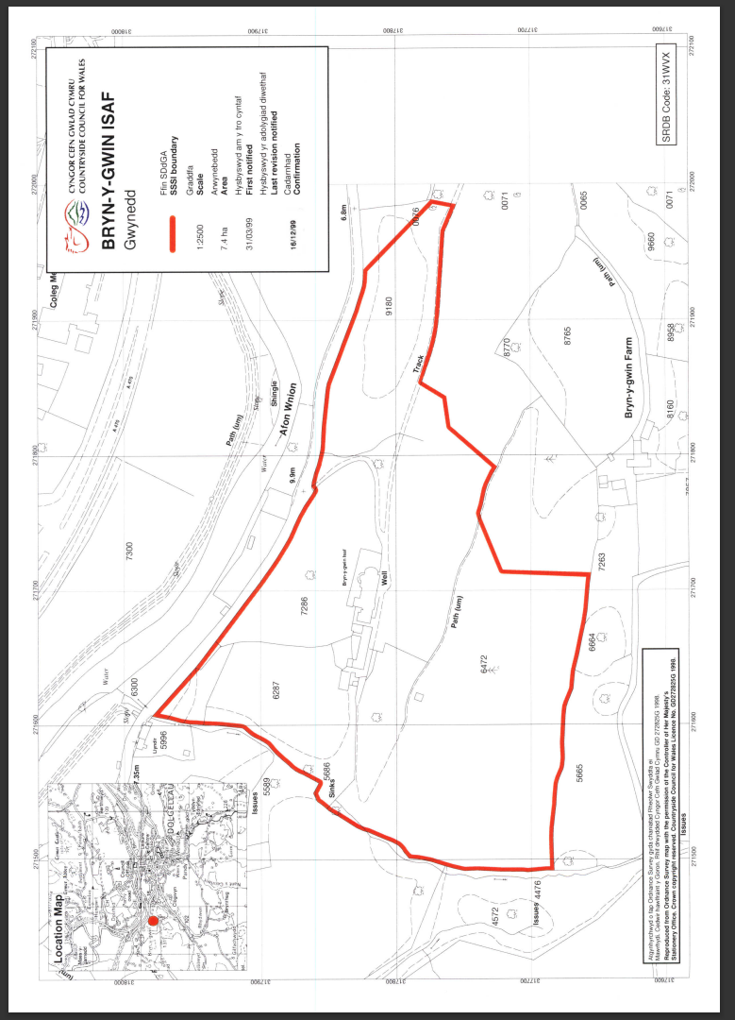
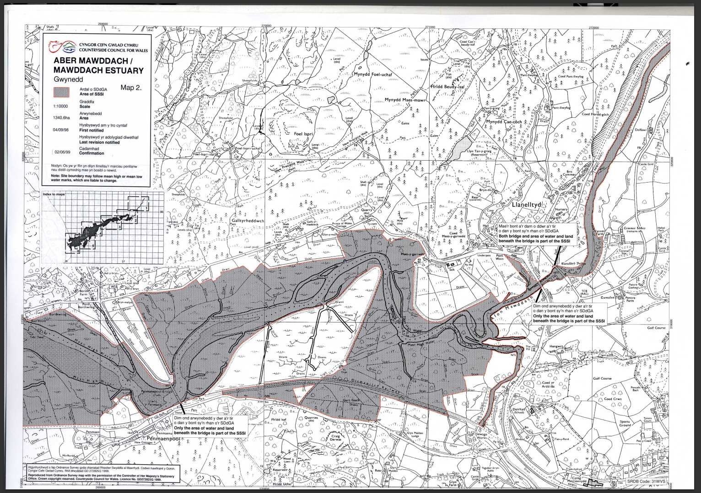
Llwyn-iarth is South of fields 9216 and 1113, Bryn y Gwin Isaf is South East of field 1113, Aber Mawddach is North of fields 9216 and 1113.
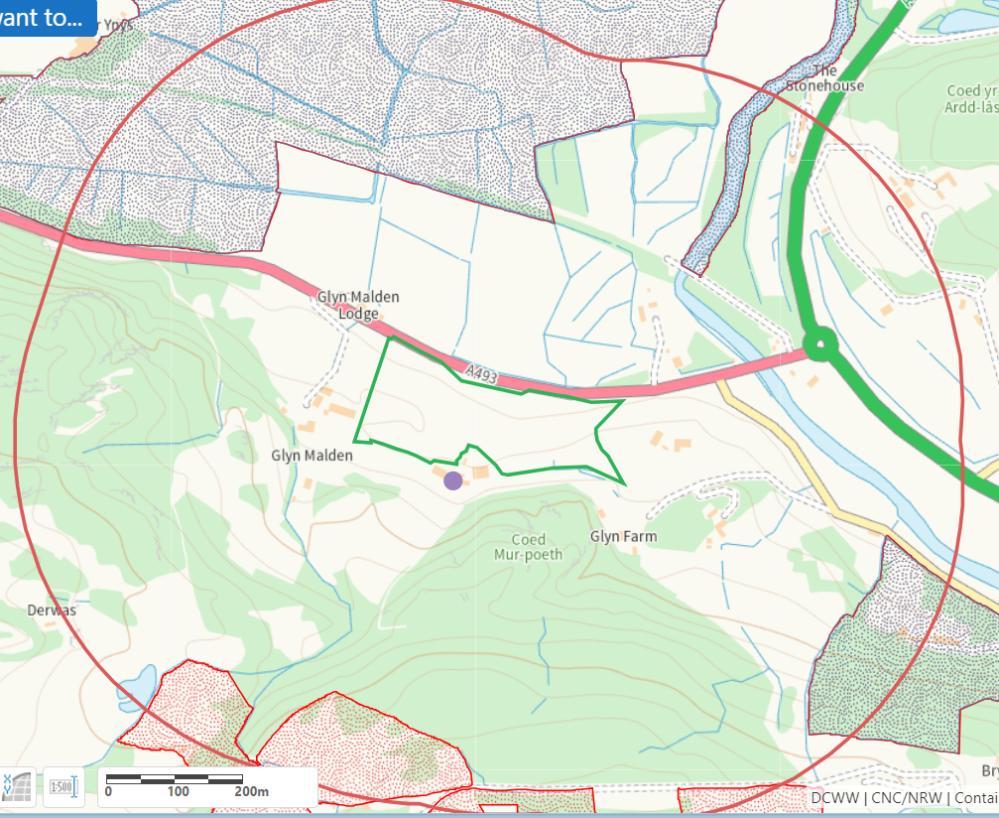
END

