PAN-030462 Mapping Report
Application maps
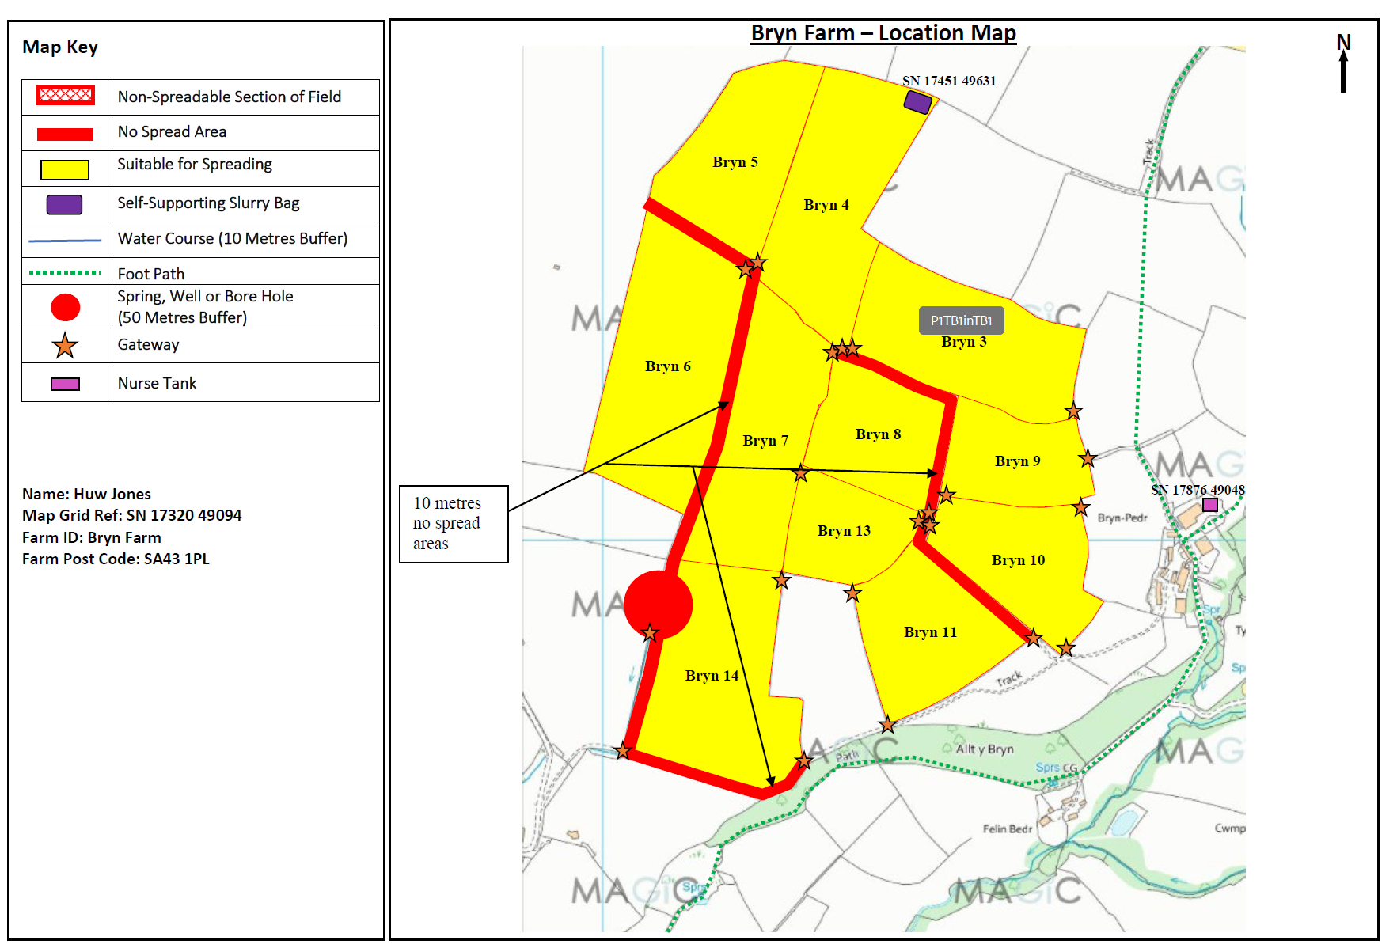
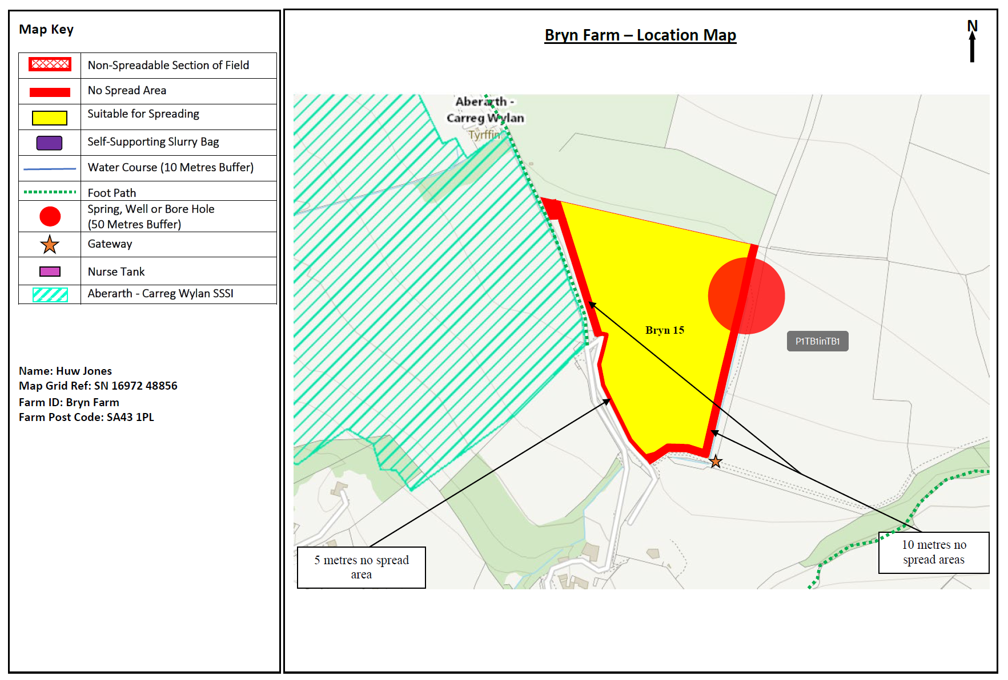
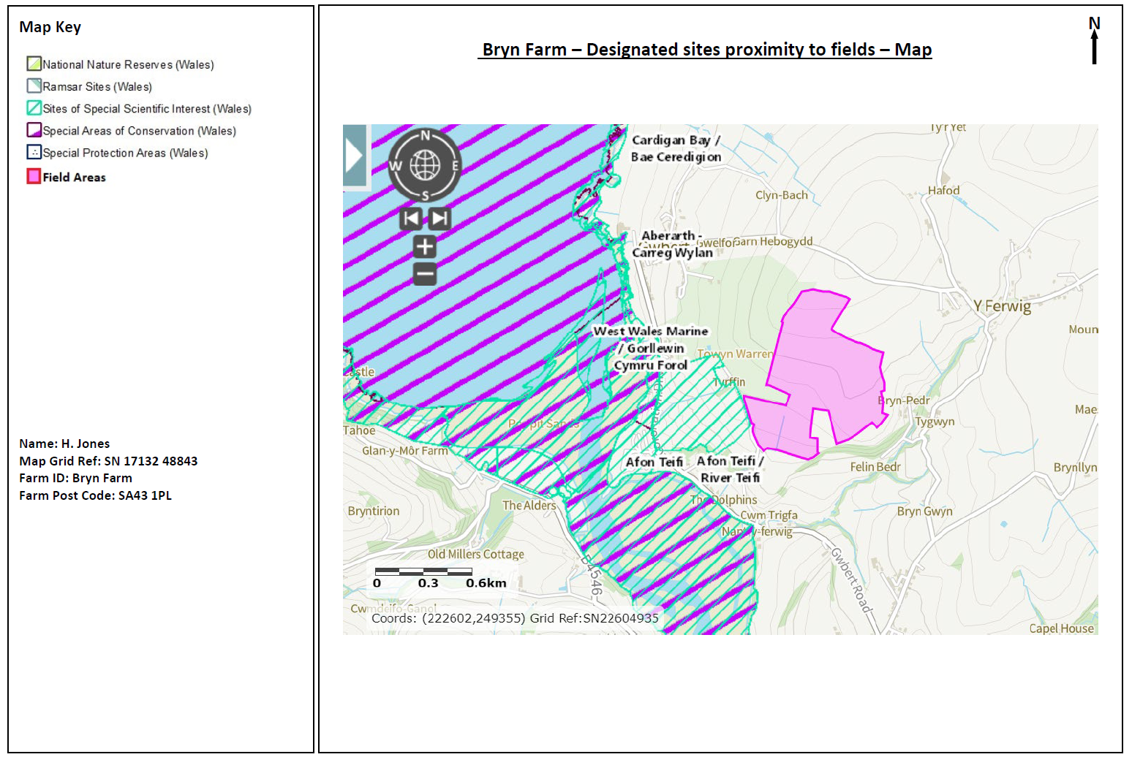

Deployment Boundaries and storage
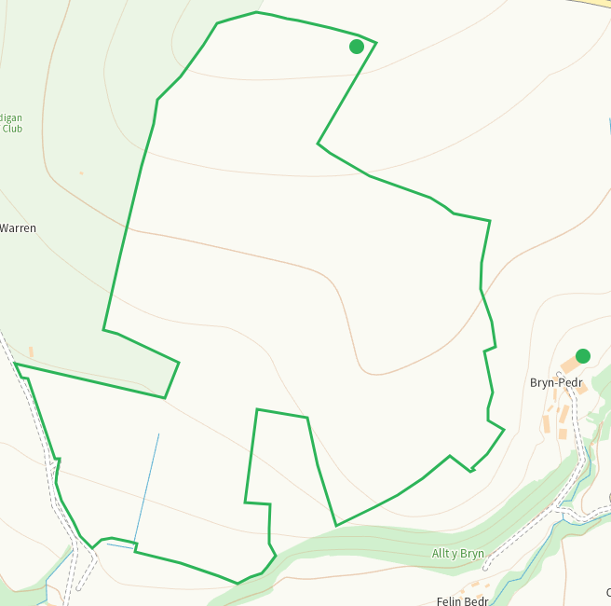
Detailed river network 10m
Watercourse between 14 and 15. Shown on application map and buffered
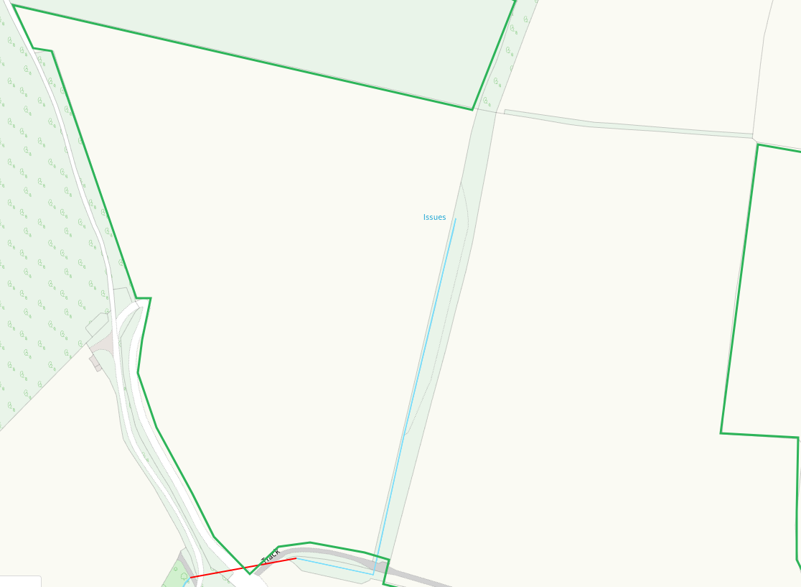
None at other feilds
Groundwater source protection zones
none
Any well, spring (or issue) or borehole used for the supply of water for human consumption including from a private water supply or supplies within 50m.
Issue between 14 and 15, buffered.
None at other fields or storage
Any well, spring (or issue) or borehole used for the supply of water for human consumption including from a private water supply or supplies within 250m.
Issue N of 14, shown on application map
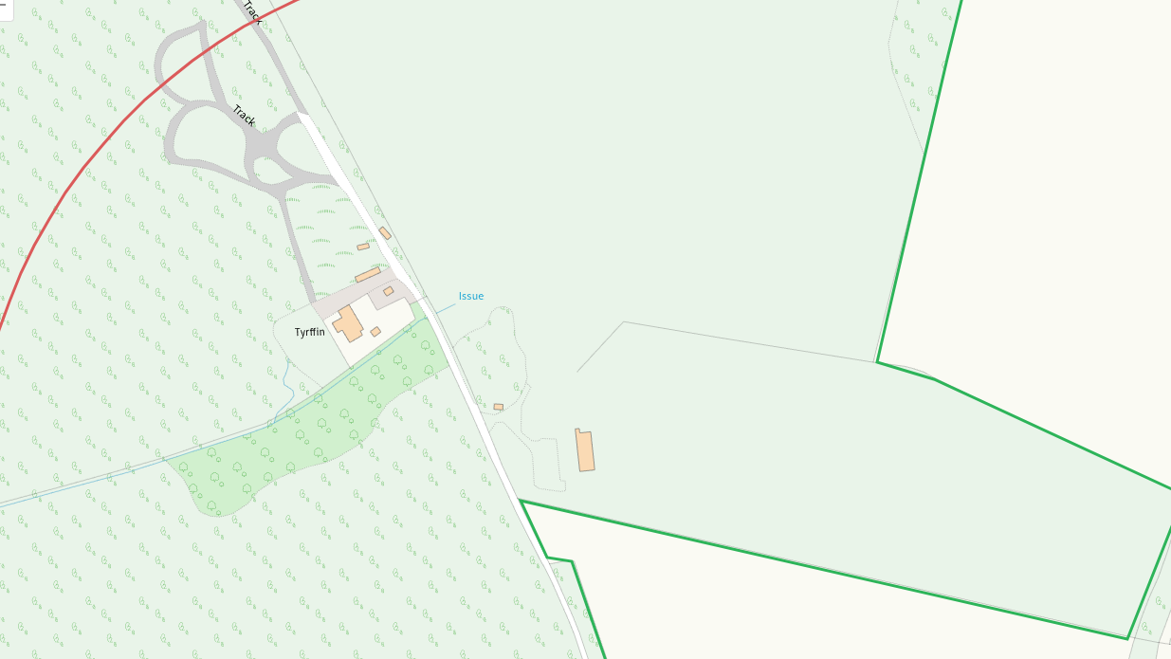
2x springs E of 10, shown on application map
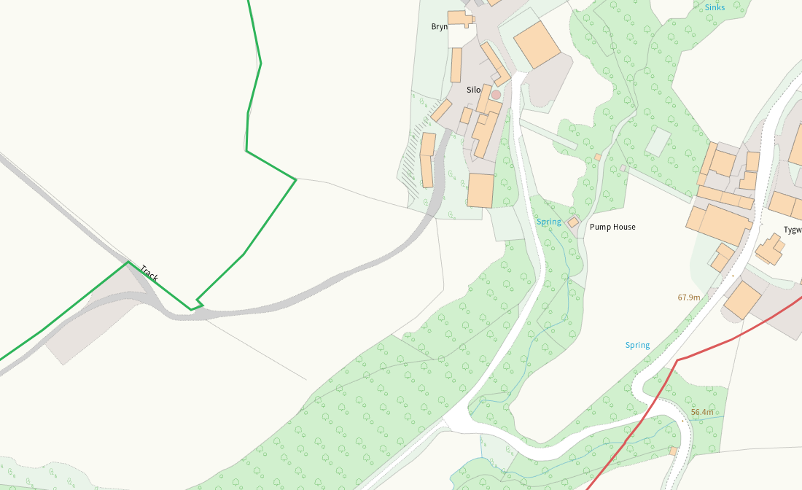
Spring SE of 11, shown on application map
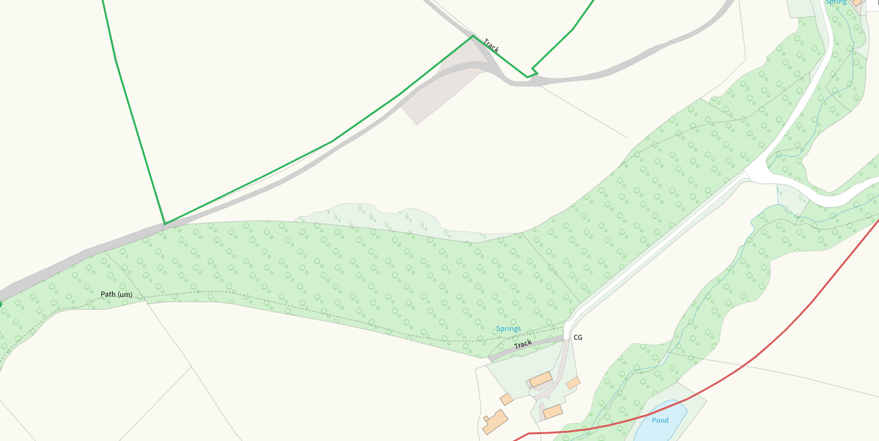
Within Groundwater Safeguard Zone
none
European designated sites- Natura 2000 (SPA, pSPA, SAC or cSAC) or Ramsar- or SSSI within 500m
SSSI Aberarth - Carreg Wylan adjacent to 15, buffers in place at the boundary
SSSI and SAC Afon Teifi SW of 15, buffers in place to watercourse and boundary
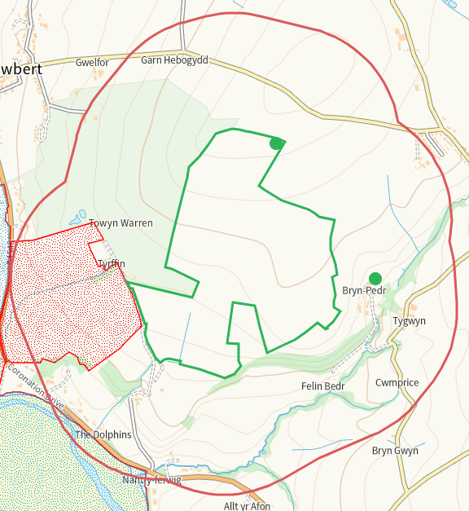
None at other fields or storage
Other protected sites within 500m:
- Protected Species- None
- Protected Habitats-
Coastal saltmarsh, Lowland dry acid grassland and Lowland calcareous grassland, Purple moor grass and rush pastures within range. Nil risk

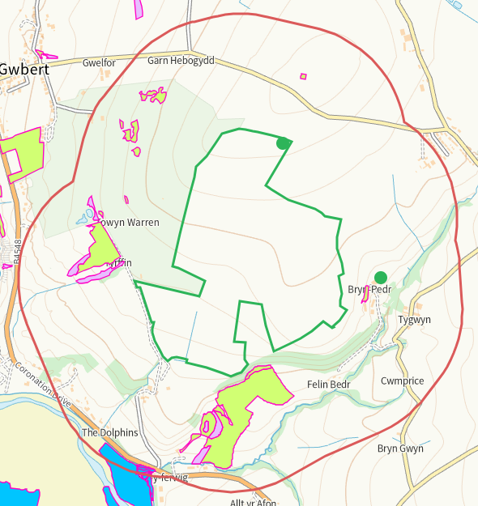

- Scheduled Ancient Monument- none
- Local Nature Reserve- none
- National Nature Reserve- none
- Ancient Woodlands- none
- Local Wildlife Sites (SINC)- none
- National Park- none
- Nitrate Vulnerable Zone (NVZ)- ALL Wales
- Groundwater Safeguard Zone- none

Flood risk
None
Public rights of way
None
Any buildings or houses within 250m
Several within range, shown on application maps where applicable and mitigated in SSRA for human receptors.
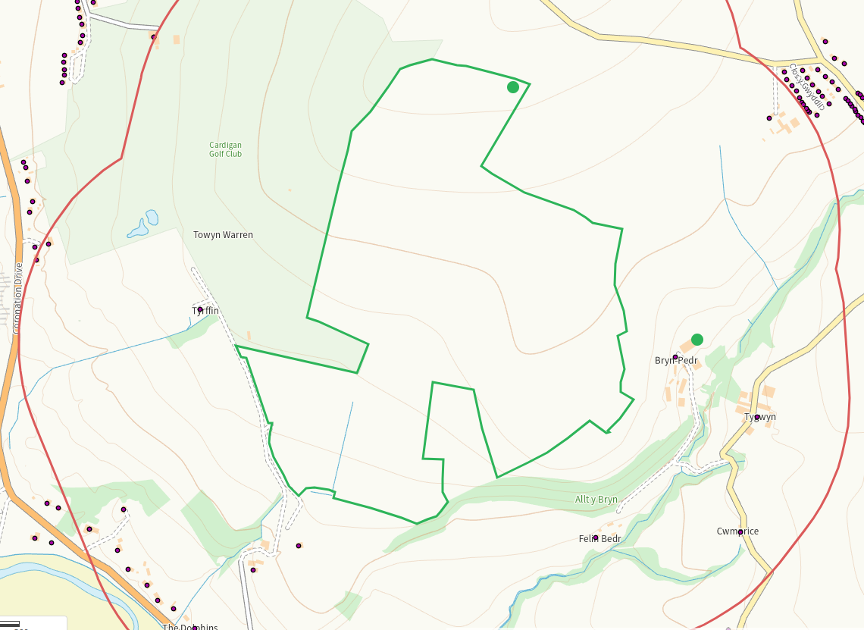
Distance from Main Farm Address
Adjacent
Slope Map
All fields 0-7 with the exception of 11 which has scattered areas of 7-12 and 12+. These areas of steeply sloping ground are contained within the field and risk of run off is nominal.
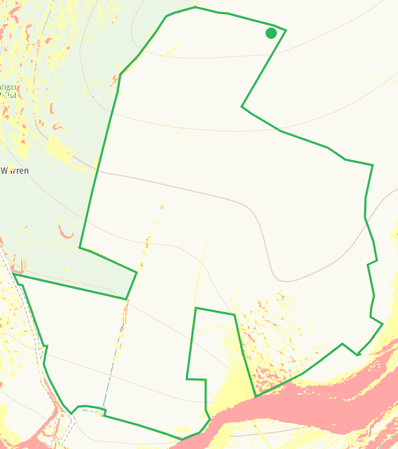
END

