Non-Technical Summary

Environmental Permit Variation Application

Kellogg Company of Great Britain
Wrexham Breakfast Cereals
Bryn Lane
Wrexham Industrial Estate
BV8016ID

September 2025

1 INTRODUCTION
This Non-Technical Summary (NTS) provides an overview of what is being applied for, the regulated facility and outlines the key technical standards and control measures that will be implemented at the Site.

2 APPLICATION OVERVIEW
The existing installation comprises of the following activities listed in Part 2 of Schedule 1 to the Environmental Permitting Regulations and the following directly associated activities.
AR1 - Section 6.8 A(1)(d)(ii) – Treating and processing materials intended for the production of food products from vegetable raw materials at plant with a finished product production capacity of more than 300 tonnes per day.
AR2 - Section 1.1 A(1)(a) – Burning any fuel in an appliance with a rated thermal input of 50 Megawatts or more.
AR3 - Section 5.4 A(1)(a)(i) – Disposal of non-hazardous waste in a facility with a capacity of more than 50 tonnes per day by biological treatment.
AR4 - Surface water drainage.
AR5 – AR8 – MCPs under Schedule 25A

What is being applied for?
Kellogg’s are applying to vary the Site’s environmental permit to incorporate temporary generators on site.
No changes are proposed to the manufacturing process, existing boiler plant, effluent treatment plant or surface water drainage as part of this application.

3 OVERVIEW OF DEVELOPMENT

As part of the ongoing investment there will be an increase in power demand on site. Our energy supplier, Scottish Power has agreed to supply the extra electricity however they are unable to do this until May 2027.
In the interim (from late 2025) we are looking at installing three 600 kVA generators to supply the additional load to the plant. Of the three units only two will be used at one time with the third as back up only, to a maximum of 999 KVa. They will not be used to provide balancing services to the grid or for the purposes of Triad avoidance. The units will use hydrotreated vegetable oil (HVO) and not diesel as a fuel.
An additional four 300 kVA generators may also be required to supply the additional electricity supply to the effluent treatment plant (ETP). If installed these units will be required from approx. May 2026 until December 2027 and will also be fuelled by the same specification HVO as the 600 KVa units.
The four smaller units may not be required but have been included as worst case scenario due to the timing of the variation application. The modelling for the application has been based on the installation of all seven units.
The units will be Stage V compliant and the design specification sheets can be found in Appendix A.
Appendix B includes details on the specification of the associated HVO fuel tank (19,000 litres).
Appendix C – specification for the Ad Blue tanks (2000 litres).
All tanks will be double skinned. Spill kits will be located in the area for use in the event of a spillage during unloading. Deliveries will be supervised so that in the event of a spillage it is contained prior to entering the surface water system. In the unlikely event of a catastrophic failure the surface water drains go through an oil interceptor before entering the balancing pond and the outlet to the pond is able to be closed. The Accident Management Plan will be updated to reflect the tanks as an additional source.
The HVO we propose to use on all units is fossil free, complies with EN15940 and is certified under the International Sustainability and Carbon Certification.
Following advice from SLR we believe these temporary units would classed as specified generators rather than new medium combustion plant. Copy of the technical memorandum is included in Appendix D.

Location
The three 600 kVA units and associated tanks will be stored on the yard to the south of the manufacturing plant (see point A in Appendix E).
The four 300 kVA units will be located in the current lorry park just to the east of the effluent plant (see point B in Appendix E).
The installation of the effluent plant temporary units and associated tanks will be outside of the existing installation boundary. See Appendix F for an updated site plan reflecting this change. Our EMS documents will be updated to reflect this change to the installation boundary. The relevant area is hardstanding and has been part of the lorry park since the permit was issued. There have been no reported spillages in the area. The ground surrounding this area was considered as part of the original permit application and not found to be contaminated. The original Site Report (January 2005 KelloggsWrexASRFINALCli200105) is considered to remain relevant and can be provided if required.

Time Limited
As it is known that the proposed changes will be temporary, and the impact on our permit conditions is likely to be minimal, we request that rather than a further variation be required to remove reference to the units we can do this via an exchange of letter or as time limited permit conditions. The 600 kVA units will be removed from site within two months of Scottish Power completing the upgrade. If they are brought to site the 300 kVA units will be removed by the end of 2027.

Waste Water Treatment Activity
The temporary power will have no impact on the existing waste water treatment plant (WWTP).

Manufacturing Activity
No changes are proposed to food manufacturing activities.

Site Drainage Systems
There will be no changes to the existing site drainage systems as a result of the proposed changes.

Environmental Risk Assessment
Section 5 of the application assesses the impact of the temporary units from an amenity and accident point of view.

4 EMISSION POINTS

There will be 7 new emission points associated with the changes (1 for each unit). These are summarised in the table below. Drawing W-Bl-303 has been updated to reflect these new points.

Reference on DWG W-BL-303r24 | Source
136 (A46) | Generator Unit 1
137 (A47) | Generator Unit 2
138 (A48) | Generator Unit 3
139 (A49) | ETP Generator Unit 1
140 (A50) | ETP Generator Unit 2
141 (A51) | ETP Generator Unit 3
142 (A52) | ETP Generator Unit 4

Given that the proposed units are Stage V compliant, and therefore the emissions low, as well as the fact the units are only temporary, it is not proposed to carry out any emissions monitoring on the temporary generators. Appendix A includes details of the emissions from the units.

An air emissions risk assessment has been carried out (Section 3 of the application) to model the impact of the changes. The conclusions of the AERA are as follows:
• The NOX, CO, PM10 and PM2.5 process contributions from the proposed additional sources do not lead to any exceedances of the standards (long-term or short-term) for the protection of human health at any location outside of the Site.
• The emissions from the proposed additional sources are considered to cause ‘no likely significant effect’ to the SACs and Ramsar site, and ‘no significant pollution’ to the Ancient Woodlands.

5 RAW MATERIALS
There will be no impact on the raw materials used in the manufacturing process as a result of the changes. HVO is not currently used on site and will be introduced as the fuel for the temporary generators.
The HVO we propose to use on all units is fossil free, complies with EN15940 and is certified under the International Sustainability and Carbon Certification.
AdBlue will also be required for the temporary units.

6 NOISE MANAGEMENT
The proposal will result in the installation of up to seven units each within acoustic housing. Information on the predicted sound level from the units can be found in Appendix A.
The noise impact assessment carried out as part of variation 009 (issued August 2025) has been updated to reflect the proposed additional temporary generators. This assessment is included in Section 4 of the application. The conclusion of this assessment is
“The assessment has found no change in the noise levels permitted in the approved August 2025 variation, except at just two locations where the total cumulative specific sound level will increase by just 1dBA. This assessment concludes that while the proposed changes may result in rating levels above the 2023 baseline background sound levels, as the noise level from the existing Site is already above the baseline background sound level, it is considered unlikely that the proposed variation will cause a noise impact on the nearest noise sensitive receptors.”

7 ENVIRONMENTAL MANAGEMENT SYSTEM
Kellogg’s is committed to managing and continually improving environmental performance and has an existing EMS which covers all existing site operations and change management. The EMS will be updated to reflect the proposed changes on site.
The management system ensures that:
- risks that the activities pose on the environment are identified and minimised;
- activities are carried out in line with the relevant procedures;
- performance against the EMS is assessed at regular intervals;
- the environmental permit is complied with;
- training is provided so that everyone on site understands the impact on their role on the environment;
- the environmental impact of proposed changes on site including construction and decommissioning are considered.

8 TECHNICAL STANDARDS AND KEY CONTROL MEASURES

Technical Standards
Key technical standards laid out in the following documents govern the design and operation of the plant:
- How to comply with your environmental permit. Additional guidance for The Food and Drink Sector (October 2014);
- Monitoring stack emissions: environmental permits (March 2024);
- Specified Generator: Comply with Permit Conditions.

Key Control Measures
Key control measures that will be applied at the Site are as follows:
- The existing Accident Management System for the Site will be reviewed and updated to incorporate the new units ^{Note 1};
- The site’s existing Noise Management Plan will be reviewed and updated to incorporate the new units prior to when they are brought online ^{Note 2};
- A preventative maintenance schedule is implemented on these units;
- Where necessary the existing Environmental Management System will be updated to reflect the additional generators before they are brought online;
- The temporary units are Stage V compliant, therefore the emissions are abated.

Note 1 – There are a number of control measures already in place on site to minimise the impact of an environmental accident on site – eg liquids stored in bunded areas, drains in the delivery areas go to the effluent plant not surface water, maintenance, regular site audits. The same control measures will be adopted once the changes have been carried out so the changes are likely to be minimal.
Note 2 – There are a number of control measures already in place on site to minimise the impact of site activities in relation to noise – eg maintenance, speed limit, restrictions on deliveries, regular site audits, training, noise abatement. These same control measures will be followed once the changes have been carried out.

9 PERMIT CONDITION CHANGES

Our existing permit, BV8016ID V009, was issued in August 2025.

It is anticipated that minimal changes will be required as a result of the temporary units, these are summarised in Appendix G.

Appendix A
Specification of the 300 kVA and 600 kVA temporary units

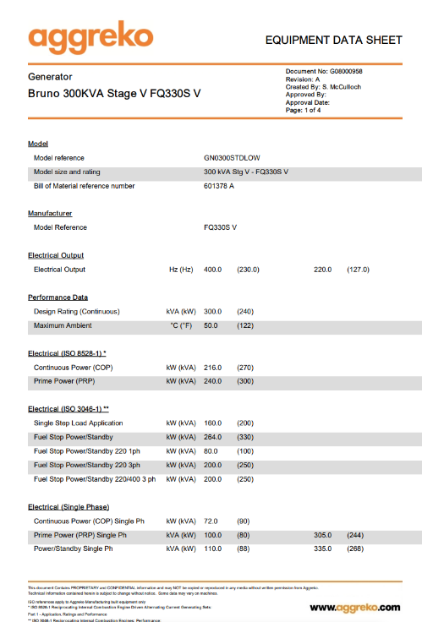
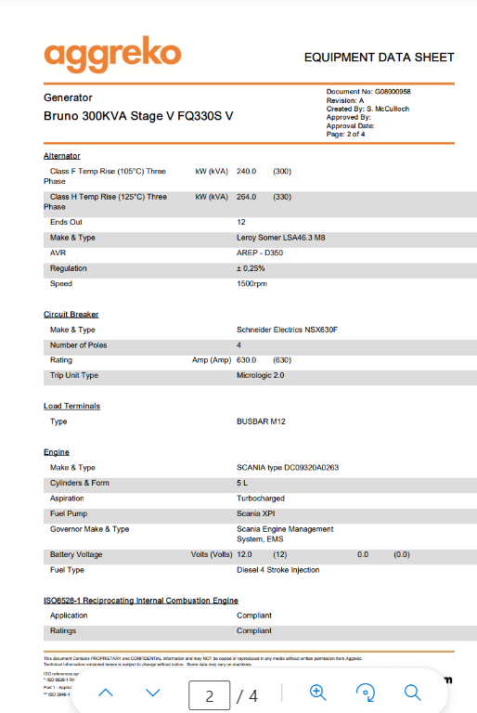
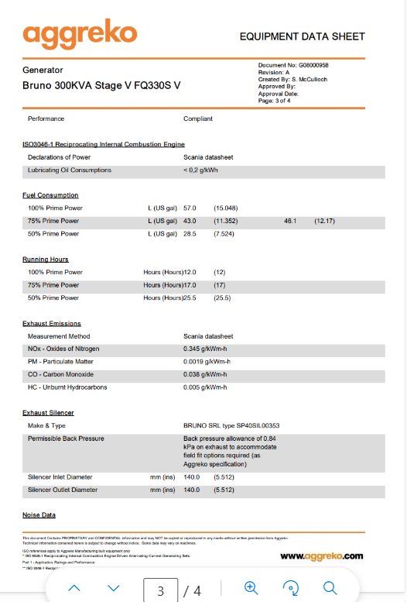
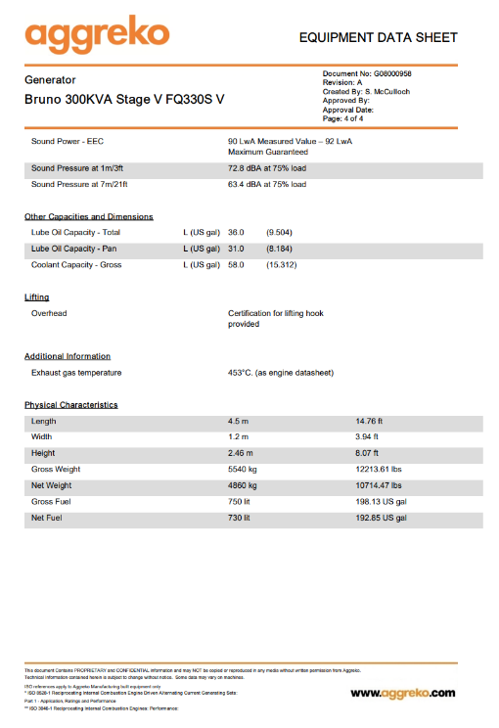
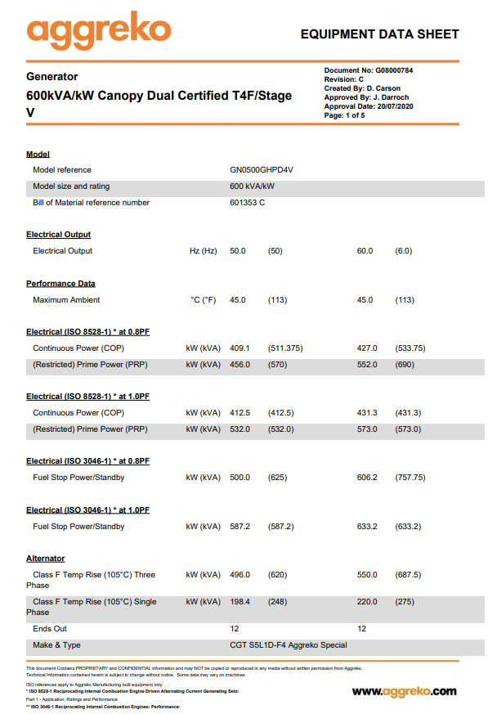
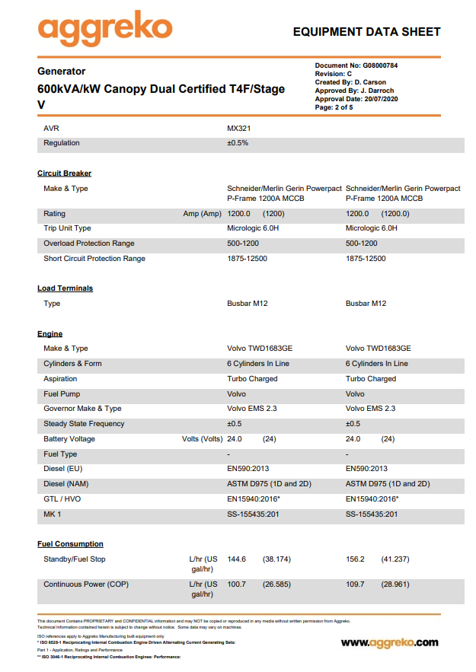
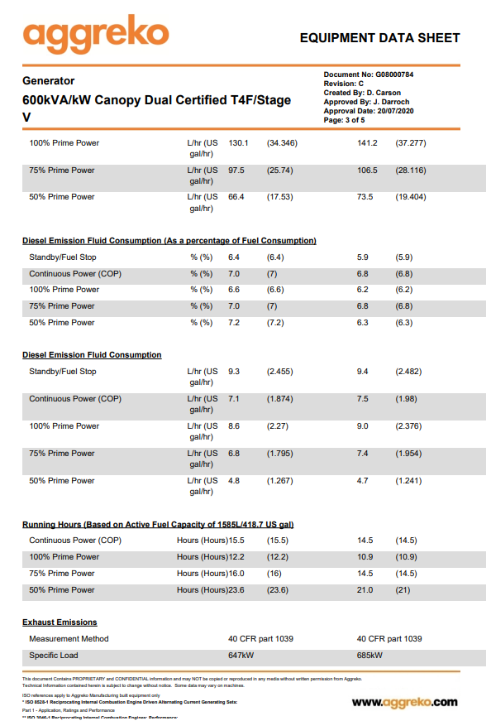
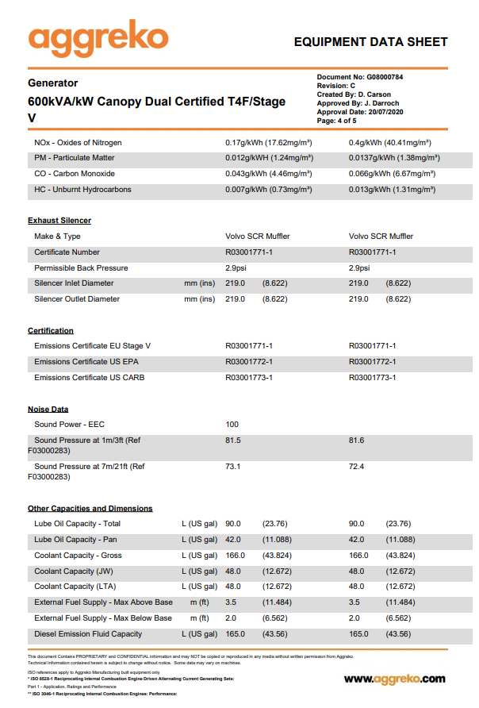
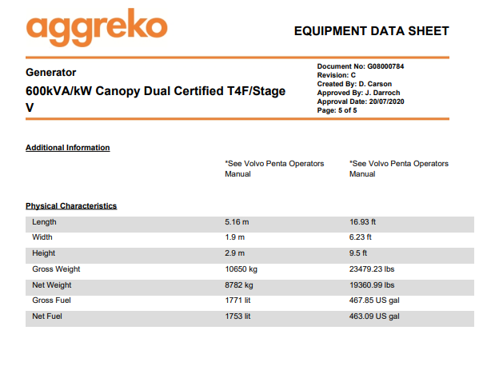

Appendix B
Specification of temporary HVO tank

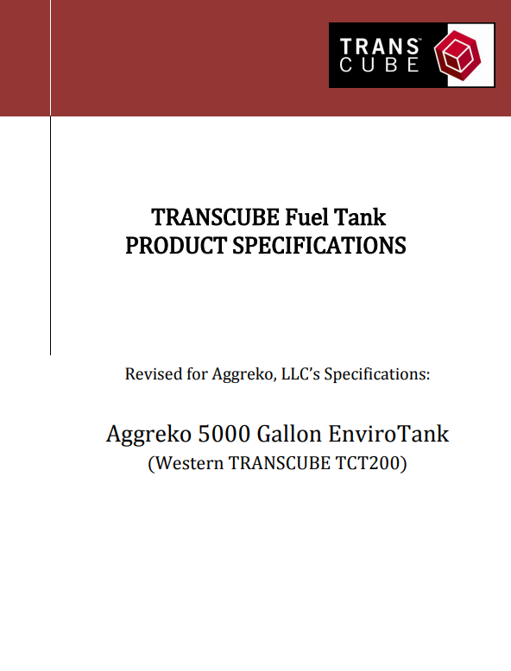
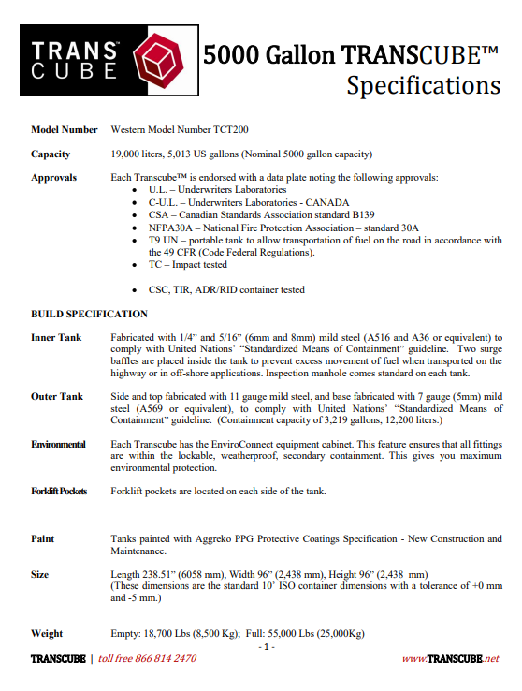
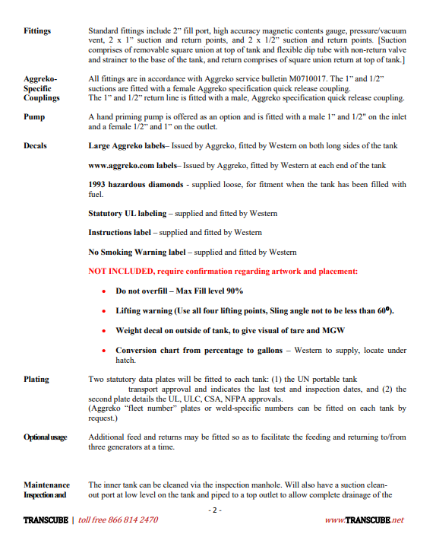
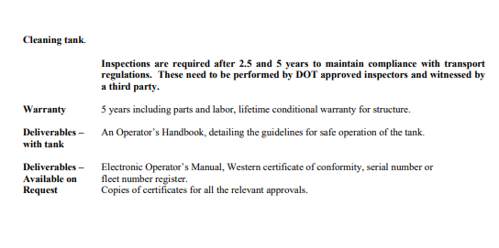

Appendix C
Specification of Temporary AdBlue Tank

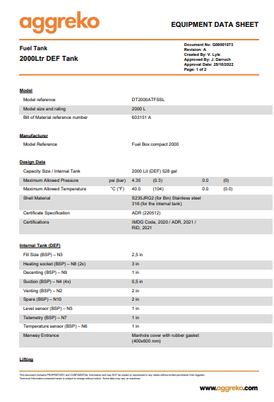
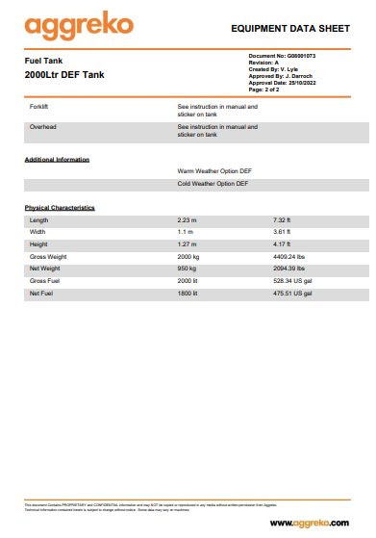

Appendix D
SLR Technical Memorandum

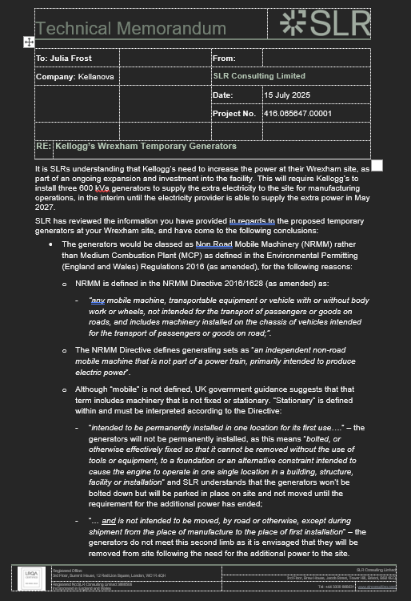
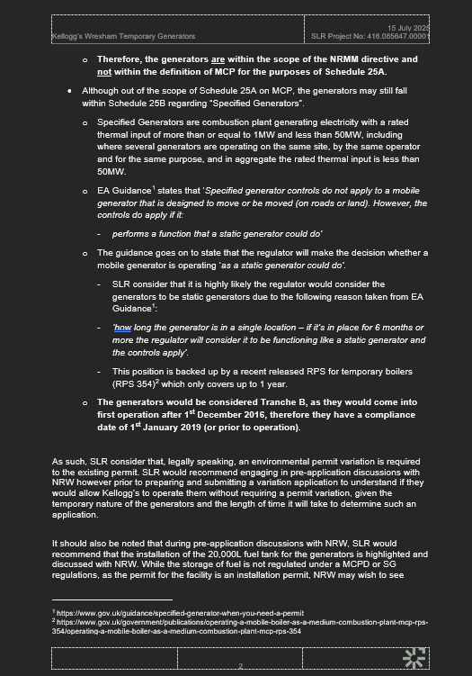

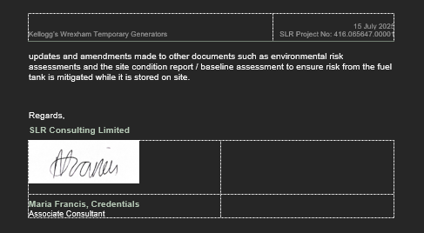

Appendix E
Location Plan

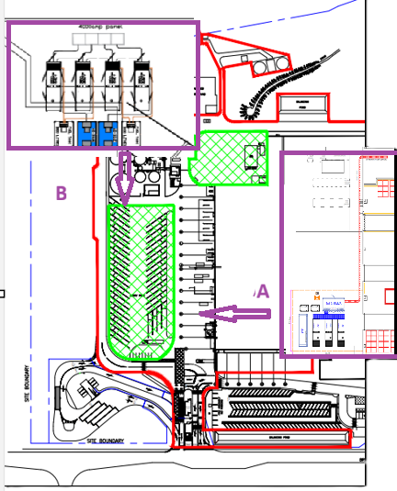

Appendix F
Site Plan
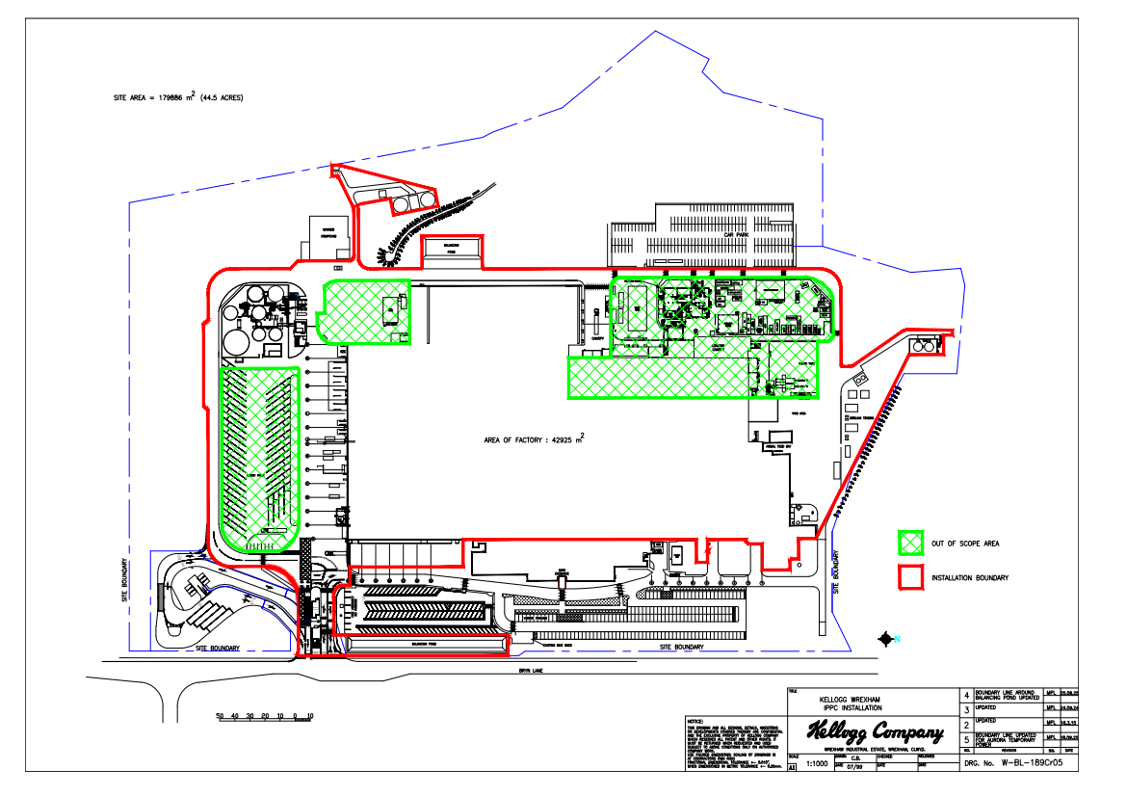

Appendix G
Permit Condition Changes
2.3.6 as follows
Add for the following activities referenced in Schedule 1, Table S1.1, AR9 to AR15, the activities shall be operated temporarily only up until the site’s electrical grid connection upgrade is completed (expected 2027).

Schedule 1

The temporary activities will need adding for AR9 to AR15 for a Specified Generator activity.

Schedule 2

Add in the HVO as a fuel type

Schedule 3

Add Table S3.1b for ‘temporary emission points to air required until grid connection upgrade completed’

Schedule 7

Site plan needs updating

