Pollution Incident Storyboard

Included: Information relating to the environmental impact of this incident, our initial investigations into the cause and the actions we have taken to prevent a reoccurrence.
Not included: Detailed root cause investigations and medium to long term actions or proposals for capital intervention

Details
Reported By | Michelle Thompson
Email | Ann.Thompson@dwrcymru.com
Contact Number | 07443 268055
Incident Date | 28/05/2025 07:56
10 Day Report Date | 10/06/2025
WIRS/NIRS Number | 2505092
SAP Number | 317362002
Address & Postcode | Dock Road SPS Behind 4 Dock Rd, Connah’s Quay, CH5 4DS
Grid Reference | SJ2942369777
Catchment | North East

Incident Type
Notification Type | Self Report
Could this incident have been Self Reported? | N/A
If Yes – How? | N/A

Summary of events

Details
Asset Type Cause | Sewage Pumping Station
Asset Type Discharge Point | Sewage Pumping Station
Permit reference | CM0164901
Responsibility | Waste
Details of event | 28/05/2025 08:56  Pump issue at Dock Rd SPS. Crews attending site to assess & rectify issue.  Update to follow.  28/05/2025 10:52 - Michelle Thompson  Upgrade Early Warning to Self Report  28/05/2025 11:15 - Michelle Thompson  Upgraded to a Self-report. Crews attended site and found Pump 1 & 2 blocked which has resulted in a brief spill to the environment during heavy rainfall. Tankers will mitigate flows until the blockage is resolved. A well spill samples has been obtained. Photos of the receiving watercourse have been taken with no visible signs of impact present. Unable to obtain samples from outfall / river as access is unsafe on the Dee estuary.  Updates to follow.  28/05/2025 15:40 - Michelle Thompson  The pumps have been unblocked and the well cleaned. SPS is now operational.  Storyboard to follow.  OPNOT 280525101 also issued for site.  An alarm came in at approximately 01:19 (both pumps failed), this alarm was actioned shortly after and the Standby Operator was called to attend. The Operator requested the location (what3words) from the information mimic page. Unfortunately, the mimic page provided incorrect location details, leading the Operator to the wrong SPS. On arrival this SPS was checked and found to operating as designed and no further action was taken.  An alarm review was carried out first thing that morning and found the 'both pumps failed alarm' was still active. The Operator was immediately contacted and arrived at the correct SPS at approximately 8am. Access to this SPS is located within company premises and on arrival the external business gate was locked. The external key was located at another SPS and once access was gained, immediate action was taken to assess and rectify the issues on site and a well sample was also obtained. A Pollution Technician also attended site and visually inspected the watercourse, as access was deemed unsafe.  Both pumps were found to be blocked and a guide rail had detached from the wall. Tankers were utilised to manage flows until the guide rail was repaired, both pumps unblocked and the well was fully cleaned. The SPS has worked as designed without further issues.

Impact Assessment

Weather conditions | Heavy Rain
Previous weather conditions | Heavy Rain
Watercourse affected (name) | River Dee
Substance released | Sewage (Liquid Only)
Volume (may be an estimate) | N/A
Likely environmental impact (DCWW assessment) | No Impact
Nature of impact | Water
Secondary impact | N/A

Laboratory Analysis (mg/l)

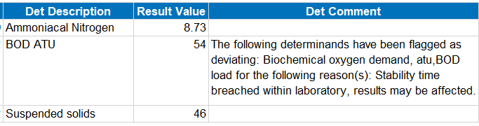
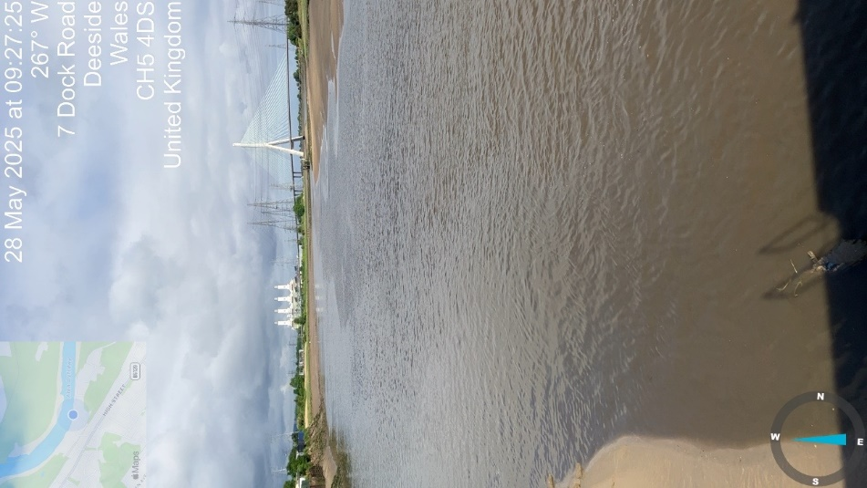  Figure 1 - Photo showing the receiving watercourse | 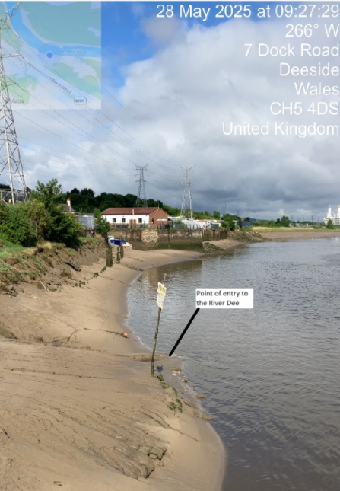  Figure 2 - Photo showing the point of entry | 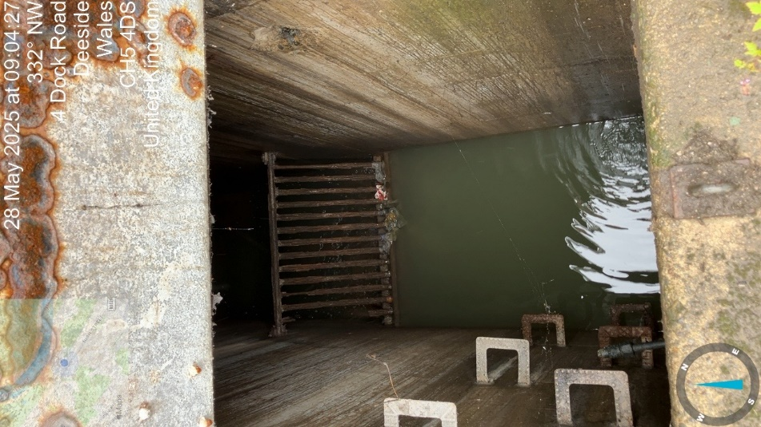  Figure 3 - SPS storm well with screen. Photo shows it was high level at this time but no longer weiring over to the EO via the nonreturn flap.

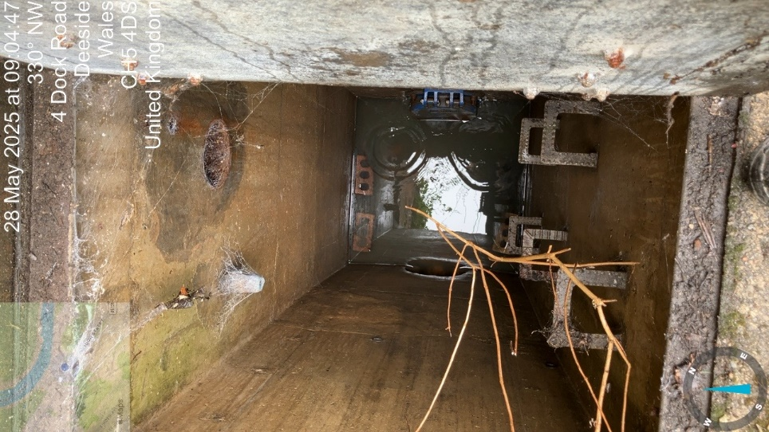  Figure 4 - Outfall section of the storm well with the remaining liquid. The nonreturn flap had no flow from the screened storm well at this time. | 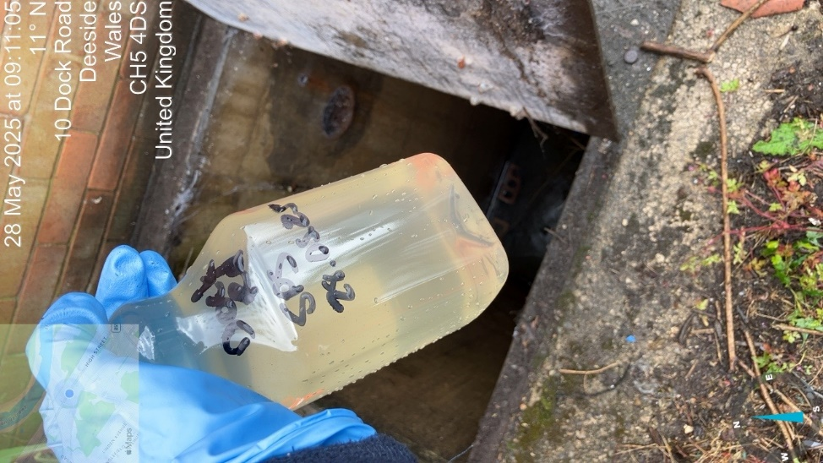  Figure 5 - SPS storm spill sample | 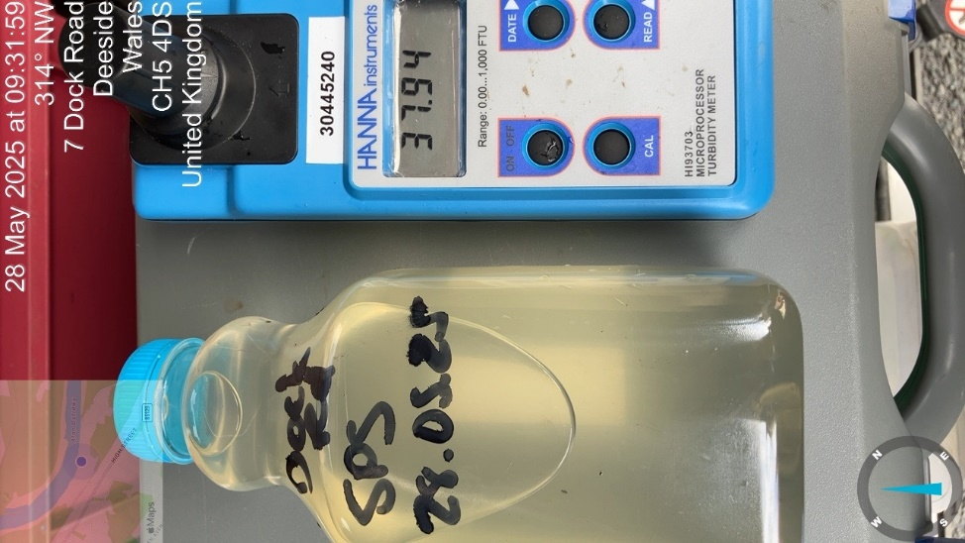  Figure 6 - Spill sample Turbidity reading of 37.94FTU

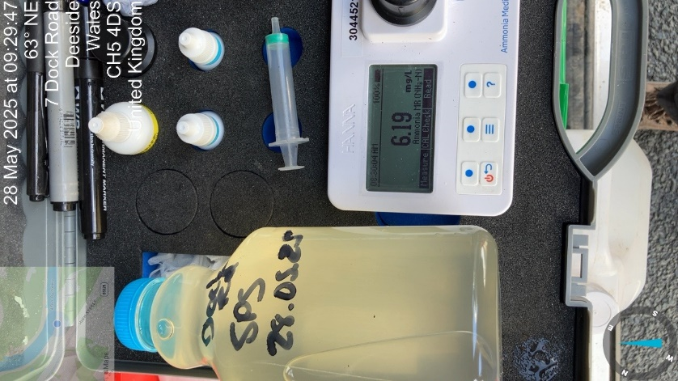
Figure 7 - Spill sample Ammonia reading of 6.19mg/l

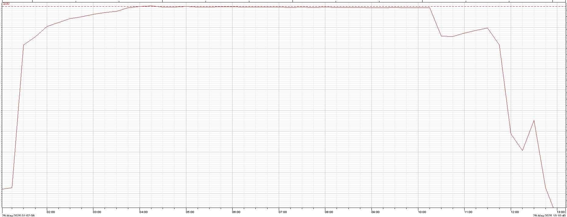
Figure 8 - Telemetry data SPS well level

The well level trend reached over 100% between 04:00 – 04:25 and remained between 99.4 & 99.8% between the hours of 04:26 - 10:15 and began to drop once tankers were utilised and the SPS issues resolved.

Plan
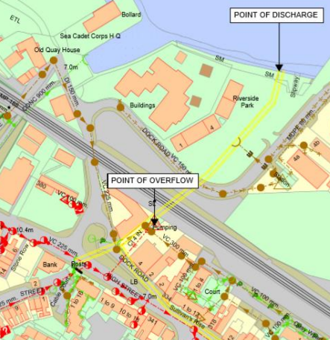

Performance History

Details
Are you aware of previous issues with this asset? | No
Performance History (Screenshot) | N/A
Performance History Comments | N/A

Cause and actions taken
Details
Primary Pollution Cause | Blockage-Full
Secondary Pollution Cause | N/A
Brief description of cause | Pumps 1&2 became blocked during heavy rainfall resulting in a brief spill to the environment. Tankers mitigated flows until the pumps had been unblocked, guide rails repaired and well cleaned.

Action taken (1) | Tankers mitigated flows while guide rail was repaired and pumps unblocked
Action taken (2) | Full well clean was carried out
Action taken (3) | The correct SPS location details (what3words) has been added to the Telemetry information page, as well as the location of the external gate key if needed out of business hours
Action taken (5) | The team was briefed on the above actions regarding correct information and where to find it. All necessary information is available on the SPS mimic information page to stop the risk of this type of setback happening again.

Final Assessment

Dŵr Cymru consider that this incident should be considered as:

Caused by a third party | No
Caused by a misconnection | No
No environmental impact | Yes
An ongoing incident that should be duplicated with an existing record | No
A pollution incident | No

Final Assessment Comments
The primary cause was pump blockage which resulted in issues at site. The Operator was called following an alarm for ‘both pumps failed’ and headed to site . However, the initial response was delayed due to inaccurate location details provided by the mimic information page, leading the Operator to the wrong SPS. We have ensured the accuracy of the telemetry information page to aid response time and the team was immediately briefed on correct details and where to find vital information, as well as any learning opportunities from this situation. Once the correct site was accessed, immediate action was taken to rectify the issues on site and tankers were utilised until the SPS was running as designed with no further issues. A Pollution Technician was immediately called and a spill sample was obtained to assess the environmental impact. The outfall is located on the Dee Estuary and access to sample was unsafe. Upon visual inspection there was no signs of discolouration or sewer debris within the watercourse. It is believed that the brief screened discharge to have had no environmental impact due to heavy rainfall before and during the SPS issues which would’ve diluted the discharge. Additionally, the spill sample analysis shows low levels of Ammonia, Biological Oxygen Demand, Total Suspendid Solids and Turbidity. These results indicate that the brief discharge did not impact the watercourse, as the levels are within the Final Effluent compliance standards for the Wastewater Treatment Works on the same stretch of River for most parameters. This suggests that the discharge was similar quality to the treated effluent discharge by the WwTW.

