Annex (iv) – SSSI Assessment Form
SSSI Assessment for permit/licence and deployment applications | 
To be completed by Permitting Officers for any applications for a permission which Natural Resources Wales has considered under S28I duty to notify SNCB and take their advice into account. This applies to all proposed permissions within a SSSI, and to operations outside the SSSI boundary which are likely to damage its special features.
NRW as a Section 28G authority has, when exercising its functions, a general duty to take reasonable steps, consistent with the proper exercise of its functions, to further the conservation and enhancement of the flora, fauna or geological or physiological features by reason of which the site is of special interest’

Part 1 – SSSI Assessment
Part 2 – Formal notification to SNCB (to be completed if part 1 assessment concludes likely damage, not likely to damage because of conditions or you cannot conclude no likely damage)
Part 3 – Decision
Pink text – drafting notes, to be deleted before completion/consultation.
Blue text – examples, to be replaced with permission-specific information and text turned to black.

Part 1 – SSSI Assessment

- Permitting officer/team | Owen Clee, Waste permitting
- Permit application reference and site name | PAN-029123
- a. SSSI name(s)  b. location  c.NRW Operational Area/Environment Team | a. Cors Gyfelog SSSI  b. Llanllyfni, Caernarfon, Cefn Graianog Quarry, Cefn Graianog LL54 6SY Grid reference :SH 460 480  c. Northwest Wales, Environment Dwyfor a Meirionnydd  TimAmgylcheddDwyforacMeirionnydd@cyfoethnaturiolcymru.gov.uk  There is one SSSI located within 2km of the proposed site Cors Gyfelog, and is approximately 382 meters from the site boundary at its closest point (see map below).  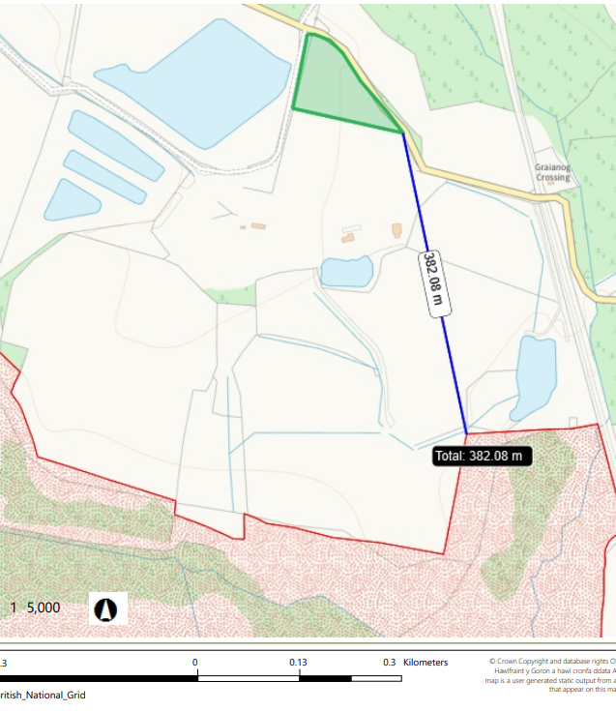
- Brief description of proposal  . | A bespoke waste permit application for an A16 - physical treatment of non-hazardous waste. The facility is proposed to accept and physically treat the following waste codes listed in the table below.  Physical treatment will only consist of screening, sorting, separation and blending of waste for recovery as a soil, soil substitute or aggregate to become a non waste.  The proposed activity will treat up to 50,000 tonnes per year with up to 20,000 tonnes (approximately 10,000 m³) stored at any one time within the permit boundary. The proposed waste will primarily arise from dredging, excavation and demolition activities. The maximum quantities to be tipped at the site in any one working day will be 1,000 tonnes. The maximum duration of unprocessed waste is 12 months.  All vehicles transporting waste to the site will arrive (and leave) will be sheeted to reduce the risk of dust emissions while in transit.  The site surfacing of the waste site will be hardstanding.  The site lies within an active quarry site (sand and gravel), but no quarry operations will be carried out within the permit boundary.  The site will be engineered in a way to allow water to drain into a temporary surface water collection point within the permitted area. This water is then pumped to the quarry’s settlement ponds (outside of the permit boundary) and surface water management system for reuse as process water for washing/ grading of aggregates, as well as dust suppression. There is no discharge of surface waters from the larger (quarry) site to surface water. The surface water system is a closed loop system.  Application documents for this application can be viewed on the DMS located here.
  Waste codes | Description
  01 04 08 | Waste gravel and crushed rocks
  01 04 09 | Waste sand and clays
  17 01 01 | Concrete
  17 01 02 | Bricks
  17 01 03 | Tiles and Ceramics
  17 01 07 | Mixtures of Concrete, Bricks, Tiles and Ceramics
  17 03 02 | Bituminous mixtures
  17 05 04 | Soil and stones other than those mentioned in 17 05 03
  17 05 06 | Dredging spoil other than those mentioned in 17 05 05
  20 02 02 | Soil and stones
- What aspects of the proposed permission are likely to damage the SSSI features of special interest?

The following activities are likely to cause damage:

7 Dumping, spreading or discharging of any materials.

22. Storage of materials.

The following SSSI(s) features and potential impacts have been considered to assess the likelihood of damage:

- A mosaic of rush vegetation (rhos pasture), moderately acidic mire, fen and swamp habitats

- A large, diverse wet woodland community

- A population of the endangered slender green feather-moss

- A population of the endangered marsh fritillary butterfly

As the proposed waste site is located 382 meters from the site boundary at its closest point. The only creditable impact pathway to which may affected the listed features above is through dust emissions which is further explained below. It is highly unlikely there are no other potential impact pathways due to the proximity of the proposed waste site is from the SSSI.

Discharge from site runoff

The site surfacing is constructed out of hardstanding. Surface water from the proposed waste processing and storage area will be contained and drained into a collection point within the permit. This collected water will then be pumped west into the existing silt lagoons. A bund will be put in place along the southern permit boundary to contain the surface water within the permit boundary. Therefore, there will be very little/no surface water running downslope towards the SSSI, hence there is no pathway for suspended solids originating from the proposed activity to enter the SSSI. The drainage setup on site acts in a closed system. Mitigation measures are in place as part of the wider quarry works which include a below ground clay barrier constructed to the south of the Water Management Pond (No. 1) along the southern boundary of the site, regular monitoring of boreholes installed along the southern perimeter of the site by NRW to prevent any potential contaminated groundwater from entering the adjacent Cors Gyfelog SSSI. The proposed waste types along have a low risk of producing leachate due to the site only accepting non hazardous wastes with good pre acceptance procedures. Therefore an impact pathway for leaching in relation to determine to the SSSI features can be ruled out.

Impact pathway (dust)

As this waste facility is screening, sorting, separation and blending wastes of aggregates there is the potential for dust emissions. Large dust emissions can negatively affect human health and the environment including physically smothering the leaves, affecting photosynthesis and respiration. There can also be chemical changes/toxicity issues depending on the dusts composition and potential for changes in pH if the dust is alkaline in nature.

The proposed waste facility is not likely to damage the SSSI features from dust emissions because the waste facility wishes to screen, sort, separate and blend the wastes. No crushing is proposed for the site which would increase the risk of dust emissions as the aggregate size is made small generating dust in the process. As the proposed waste site is located 382 meters from the SSSI it is highly unlikely if a dust emission did occur that it could cause detriment to the SSSI due the dust dispersing/ diluting in the air over the distance to the SSSI. A dust emission on this scale is also very unlikely due to the site not crushing wastes and also the standard controls proposed to keep dust emissions on site to a minimum. This is outlined in the following documents Environmental Risk Assessment and Dust Management Plan. The standard controls which all reduce the risk of dust leaving the site includes:
- Waste acceptance excludes solely dusty wastes.

- All site haul roads are maintained and cleaned as necessary to minimise the accumulation of mud or dusty materials.

- All vehicles onsite shall not exceed the onsite speed limit (10mph).

- All vehicles are sheeted so as to prevent spillage or dust blowing from their loads.

- Drop heights are minimised.

- Site staff will check departing vehicles for mud and vehicles will be cleaned on site.

- A street sweeper will regularly clean site access road of any mud trailed on from site vehicles.

- A water bowser will be maintained onsite at all times to supress dust on roads and surfaces during periods of dry and / or windy weather conditions, this also includes waste stockpiles.

- Daily visual inspection by appropriate site staff at suitable locations taking account of the prevailing wind direction.

- All site staff will receive appropriate training in order to ensure that employees are conversant with the Site Dust Action Plan.

- During meteorological conditions that are likely to lead to fugitive dust emissions, suitably trained site staff will monitor the Site at least once per day to ensure that dusty conditions do not prevail.

- If a dust nuisance is identified an investigation will be undertaken to identify the source and remedial measures put in place in accordance with the Site’s EMS (e.g. reduce / suspend activities, additional dust suppression, additional wheel cleaning, additional use of road sweeper).

- A complaints procedure is in place onsite, and all complaints and remedial action will be recorded in accordance with the Site’s EMS.

- The site will adhere to a Dust management plan which takes the necessary measures to reduce the risk of dust emissions onsite.

In conclusion the proposed waste operation is unlikely to damage the SSSI.

- Summary of any informal advice received from internal experts (if required and including pre-app advice) | n/a
- Recommendation | The proposed permission is not likely to damage any of the flora, fauna or geological or physiological features which are of special interest.  The reasons for this are due to the standard control measures in place on the site in terms of dust emission and the proximity the proposed waste facility is from the SSSI (382 metres).
- Signature and date assessment made | Owen Clee 15/09/2025
- Officers name and job title | Owen Clee  Waste permitting Officer

