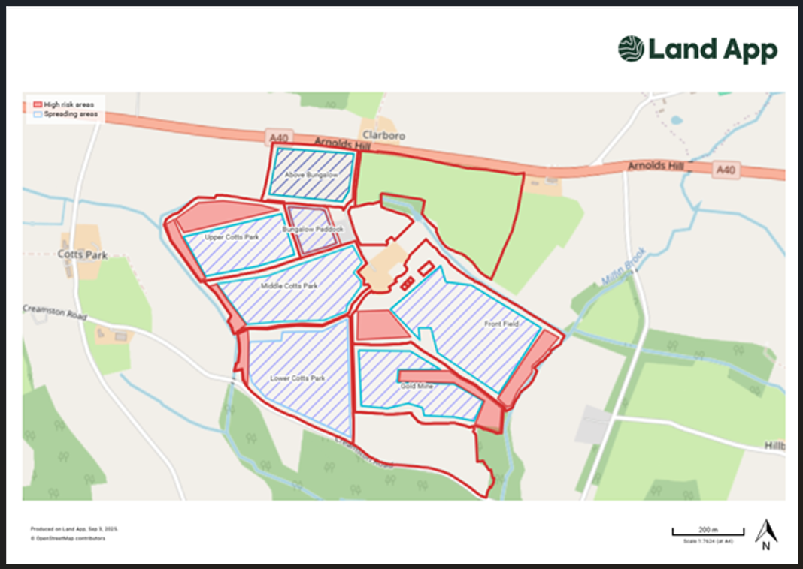
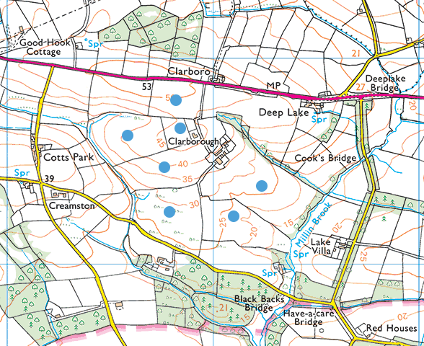

surface water courses, well, spring (or issue) or borehole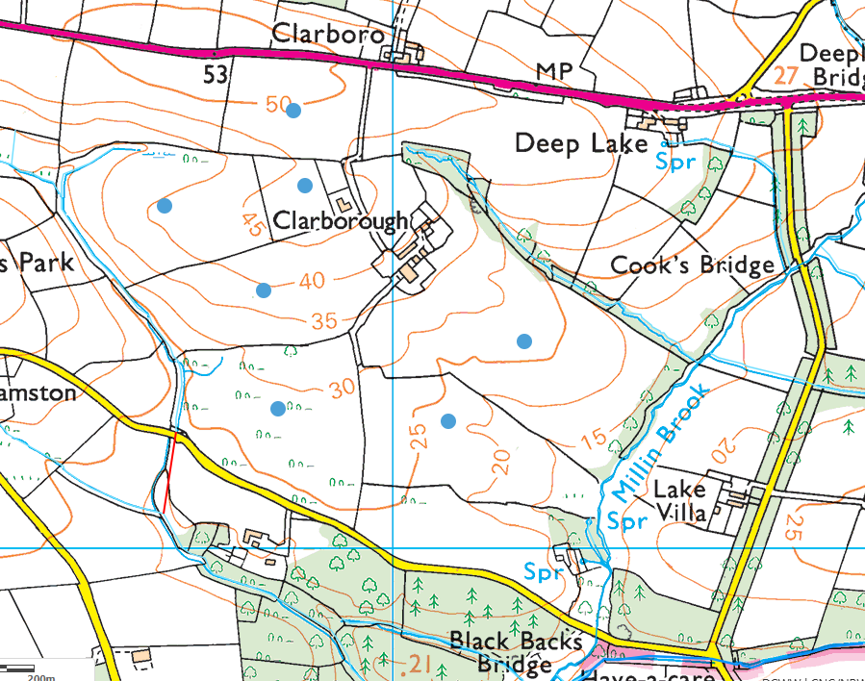

Ancient Woodlands
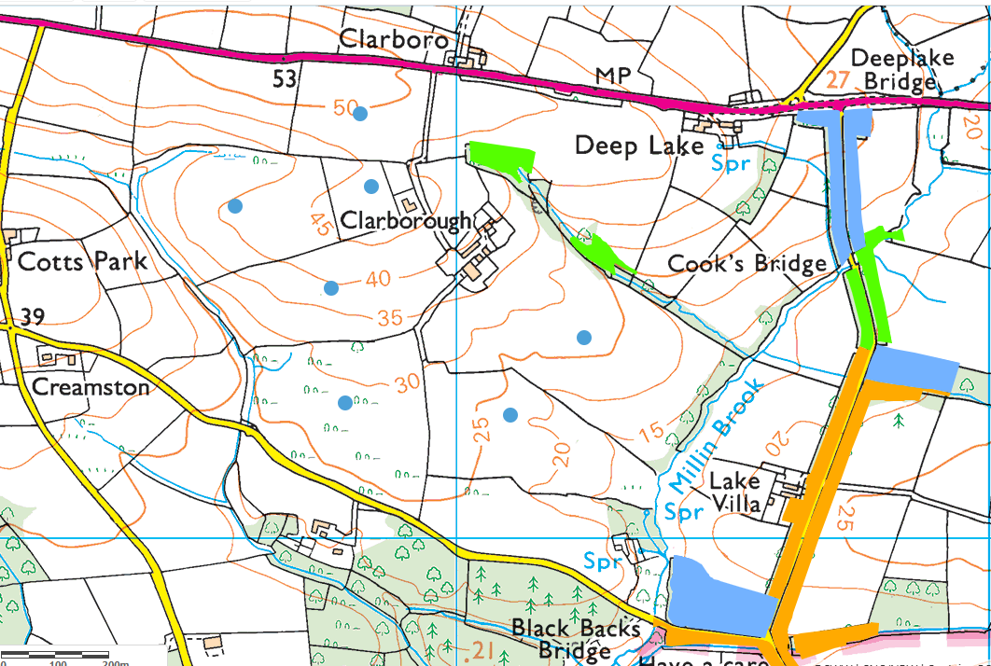
Protected Habitats/Species
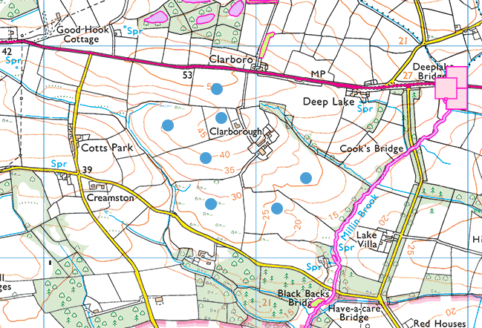

National Park
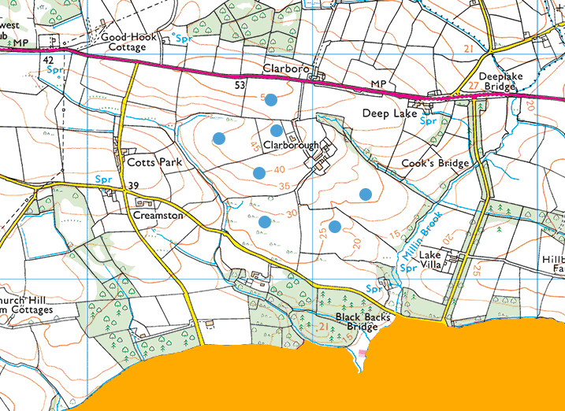
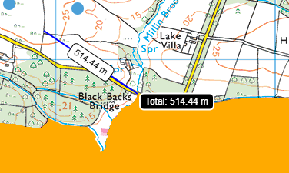

Flood risk
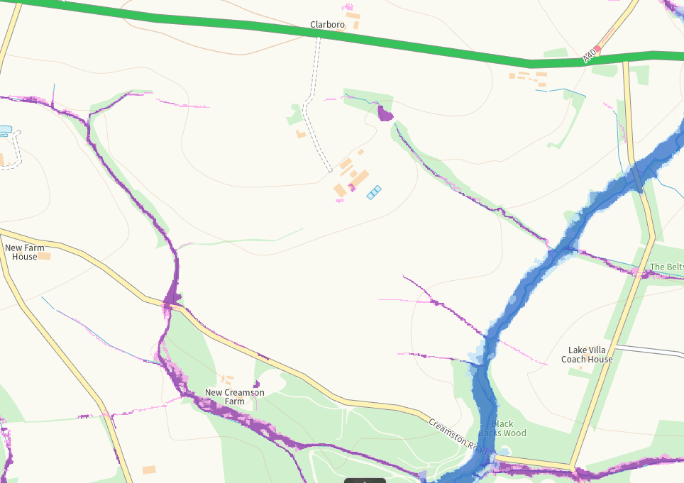
Slope
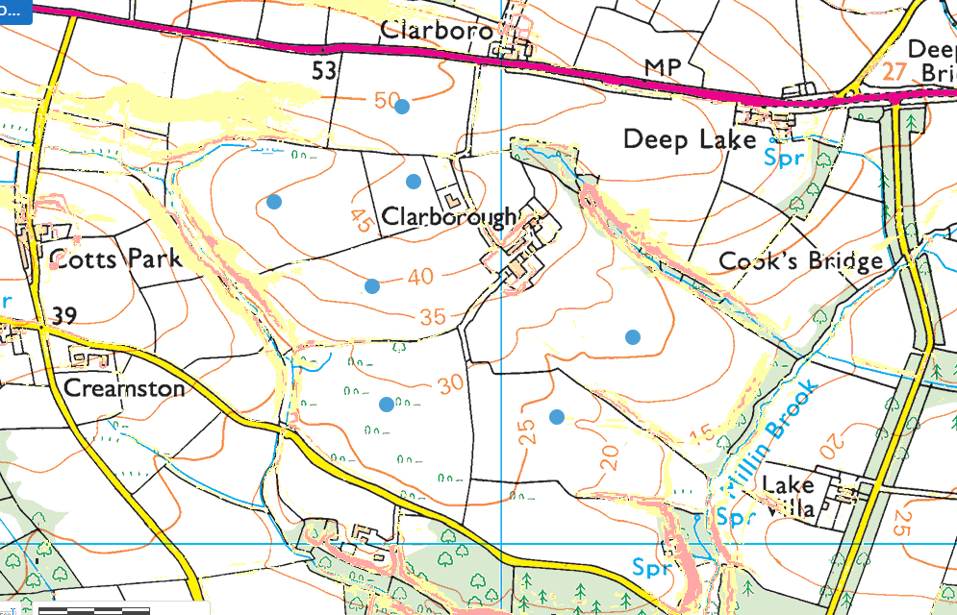

None found:
- groundwater source protection zones
- European designated sites- Natura 2000 (SPA, pSPA, SAC or cSAC) or Ramsar- or SSSI within 500m
- public rights of way
- Groundwater Safeguard Zone
- Scheduled Monument
- Local Nature Reserve
- National Nature Reserve
- Local Wildlife Sites (SINC)

