Public reg

PAN-030464 Return of mobile plant deployment application

Deployment ref: PAN-030464
Permit reference: EPR/GP3792SK
Permit holder: BYPRODUCT RECOVERY LIMITED
Location of the deployment: Great House Farm, Newport, NP18 1LU

Dear Miss Loos,

Thank you for your application received on 16/09/025. Unfortunately, we must return the deployment application.

The following points do not meet the conditions of the guidance (TGN 8.01 & RB209 section 1) and would require significant reassessment of your deployment application. We are therefore returning your application The following points below, explain why the deployment was returned.

Return Points

Agricultural Benefit Statement (ABS)

The singular waste stream proposed to be spread under this deployment was DCWW Court Farm (EWC 19 09 02). This waste is significantly high in magnesium where the additions of magnesium to the soil would be 103.81 kg/ha. The majority of these fields under this proposed deployment ( 1, 2 ,3 ,4 ,5, 6, 3C, 1 CA, 5 CA & 6 CA) contain a soil index value for magnesium of 3 which is above optimum levels (refer to RB209 section 1).

TGN 8.01 section 5.4 states the following in regards to spreading magnesium wastes where field soil index values are at index 3 for magnesium:

‘If magnesium is to be applied at index 3 or above the operator should:

- Explain why the increased levels are appropriate for the receiving land

- Address the increased risks in the risk assessment within the benefit statement.’

The submitted ABS and SSRA does not include the above information as required by TGN 8.01. It is also worth noting that a significant explanation would be needed to justify why the high magnesium bearing waste would need to be applied to these fields where the soil index value of magnesium is already above optimum levels. Adding new information into the ABS and the SSRA would constitute reassessment under our request for information process. Please note the deployment was also returned for further points listed below.

Spreading Maps

Our location screening has identified field 4 encroaches onto an ancient woodland site (see map below). The spreading map does not identify this ancient woodland site as required by TGN 8.01 box 3.1. In addition to this, the area to which the ancient woodland encroaches onto field 4 would need to be buffered out of the deployment and considered in the SSRA as this information has not been provided in the SSRA and is not site specific and would require reassessment.

You can use the following resource to find the location of ancient woodlands for deployment applications: Ancient Woodland Inventory 2021 | DataMapWales.
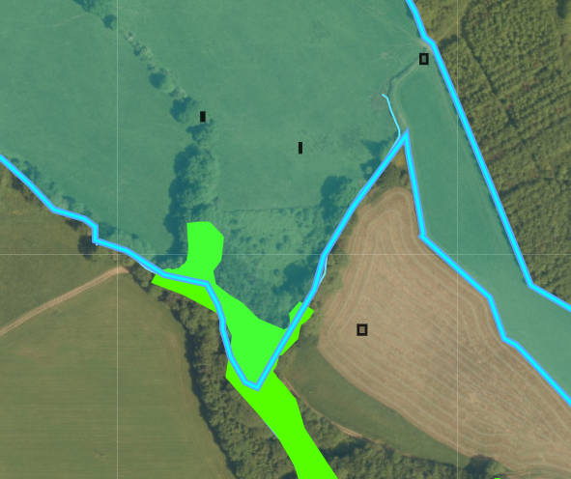

Fields F5, F8 and F3 are all located near or border ancient woodland sites (see maps below). As the spreading maps and submitted ABS and SSRA do not contain these sites in the deployment application they are not site specific and constitute a return. If you decide to reapply you will need to acknowledge these sensitive receptors in the deployment application.
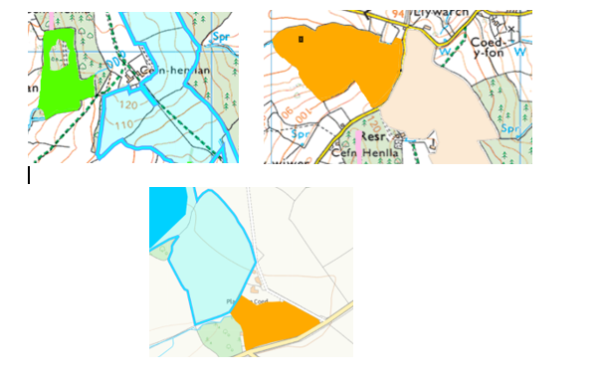

Consent Form

The provided spreading map and storage document suggest a total of 15 stockpiles were proposed to be stored based on operational requirements. However the provided consent form only contained 14 stockpiles (with others crossed out). As a result a new CPH consent form would need to be provided and resigned constituting reassessment.

Site Specific Risk Assessment (SSRA)

As previously mentioned in the above points the SSRA currently is not site specific to where the following needs to be included:

- Full justification of why high magnesium bearing waste is being applied to fields with a soil index value of 3 (above optimum) and the mitigation measures in place to prevent harm to nearby designated sites i.e. The River Wye SAC and SSSI bordering spreading fields.

- Ancient woodlands need to be added as a sensitive receptor to the SSRA and include mitigation measures to mitigate the risk to these sites.

___________________________________________________________________

In addition to the return points identified above. A full assessment of this deployment application has been undertaken. The following points below would have been included in a request for information if this deployment application was not returned. If you decide to reapply you will need to ensure the following points below have been addressed.

Agricultural Benefit Statement (ABS)

In the submitted SSRA it contains information on the flood risk for fields and spreading restrictions, this section of the SSRA will need to be copied into the ABS if you decide to reapply.

Field 13CA are receiving 86.89 kg/ha of phosphorus above offtake as the soil index value for phosphorus is below optimum levels. However field 13CA is at soil index value of 1 for phosphorus where the limit is 85 kg/ha, so a slight decrease is needed to comply with limit and would require a decrease in application rate for this field. For further information refer to RB209 section 3 table 3.3.

Fields 1CA & 6CA have a soil index value of 2 for phosphorus (optimum level) so a maintenance dressing should only be applied to these fields. The current application rate is causing an increase of phosphorus by 3.82 kg ha. This will need to be readjusted to meet offtake if you decide to reapply. For further information refer RB209 section 3 table 3.3.

Section 4.1 cropping details of the ABS states the following:

‘Targeted periods of spreading on grass fields include early spring, after cutting of silage, and prior to grazing through spring and autumn (February-October)’.

The spreading timings given are not specific and are essentially giving the whole spreading season window. For further information refer to TGN 8.01 section 6.10.

Spreading maps

Field F4 borders a spring (see map below). This has not been buffered by 50 meters as required by SR2010no4.
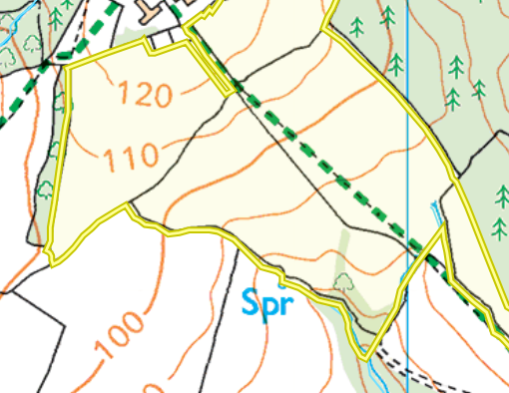

Field F4 is located within 50 meters of a Well. This has not been This has not been buffered by 50 meters in the spreading maps as required by SR2010no4.
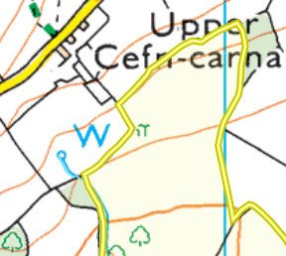

The grid reference for Stockpile F doesn’t match the submitted spreading map location.

Your deployment application fee covers our assessment costs. Our decision to return follows a complete technical assessment of your application, including all supporting information. As such, we will not be returning any of the fee on this occasion.

If you are not satisfied with the service, you have been provided by me or any other area of NRW then we would respectfully direct you to our complaints procedure. Natural Resources Wales / How to make a complaint

If you have any queries about this matter, please contact us by telephone on 0300 065 3000 or email us at enquiries@naturalresourceswales.gov.uk quoting your deployment application reference.

Yours sincerely,

Owen
Permitting Officer

