PAN-030463 My Map Report:
Application maps
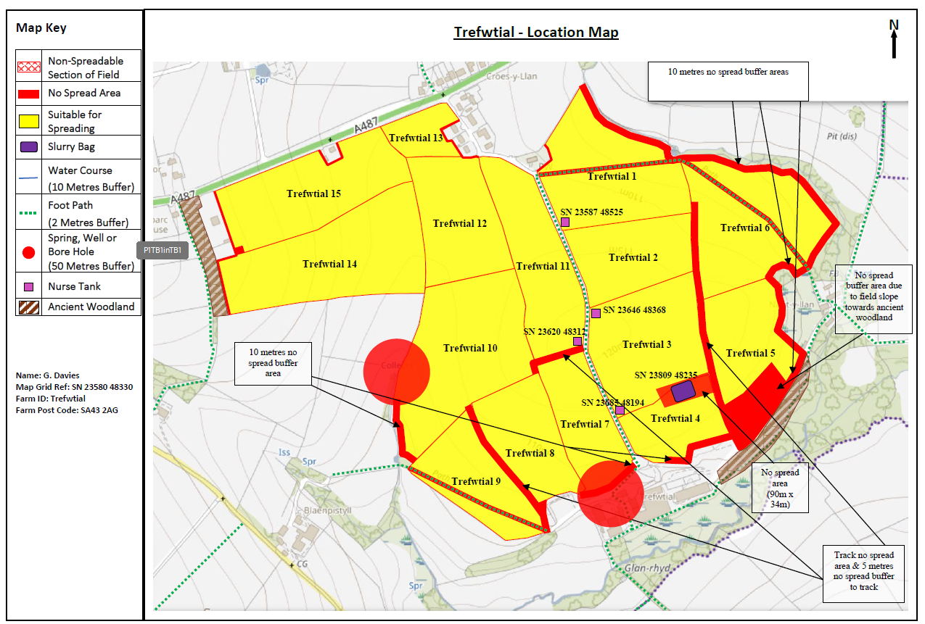
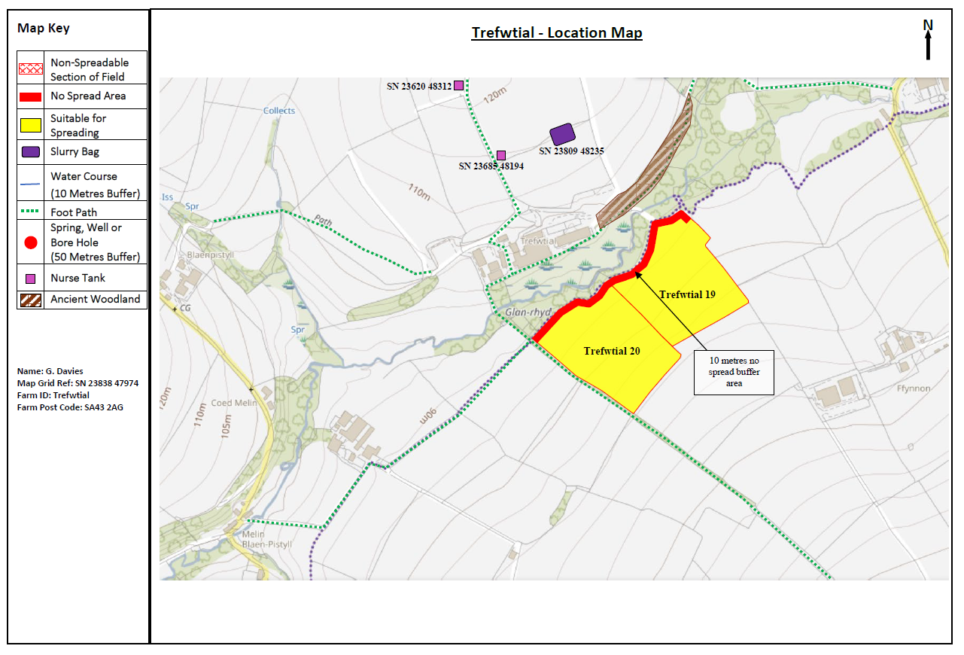
Deployment Boundaries and storage
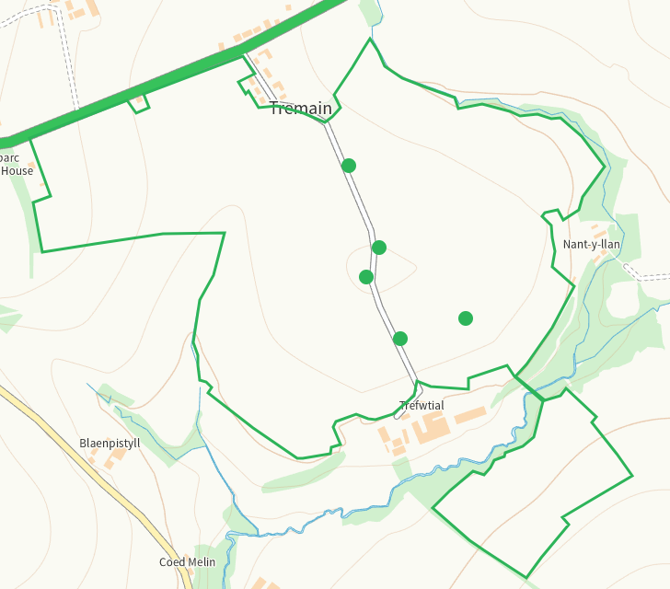

Detailed river network 10m
Several watercourses within range, all buffered on application map
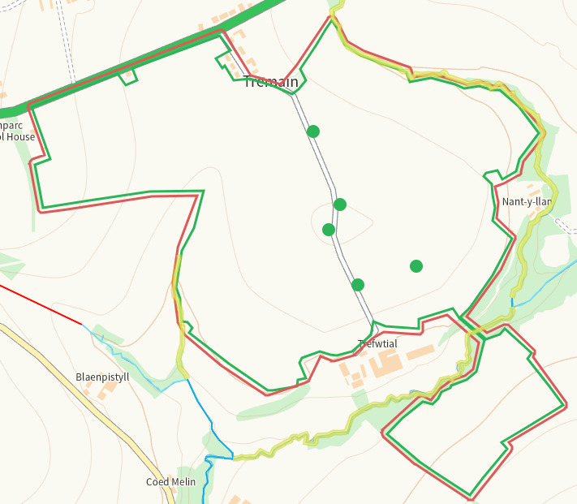
Groundwater source protection zones
None
Any well, spring (or issue) or borehole used for the supply of water for human consumption including from a private water supply or supplies within 50m.
Well S of 7, buffered on application map
None at other fields
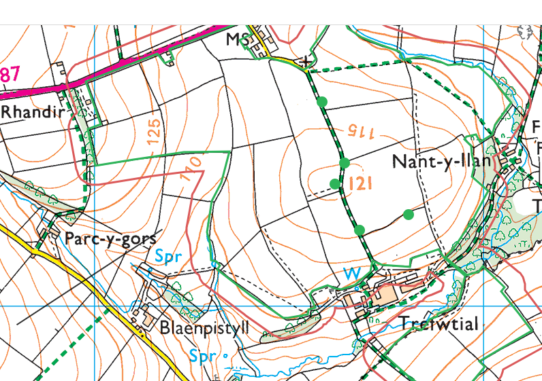
Any well, spring (or issue) or borehole used for the supply of water for human consumption including from a private water supply or supplies within 250m.
Issue and springs W of 9, shown on application map
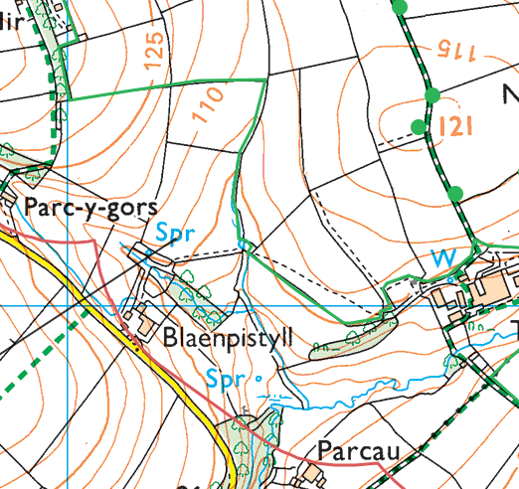
Sprnig N of 15, shown on application map
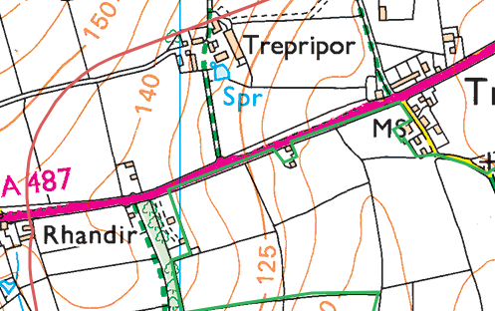
Within Groundwater Safeguard Zone
none
European designated sites- Natura 2000 (SPA, pSPA, SAC or cSAC) or Ramsar- or SSSI within 500m
none
Other protected sites within 500m:
- Protected Species-
Several within range, mainly otter and bat, latest record 2019

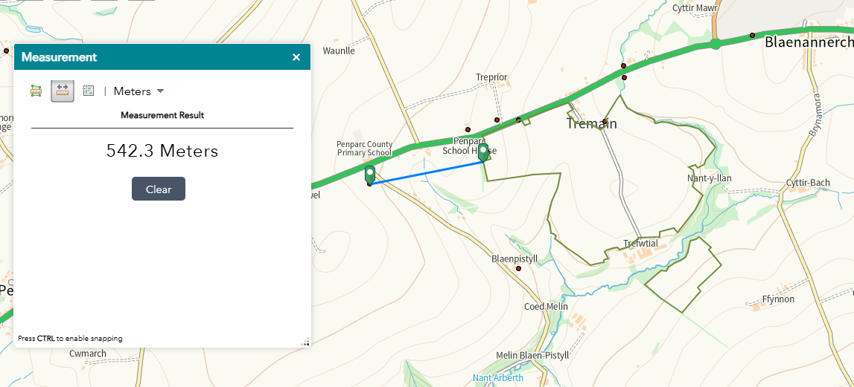

- Protected Habitats-
Purple moor grass and rush pastures, Lowland dry acid grassland and Lowland calcareous grassland within range
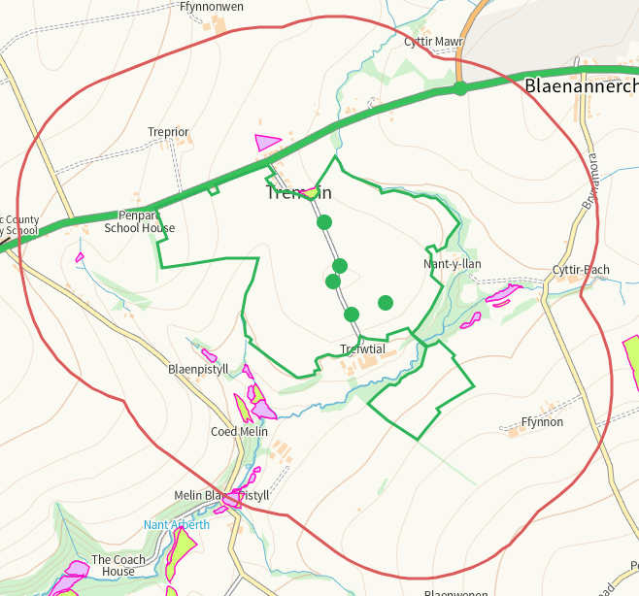

- Scheduled Ancient Monument- none
- Local Nature Reserve- none
- National Nature Reserve- none
- Ancient Woodlands-
Several within range, shown on application maps with buffers where required
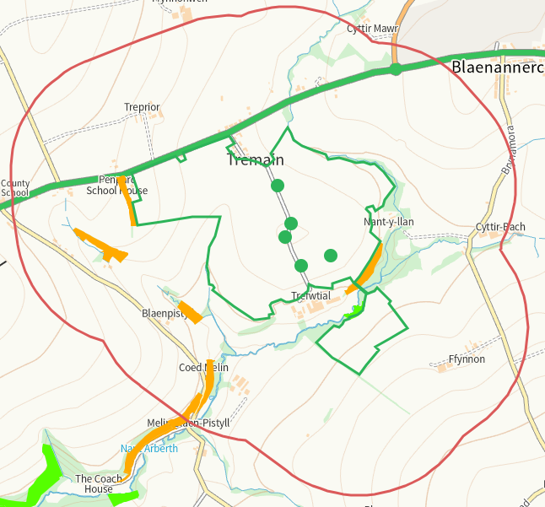
- Local Wildlife Sites (SINC)- none
- National Park- none
- Groundwater Safeguard Zone- none

Flood risk
Risk N of 1 and 6, W of 10, buffered on application map
None at other feilds
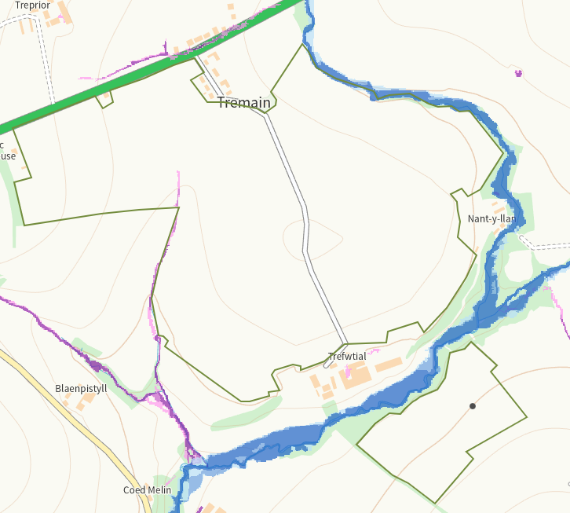
Public rights of way
Footpath Adjacent W of 20, shown on application map.
None at 19
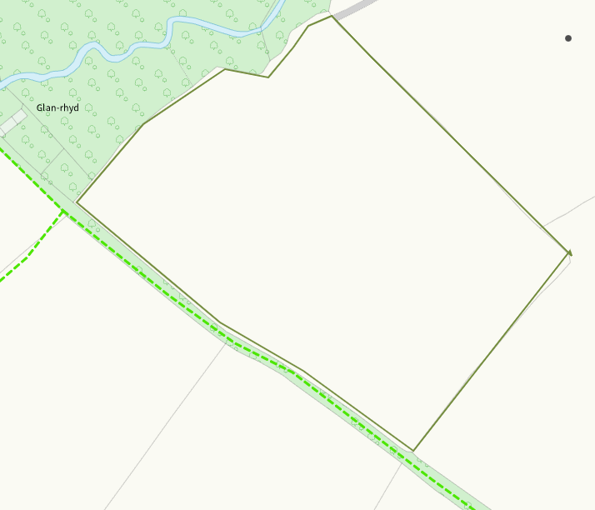
Footpaths W of 14, between 7/11 and 1-4, within 1, 6 and 9, S of 5. All shown on application map
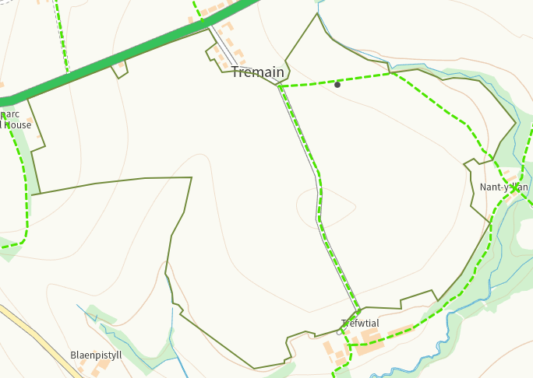
Any buildings or houses within 250m
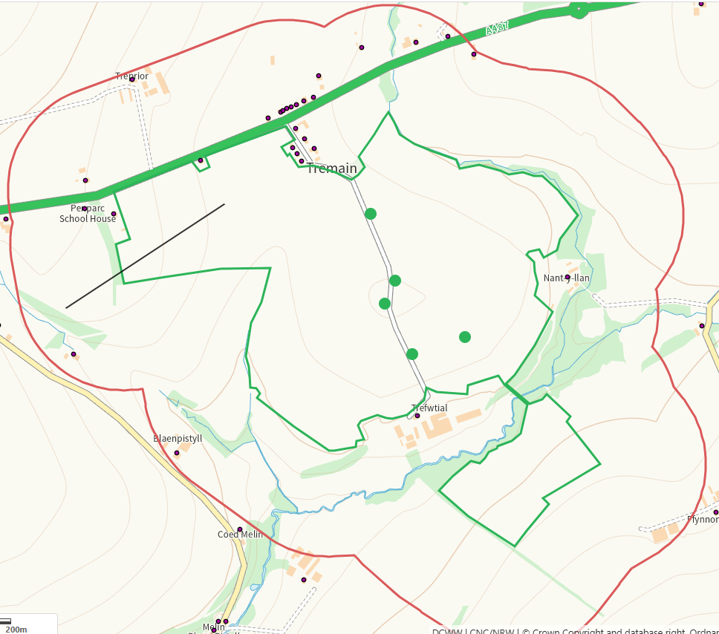
Distance from Main Farm Address
Adjacent
Slope Map
12+ slopes are buffered on application maps
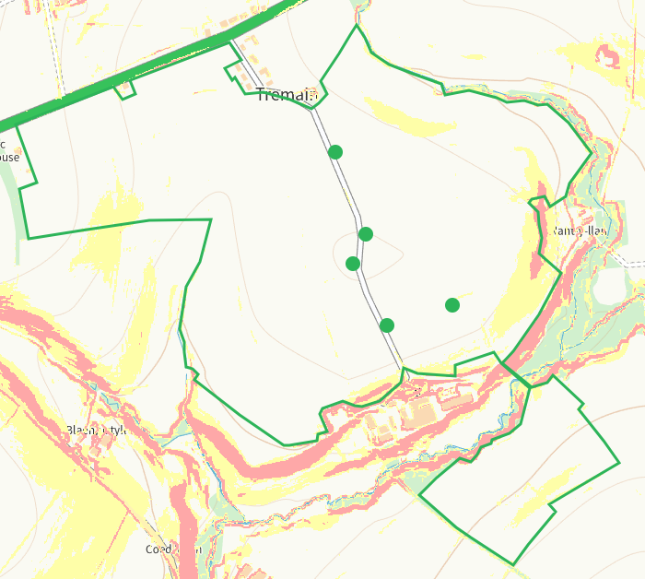

END

