Annex (iv) – SSSI Assessment Form
SSSI Assessment for permit/licence and deployment applications | 
To be completed by Permitting Officers for any applications for a permission which Natural Resources Wales has considered under S28I duty to notify SNCB and take their advice into account. This applies to all proposed permissions within a SSSI, and to operations outside the SSSI boundary which are likely to damage its special features.
NRW as a Section 28G authority has, when exercising its functions, a general duty to take reasonable steps, consistent with the proper exercise of its functions, to further the conservation and enhancement of the flora, fauna or geological or physiological features by reason of which the site is of special interest’

Part 1 – SSSI Assessment
Part 2 – Formal notification to SNCB (to be completed if part 1 assessment concludes likely damage, not likely to damage because of conditions or you cannot conclude no likely damage)
Part 3 – Decision
Pink text – drafting notes, to be deleted before completion/consultation.
Blue text – examples, to be replaced with permission-specific information and text turned to black.

Part 1 – SSSI Assessment

- Permitting officer/team | Bryan Burn / Waste Permitting
- Permit application reference and site name | PAN-030462  Bryn Farm, Ferwig, Cardigan, Ceredigion SA43 1PL
- a. SSSI name(s)  b. location  c. NRW Operational Area/Environment Team | a. SSSI Aberarth - Carreg Wylan  b. Cardigan  c. Mid / Env Team 5 - Ceredigion  a. Afon Teifi  b. Cardigan  c. Mid / Env Team 5 - Ceredigion
- Brief description of proposal | Landspreading deployment under SR2010No4 Mobile plant permit. Spreading 02 05 02 Waste from the dairy products industry – sludges from onsite effluent treatment, from 3 sites with one nurse tank and 1 slurry bag.  The waste from Volac/Sensient–Felinfach is high in readily available nitrogen and is proposed to be spread on field 15 which is adjacent to Aberarth - Carreg Wylan. A 10 metre no spread buffer is in place and a road lies between the field and SSSI. See comments in recommendation section below.  Afon Tiefi is just within the 500 metre range.  The activity is not wholly or partly within the SSSI boundaries.  The fields will be spread February-April 2026 prior to first cut silage, following silage cuts & in advance of periods of grazing May – August 2026. Spreading of these grass fields may be split into up to 2 applications & the total of applications will not exceed the max application rate for each field as listed in table  Each individual application will not exceed 50t/ha in any one application to a field.  The liquid sludge is delivered by HGV road tankers and discharged into a nurse tank. The liquid sludge is either spread from nurse tank, or transferred to slurry bag for temporary storage prior to spreading. Only liquid sludge as specified in this deployment is to be stored in the nurse tank & slurry bag at the proposed locations prior to spreading.  The nurse tank is a purpose-built AW Trailers nurse tank with designated fill and empty valves that can be shut by gate valves and locked off in the event of temporary overnight storage if the tank contains liquid to ensure secure storage.  The tank fills from the top via internal pipework with a ‘swanneck’ reducing chances off any spills when decoupling connecting pipes after filling. The empty valve allows the tank to be completely emptied to the bottom. The tank is  sealed with roof to prevent odour, rainwater entering the tank and for safety, and can be vented if required. A lifting axle in the middle allows the tank to positioned and lowered so the whole tank is on the ground.  The Labaronne Citaf self-supporting slurry bag is for temporary storage and is purpose built, sealed, can be vented and has designated fill and empty valves and is sited on a suitable flat area. The bag has a 10 year manufacturer guarantee 100% against all material (technical fabric) and manufacturing (welding) defects. The technical fabric is composed of polyester coated with PVC and protected with an anti UV treatment on both sides. The bag has a life expectancy of 20 years +. The liquid is transferred to the bag from a nurse tank via tractor and tanker, or pumped via lay flat hose across fields and connected to the bag fill valve. There are 2 gate valves in sequence over a metre apart and a non return valve.  The bag features a number of degassers with anti-odour filters. The slurry bag has a soil bund around the perimeter and is fenced to prevent access & damage.  The liquid sludge is spread from a nurse tank or the slurry bag onto the deployed fields at the required timings as stated above. This is done by either umbilical method with the liquid delivered to tractor in deployed fields pumped through hose and spread by dribble bar applicator mounted onto the back of the tractor, or a tractor and vacuum tanker with dribble bar applicator. The dribble bar applicator places the liquid in bands onto the surface of the ground. This spread method is effective in limiting odour generation & nutrient losses associated with higher trajectory spread methods such as splash plate. Spreading is undertaken with the use of flow meters to ensure correct rates are applied.  Spreading of the waste will be carried out in accordance with the Code of Good Agricultural Practice, The Water  Resources (Control of Agricultural Pollution) (Wales) Regulations 2021 and in accordance with the requirements of the deployment and Environmental Permitting Regulations.  NRW will be informed at least 48 hours prior to any spreading commencing and no spreading will occur within 48 hours of forecasted heavy rainfall.  Each individual application will not exceed 50t/ha in any one application to a field.  Waste will not be stored or spread in combination (i.e. only one waste stream per field).  Farm location  SN 17839 48999  Fields  SN 17534 49286  SN 17324 49502  SN 17191 49544  SN 17094 49248  SN 17234 49159  SN 17405 49151  SN 17599 49117  SN 17604 48973  SN 17468 48869  SN 17351 49009  SN 17151 48793  SN 16974 48848  Storage  SN 17876 49048  SN 17451 49631  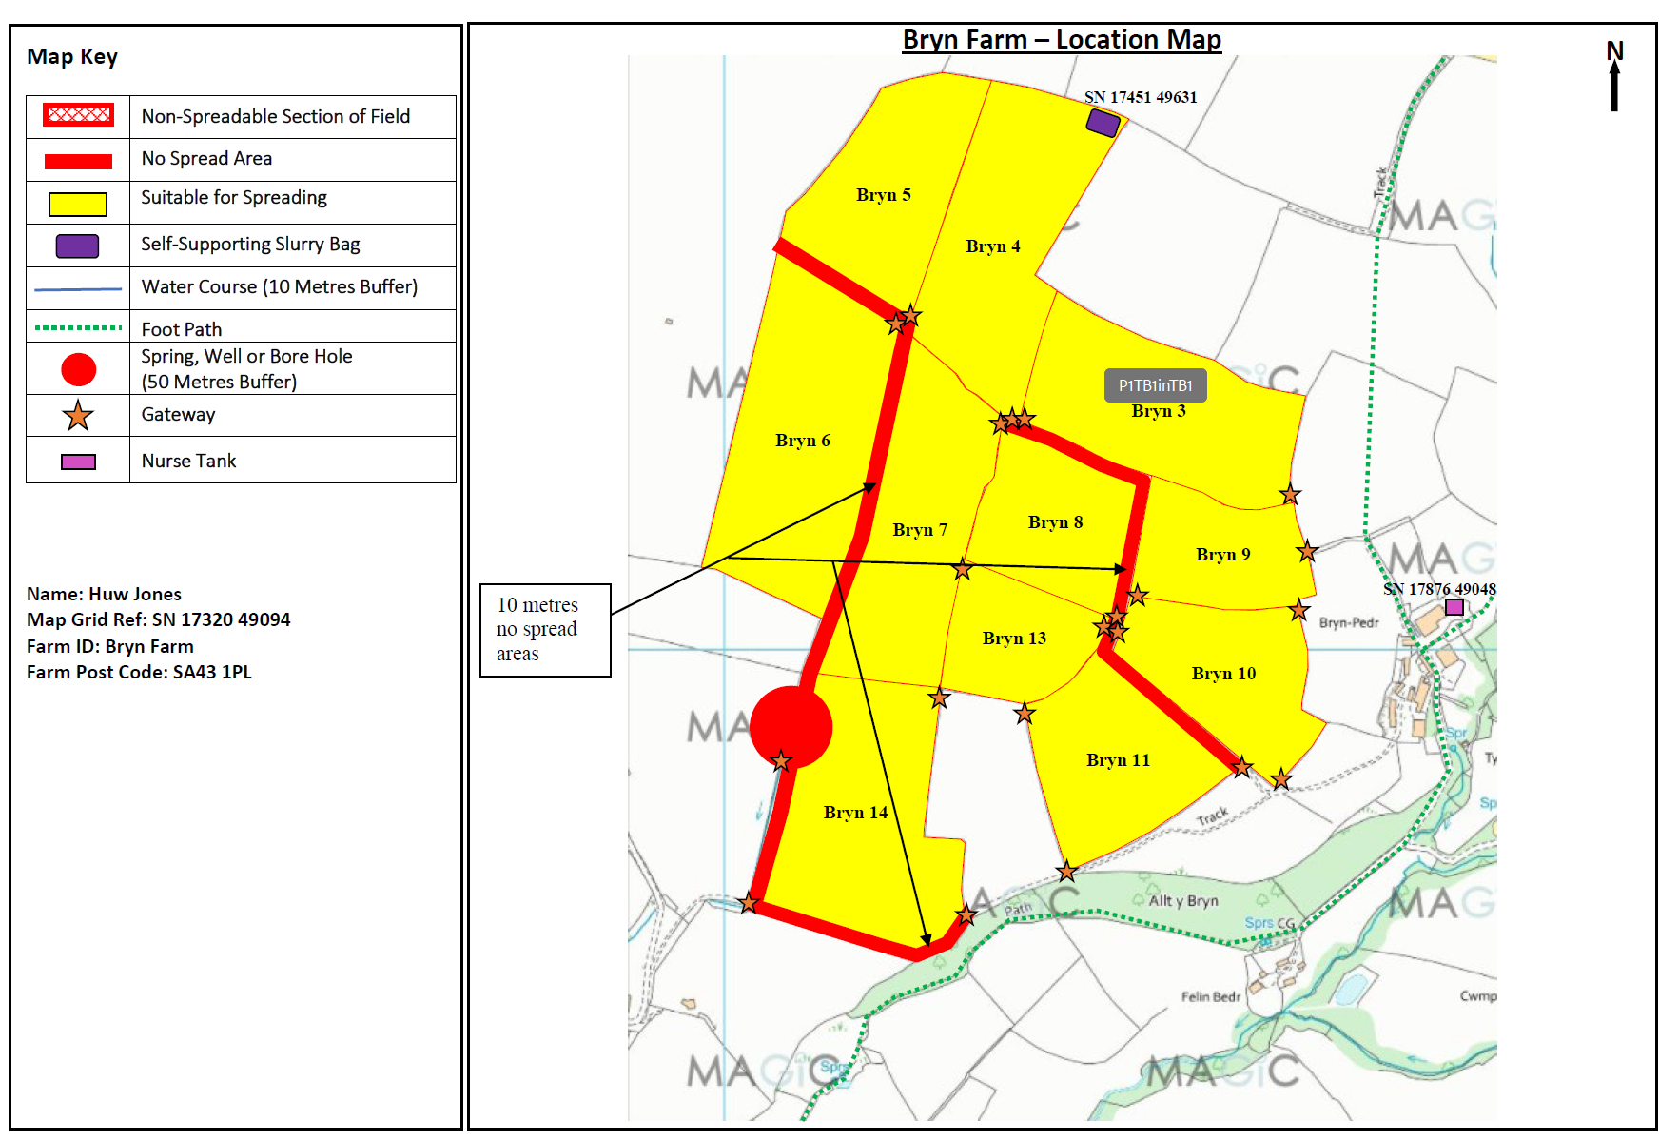  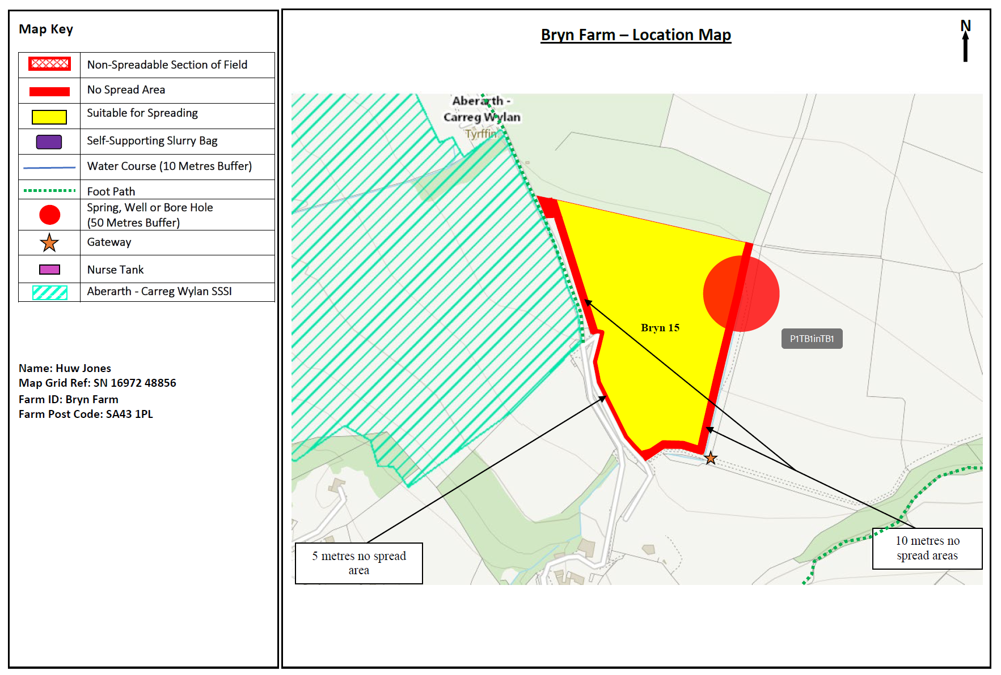  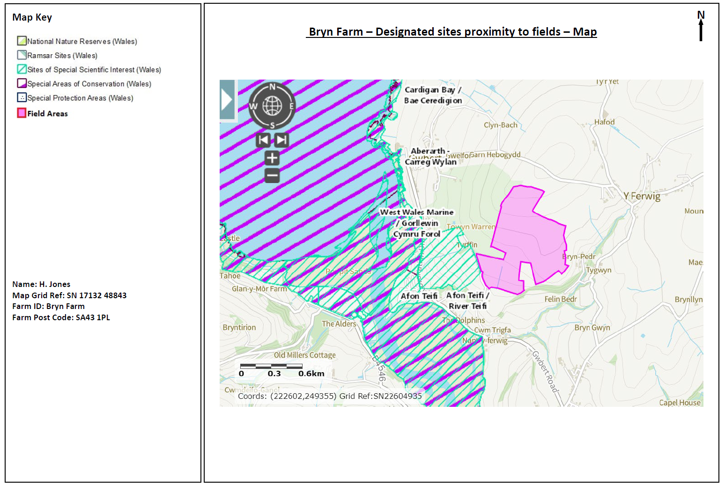  Red line indicates 500 metre distance from field boundaries.  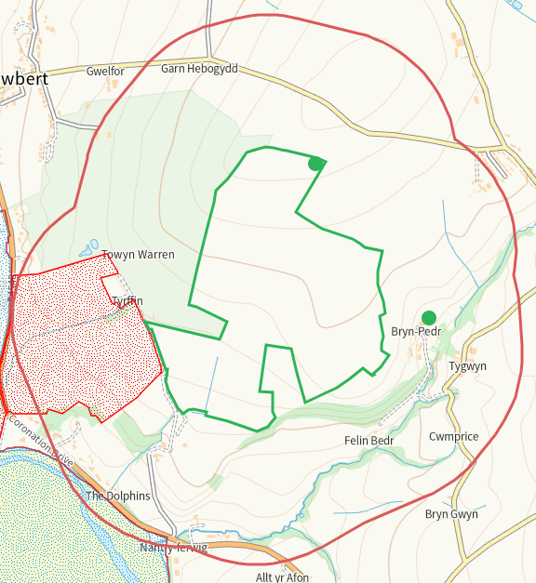
- What aspects of the proposed permission are likely to damage the SSSI features of special interest?

The following activities are likely to cause damage:

Aberarth – Carreg Wylan
- Application of manure, slurry, silage liquor, fertilisers and lime.
- Dumping, spreading or discharging of any materials.

Afon Teifi
- Application of manure, slurry, silage liquor, fertilisers and lime to agriculturally unimproved permanent grass, forestry and all other unimproved riparian habitats.
- Dumping, spreading or discharging of any materials
- Storage of materials.

The following SSSI(s) features and potential impacts have been considered to assess the likelihood of damage:

Aberarth - Carreg Wylan
https://cdn.cyfoethnaturiol.cymru/641362/SSSI_0355_SMS_EN0017c63.pdf
https://cdn.cyfoethnaturiol.cymru/641262/SSSI_0355_Citation_EN0018c6a.pdf
- Zonation of intertidal communities, honeycomb worm reefs and overhangs and caves
- Rare and uncommon plant species
- Bottlenose dolphin and seals
- Kittiwake
- Chough
- Lesser black-backed Gull
- Rare and uncommon invertebrates species
- Caledonian structures exposed in the sea cliffs and foreshore (Traeth Penbryn and Cwmtudu)
- Pleistocene / Quaternary sedimentary profiles exposed in the sea cliffs and foreshore (Mwnt and Poppit)
- As well as the features listed above, Aberarth – Carreg Wylan SSSI has other habitats that contribute to the special wildlife interest. These include sand dune, continuous bracken and woodland, dense scrub, acid grassland, marshy grassland, together with other elements such as hedgerows, streams, springs, flushes, small rock outcrops and individual trees.

Nutrient Enrichment
Maritime grassland and heathland require low soil fertility so use of fertilizers should be avoided. Stock feeding can also lead to nutrient enrichment, and may not be appropriate in some areas.

As the fields are not wholly or partly within the SSSI, suitable no spread buffers are in place where required, method of delivery is inline with guidance and with the applicants adherence to their permit conditions, regulations and guidance; the risk of transference of the applied waste to the SSSI is highly unlikely to impact the features mentioned above.

The waste from Volac/Sensient–Felinfach is high in readily available nitrogen and is proposed to be spread on field 15 which is adjacent to Aberarth - Carreg Wylan. SSRA states ‘The materials are low in available nitrogen’ This is incorrect for the Volac/Sensient – Felinfach waste which is high in available nitrogen as declared on the application form and identified through the nutrient calculator.

Afon Tiefi
https://cdn.cyfoethnaturiol.cymru/682986/sssi_1027_sms_en001.pdf
https://cdn.cyfoethnaturiol.cymru/676367/sssi_1027_citation_en001.pdf
• A range of river plant communities including those characterised by water
crowfoot.
• Associated riverside habitats, including marshy grassland, swamp, saltmarsh
and broadleaved woodland.
• Nutrient-poor, mildly acidic upland lakes (the Teifi Pools).
• Fish, including Atlantic salmon, bullhead, and three species of lamprey.
• Otters.
• A range of unusual flowering plants and mosses, including floating water plantain, northern yellow-cress and multi-fruited river moss.
• A range of rare and scarce insects and other invertebrates, including club tailed dragonfly and freshwater pearl mussel.
• Breeding river and wetland birds.
• Bottle-nosed dolphins (which sometimes come into the lower estuary).

The nearest field is just within 500 metres of the SSSI beyond a built environment, suitable no spread buffers are in place where required, method of delivery is inline with guidance and with the applicants adherence to their permit conditions, regulations and guidance; the risk of transference of the applied waste to the SSSI is highly unlikely to impact the features mentioned above.

- Summary of any informal advice received from internal experts (if required and including pre-app advice) | nil
- Recommendation | The proposed permission is not likely to damage any of the flora, fauna or geological or physiological features which are of special interest.  Afon Teifi  Closest fields are 14&15 where the SSSI is just within the 500 metre range with built environment between the fields and the SSSI. There is no potential impact pathway between the fields and SSSI.  Aberarth - Carreg Wylan  Field 15 is adjacent East, has a 10 metre no spread buffer to the boundary with the SSSI and 5 metre no spread buffer to the remaining Western boundary and with a lane between the field and the SSSI. Field 15 shows as gently sloping 0-7 degrees, method of application is dribble bar and single applications will not exceed 50t/Ha, the watercourse and issue between feilds 14&15 are suitably buffered, run off risk negligible.  The wastes will be applied to the fields with an appropriate application method for the types of waste (dribble bar) which is an effective way of applying the wastes to the soils directly which improve spreading accuracy, maximising nutrient use and minimising nutrient losses.  Watercourses/springs/issues have been appropriately buffered.  A site-specific risk assessment has been provided by the operator to take into account any potential issues and has provided appropriate mitigation measures to protect the SSSI’s and other sensitive sites from harm.  To mitigate against surface runoff/leachate further the wastes will be split into multiple applications and will not exceed 50t/ha in any one application. This allows for the soils to effectively uptake the wastes.  Any spillages will be reported immediately to NRW.  Operators will aim to empty spreading equipment before the end of each working day to avoid overnight storage of waste in machinery.  Regular servicing of all machinery is conducted and spreading equipment is annually calibrated. To prevent waste being held in faulty machinery replacement spreading equipment will be available.  Spreading machinery will travel over the field in a direction which will most easily allow the machinery to turn within the boundaries of the field. Any spreading equipment will be turned off and/or lifted out of the soil prior to turning at the end of each run.  Machinery turns will be routed to avoid rutting and wheel slip. The turns will not be executed on any buffer strips.  Weather conditions will be monitored prior to spreading with wind speed and direction assessed.  The waste from Volac/Sensient–Felinfach is high in readily available nitrogen and is proposed to be spread on field 15 which is adjacent to Aberarth - Carreg Wylan. SSRA states ‘The materials are low in available nitrogen’ This is incorrect for the Volac/Sensient – Felinfach waste which is high in available nitrogen as declared on the application form and identified through the nutrient calculator.
- Signature and date assessment made | Bryan Burn 24/10/2025
- Officers name and job title | Bryan Burn Permitting officer

