PAN-030537 Mapping report:
Application maps
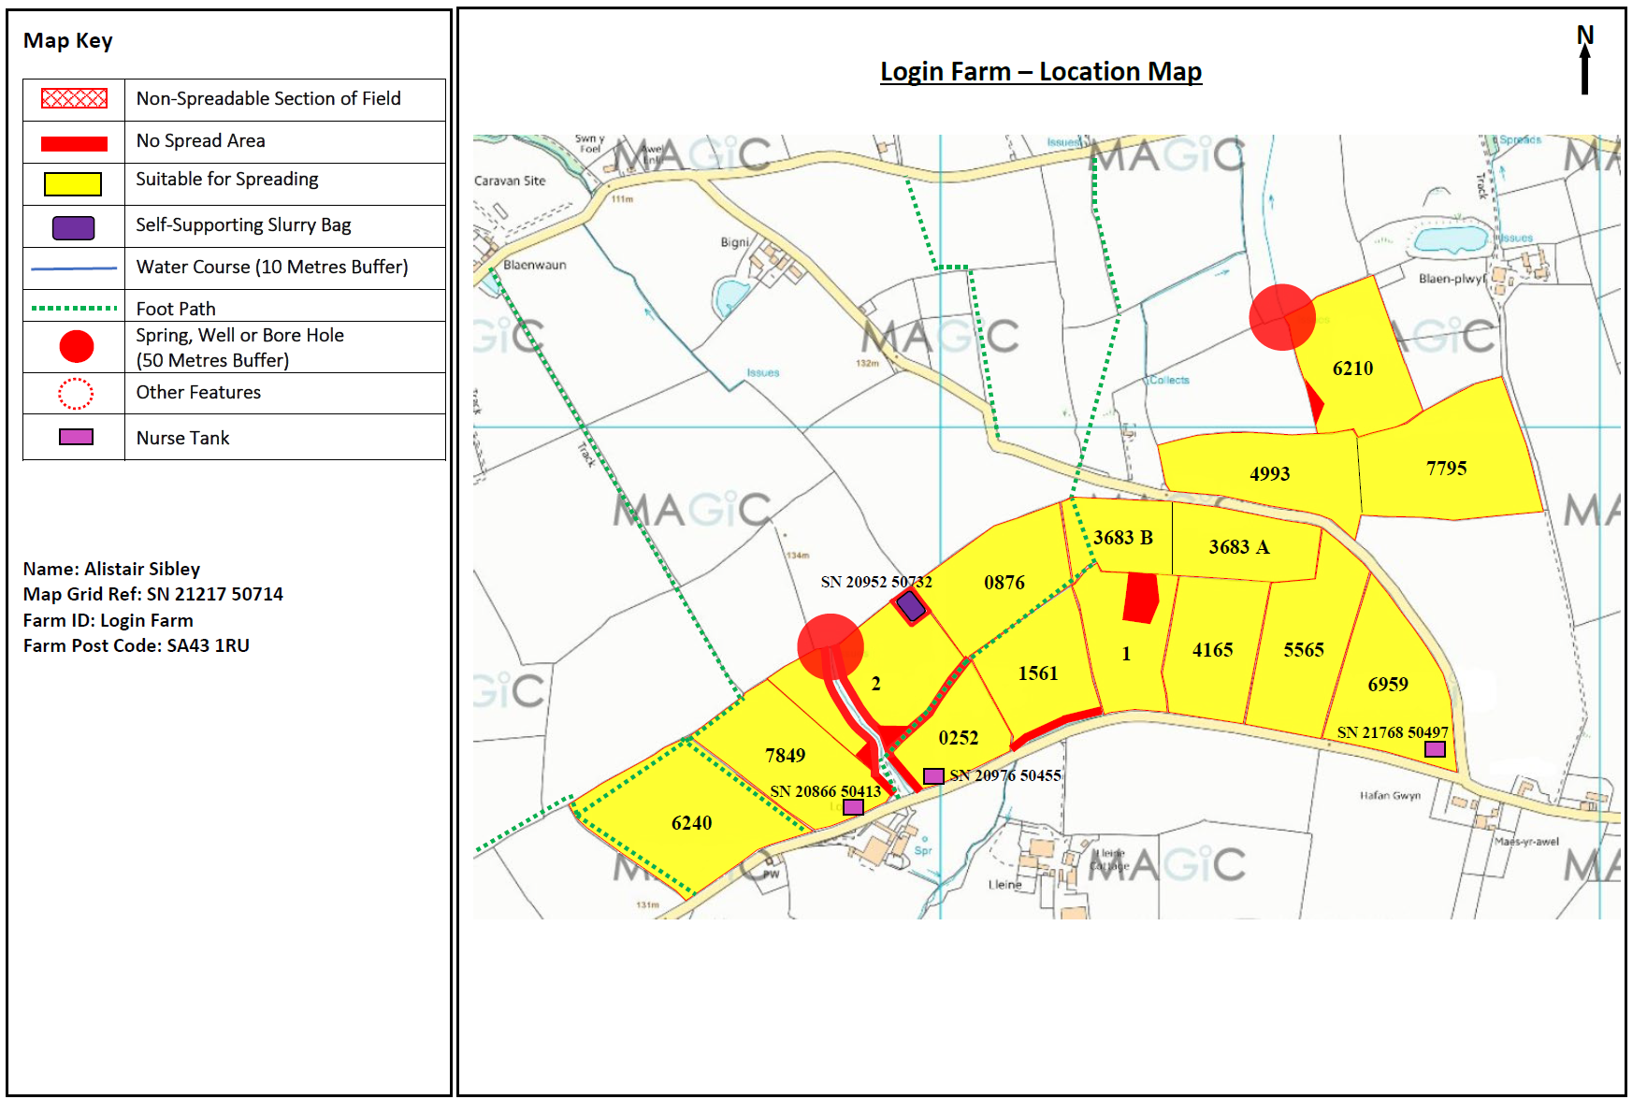
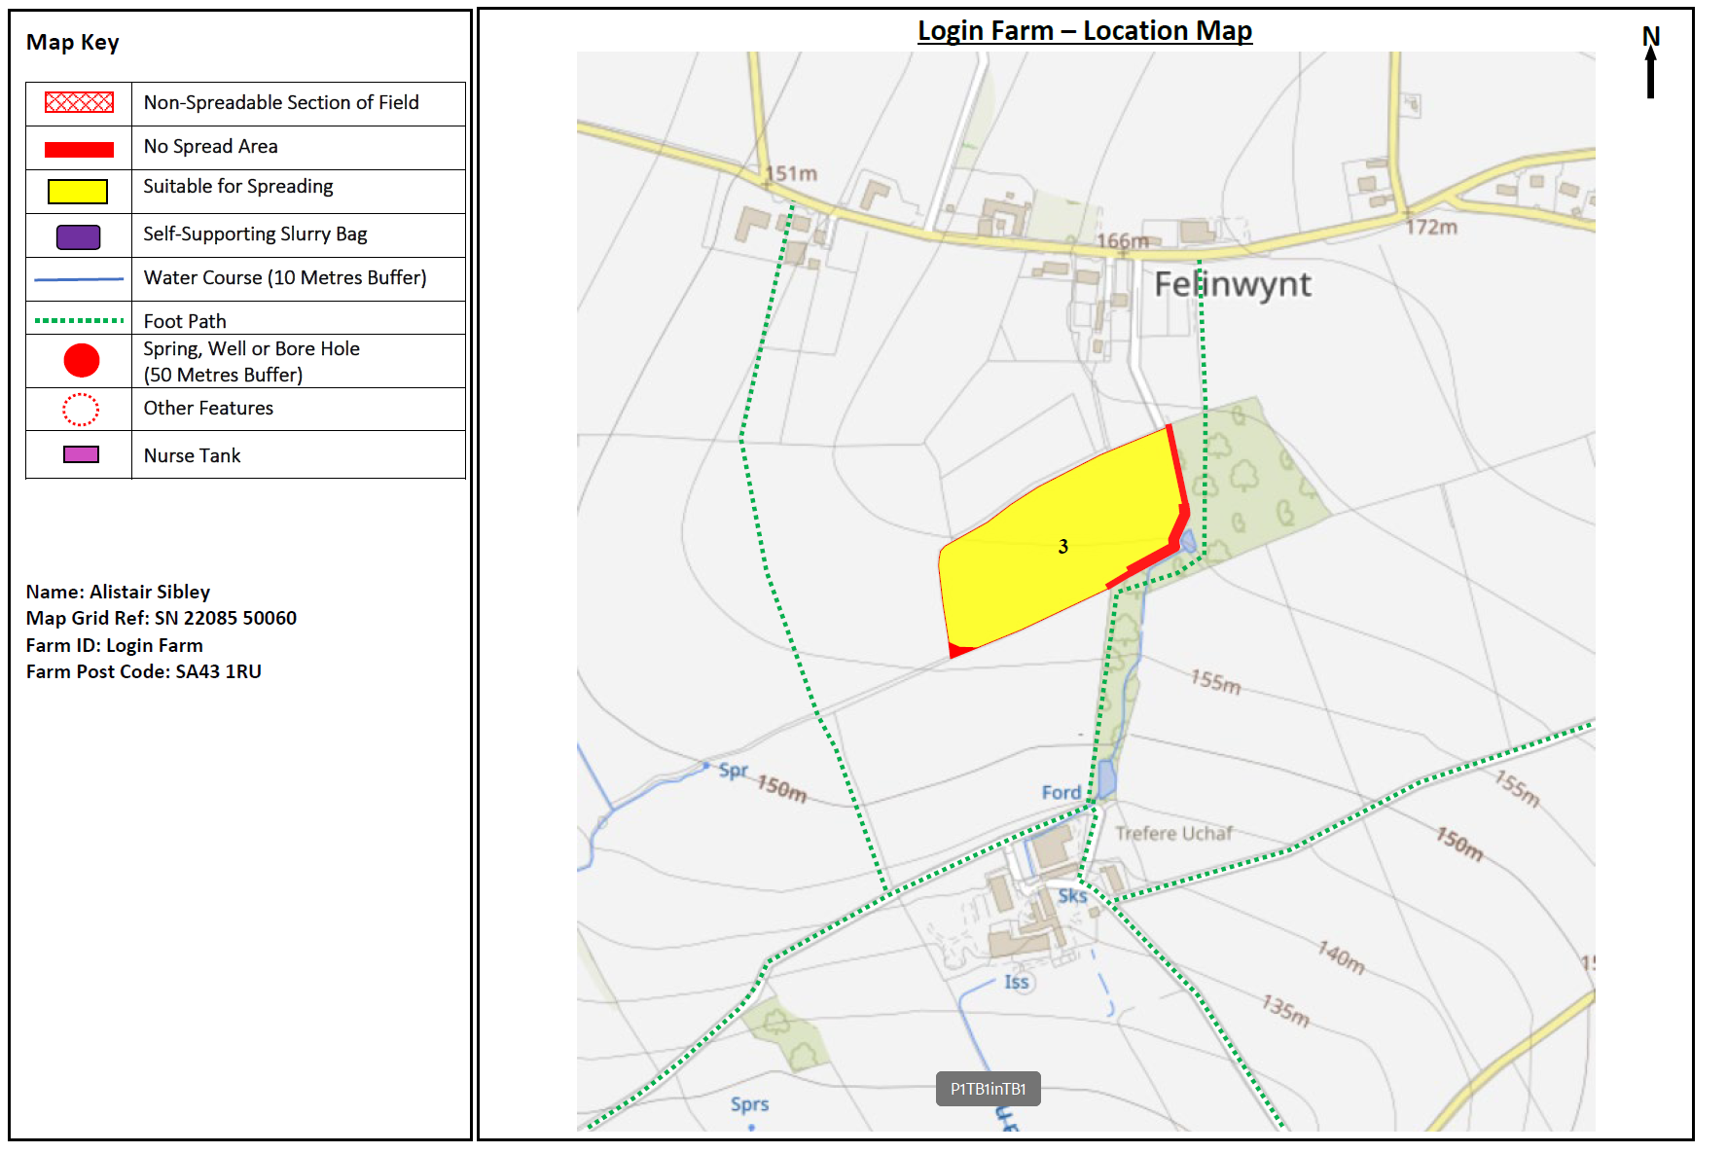
Deployment Boundaries and storage
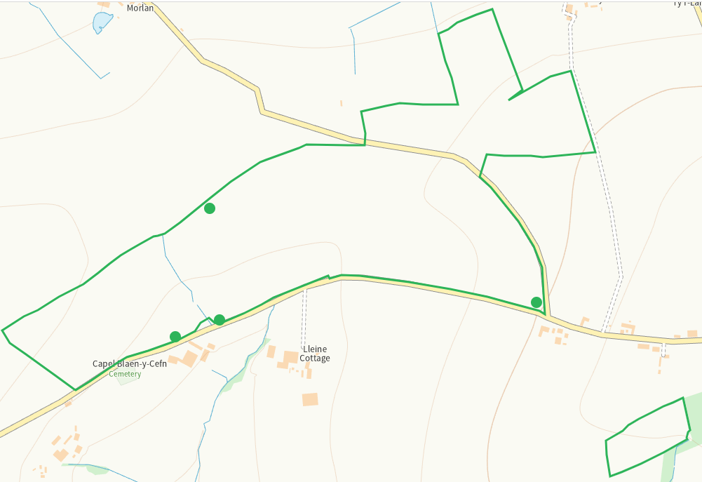
Detailed river network 10m
Watercourses between 7849, 2 and 0252, also to the S boundary of 1561. Buffered on application map.
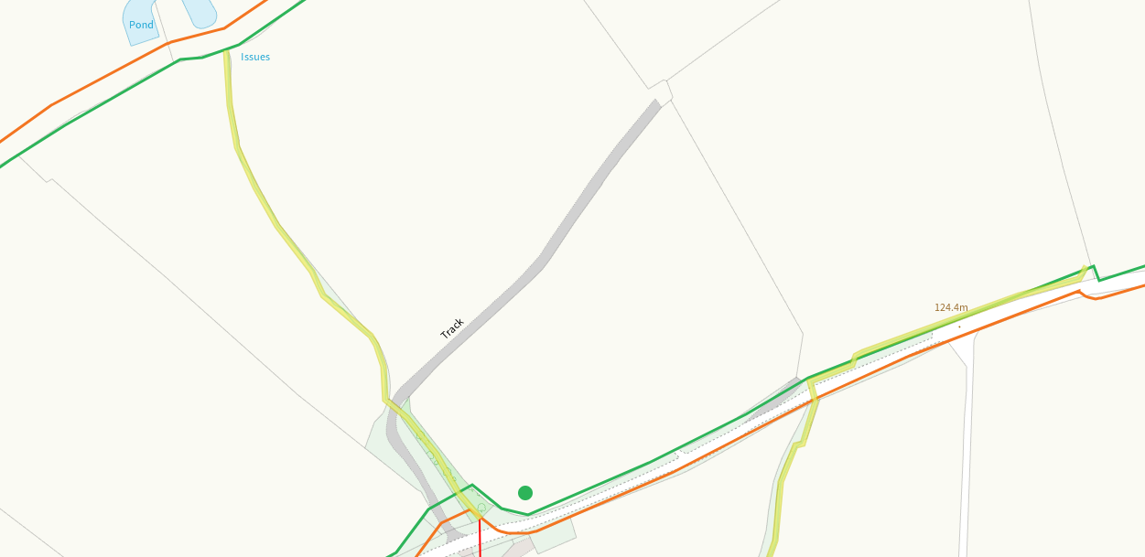
Pond within 1. Buffered on application map.
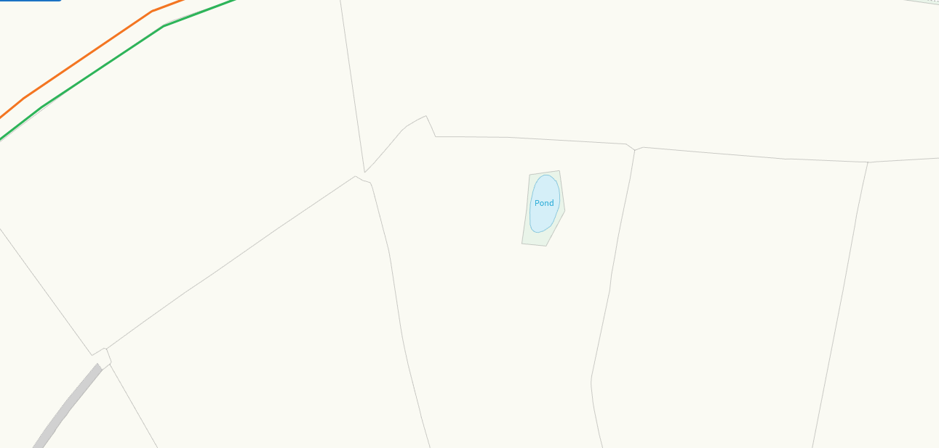
Pond and watercourse to the SE of 3, buffered on application map
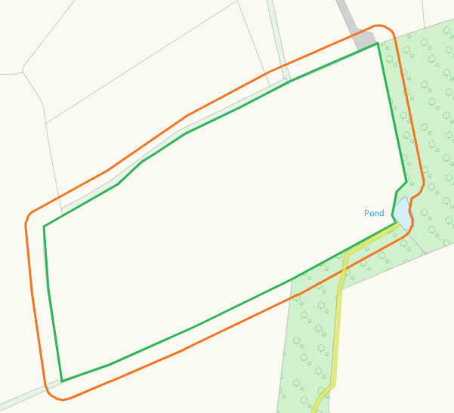
None at other fields
Groundwater source protection zones
none
Any well, spring (or issue) or borehole used for the supply of water for human consumption including from a private water supply or supplies within 50m.
Issue NW of 6210 buffered on application map
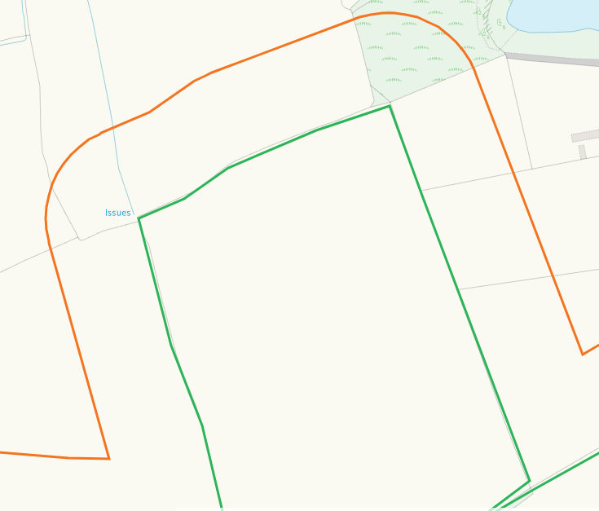
Issue between 7849 and 2, buffered on application map
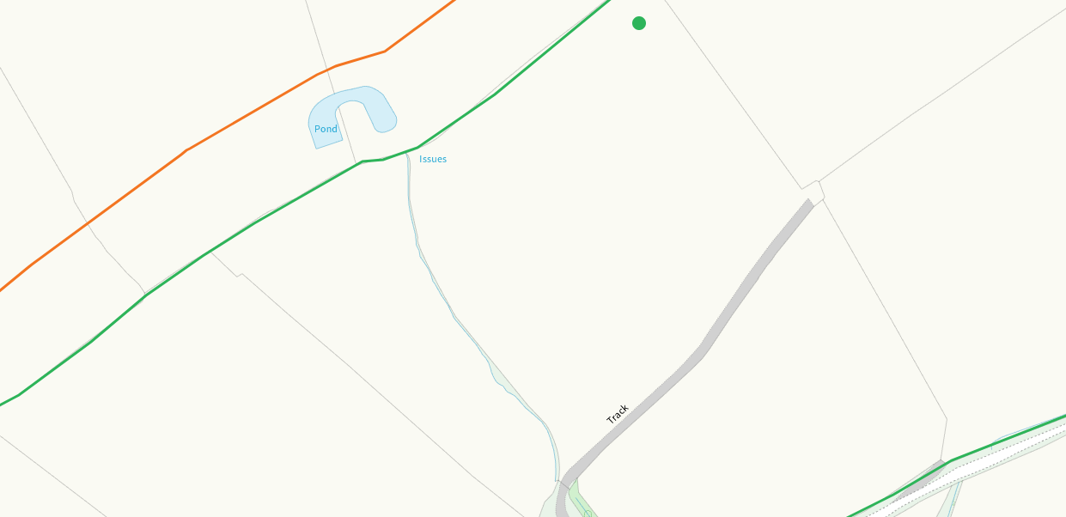
None at other fields.
Any well, spring (or issue) or borehole used for the supply of water for human consumption including from a private water supply or supplies within 250m.
Issue E of 6210, shown on application map
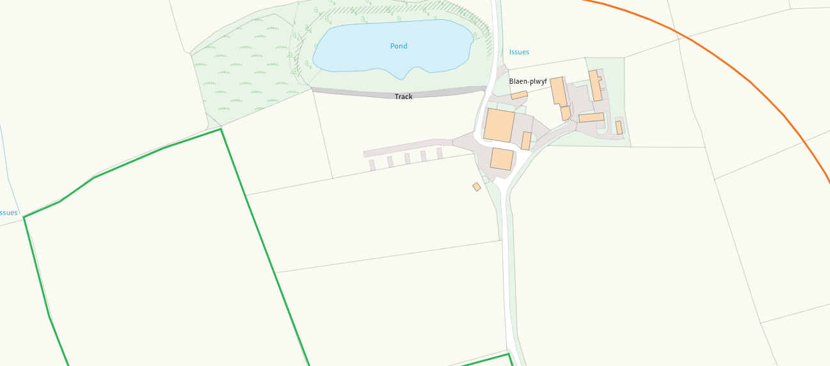
Spring S of 0252, shown on application map
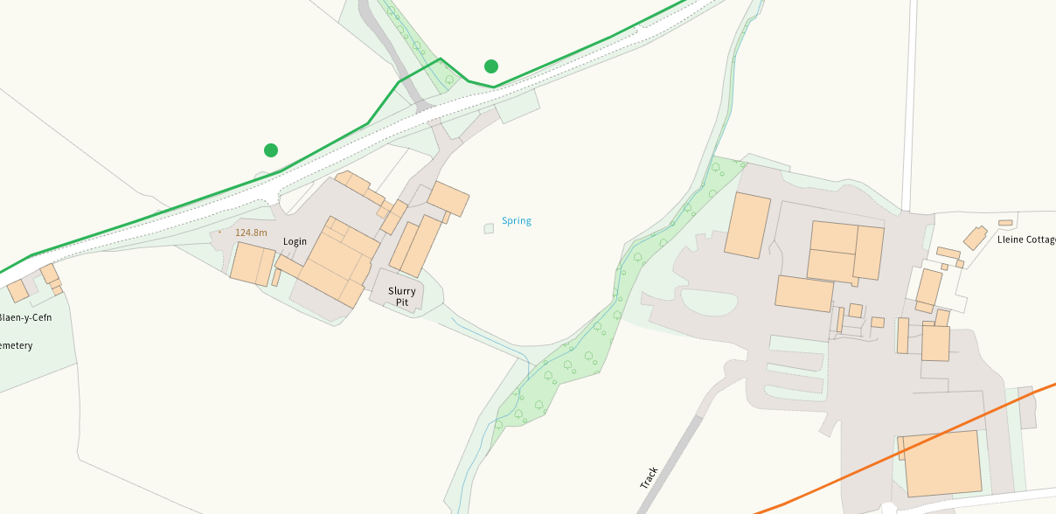
None at other feilds
Within Groundwater Safeguard Zone
none
European designated sites- Natura 2000 (SPA, pSPA, SAC or cSAC) or Ramsar- or SSSI within 500m
none
Other protected sites within 500m:
- Protected Species, section 7-
Several within range mainly hedgehogs recorded in 2021/22

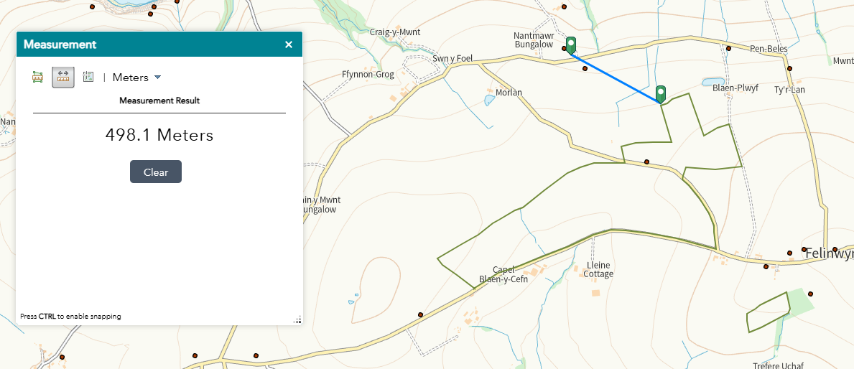
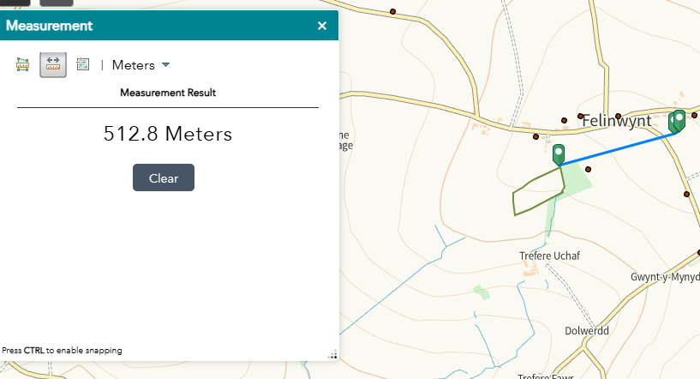

- Protected Habitats-

Reedbeds adjacent pond within 1, buffered on application map
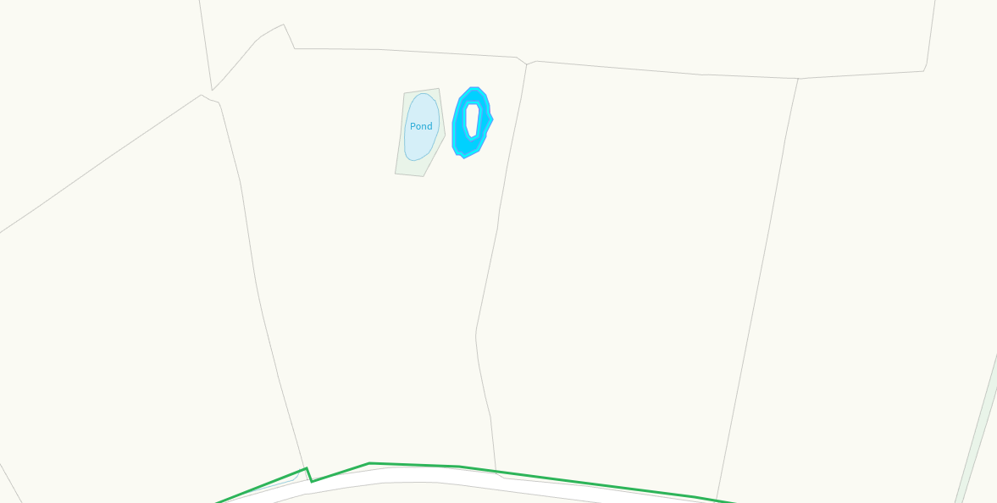
Lowland dry acid grassland and Lowland calcareous grassland and Purple moor grass and rush pastures within 500metres. Nil risk due to waste type and delivery method
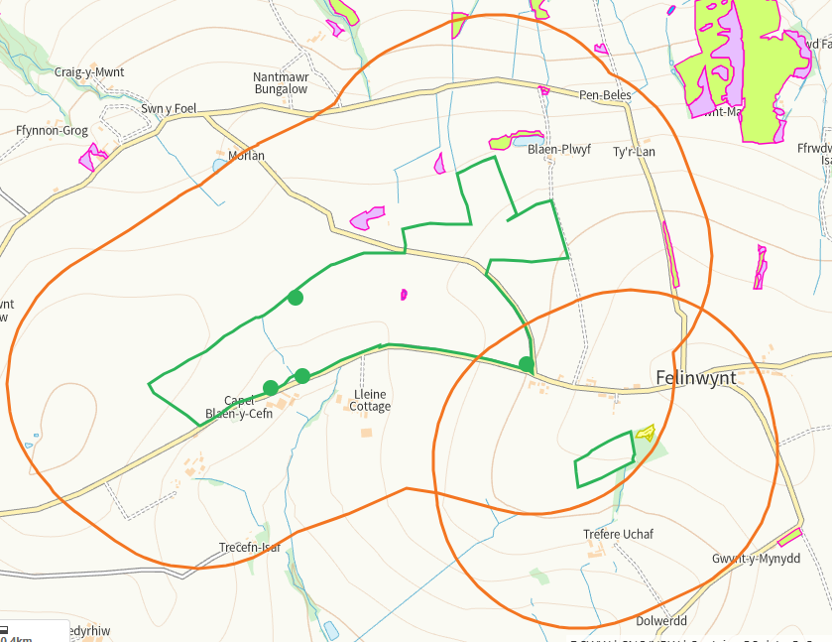
- Scheduled Ancient Monument- none
- Local Nature Reserve- none
- National Nature Reserve- none
- Ancient Woodlands- none
- Local Wildlife Sites (SINC)- none
- National Park- none
- Nitrate Vulnerable Zone (NVZ)- ALL Wales
- Groundwater Safeguard Zone- none

Flood risk
none
Public rights of way
All footpaths within fields are shown on application maps
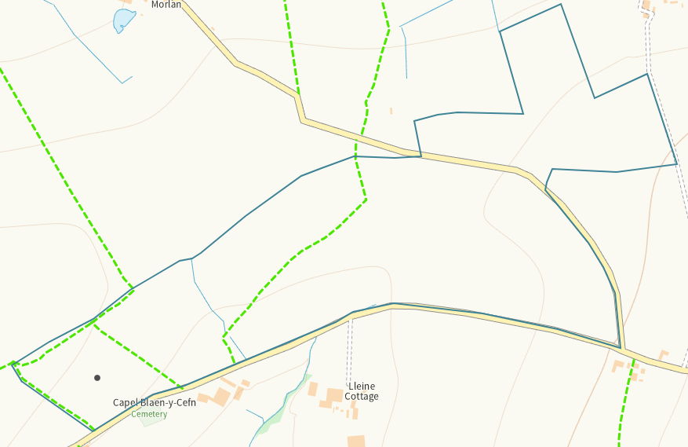
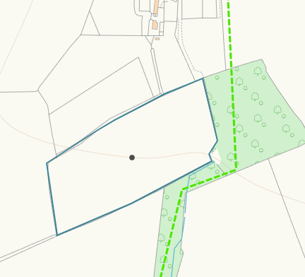

Distance from Main Farm Address
Adjacent
Slope Map
All fields 0-7
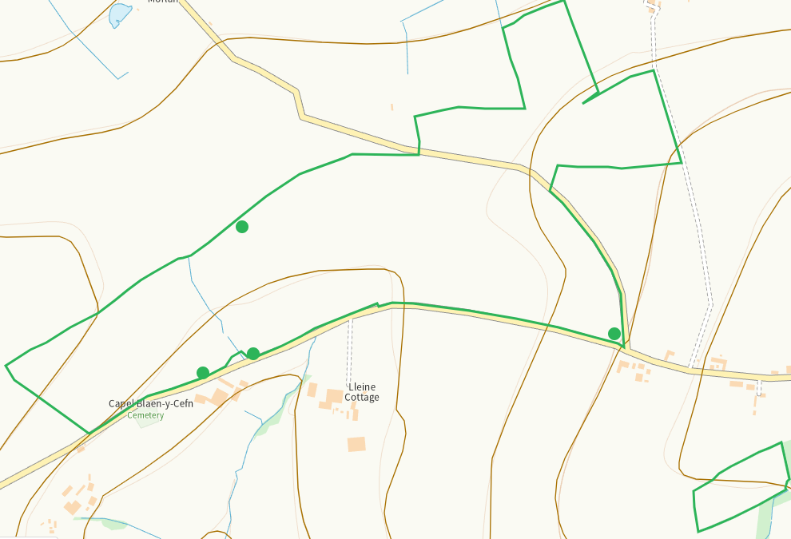
END

