PAN-030515 Mapping report
https://maps-alpha.cyfoethnaturiolcymru.gov.uk/Html5Viewer_4_14/index.html?viewer=MyMapPermitting.MyMapPermittingHTML5&project=8f8e909b07df4d349c93023d9e1b52a3
Coedydd Derw Elwy SSSI
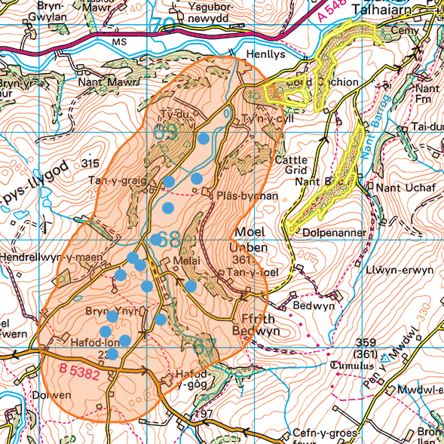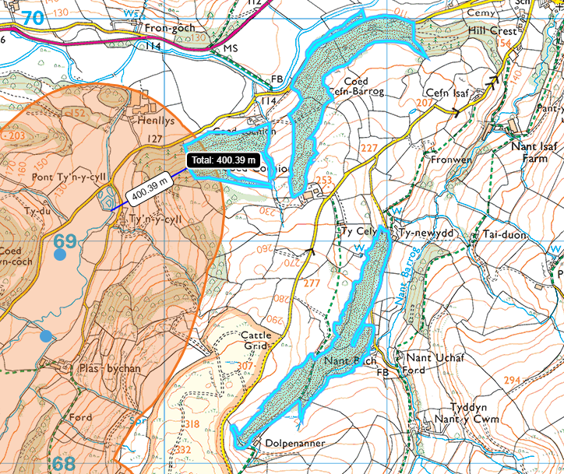

surface water courses, springs, wells, boreholes
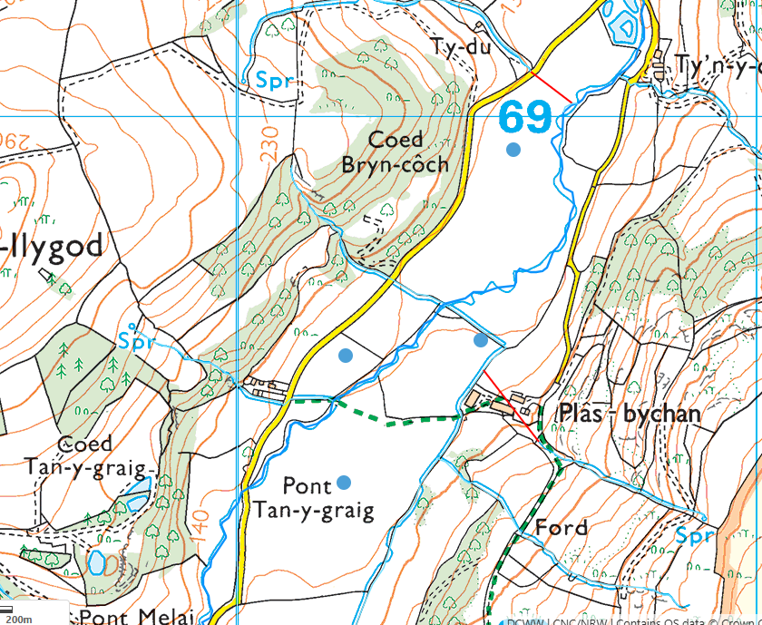
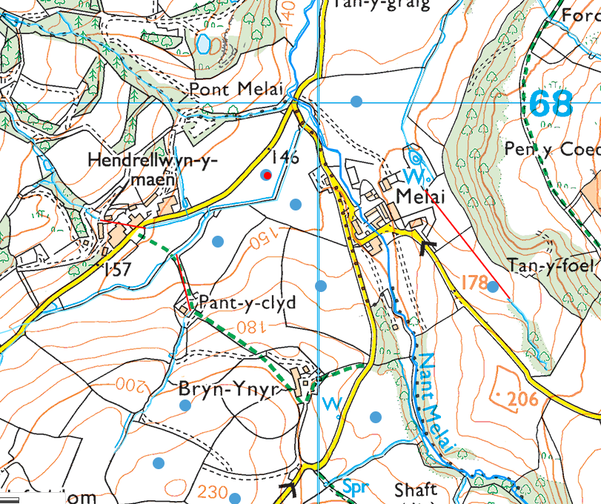
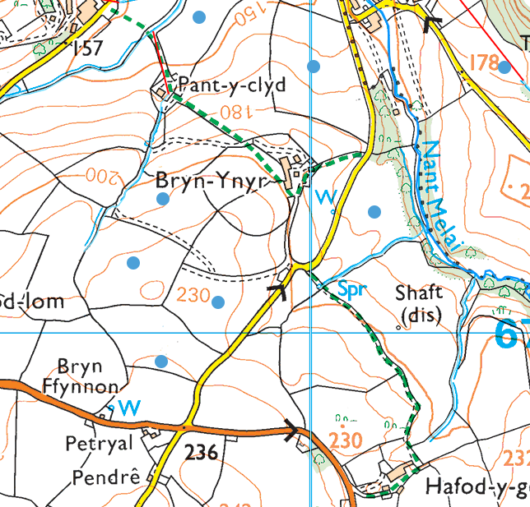
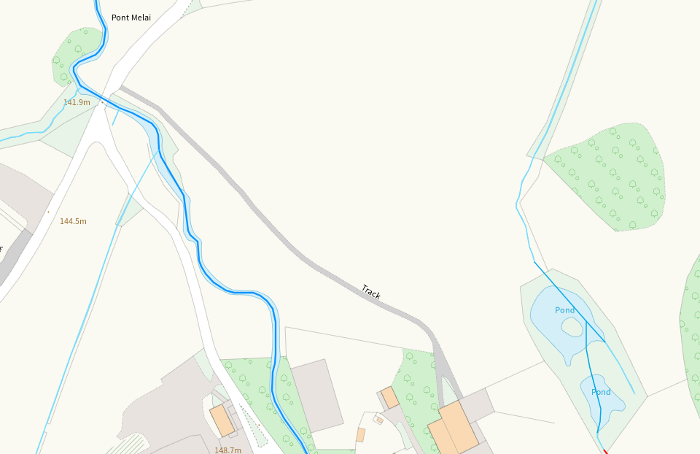
Field 17- watercourse in field missing

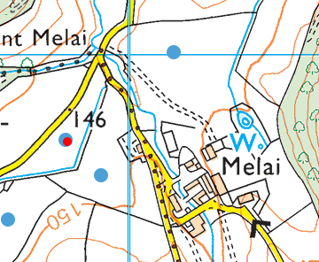 Well SE of field 17

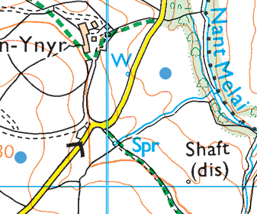Well NW of field 7, and spring within field 7
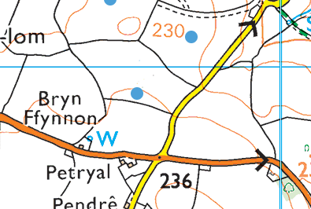 Well within field 14

location of any public rights of way
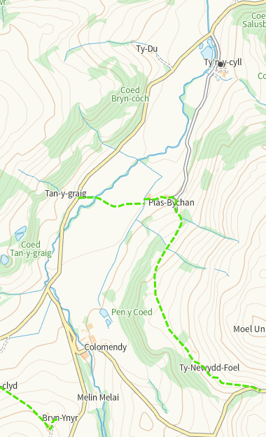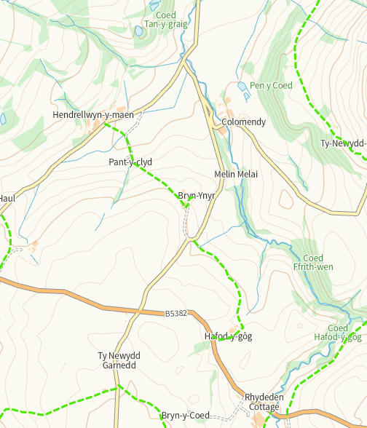

Habitats/Species
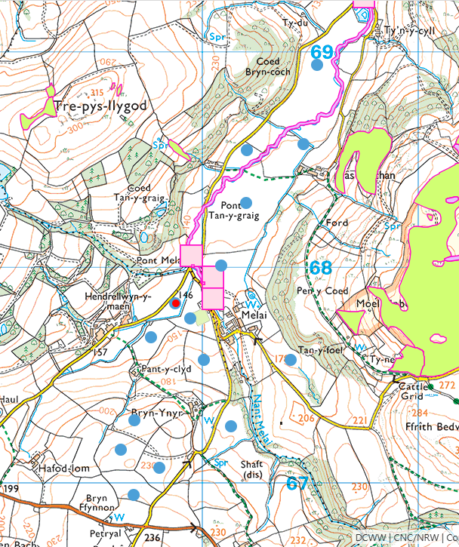
Within Nant Melai:
- Brown/Sea Trout
- Bullhead
- European Eel
- European Eel migratory route
- Unidentified Lamprey
- Atlantic Salmon
On valley sides;
- Lowland dry acid grassland and Lowland calcareous
- Lowland dry acid grassland

Ancient Woodlands
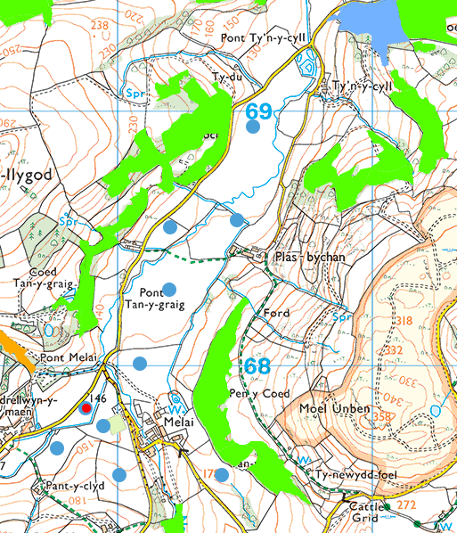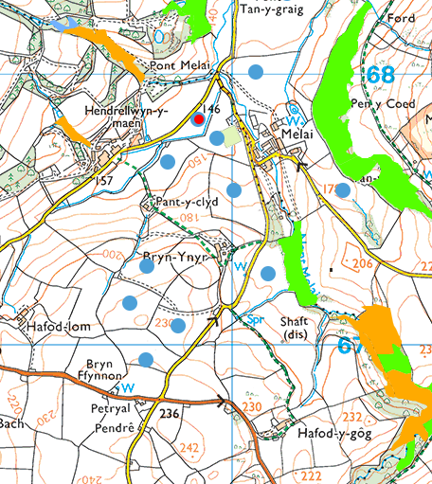

Local Wildlife Sites (SINC)
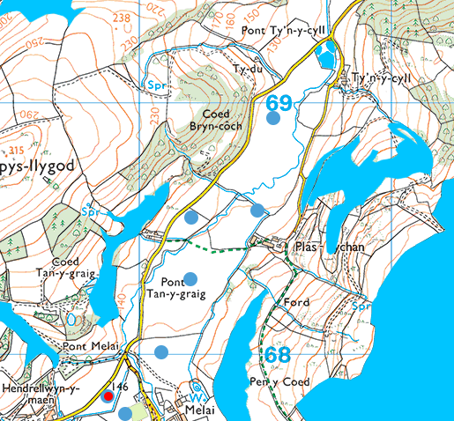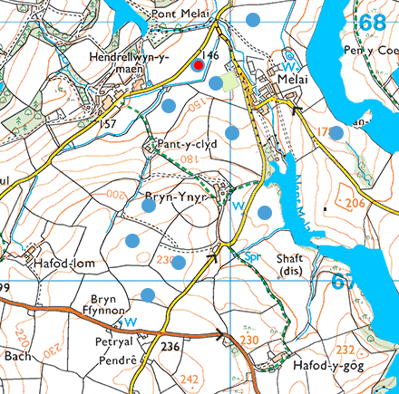
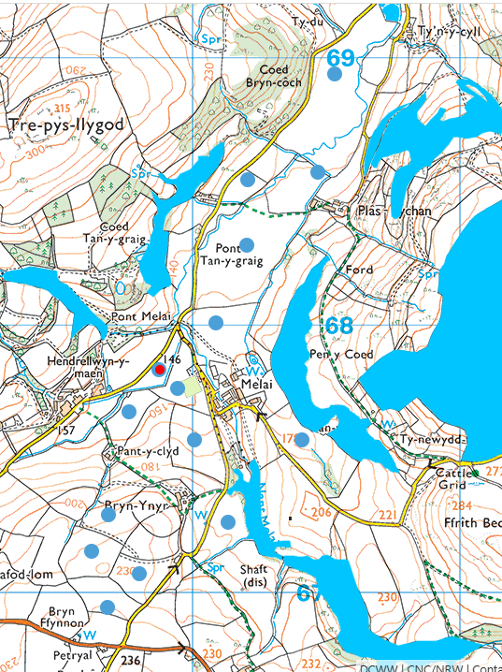
Flood risk
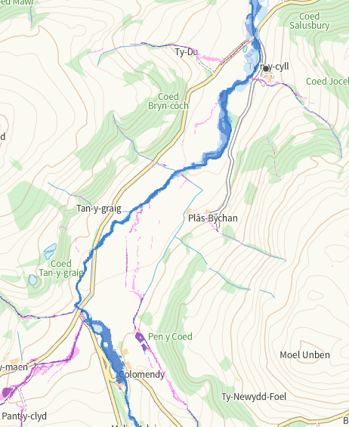
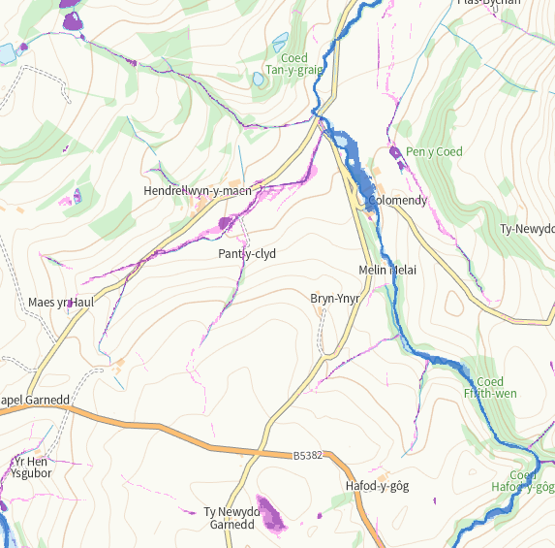

Slope
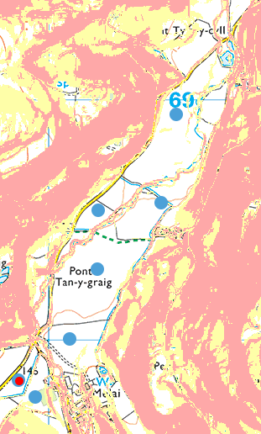 Fields 17, 18, 19, 20 ,21
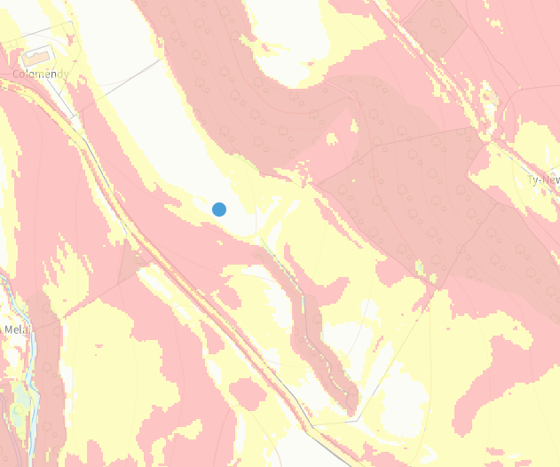 Field 15
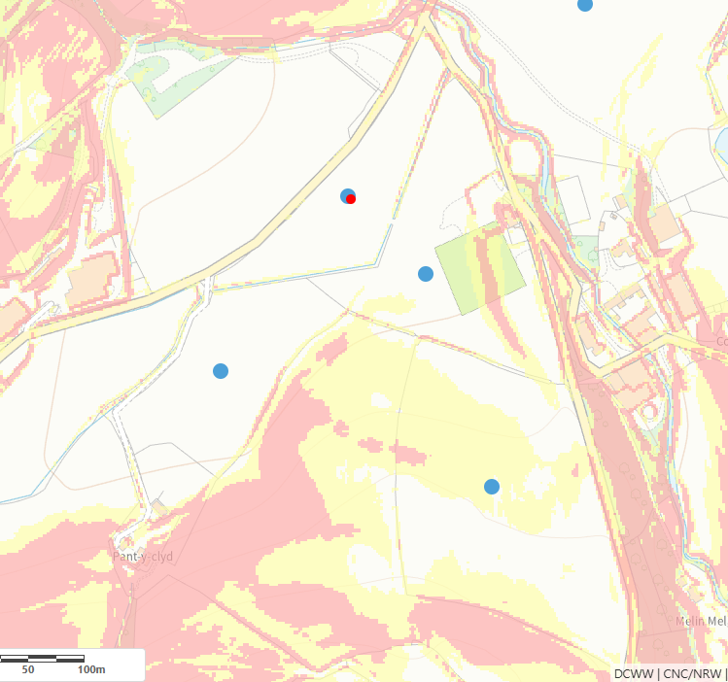Fields 1, 2, 3, 5
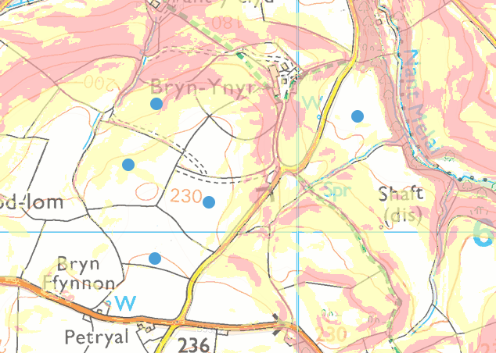 Fields 7, 11, 12 13, 14
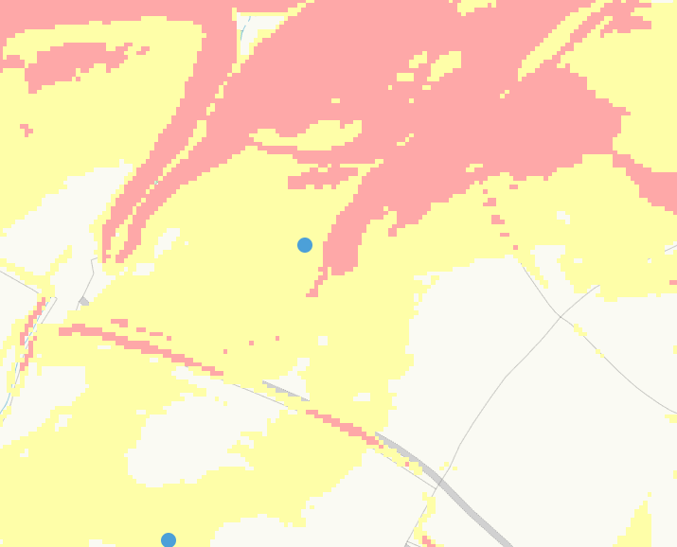Field 12

Storage
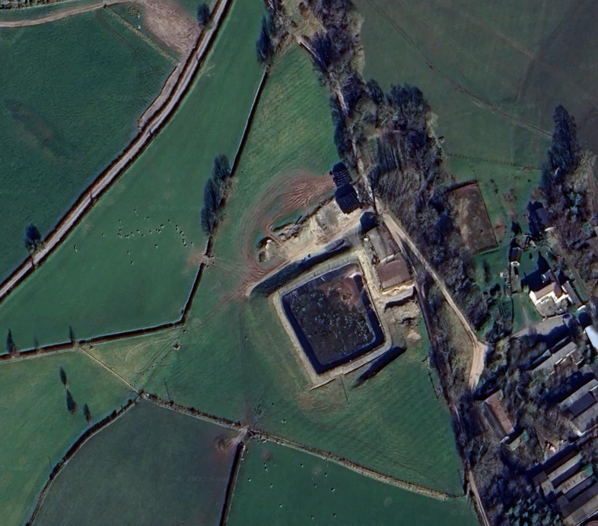
None found within relevant distances
- European designated sites- Natura 2000 (SPA, pSPA, SAC or cSAC) or Ramsar
- groundwater source protection zones
- Groundwater Safeguard Zone
- Scheduled Monument
- Local Nature Reserve
- National Nature Reserve
- National Park

