Monte Carlo M odelling

Hydrology data
Watercourse name: Drain leading to Afon Lliw
Map showing the Discharge Point and the Confluence with the WFD designated watercourse

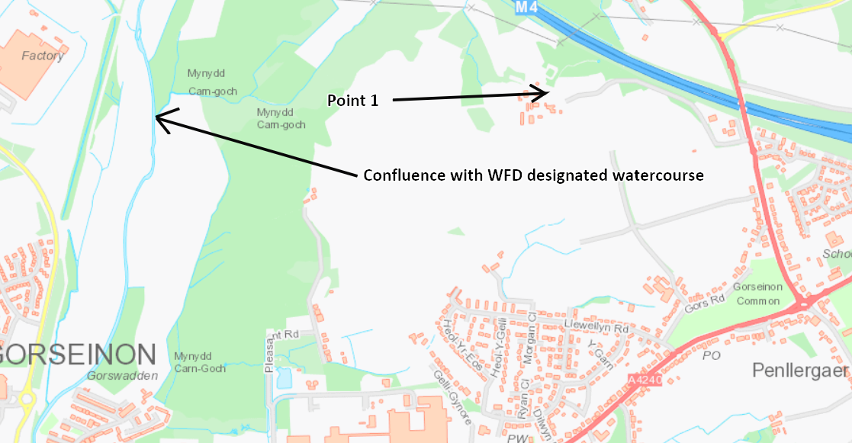

Flow Data: -
Point | Mean Flow m3/day | Q95 m3/day
WFD Waterbody | 72,662 | 9,850

Assumptions:
The river flow at the WFD designated watercourse is the closest point at which we could obtain data to utilise within the modelling. Modelling the impact of the discharged effluent entering the environment has been completed using the data at the WFD designated watercourse.
All data has been provided by NRW hydrology team.
The current WFD class of the designated water body of the Afon Lliw is High.

Discharge Data
Volume = 7.5 m3/day Mean = 3.74 Standard Deviation = 1.23

Effluent quality: -
@ 20mg/l Ammonia: Mean = 13.0 Standard Deviation = 5.3
@ 20mg/l BOD: Mean = 10.7 Standard Deviation = 5

WFD data: -
Ammonia WFD data (Type 2, High Class)
WFD watercourse: GB1100590032100
Ammonia WFD Data: Mean = 0.0526 Standard Deviation = 0.1302

Mid Class data
Type 2, Class: High
Ammonia: Mean = 0.09 Standard Deviation = 0.05
BOD: Mean = 1.15 Standard Deviation = 0.69

Summary of Results
Ammonia | WFD watercourse
20 mg/l | 0% det

BOD | WFD watercourse
20 mg/l | 0%

The BOD and Ammonia concentrations of the discharge will have a negligible impact of the receiving water course; therefore it can be considered not likely to have an impact on the WFD designated stretch of the Afon Lliw.

Calculated BOD deterioration at 20mg/l at high at the WFD watercourse
MASS BALANCE CALCULATION: MONTE CARLO METHOD
Version 2.5
Calculations done on 07/11/2019 at 13.07
Name of discharge | Llys Nini
Name of river | Afon Lliw - Type 2
Name of determinand | BOD - High Class
INPUT DATA |  |  | RESULTS
UPSTREAM RIVER DATA |  |  | RIVER DOWNSTREAM OF DISCHARGE
Mean flow | 72662.0 |  | Mean quality | 1.16
95% exceedence flow | 9850.0 |  | Standard deviation of quality | 0.71
Mean quality | 1.15 |  | 90-percentile quality | 2.00
Standard deviation of quality | 0.69 |  | 95-percentile quality | 2.45
90-percentile | 2.01 |  | 99-percentile quality | 3.57
DISCHARGE DATA |  |  | DISCHARGE QUALITY
Mean flow | 3.74 |  | Mean quality | 10.91
Standard deviation of flow | 1.23 |  | Standard deviation of quality | 4.95
Mean quality | 10.70 |  | 95-percentile quality | 20.33
Standard deviation of quality | 5.00 |  | 99-percentile quality | 26.83
... or 95-percentile | 20.14 |  | 99.5-percentile quality | 28.93
percent deterioration | -0.4975
Mean percent deterioration | -0.8696

Modelling at the WFD watercourse using High Mid-class data, as there is no recent WFD data, shows a 20mg/l BOD limit causes 0% deterioration.

Calculated Ammonia deterioration at 20mg/l at high class at the WFD watercourse
MASS BALANCE CALCULATION: MONTE CARLO METHOD
Version 2.5
Calculations done on 06/11/2019 at 16.38
Name of discharge | Llys Nini Animal Centre
Name of river | River Dulas
Name of determinand | Ammonia - High Class
INPUT DATA |  |  | RESULTS
UPSTREAM RIVER DATA |  |  | RIVER DOWNSTREAM OF DISCHARGE
Mean flow | 72662.0 |  | Mean quality | 0.06
95% exceedence flow | 9850.0 |  | Standard deviation of quality | 0.16
Mean quality | 0.05 |  | 90-percentile quality | 0.12
Standard deviation of quality | 0.13 |  | 95-percentile quality | 0.20
90-percentile | 0.12 |  | 99-percentile quality | 0.51
DISCHARGE DATA |  |  | DISCHARGE QUALITY
Mean flow | 3.74 |  | Mean quality | 13.23
Standard deviation of flow | 1.23 |  | Standard deviation of quality | 5.26
Mean quality | 13.00 |  | 95-percentile quality | 23.13
Standard deviation of quality | 5.30 |  | 99-percentile quality | 29.54
... or 95-percentile | 22.94 |  | 99.5-percentile quality | 31.57
percent deterioration | 0

Calculated Ammonia deterioration at 20mg/l at high class at the WFD watercourse x 1000
MASS BALANCE CALCULATION: MONTE CARLO METHOD
Version 2.5
Calculations done on 06/11/2019 at 16.50
Name of discharge | Llys Nini Animal Centre
Name of river | River Dulas
Name of determinand | Ammonia - High Class
INPUT DATA |  |  | RESULTS
UPSTREAM RIVER DATA |  |  | RIVER DOWNSTREAM OF DISCHARGE
Mean flow | 72662.0 |  | Mean quality | 56.60
95% exceedence flow | 9850.0 |  | Standard deviation of quality | 155.85
Mean quality | 52.80 |  | 90-percentile quality | 118.80
Standard deviation of quality | 130.30 |  | 95-percentile quality | 196.74
90-percentile | 119.16 |  | 99-percentile quality | 512.52
DISCHARGE DATA |  |  | DISCHARGE QUALITY
Mean flow | 3.74 |  | Mean quality | 13228.5
Standard deviation of flow | 1.23 |  | Standard deviation of quality | 5258.1
Mean quality | 13000.0 |  | 95-percentile quality | 23133.1
Standard deviation of quality | 5300.0 |  | 99-percentile quality | 29551.6
... or 95-percentile | 22944.5 |  | 99.5-percentile quality | 31579.0
percent deterioration | -0.3021
Mean deterioration | 7.19697

Modelling at the WFD watercourse using WFD data shows a 20 mg/l Ammonia limit causes 0% deterioration.
Please note figures have been multiplied by 1000 to account for large number of decimal places that aren’t reflected in the Monte Carlo spreadsheet.

Conclusion
The discharge is being made to a ditch prior to it entering a small watercourse before entering the Afon Lliw. The flow in the drain offers little dilution, therefore it was only possible to achieve Hydrology data for the main designated watercourse. This means there is the potential for large deterioration within the drain. However, as the drain is an undesignated watercourse, allowing potential deterioration is in line with NRW’s no deterioration policy. In addition, this is an improvement on the current unregulated discharge of a septic tank and reed bed system.
Modelling at the WFD watercourse of the Afon Lliw shows the level of deterioration for both Ammonia and BOD is acceptable at 0% and the watercourse will remain within High Class for both determinants (based on Mid-Class data).

