PAN-023528 MyMap Report
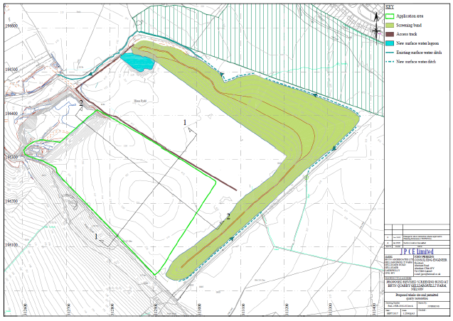

national parks- none
areas of outstanding natural beauty (AONBs)- none
special areas of conservation (SACs) (1km)- none
special protection areas (SPAs) (1km)- none
Ramsar sites (wetlands) (1km)- none
marine conservation zones (1km)- none
Air quality management area (2km)- none

sites of special scientific interest (SSSIs) (1km)
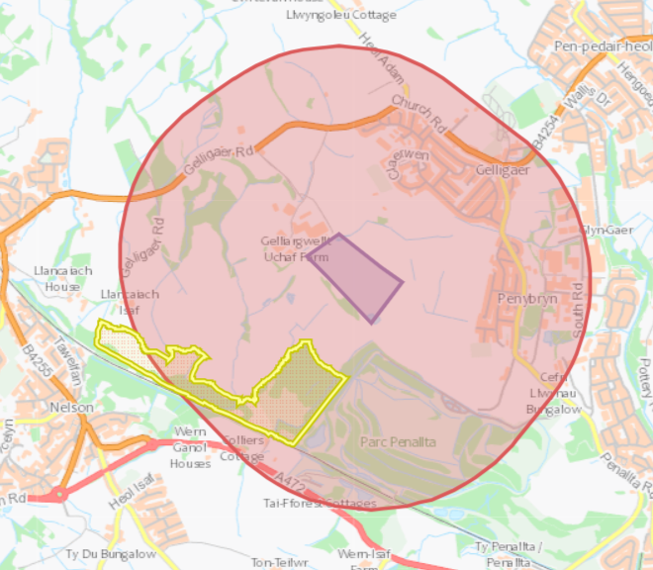
- Nelson Bog

ancient woodlands (500 meters)
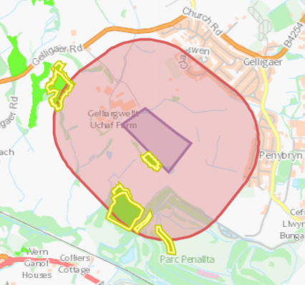
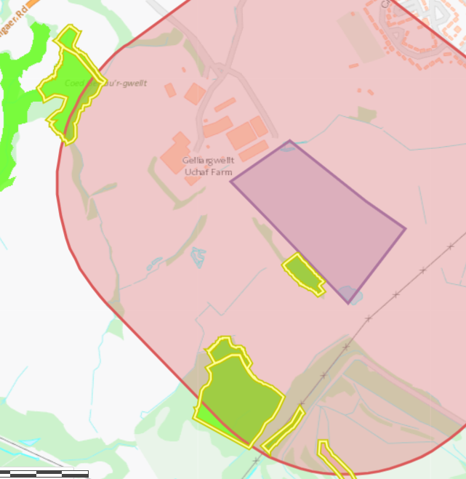
- Ancient semi natural woodland (all except)
- Ancient woodland site of unknown category
- 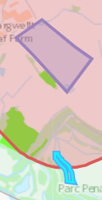

Flooding
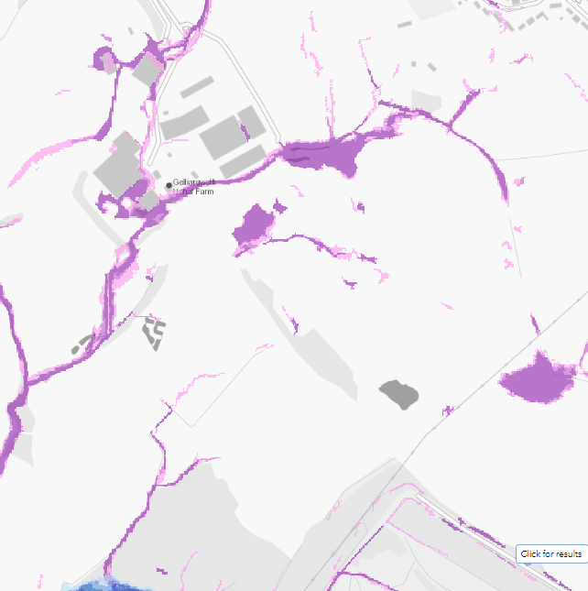
- Flood risk from surface water and small watercourses
protected habitats/species and section 6/7 species (500 meters)
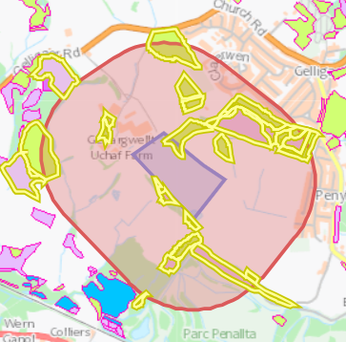
- Blanket bog
- Lowland dry acid grassland
- Lowland dry acid grassland and Lowland calcareous grassland- on site boundary to the north
- Lowland heathland
- Purple moor grass and rush pasture- on site boundary to the south
- Reedbeds

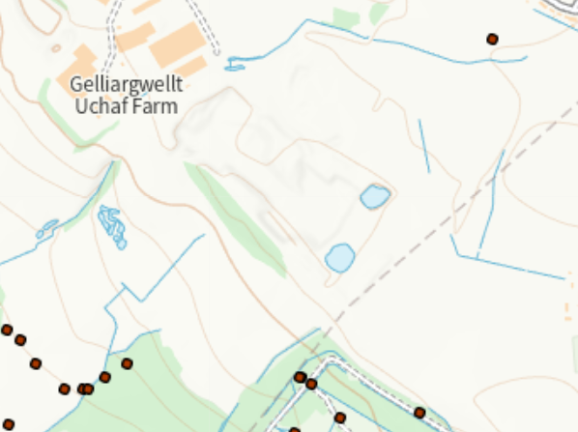

historic items (ancient monuments, historic sites etc.) (500 meters)
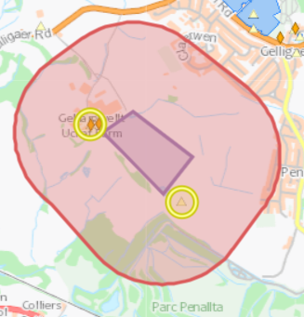
- GELLIARGWELLT-UCHAF- ST12489644- Domestic DWELLING
- CALVARY, PEN-Y-BRYN- ST1396- Religious, Ritual and Funerary CHAPEL
- Gelliargwellt Uchaf Farmhouse- Situated amidst farmland and adjacent to a quarry, reached by a farm track from the main road.
- Bee-boles at Gelliargwellt Uchaf- Set in the E garden wall of Gelliargwellt.

source protection zones/aquifers
- No SPZ
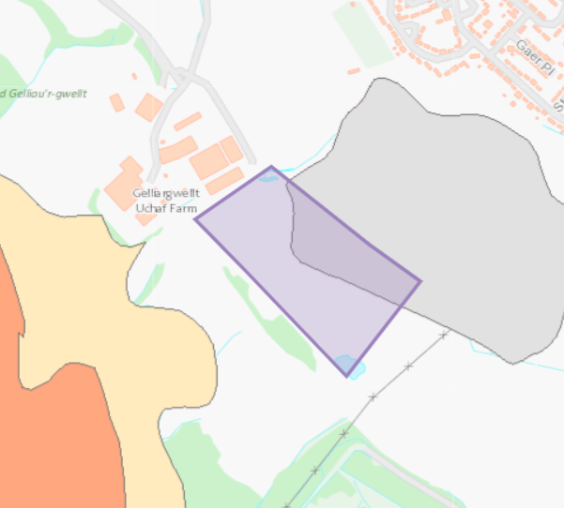
- Superficial aquifer- Unproductive

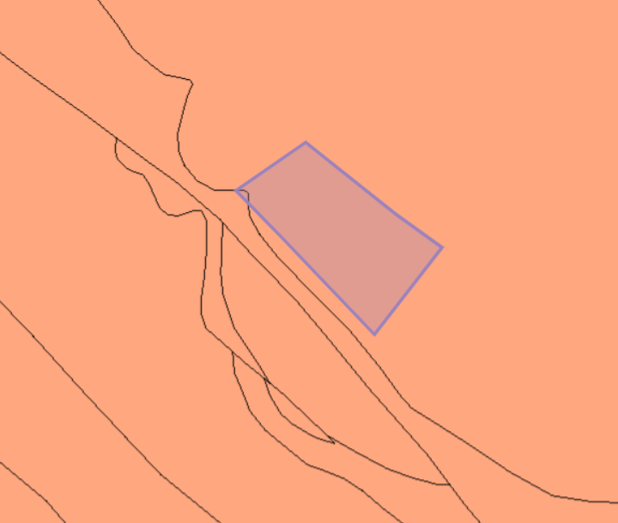
- Bedrock aquifer- Minor- Secondary A

local wildlife sites (500 meters)
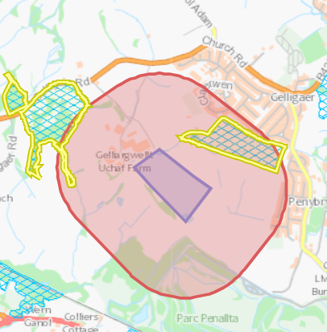

- Waun Rydd, Gelligaer (to the east)
- Coed Gelliau'r-Gwellt, East of Llancaiach (to the west)

surface water courses (sinks/issues/springs/wells etc.)
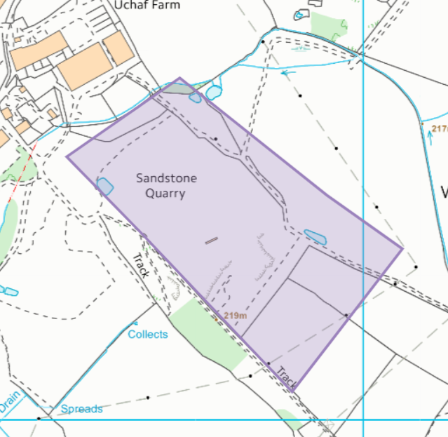
- Ponds
- Watercourse to the north (permit boundary unclear)
“The closest main primary water bodies to the Site are the River Taff located approximately 3.2 km to the west; and the River Rhymney located approximately 2.5km to the east. The Nant Caeach and the Nant Cylla are two smaller water bodies that are tributaries to the River Taff, and the River Rhymney respectively, and located 1.5km to the west and east respectively, as shown in Drawing HRA3. There are a number of surface water springs and surface water features in close proximity to the quarry and the larger site area. The closest up-gradient water feature (a stream) is located approximately 268m to the northwest of the current quarry area, located at the southwestern corner of the Waun Rhydd SINC running along the bund into Gelliargwellt Uchaf Farm. The majority of the surface water features are located down gradient, at a lower level to the south and southwest of the site.”
local residents
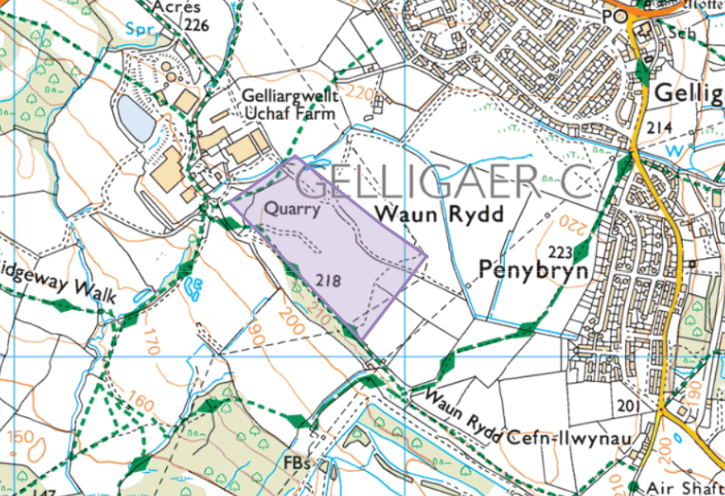
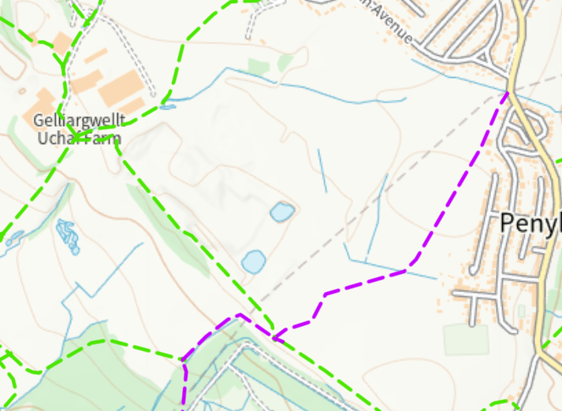
- Green footpath
- Purple bridleway
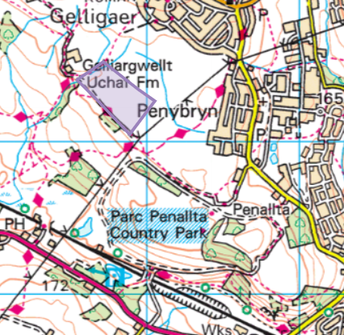
- Parc Penallta to the south

“There are residential properties within approximately 500 metres (sensitive receptors) of the facility. The closest independent sensitive receptor is allotments that are 385m north of the site, the next closest are residential properties on Claerwen which are 455m north of the site.”

