Annex (iv) – SSSI Assessment Form
SSSI Assessment for permit/licence and deployment applications | 
To be completed by Permitting Officers for any applications for a permission which Natural Resources Wales has considered under S28I duty to notify SNCB and take their advice into account. This applies to all proposed permissions within a SSSI, and to operations outside the SSSI boundary which are likely to damage its special features.
NRW as a Section 28G authority has, when exercising its functions, a general duty to take reasonable steps, consistent with the proper exercise of its functions, to further the conservation and enhancement of the flora, fauna or geological or physiological features by reason of which the site is of special interest’

Part 1 – SSSI Assessment
Part 2 – Formal notification to SNCB (to be completed if part 1 assessment concludes likely damage, not likely to damage because of conditions or you cannot conclude no likely damage)
Part 3 – Decision
Pink text – drafting notes, to be deleted before completion/consultation.
Blue text – examples, to be replaced with permission-specific information and text turned to black.

Part 1 – SSSI Assessment

- Permitting officer/team | Louise Bailey  Waste Permitting Team
- Permit application reference and site name | PAN-027639
- a. SSSI name(s)  b. location  c. NRW Operational Area/Environment Team | a.  - Gwent Levels - Whitson  - Gwent Levels - Nash and Goldcliff  - Gwent Levels - Redwick and Llandevenny  b. Newport  c. Blaenau Gwent, Caerphilly & Newport Environment Team
- Brief description of proposal | The Tata Steelworks Llanwern site referred to as South Side Queensway (SSQ) in this application is to treat stockpiles of various products, by-products and wastes from steelmaking. Tata seeks to remove contaminants and unsuitable materials to reduce this risk further and facilitate recovery of the materials.  The waste to be treated comprises various non-hazardous iron and steelmaking wastes. An estimated 900,000 tonnes of this material is currently in stockpiles requiring treatment.  DLS considers that the following remedial technologies will prove successful and facilitate redevelopment:  - Separation – as the material contains contaminants in the fine fraction and light fraction contaminants, closed-loop washing will allow these contaminants to be separated and removed. During this process, the fine silts and sands will be density separated from the light fraction contaminants such as timber and plastic.  - Screening, crushing and blending – to enhance the success of soil washing and to remove metals and other anthropogenic contaminants.  The three treatment areas are as follows with their distances to the 3 SSSIs:  - Stockyard 5 (Area 1_5)- 222m from Gwent Levels - Nash and Goldcliff  - Stockyard 10 (Area 2-10)- 320m from Gwent Levels - Nash and Goldcliff and 496m from Gwent Levels – Whitson  - Lagoon 26 (Area 3_26)- 220 metes from Gwent Levels – Whitson and 443m from Gwent Levels - Redwick and Llandevenny  The main risks from the proposed activities are Dust, Noise & Vibration and possible water emissions.  The applications Risk Assessment (2473r2v3d0625 ERA) includes the procedures for management of these risks. The relevant procedures have been incorporated in to the permit to ensure compliance. Sections:  - 6.1 Release of Airborne Particulates  - Table 6-1 Assessment of potential impact of airborne particulates on identified human receptors  - Table 6-2 Assessment of potential impact of airborne particulates on flora and fauna at SSSI  - 6.2 Release of Polluting Fluids  - Table 6-3 Assessment of potential risks to surface water  - 6.3 Noise and Vibration  - Table 6-4 Assessment of potential impact of noise and vibration on identified human receptors  - Table 6-5 Assessment of potential impact of noise and vibration on Flora and Fauna at SSSI  - 6.7.2 Air Quality  - Table 6-7 Triggers for Dust Suppression  - 6.7.3 Odour  - 6.7.5 Noise and Vibration  - 6.7.8 Leaks and Spills  - 6.7.9 Controlled Water
- What aspects of the proposed permission are likely to damage the SSSI features of special interest?

The following activities are likely to cause damage apply to all 3 of the SSSIs within the screening distance of 2km, however it must be noted that none of the proposed permitted activities are occurring on or within the SSSIs:
- 7 Dumping, spreading or discharging of any waste materials.
- 21. Construction, removal or destruction of roads, tracks, walls, fences, hardstands, banks, ditches or other earthworks.
- 22. Storage of materials.
- 26. Use of vehicles likely to damage riparian and bank vegetation or craft likely to disturb fauna.

Features of interest of all 3 SSSIs:
- Reen and Ditch Habitat- aquatic plants and other wildlife
- Insects and other Invertebrates
- Shrill carder bee- un-mown ditch banks and rough grassland areas provide ideal habitat
- Habitats that contribute to the special wildlife interest including green lanes, hedgerows and flower rich ditch banks

Mechanisms/pathways of impact of all 3 SSSIs:
- Ditch clearance- due to the mechanisms in place, the proposed activities should not introduce sediment/dust into the reens, which could require more frequent clearances. The proposed activities will not interfere with any planned ditch clearances.
- Water Levels- due to the mechanisms in place, the proposed activities should not introduce sediment/dust into the reens, which could reduce the water levels. Water will be taken from the on-site Tata effluent drainage system for use in the wash plant; wastewater will not be discharged back into the system, but will be tankered off to be treated/disposed of appropriately. There are no discharges from this site/activity.
- Shading by hedgerows- The proposed activities are not relevant to hedgerow growth.
- Water Quality- due to the mechanisms in place, the proposed activities should not introduce sediment/dust into the reens. There are no discharges from this site/activity.
- Development Pressure/ Land Use and Development- proposed activities are not being carried out on the SSSIs. The proposed activities are to treat and reuse/remove existing wastes on the Llanwern site, which may lead to future development, but this is not under the control of the proposed activities.

Mechanisms/pathways of impact of Gwent Levels - Nash and Goldcliff only:
- Newport Wetlands Reserve- proposed activities are approx. 2.5km from the wetlands and is therefore out of scope of this assessment.

- Summary of any informal advice received from internal experts (if required and including pre-app advice) | n/a
- Recommendation | The proposed permission is not likely to damage any of the flora, fauna or geological or physiological features which are of special interest.
- Signature and date assessment made | Louise Bailey  16/06/25
- Officers name and job title | Louise Bailey  Waste Permitting Officer

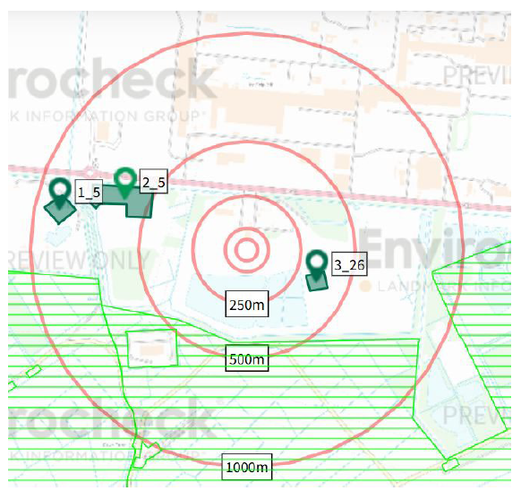
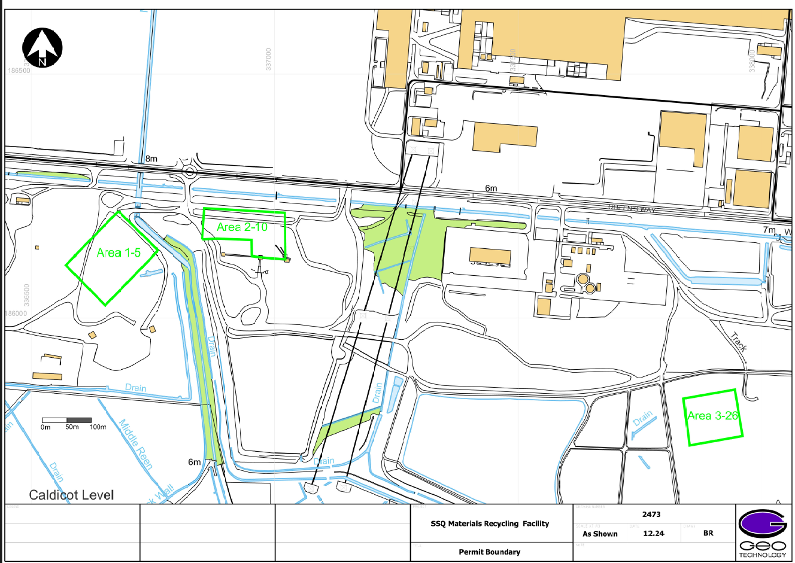
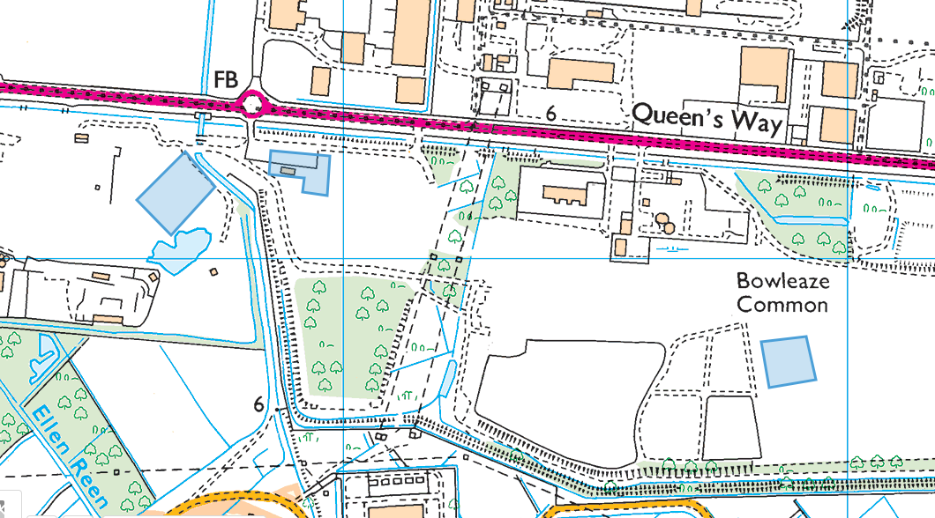

sites of special scientific interest (SSSIs) witthin 2km
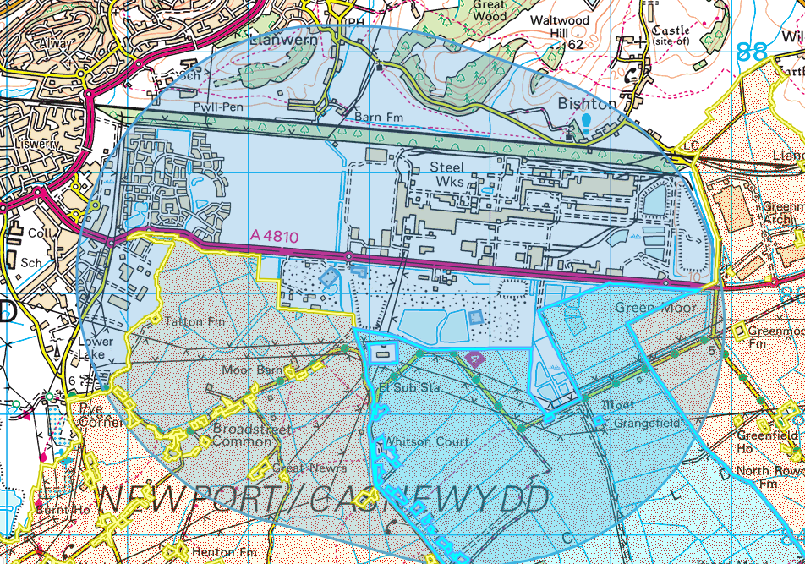
- Gwent Levels - Whitson
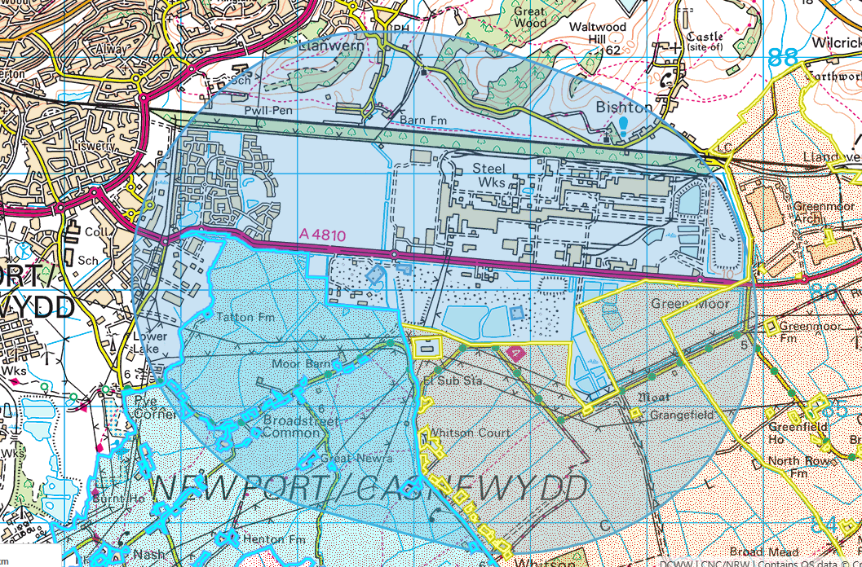
- Gwent Levels - Nash and Goldcliff
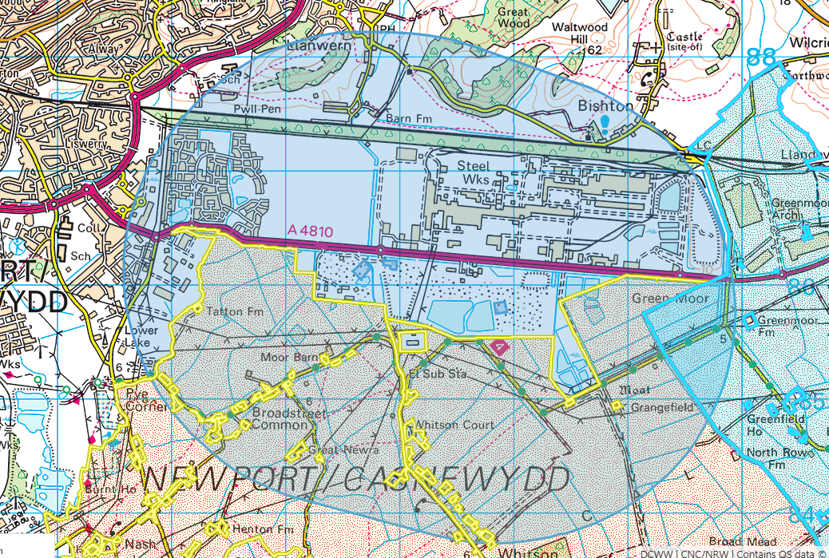
Gwent Levels - Redwick and Llandevenny

