Margam and Port Talbot Substations and Interconnector

Margam Site Water Management:
Best Practices and Procedures



Prepared by: Laing O’Rourke
Version: For Information
Revision: P01
Reference: MARPT-LOR-XX-XX-PL-R-090019
Margam Site Water Management
S5 – For review and acceptance
Security Classification: Public

Document Number: MARPT-LOR-XX-XX-PL-R-090019

Revision | Author | Checked by | Approved by | Date | Reason for revision
P01 | Elliot Hutchings | Matthew Wisdom | Rob Jones | 14.04.2025 | Initial draft for review

DOCUMENT OWNER: Elliot Hutchings
SECURITY CLASSIFICATION: OFFICIAL
Handling instructions: Uncontrolled when printed

Contents
1. Introduction 4
2. Preliminaries 4
2.1 Scope 4
2.2 Purpose 4
3. Responsibilities 5
4. Compliance 6
4.1 Environmental Permitting Regulations 2016 6
5. Procedural Control Measures 6
5.1 Silt netting and Sediment Control 6
5.2 Drainage Management 6
5.3 Enhanced Water Treatment Solutions 6
5.4 Permit to Pump 6
6. Waste Arisings 7
6.1 Silt Management 7
7. Water Quality 7
7.1 Test Results (pending) 7
8. Monitoring 7
9. Discharge and Calculations 8
10. Operational Arrangements 8

Introduction
This Margam Site Discharge Management Plan is to identify Laing O'Rourke's activities that will require water-related consents to prevent contamination of existing watercourses. This plan also details the management and monitoring procedures in accordance with regulatory guidelines and advice.

Key areas of focus include:
- Surface Waters (Turbid waters from earthworks)
- Cementitious waters (Interaction of cement-based products)

Definitions

Surface waters | are a manageable unit of water, including streams, rivers, canals, lakes, and reservoirs. Waters from excavations and clearance may become contaminated with silt due to the disturbance of ground activities and mixing with rain-dependent waters and surface waters (perched waters).
Perched waters | an accumulation of surface water that is above the main water table due to an impermeable layer i.e. Clay.
Cementitious waters | are the byproducts of water used involving cement-based materials in construction.

References
- Margam Drainage Report MARPT-BHK-01-XX-RP-C-000001
- LOR Construction Environmental Management Plan – MARPT-LOR-XX-XX-PL-R-090009
- LOR Environmental Emergency Plan - MARPT-LOR-XX-XX-PL-R-090013
- Ciria Control of Water Pollution from Linear Projects

Note: This management plan should be read in conjunction with Activity 1 permit applications:
- Activity 1: MARPT-LOR-XX-XX-PL-R-090022

Preliminaries

Scope
Turbid and cementitious waters are by-products of site activities such as earthworks, drainage, and the use of cement-based materials. Turbid waters can degrade water quality by depositing heavy silt, restricting habitats, reducing sunlight, and depleting oxygen levels. Cement-based products and activities, such as soil stabilisation with cement, are highly alkaline and corrosive, generating fine silt (pH 11.5) that can damage both terrestrial and aquatic environments. Operators must prevent cement-based products used within construction from entering waterways, drains, and groundwater, adhering to regulatory guidelines for wastewater management.
- Follow guidance set out within Pollution Prevention Guidelines 6, Section 2 Drainage, Section 3 Excavations, Section 4 Materials Storage, Stockpiles and Exposed Ground.
- Follow guidance set out within Pollution Prevention Guidelines 6, Section 7 Cement, Concrete & Grout.

Note: It is understood that these guidelines have been withdrawn. However, Laing O'Rourke has received communication from NRW that certain Regulatory Position Statements do not apply in Wales, and PPGs are to be adhered to.

Purpose
The purpose of this plan is to establish a site-wide protocol that ensures the control of surface waters and the introduction of cement-based products on the project. Works involving cut and fill activities will result in the generation of turbid water, while the use of cement for ground stabilisation has the potential to produce high pH water:
- Formal discharge to surface waters or ground under an environmental permit.
- Reuse where applicable after treatment under a Regulatory Position Statement.
- Tanking from the site as hazardous waste, as a last resort.

Responsibilities
All personnel are considered responsible for the prevention of pollution and the provision of an immediate and effective response in the event of an incident.

All personnel are responsible for ensuring the following actions are implemented to maintain water quality and prevent contamination:
- Concrete and cement mixing should be:
  - Sited on an impermeable designated area.
  - At least 10 metres away from a watercourse or surface water drain to reduce the risk of run-off entering a watercourse.
- Surplus dry concrete, cement, and grout:
  - Should be used elsewhere on site if possible, or as inert rubble.
  - If not reusable, it must be disposed of off-site and transported using a registered waste carrier.
- Equipment such as chutes, portable mixers, barrows, pump lines, and shovels:
  - Should be washed out in a designated area specifically designed to contain wet concrete/wash water.
- Concrete mixing and delivery lorries:
  - Should return to the batching plant for washout.
- Excess concrete:
  - Should be sent back to the batching plant.
  - If returning is not possible (e.g., with design concrete), a designated area should be built to allow the concrete to cure without polluting the ground or watercourses
- Separation of concrete waters:
  - Concrete wash waters must be kept separate from surface waters and ground waters to prevent contamination.

These measures are crucial to mitigate the potential impact of construction activities on local water resources and comply with environmental regulations.

Rey roles for flood risk management include:

Name | Role | Contact | Email
Robert Jones | Project Manager | 07385 487733 | rjones@laingorourker.com
Lee Williams | Construction Manager | TBC | leewilliams@laingorourke.com
Ali Sehat | Technical Lead | 07385 945206 | Asehat@laingorourke.com
Elliot Hutchings | Sr. Environmental Advisor | 07350 401035 | ehutchings@laingorourke.com
Gareth Williams | H&S Manager | 07917 040708 | garwilliams@laingorourke.com
Jordan Riseley | Temporary Works Co | 07384 526298 | Jriseley@laingorourke.com

Compliance

Environmental Permitting Regulations 2016
These Regulations establish an environmental permitting and compliance regime applicable to various activities and industries. Permits set controls and emission standards to minimise pollution and allow operators of certain installations to operate. Any operational 'regulated facility' requires an environmental permit. A regulated facility includes water discharge, groundwater, and radioactive substances activities.

Procedural Control Measures

Silt netting and Sediment Control
As part of the comprehensive water management for the proposed works, there will implement sediment control measures in accordance with CIRIA C648 guidance. Specifically, proposed use of silt netting, sediment fences, and check dams to intercept and retain suspended solids within the site boundary. These controls aim to minimise sediment transport to adjacent watercourses.

Drainage Management
To mitigate potential impacts on local watercourses, a robust drainage system shall be developed using existing drainage features on site, based on CIRIA C648 principles. The design will promote natural infiltration and drainage where practicable. It ensures the quality of water at the point of discharge and manages runoff volumes and velocities to prevent downstream flooding. Drainage shall be sufficiently controlled and monitored in line with the sediment control features mentioned above.

Enhanced Water Treatment Solutions
In addition to standard sediment control measures, it is recognized that certain site conditions and environmental sensitivities may necessitate enhanced water treatment solutions. Therefore, it is proposed to use a water management treatment system, such as a Siltbuster unit, to manage and treat sediment-laden water before discharge from the site. This system effectively removes suspended solids and other contaminants, ensuring that all discharged water consistently meets or exceeds the environmental quality standards required by the regulatory authority.
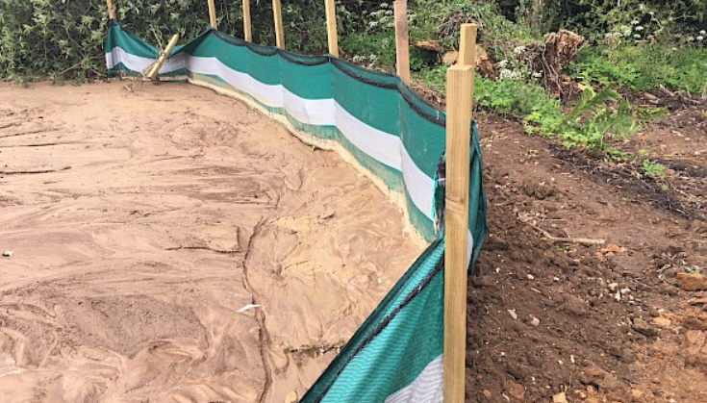 | 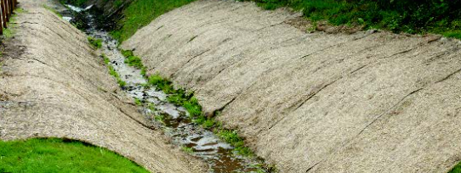 | 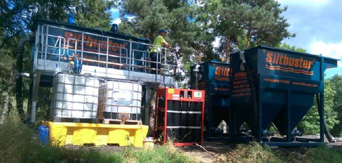

Permit to Pump
Before any works for dewatering commences all Contractors must submit a ‘Permit to Pump’ or similar works authorisation will be sought from the Environmental Team.
- Submit a Permit to Pump request to the environmental department.
The following details will be included as a minimum:
- Where are the pumping operations being carried out and why?
- Where is the water discharging to?
- Who is responsible for checking the discharge during pumping operations to ensure that no environmental damage is being caused?
- Is settlement of solids required as part of discharge?
- If pumping to a watercourse or land outside the project boundary has corrective consent been approved
All permit requests will be completed by those preparing for the work e.g. section engineers or project managers, refer to MARPT-LOR-XX-XX-PL-R-090016

Waste Arisings

Silt Management
Waste silt from the treatment process shall be stockpiled on site and tested against reuse criteria to determine if the material is suitable for landscaping. If the material is not deemed suitable, it shall be removed from the site by a licensed contractor, either through muck away or vacuum excavation, depending on the material's stability. When materials are stored on site, they shall comply with general pollution prevention guidelines as outlined in PPG 6, Section 4, for stockpile management.

Water Quality
Laing O'Rourke has conducted tests on the site waters to confirm their quality, as well as that of the proposed discharge point, namely the Upper Mother Ditch. The aim is to discharge waters from the site, ensuring they match the quality of the existing watercourse or do not exceed the environmental quality standards. Below is an account of the results. It is also noted that silt contamination is a possibility, and measures have been considered as part of the water quality aspect, along with pH correction for dewatering of trenches where Concrete Bound Sand is to be utilised.
- Total TPH and PAH
- Metals (Lead, Cadmium, Mercury, Arsenic, Chromium, Nickel, Zinc, Iron, and Manganese)
- Selenium (based on previous mine workings and 5 outcrop seams within the footprint of the development)
- Solid settlement based on earthworks soil strata interactions

Test Results
Site monitoring has identified a clear and consistent correlation between Total Suspended Solids (TSS) and concentrations of several heavy metals within the discharge proposal, specifically iron, manganese, lead, zinc, and copper. Analytical results (03. Siltbuster) show that elevated metal levels coincide with higher TSS values, confirming that these metals are primarily present in a particulate-bound form. This correlation supports the principle that controlling and reducing TSS will directly reduce the concentrations of associated metals. On this basis, the proposed method of treatment targets suspended solids as the primary means of achieving compliance with Environmental Quality Standards (EQS) for these metals.
Compliance with the relevant Environmental Quality Standards (EQS) for heavy metals will be achieved through the treatment and reduction of Total Suspended Solids (TSS) within the discharge. Site-specific monitoring has demonstrated a consistent and direct relationship between TSS levels and concentrations of key metals including iron, manganese, lead, zinc, and copper. These metals are predominantly associated with particulate matter, and their presence in the discharge is directly linked to suspended solids content.
By applying a suitable solids removal treatment process, the discharge will achieve a substantial reduction in TSS, which in turn will effectively lower associated metal concentrations to within EQS limits. This approach is based on the established and evidenced behaviour of metal partitioning in similar environments. The strategy ensures compliance by design through control of a measurable and treatable parameter (TSS), without reliance on downstream dilution or post-discharge mixing.

Monitoring
Daily / Weekly physical checks will be completed in line with the requirements of the permit. For monitoring purposes and consistency, these checks will be completed at the location of the upstream, downstream and discharge point as identified in Activity 1: MARPT-LOR-XX-XX-PL-R-090022. The checks will include the following:
- pH test
- Total Suspended Solids (at discharge)
- Turbidity (up and down stream)
- Check for visible oil or grease (i.e. ‘rainbow’ sheen);
- Check that the pumping set up appears to be functioning as designed.
- Check for the build-up of solids; and
- Check the pollution prevention controls are in place.

Discharge and Calculations
For the specific details and calculations related to each activity, please refer to the respective permit applications listed below:
- Activity 1: MARPT-LOR-XX-XX-PL-R-090022

Operational Arrangements
Laing O'Rourke shall operate the Siltbuster unit at the designated location on a daily basis. The operational schedule shall follow the regular work pattern, Monday to Friday, from 07:00 to 17:00. The unit will only be operated at night in the event of consistent heavy downpour causing subsequent flooding of excavations. This will be monitored daily based on weather patterns, and notice will be given for a dedicated night/weekend shift team when required. Provision is made for 24/7 support for Siltbuster operations.

