Application form
- The table in the application form, the “Contaminants to be treated” has been given for the non-hazardous waste (19 13 02) as “Removal of oversize and unsuitable fractions”, but for the hazardous waste (19 13 01*) the treatment technology information has been repeated.
All parts of the table should be completed correctly.

Surface water management and site drainage
The following issues relate to surface water management, site drainage and infrastructure:
- The application does not include information on how surface water from the site is to be managed. No information is included in the EMS, and it has been omitted from the Emission monitoring plan section of the application form, and subsequent supporting documents.
- Section 5 of the site plans (drainage systems) show two lagoons, a lagoon overflow, two discharge points and a water pipe to outlet, but the operational procedures and management of these have not been explained or quantified in the application, other than the existence of the settlement lagoons within the CRM/risk assessment.
- Our mapping checks have identified that is site is at risk from flooding from rivers, surface water and small watercourses, which does not match with the Justification for magnitude given in the sites CSM/risk assessment, specifically rows 26 and 30. This can be checked on Natural Resources Wales / Check your flood risk on a map (Flood Risk Assessment Wales Map)
- Discharge Point 2 is to an existing watercourse but Discharge Point 1 does not appear to be a watercourse- further information about this discharge point is required, such as where the water discharges to and if you have relevant permissions to do so.
- The site does not currently hold a water discharge permit. NRW confirmed in 2022 “If the water was to be discharged into the surrounding watercourses, a permit will without a doubt be required as the sampling breaches Environmental Quality Standards and the water would require treatment.” We also have concerns regarding:
  - the composition and contamination of plastics within the soil that could be entering the watercourse(s) if discharged as the lagoons are not lined.
  - the site water being contaminated with suspended solids.
- On the Site plans document; Figure 3: Site access shows a haul road through the centre of the Phase 2 site, however Figure 5: Water management shows that the haul road would be very close to the lagoons, if not overlapping with them. This is concerning regarding stability of the lagoons and contamination risks. The locations of both the haul road and lagoons and their management should be reviewed and amended if required.
- The CRM/risk assessment also states several times that “The site maps document shows no onsite receptors or pathways for silts to run off from site.” The site maps confirm several pathways including the proposed discharge points. This should be reviewed.
- Two pollution incidents have been recorded relating to the site. Procedures to prevent this occurring again must be included in the Surface water management plan:
  - In July 2023 containment bunds were breached during a rainstorm and high volumes of water run-off. Contaminated water was released into a watercourse and flooded several neighbouring properties.
  - In September 2025 contaminated water was pumped into a manhole cover which led to Porset Brook.
- The Dust Management Plan references dust suppression. The source of water for dust suppression and any emissions from its use should also be included in Surface water management plan.
A surface water management plan should be written that addresses each of the above points. The CRM/risk assessment (and any other supporting documents) should be updated where relevant.

Infrastructure
- The application references previous agreements to the relaxation of the requirement for impermeable surface with sealed drainage. Given previously implemented pollution control measures have been unsuccessful we are assessing the permit requirements afresh.
Table S1.1 of the permit requires:
- Waste soils and contaminated materials, substances or products must be stored and treated on an impermeable surface with sealed drainage, unless otherwise stated in the agreed deployment form.
- Inert wastes must be stored and treated on hardstanding or on an impermeable surface with sealed drainage.

An impermeable surface with sealed drainage for the storage and treatment of waste soils and contaminated materials, substances or products should be implemented; or a detailed risk assessment why hardstanding should be permitted, considering the other points raised in this return document should be provided.

- Document 12476 Virginia Park Groundwater Scheme of Monitoring is dated December 2020 and has not been updated. It references borehole across the site (both Phase 1 and Phase 2). They were installed in 2020; are they still present on site and have they been monitored over the last 5 years for both water levels and water quality?
An updated Groundwater Scheme of Monitoring should be provided, including information from the past 5 years of monitoring results.

EMS
- Section 2.2 states “All waste that is unsuitable will be stored in designated containers for removal from site”. It is not clear where these containers are located.
The location of the containers should be confirmed.

- Section 2.5 states “Please note the should any material on site be encountered that is not listed on the deployment form, NRW will be advised and the plan amended accordingly.” It is not clear what “plan” is being referred to here. Please note that a deployment application cannot be amended in terms of waste to be treated. A new deployment application would be needed if different wastes are needed to be treated.
This wording should be reviewed and amended where relevant.

- The EMS, nor any supporting documents, detail when the works is expected to be carried out in terms of season or time of year. This will be relevant to mitigation methods.
Information on when the works are to take place should be provided.

Maps
- The aerial photographs with the site plans document and supporting documents do not reflect the current site conditions and appear to be outdated.
The aerial photographs should be updated to reflect current site conditions.

Dust
- The treatment methodologies listed in Section 3- paragraph 1 don’t match the treatments listed in the application form nor the EMS.
This list should be reviewed and updated where relevant.

- The Dust Management Plan (sections 6 and 7) doesn’t include information on how dust from the treatment activity will be prevented, only how it will be managed when generated.
Information on how dust from the treatment activity will be prevented should be provided.

- The local authority has highlighted that complaints have been received regarding dust from vehicles accessing/egressing the site at the community centre entrance point. The Dust Management Plan provided in this application has not acknowledged this, nor has it proposed any different or additional ways of managing dust compared to the Phase 1 Dust Management Plan. The only significant change is to section 8.3 regarding Routine Monitoring.
The Dust Management Plan should be updated with information on previous complaints, how they were dealt with, and what has been implemented to avoid them in the future.

Noise
- The local authority has highlighted that complaints have been received regarding noise from vehicles accessing/egressing the site at the community centre entrance point. The Noise Management Plan provided in this application has not acknowledged this, nor has it proposed any different or additional ways of managing noise. No changes have been made to the Noise Management Plan.
The Noise Management Plan should be updated with information on previous complaints, how they were dealt with, and what has been implemented to avoid them in the future.

Japanese knotweed
The following is regarding Japanese knotweed both on the site surface and buried within the site.
Natural Resources Wales (NRW) has previously advised both the landowner and the contractor of their responsibilities and legal obligations regarding the management of Japanese Knotweed.

- In a recent visit by NRW, Knotweed growth was identified in areas designated for Phase 2 of the development (Area 3 on the map provided with the application) confirmed by employees of Prichard Remediation Ltd on site.
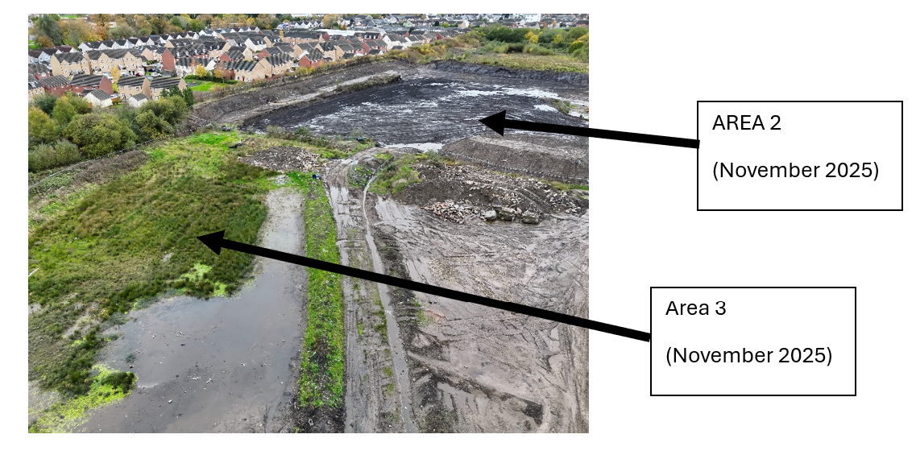
We have concerns with the potential mobilisation of the knotweed from this area, and potential surface water discharges off site.
The site plans provided do not identify these areas, nor is the management of this included in the applications EMS. We would therefore request detailed information outlining the proposed management measures.
The locations of the Japanese knotweed should be added to the site plans, and the EMS updated with proposals to manage it.

- We also believe the historic Japanese Knotweed is buried in “Area 2” as shown on Figure 4: Processing Areas.
This must be investigated, and the results of the investigation, and how it will be managed while complying with relevant legislation must be included in the application EMS.
Historic buried knotweed is considered a waste, so relevant permissions must also be sought.
The locations of the buried Japanese knotweed should be added to the site plans, and the EMS updated with proposals to manage it.

