PAN-030957 My Map Report:
Application maps
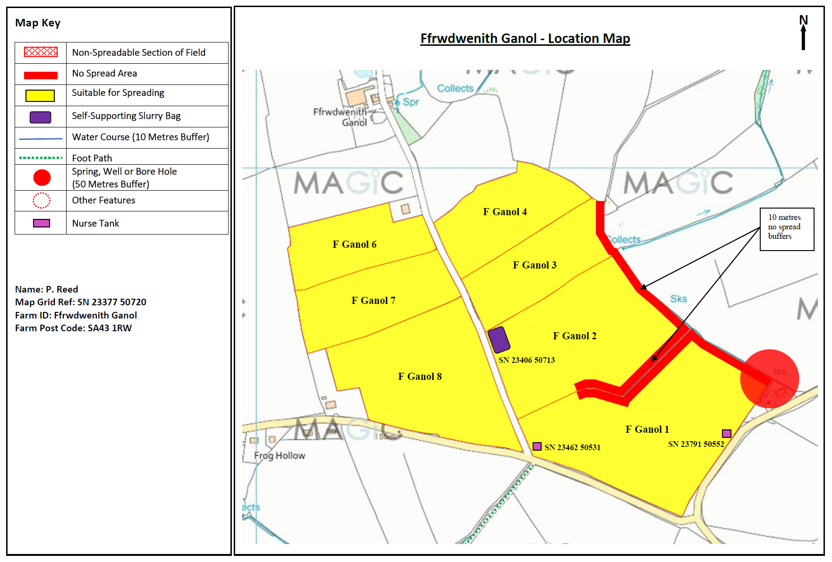
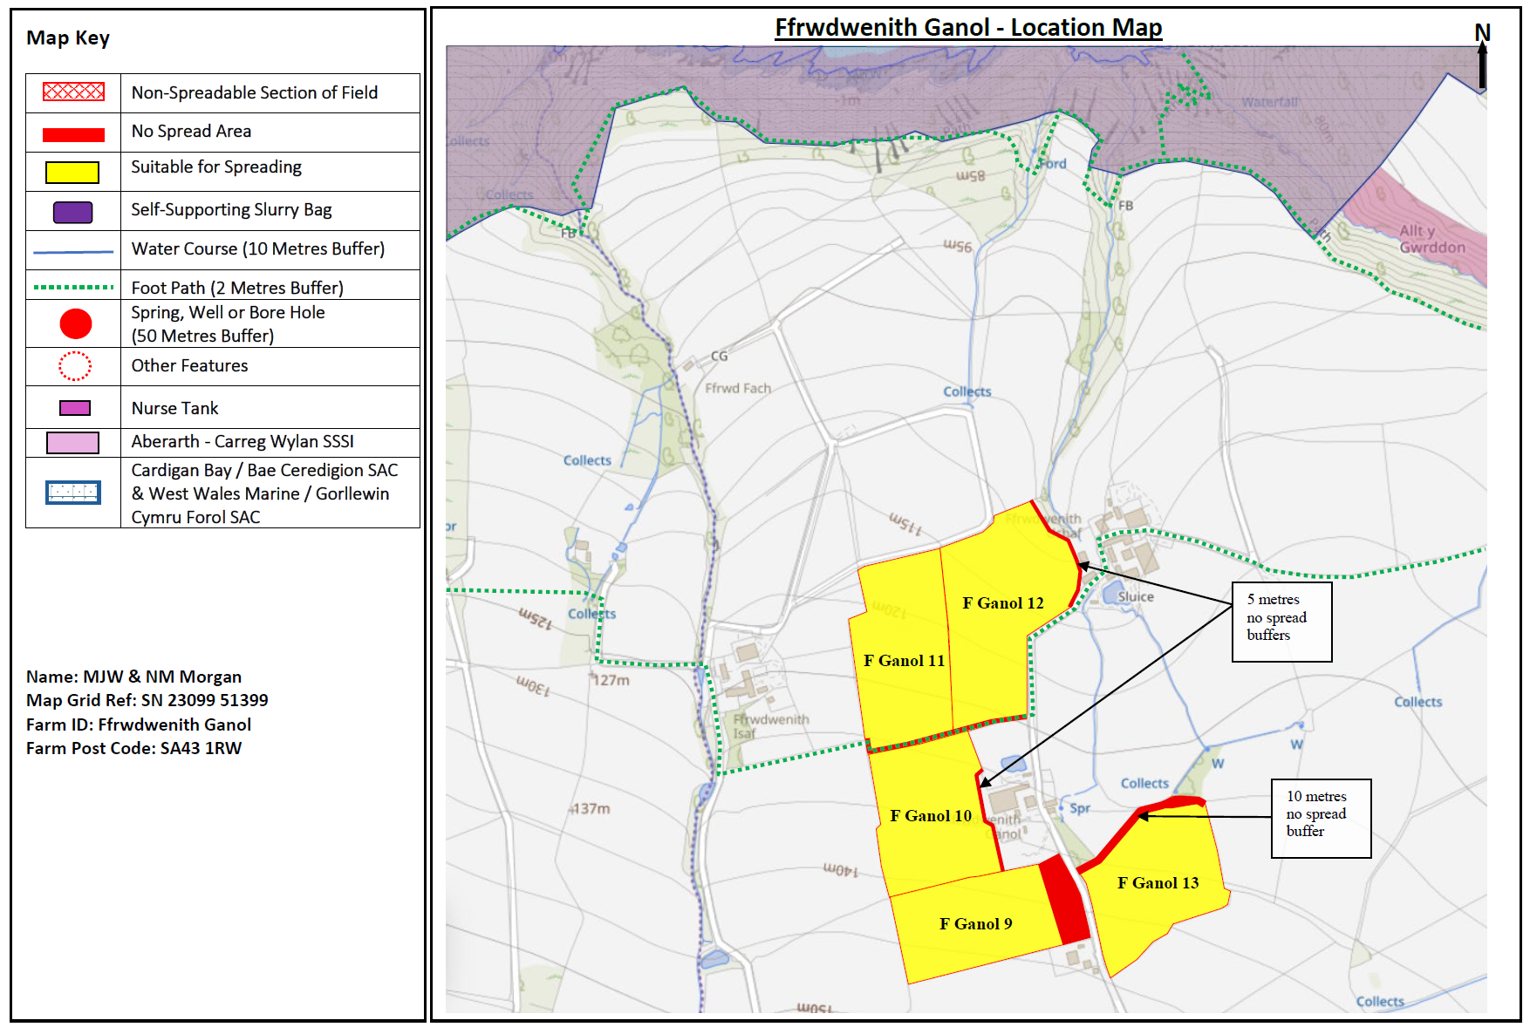
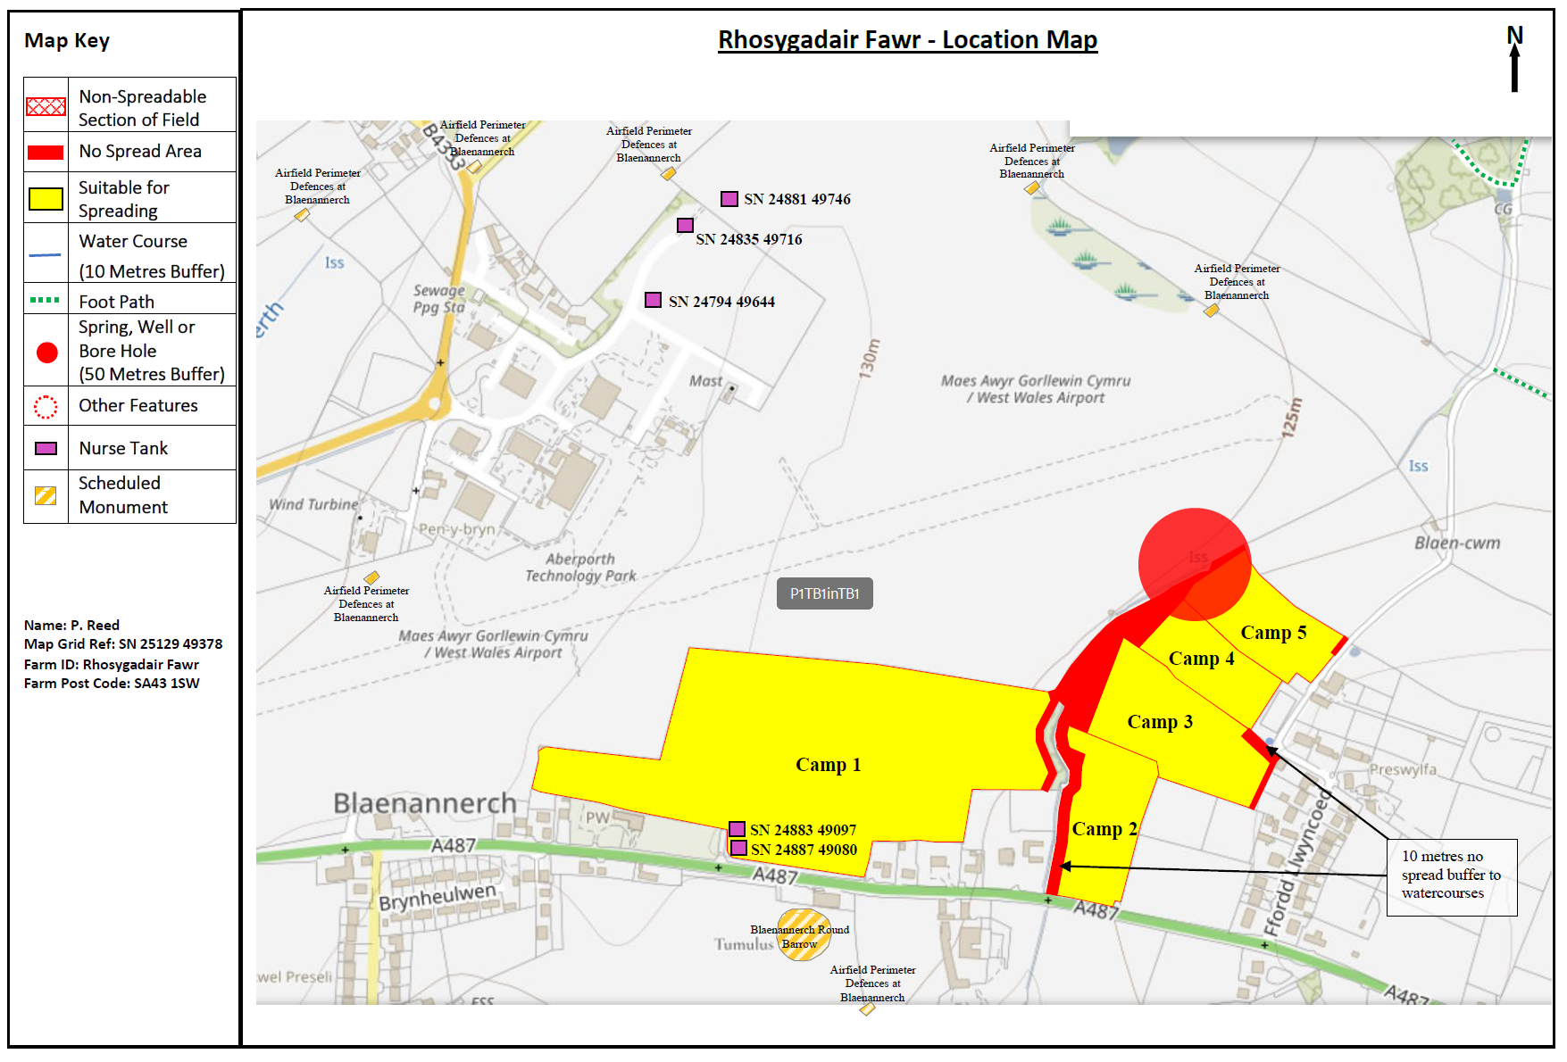
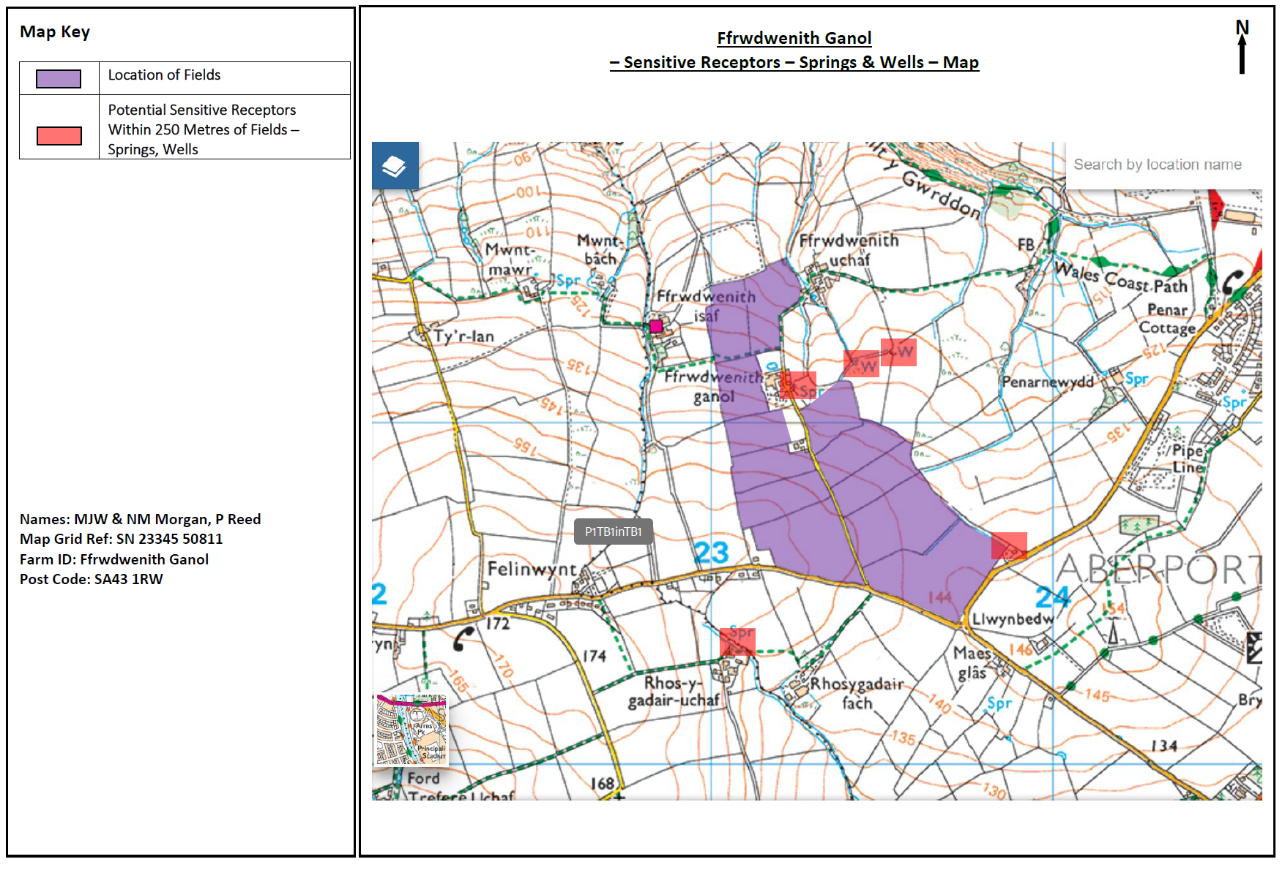
Deployment Boundaries and storage
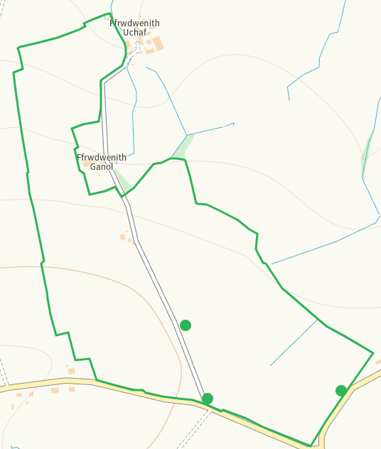
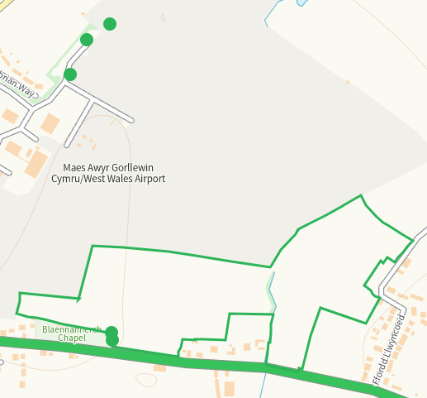

Detailed river network 10m
Watercourses NE boundary of F Ganol 12, N of F Ganol 13, NE of F Ganol 2 and NE of and within F Ganol 1, buffers in place.
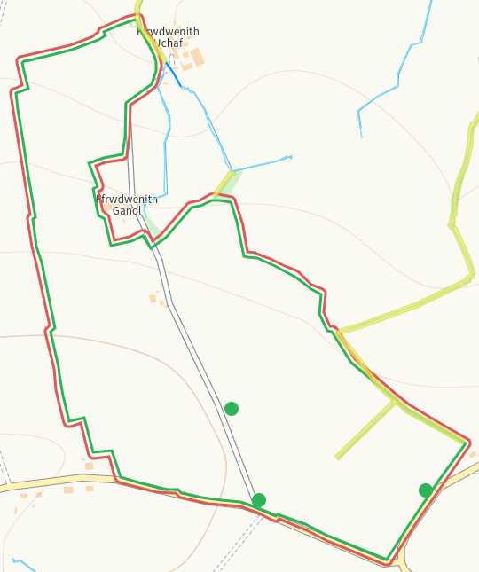
Watercourse NW of Camp 3-5, between Camp 1&2, buffers in place.
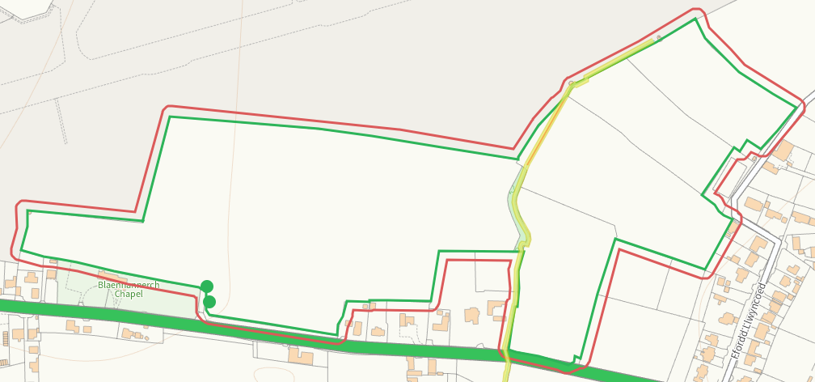
Groundwater source protection zones
none
Any well, spring (or issue) or borehole used for the supply of water for human consumption including from a private water supply or supplies within 50m.
Issue at the E boundary of F Ganol 1, on aaplication map with buffer
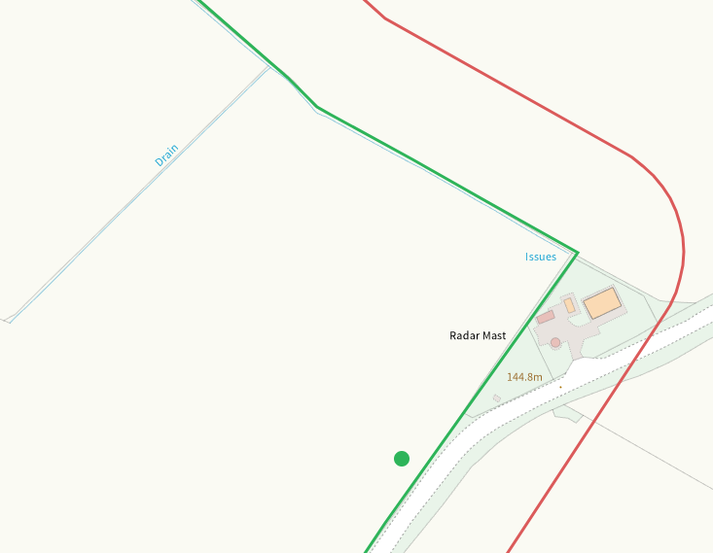
Issue N of Camp 5, on application map with buffer
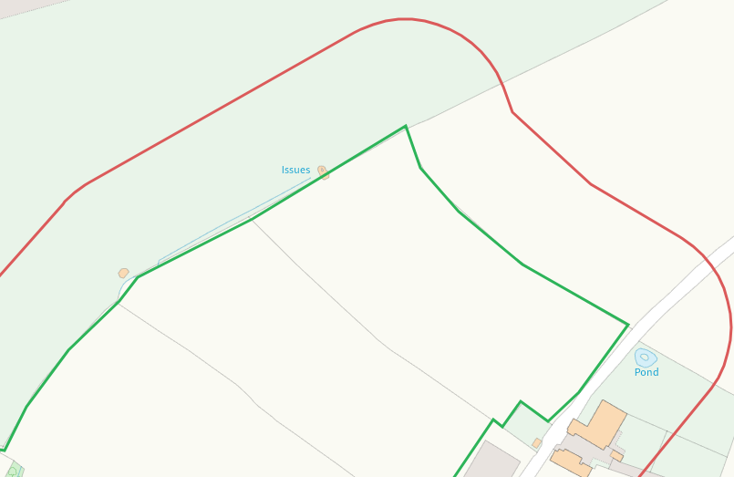
None at other fields or storage
Any well, spring (or issue) or borehole used for the supply of water for human consumption including from a private water supply or supplies within 250m.
Spring E of F Ganol 10, 2xWells NE of F Ganol 13, on application map
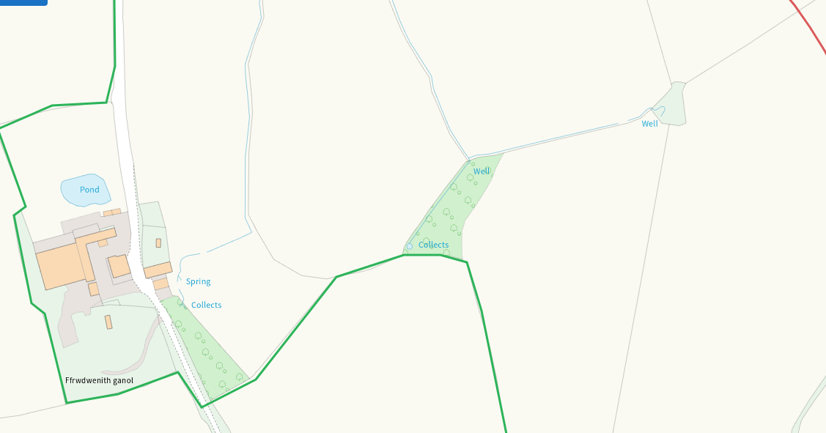
Issue NE of Camp 5, on application map
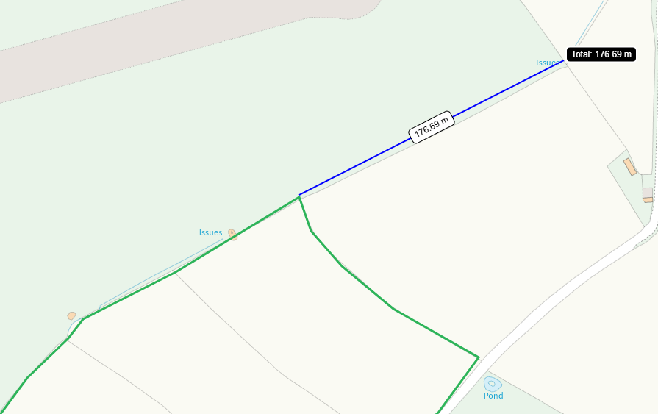
None at other fields or storage
Within Groundwater Safeguard Zone
None
European designated sites- Natura 2000 (SPA, pSPA, SAC or cSAC) or Ramsar- or SSSI within 500m

SSSI Aberarth - Carreg Wylan
SAC Cardigan Bay / Bae Ceredigion
Both within 500m N of F Ganol 12, shown on application map and mitigated in SSRA
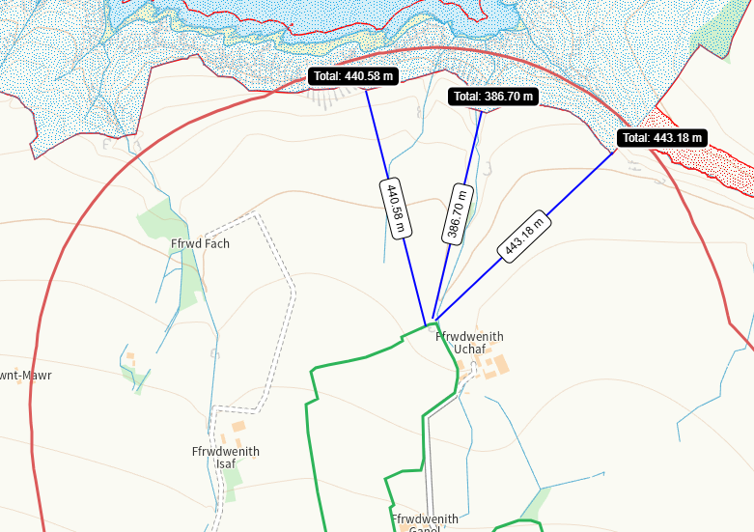
None at other fields or storage
Other protected sites within 500m:
- Protected Species-
Several within range of F Ganol fields. Nil risk from the activity.
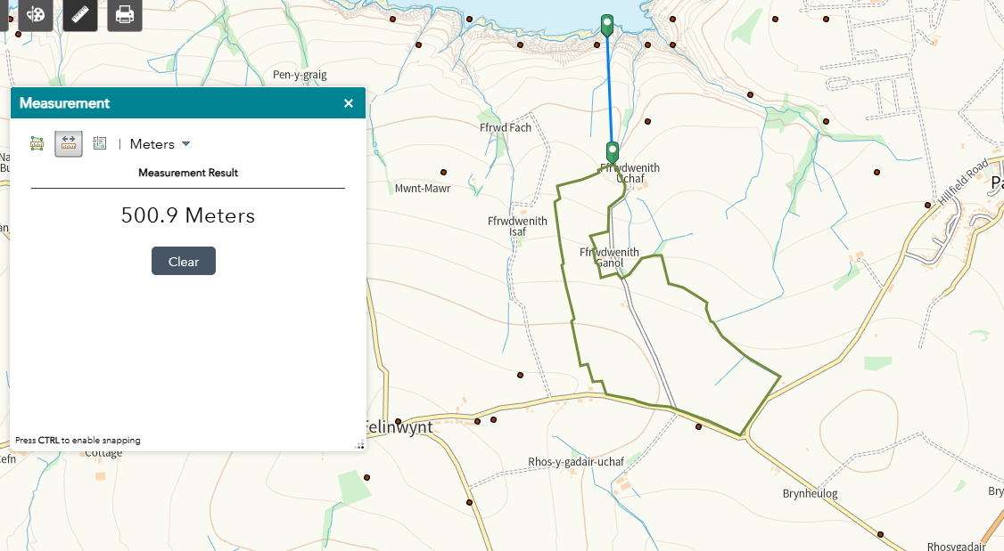

Small number recorded in range of Camp feilds. Nil risk from the activity.
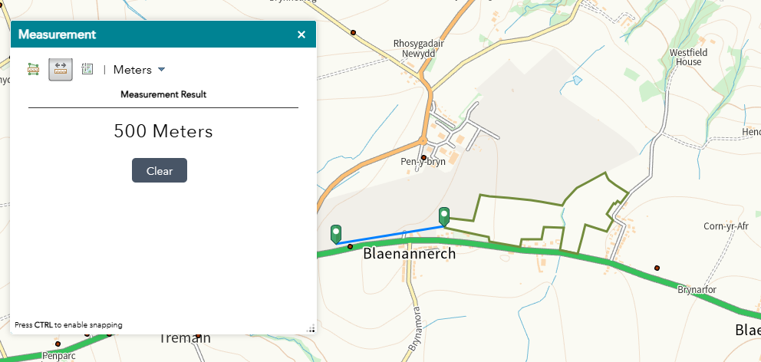
- Protected Habitats-

Purple moor grass and rush pastures and Lowland dry acid grassland and Lowland calcareous grassland within range of F Ganol feilds

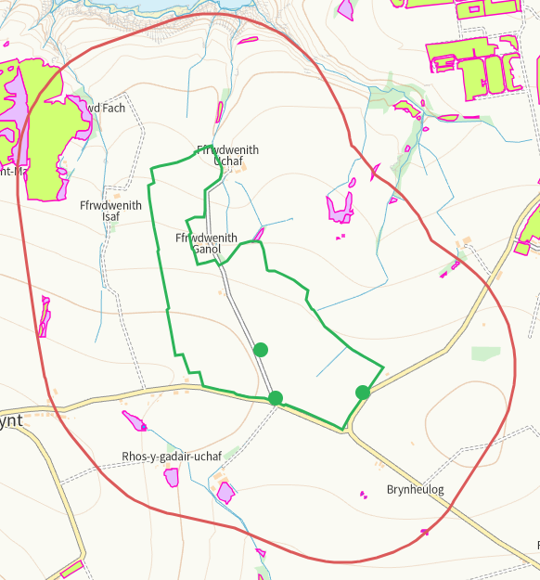

Lowland dry acid grassland and Lowland calcareous grassland E of Camp 3
Lowland dry acid grassland and Lowland calcareous grassland adjacent S of Camp 1, aerial image shows this to be a graveyard
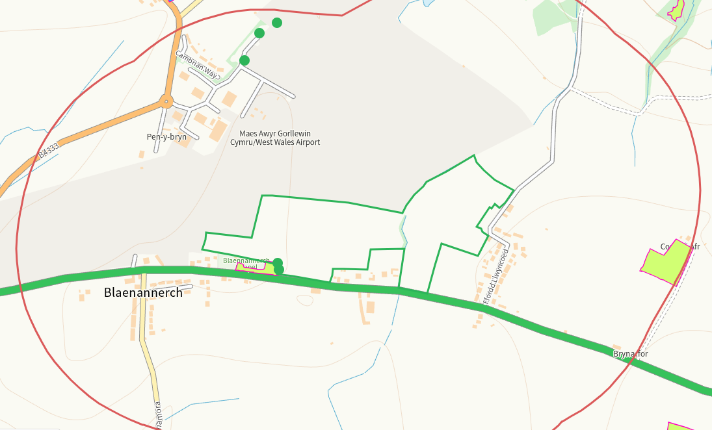
- Scheduled Ancient Monument-
Blaenannerch Round Barrow S of Camp 1 and several Airfield Perimeter Defences at Blaenannerch within range of Camp fields, on application map
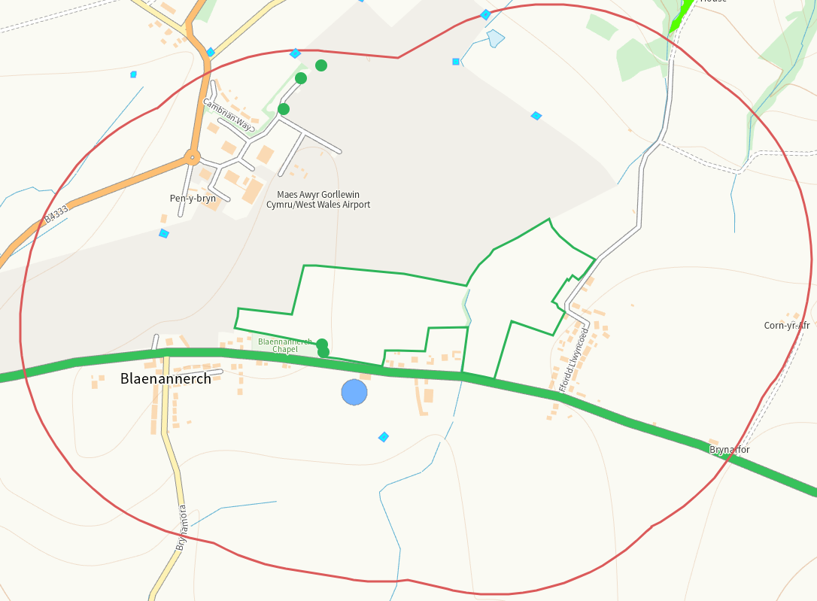

Several Airfield Perimeter Defences at Blaenannerch

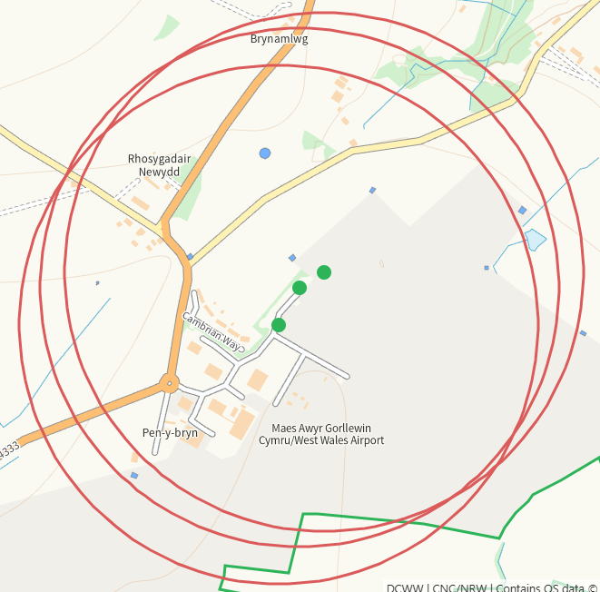

- Local Nature Reserve- none
- National Nature Reserve- none
- Ancient Woodlands- none
- Local Wildlife Sites (SINC)- none
- National Park- none
- Nitrate Vulnerable Zone (NVZ)- ALL Wales
- Groundwater Safeguard Zone- none

Flood risk
Medium to high risk at Camp 2&3, area buffered on application map
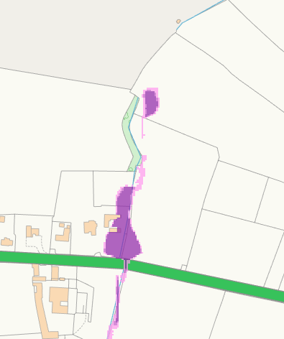
None at other feilds
Public rights of way
Footpath S of F Ganol 11 and 12, shown on application map with buffer
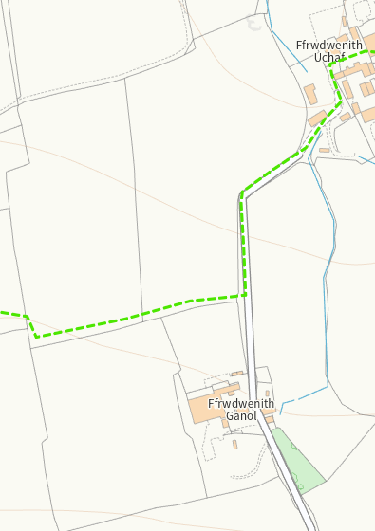
None at other feilds
Distance from Main Farm Address
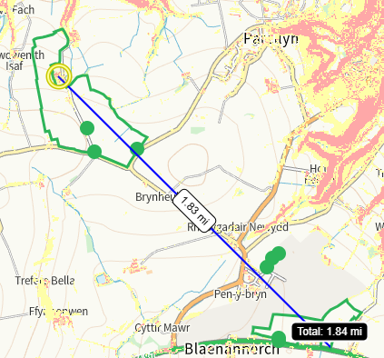
Slope Map
All fields 0-7
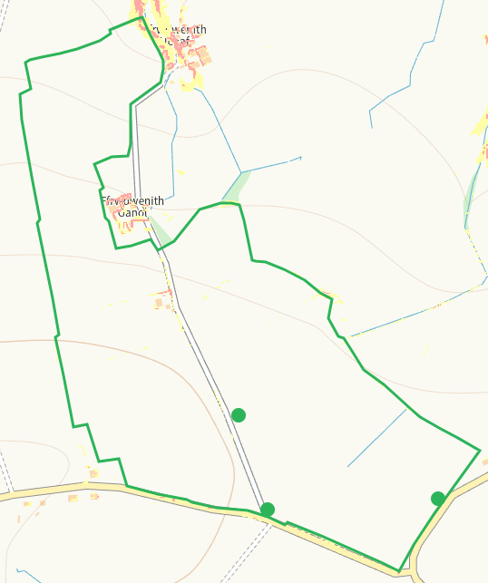
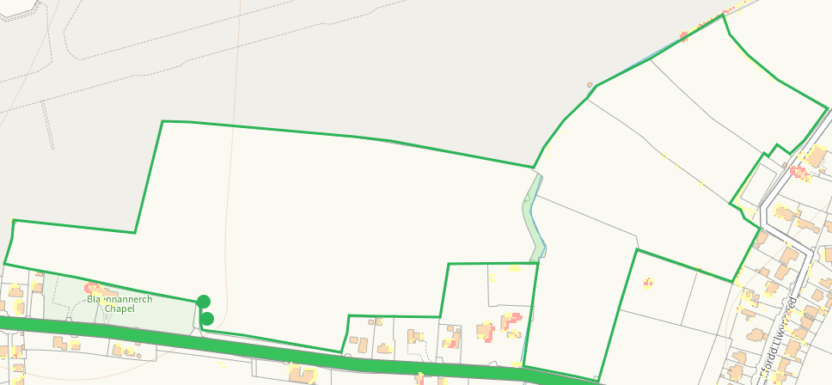

END

