Notice of variation and consolidation with introductory note
The Environmental Permitting (England & Wales) Regulations 2016

A&C Aggregates Limited

Carew Quarry
Carew
Cheriton
Tenby
Pembrokeshire
SA68 0TP

Variation application number
PAN-026220

Permit number

BP0236901

Carew Quarry

Permit number BP0236901

Introductory note

This introductory note does not form a part of the notice.

The following notice gives notice of the variation and consolidation of an environmental permit.

This variation permits an additional new direct discharge point to Mill Pond lagoon from Carew Quarry of surface water consisting of mineral extraction dewatering and rainfall related site run off. The combined total volume discharged from the quarry via the groundwater discharge (activity reference A1) and the surface water discharge (activity reference A2) shall not exceed 10,000 cubic meters per day.

The new discharge point is in addition to the existing permitted groundwater discharge via soakaway, that has connectivity to a natural adit which emerges in Mill Pond lagoon. The new surface water discharge point will be controlled and operated in accordance with the agreed operational technique cited in Table S1.1 and Table S1.2 of this permit.

Abstraction of waters associated with this activity is controlled via the Water Resources consent WA/061/0006/0023.

The schedules specify the changes made to the permit.

The status log of a permit sets out the permitting history, including any changes to the permit reference number. It is not backdated before 6 April 2010.

Status log of the permit
Description | Date | Comments
Regulator initiated variation determined BP0236901/V001 | 26/11/2011 | EPR and GWDD update
Transfer notification  PAN-023350 | Duly made  26/09/2023 | Application to transfer the permit in full to A&C Aggregates Limited.
Transfer determined  BP0236901/T002 | 29/09/2023 | Full transfer of permit complete.
Application PAN-026220 | Duly made  06/08/2024 | Application to include additional discharge point to surface water and update the permit to modern conditions.
Additional information received | 15/09/2025 | Schedule 5 response: provision of shadow HRA
Variation determined BP0236901 | 12/12/2025 | Varied and consolidated permit issued in modern condition format.

End of introductory note

Notice of variation and consolidation
The Environmental Permitting (England and Wales) Regulations 2016

The Natural Resources Body for Wales (“Natural Resources Wales”) in exercise of its powers under regulation 20 of the Environmental Permitting (England and Wales) Regulations 2016 varies and consolidates

permit number

BP0236901

issued to:

A&C Aggregates Limited (“the operator”)

whose registered office is

Rowlands View

Templeton

Narberth

Pembrokeshire

SA67 8RG

company registration number 04620255

to operate a regulated facility at

Carew Quarry

Carew

Cheriton

Tenby

Pembrokeshire

SA68 0TP

to the extent set out in the schedules.

The notice shall take effect from 12/12/2025

Name | Date
Katrin Raynor | 12/12/2025

Authorised on behalf of Natural Resources Wales

Schedule 1
All conditions have been varied by the consolidated permit as a result of the application made by the operator.

Schedule 2 – consolidated permit

Consolidated permit issued as a separate document.

Permit
The Environmental Permitting (England and Wales) Regulations 2016

Permit number

BP0236901

This is the consolidated permit referred to in the variation and consolidation notice for application PAN-026220 authorising,

A&C Aggregates Limited (“the operator”),

whose registered office is

Rowlands View

Templeton

Narberth

Pembrokeshire

SA67 8RG

company registration number 04620255

to operate a groundwater activity at

Carew Quarry

Carew

Cheriton

Tenby

Pembrokeshire

SA68 0TP

to the extent authorised by and subject to the conditions of this permit.

The permit variation and consolidation shall take effect from 12/12/2025

Name | Date
Katrin Raynor | 12/12/2025

Authorised on behalf of Natural Resources Wales

Conditions
- Management
  - General management
    - The operator shall manage and operate the activities A1 and A2:
      - in accordance with a written management system that identifies and minimises risks of pollution so far as is reasonably practicable, including those risks arising from operations, maintenance, accidents, incidents, non-conformances and those drawn to the attention of the operator as a result of complaints; and
      - using sufficient competent persons and resources.
    - Records demonstrating compliance with condition 1.1.1 shall be maintained.
    - Any person having duties that are or may be affected by the matters set out in this permit shall have convenient access to a copy of the permit.
- Operations
  - Permitted activities
    - The only activities authorised by the permit are the activities specified in schedule 1 table S1.1.
  - The site
    - The discharge activities shall take place at the discharge points marked on the site plans at schedule 7 to this permit, and as listed in table S3.2; and, the operating techniques that are the subject of conditions prefixed by 2.3 shall be applied at the locations shown, or otherwise described, in schedule 7.
  - Operating techniques
    - For the activities A1 and A2 referenced in schedule 1, table S1.1 the activities shall, subject to the conditions of this permit, be operated using the techniques and in the manner described in the documentation specified in schedule 1, table S1.2, unless otherwise agreed in writing by Natural Resources Wales.
    - If notified by Natural Resources Wales that the activities are giving rise to pollution, the operator shall submit to Natural Resources Wales for approval within the period specified, a revision of any plan or other documentation (“plan”) specified in schedule 1, table S1.2 which identifies and minimises the risks of pollution relevant to that plan , and shall implement the approved revised plan in place of the original from the date of approval, unless otherwise agreed in writing by Natural Resources Wales.
.
- Emissions and monitoring
  - Emissions to water or land
    - The limits given in schedule 3 table S3.1 shall not be exceeded.

  - Emissions of substances not controlled by emission limits
    - For the activities A1 referenced in schedule 1, table S1.1 the operator shall take appropriate measures as far as is reasonably practicable:
      - to prevent the input of hazardous substances to groundwater; and
      - where a non-hazardous pollutant is not controlled by an emission limit, to limit the input of such non-hazardous pollutants to groundwater so as to ensure that inputs do not cause pollution of groundwater.
    - Emissions of substances not controlled by emission limits (excluding odour) shall not cause pollution. The operator shall not be taken to have breached this condition if appropriate measures, including, but not limited to, those specified in any approved emissions management plan, have been taken to prevent or where that is not practicable, to minimise, those emissions.
  - Monitoring
    - The operator shall, unless otherwise agreed in writing by Natural Resources Wales, undertake the monitoring specified in the following tables in schedule 3 to this permit:
      - point source emissions specified in tables S3.1 and S3.3;
    - The operator shall maintain records of all monitoring required by this permit.
    - Monitoring equipment, techniques, personnel and organisations employed for the emissions monitoring programme and the environmental or other monitoring specified in condition 3.3.1 shall have either MCERTS certification or MCERTS accreditation (as appropriate), where available, unless otherwise agreed in writing by Natural Resources Wales.
    - Accessible monitoring points shall be provided and maintained to enable the emissions monitoring programme to be carried out at the monitoring points specified in table S3.3 and S3.4 of schedule 3 and shown marked on the site plans in schedule 7.
- Information
  - Records
    - All records required to be made by schedule 3, 4 and 5 to this permit shall:
      - be legible;
      - be made as soon as reasonably practicable;
      - if amended, be amended in such a way that the original and any subsequent amendments remain legible, or are capable of retrieval; and
      - be retained, unless otherwise agreed in writing by Natural Resources Wales, for at least 6 years from the date when the records were made.
    - The operator shall maintain convenient access, in either electronic or hard copy, to the records, plan and management system required to be maintained by this permit.
  - Reporting
    - The operator shall send all reports and notifications required by the permit to Natural Resources Wales using the contact details supplied in writing by Natural Resources Wales.
    - Within the time period after the end of the reporting period specified in schedule 4 table S4.1 the operator shall, unless otherwise agreed in writing by Natural Resources Wales, submit reports of the monitoring and assessment carried out in accordance with the conditions of this permit, as follows:
      - in respect of the parameters and monitoring points specified in schedule 4 table S4.1;
      - [for the reporting periods specified in schedule 4 table S4.1 and] using the forms specified in schedule 4 table S4.2; and
      - giving the information from such results and assessments as may be required by the forms specified in those tables.

  - Notifications
    - Natural Resources Wales shall be notified as soon as reasonably practicable following detection, within the site of the regulated facility of:
      - any malfunction, breakdown or failure of equipment or techniques, accident, or emission of a substance not controlled by an emission limit which has caused, is causing or may cause significant pollution; and
      - any breach of a limit specified in schedule 3 table S3.1.
Any other significant adverse environmental effects, which may have been caused by the activity, shall also be notified to Natural Resources Wales as soon as reasonably practicable following detection.
    - The information provided under condition 4.3.1 shall be supported by sending the information listed in schedule 5 to this permit within the time period specified in that schedule.
    - Where Natural Resources Wales has requested in writing that it shall be notified when the operator is to undertake monitoring and/or spot sampling, the operator shall inform Natural Resources Wales when the relevant monitoring and/or spot sampling is to take place. The operator shall provide this information to Natural Resources Wales at least 14 days before the date the monitoring is to be undertaken.
    - Natural Resources Wales shall be notified within 14 days of the occurrence of the following matters, except where such disclosure is prohibited by Stock Exchange rules:
Where the operator is a registered company:
      - any change in the operator’s trading name, registered name or registered office address; and
      - any steps taken with a view to the operator going into administration, entering into a company voluntary arrangement or being wound up.
Where the operator is a corporate body other than a registered company:
      - any change in the operator’s name or address; and
      - any steps taken with a view to the dissolution of the operator.
    - Where the operator proposes to make a change in the nature of the activity by increasing the concentration of, or the addition of, or allowing the introduction of, a substance to the activity to an extent that the operator considers could have a significant adverse environmental effect on the receiving waters, and the change is not permitted by emission limits specified within schedule 3 table S3.1 or the subject of an application for approval under the EP Regulations or under the terms of this permit:
      - Natural Resources Wales shall be notified in writing at least 14 days before the increase or addition or allowing the introduction; and
      - the notification shall contain a description of the proposed change.
  - Interpretation
    - In this permit the expressions listed in schedule 6 shall have the meaning given in that schedule.
    - In this permit references to reports and notifications mean written reports and notifications, except where reference is made to notification being made “as soon as reasonably practicable”, in which case it may be provided by telephone.

Schedule 1 – Operations

Table S1.1 Activities
Activity reference | Description of activity | Limits of specified activity
A1 | Groundwater activity: discharge to ground of trade effluent consisting of mineral extraction dewatering and rainfall related site run off. | Via a soakaway system centred on NGR SN 04595 04048 that is hydraulically linked to a natural adit connected to Mill Pond lagoon.  The combined total volume discharged from activity A1 and A2 shall not exceed 10,000 cubic meters per day.
A2 | Surface water activity: overflow discharge to surface water consisting of mineral extraction dewatering and rainfall related site run off. | The overflow discharge direct to Mill Pond Lagoon surface water at NGR SN 04582 03925 shall only occur when conditions set out in the operating technique specified in Table S1.2 have been met.  The combined total volume discharged from activity A1 and A2 shall not exceed 10,000 cubic meters per day.

Table S1.2 Operating techniques
Activity reference | Description of documentation | Parts | Date Received
A1 | Crew Quarry Schedule 5 Response A & C shadow HRA | Appendix B - Operating Techniques | 15/09/2025
A2 | Crew Quarry Schedule 5 Response A & C shadow HRA | Appendix B - Operating Techniques | 15/09/2025

Schedule 2 – Waste types, raw materials and fuels

Schedule 2 not in use.

Schedule 3 – Emissions and monitoring

Table S3.1 Point Source emissions to water (other than sewer) and land – emission limits and monitoring requirements
Activity reference | Effluent(s) and discharge point(s) | Parameter | Limit (including unit) | Reference Period | Limit of effective range | Monitoring frequency | Compliance Statistic
A1 | Trade discharge to ground of trade effluent consisting of mineral extraction dewatering and rainfall related site run off via Outlet 1 | Maximum daily discharge volume | See condition 2.3 and table S1.1 | Total daily volume | N/A | Continuous | Maximum
A1 |  | Maximum rate of discharge | 115 litres per second | Instantaneous (spot sample) | N/A | Continuous | Maximum
A1 |  | 15-minute instantaneous or averaged flow | No limit set. Record as l/s | 15 minute | N/A | Continuous | N/A
A1 |  | Suspended solids (measured after drying at 105ºC) | 50 mg/l | Instantaneous (spot sample) | N/A | N/A | Maximum
A1 |  | pH | 6 to 9 | Instantaneous (spot sample) | N/A | N/A | Minimum and maximum
A1 |  | Visible oil or grease | No significant trace present | Instantaneous (spot sample) | N/A | N/A | No significant trace
A2 | Trade discharge: overflow discharge to surface water consisting of mineral extraction dewatering and rainfall related site run off. | Maximum daily discharge volume | See condition 2.3 and table S1.1 | Total daily volume | N/A | Continuous | Maximum
A2 |  | Maximum rate of discharge | 115 litres per second | Instantaneous (spot sample) | N/A | Continuous | Maximum
A2 |  | 15-minute instantaneous or averaged flow | No limit set. Record as l/s | 15 minute | N/A | Continuous | N/A
A2 |  | Suspended solids (measured after drying at 105ºC) | 50 mg/l | Instantaneous (spot sample) | N/A | N/A | Maximum
A2 |  | pH | 6 to 9 | Instantaneous (spot sample) | N/A | N/A | Minimum and maximum
A2 |  | Visible oil or grease | No significant trace present | Instantaneous (spot sample) | N/A | N/A | No significant trace

Table S3.2 Discharge points
Activity reference | Effluent Name | Discharge Point | Discharge point NGR | Receiving water/Environment
A1 | Trade discharge to ground of trade effluent consisting of mineral extraction dewatering and rainfall related site run off via Outlet 1 | Discharge point to sinkhole | SN 04595 04048 | Groundwater via soakaway to sinkhole
A2 | Trade discharge of overflow discharge to surface water consisting of mineral extraction dewatering and rainfall related site run off. | Outfall to Mill Pond | SN 04582 03925 | Mill Pond Lagoon

Table S3.3 Monitoring points
Activity reference | Effluent(s) and discharge point(s) | Monitoring type | Monitoring point NGR | Monitoring point reference
A1 | Trade discharge to ground of trade effluent consisting of mineral extraction dewatering and rainfall related site run off via Outlet 1 | Effluent sampling | SN 04586 04101 | Sample point
A2 | Trade discharge of overflow discharge to surface water consisting of mineral extraction dewatering and rainfall related site run off. | Effluent sampling | SN 04582 03925 | Outfall to Mill Pond

Schedule 4 – Reporting
Parameters, for which reports shall be made, in accordance with conditions of this permit, are listed below.
Table S4.1 Reporting of monitoring data
Activity reference | Parameter | Monitoring point reference | Reporting period | Period begins
A1 | Total daily volume | Flowmeter | Reports to be provided to Natural Resources Wales upon request | Upon request by Natural Resources Wales
A1 | 15-minute flow | Flowmeter | Reports to be provided to Natural Resources Wales upon request | Upon request by Natural Resources Wales
A2 | Total daily volume | Flowmeter | Reports to be provided to Natural Resources Wales upon request | Upon request by Natural Resources Wales
A2 | 15-minute flow | Flowmeter | Reports to be provided to Natural Resources Wales upon request | Upon request by Natural Resources Wales

Table S4.2 Reporting forms
Activity reference | Parameter | Reporting format
A1 | Total daily volume | electronic format specified by Natural Resources Wales
A1 | 15-minute flow | electronic format specified by Natural Resources Wales
A2 | Total daily volume | Format specified by Natural Resources Wales
A2 | 15-minute flow | Format specified by Natural Resources Wales

Schedule 5 – Notification
These pages outline the information that the operator must provide.
Units of measurement used in information supplied under Part A and B requirements shall be appropriate to the circumstances of the emission. Where appropriate, a comparison should be made of actual emissions and authorised emission limits.
If any information is considered commercially confidential, it should be separated from non-confidential information, supplied on a separate sheet and accompanied by an application for commercial confidentiality under the provisions of the EP Regulations.

Part A
Permit Number
Name of operator
Location of Facility
Time and date of the detection

(a) Notification requirements for any malfunction, breakdown or failure of equipment or techniques, accident, or emission of a substance not controlled by an emission limit which has caused, is causing or may cause significant pollution
To be notified within 24 hours of detection unless otherwise agreed in writing by Natural Resources.
Date and time of the event
Reference or description of the location of the event
Description of where any release into the environment took place
Substances(s) potentially released/type or nature of sewage released
Best estimate of the quantity or rate of release of substances and/or duration of discharge
Best estimate of the environmental impact of the discharge
Measures taken, or intended to be taken, to stop any emission
Description of the failure or accident.

(b) Notification requirements for the breach of a limit specified in schedule 3 table S3.1
The information specified below is to be notified to Natural Resources Wales as soon as reasonably practicable following detection.
Monitoring point reference/ source
Self monitoring regime (where relevant)
Type of failure
Date of sample/event
Parameter
Result and units
Limit and units

(c) Notification requirements for the detection of any significant adverse environmental effect
To be notified within 24 hours of detection
Description of where the effect on the environment was detected
Substances(s) detected
Concentrations of substances detected
Date of monitoring/sampling

Part B – to be submitted as soon as reasonably practicable unless otherwise agreed in writing by Natural Resources Wales
Any more accurate information on the matters for notification under Part A.
Measures taken, or intended to be taken, to prevent a recurrence of the incident/breach/exceedance
Measures taken, or intended to be taken, to rectify, limit or prevent any pollution of the environment which has been or may be caused by the emission

Name*
Post
Signature
Date
* authorised to sign on behalf of the operator

Schedule 6 – Interpretation
“accident” means an accident that may result in pollution.
"annually" means once every year.
“application” means the application for this permit, together with any additional information supplied by the operator as part of the application and any response to a notice served under Schedule 5 to the EP Regulations.
“appropriate measures” for the purposes of the emission of substances not controlled by emission limits condition (condition 3.2.1) do not require the operator to undertake treatment to a level beyond that specified in schedule 1 table S1.1, or to carry out routine monitoring for substances not controlled by emission limits.
“emissions of substances not controlled by emission limits” means emissions of substances to air, water or land from the permitted activities, which are not controlled by an emission limit.
“emissions to land” includes emissions to groundwater.
“EP Regulations” means The Environmental Permitting (England and Wales) Regulations SI 2016 No.1154 and words and expressions used in this permit which are also used in the Regulations have the same meanings as in those Regulations.
“groundwater” means all water, which is below the surface of the ground in the saturation zone and in direct contact with the ground or subsoil.
“MCERTS” means Environment Agency’s Monitoring Certification Scheme.
“Natural Resources Wales” means the Natural Resources Body for Wales established by article 3 of the Natural Resources Body for Wales (Establishment) Order 2012. The Natural Resources Body for Wales (Functions) Order 2013 transferred the relevant functions of the Countryside Council for Wales, and functions of the Environment Agency and the Forestry Commission in Wales to the Natural Resources Body for Wales.
"quarter" means a calendar year quarter commencing on 1 January, 1 April, 1 July or 1 October.
“Significant pollution” means a high level impact incident as indicated by NRW incident classification system.
“year” means calendar year ending 31 December.

Schedule 7 – Site plans
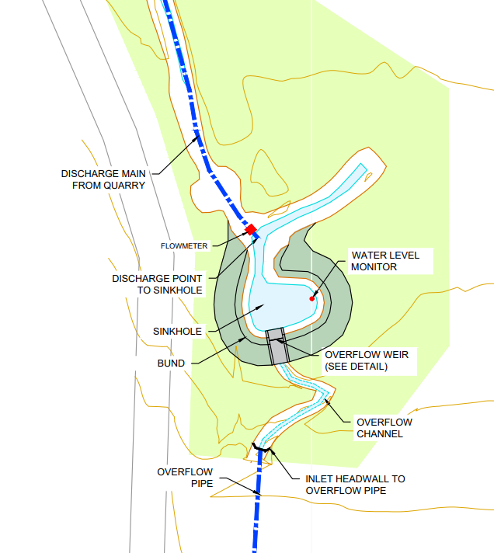

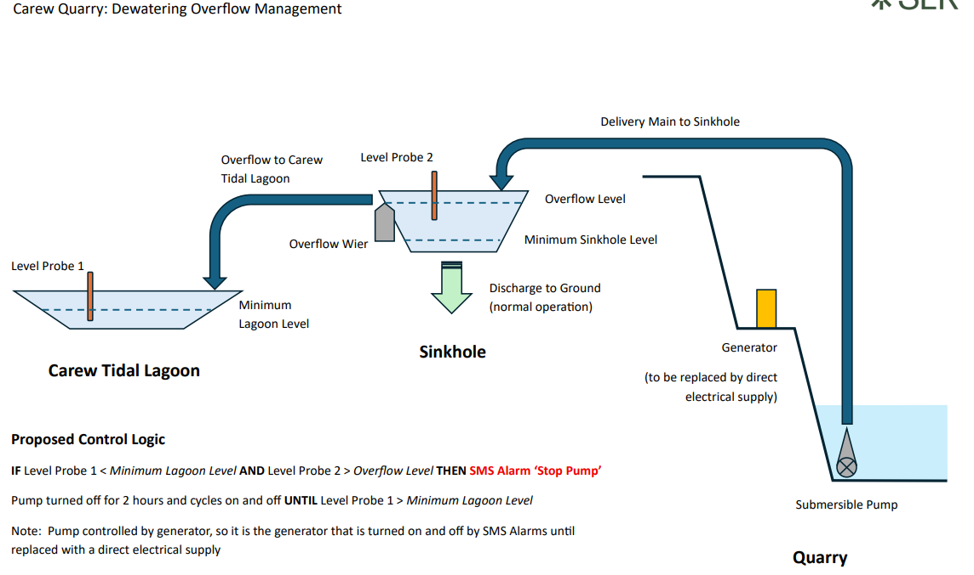

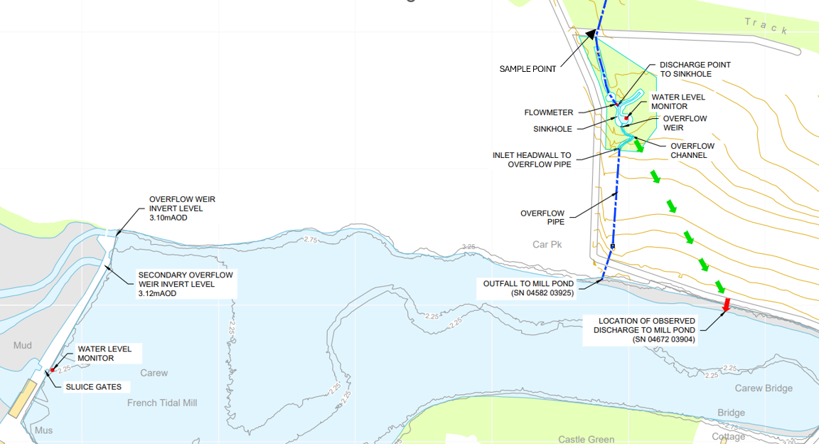

© Crown Copyright and database right 2025. Ordnance Survey licence number 100019741.

END OF PERMIT

