PAN-030780 My Map Report:

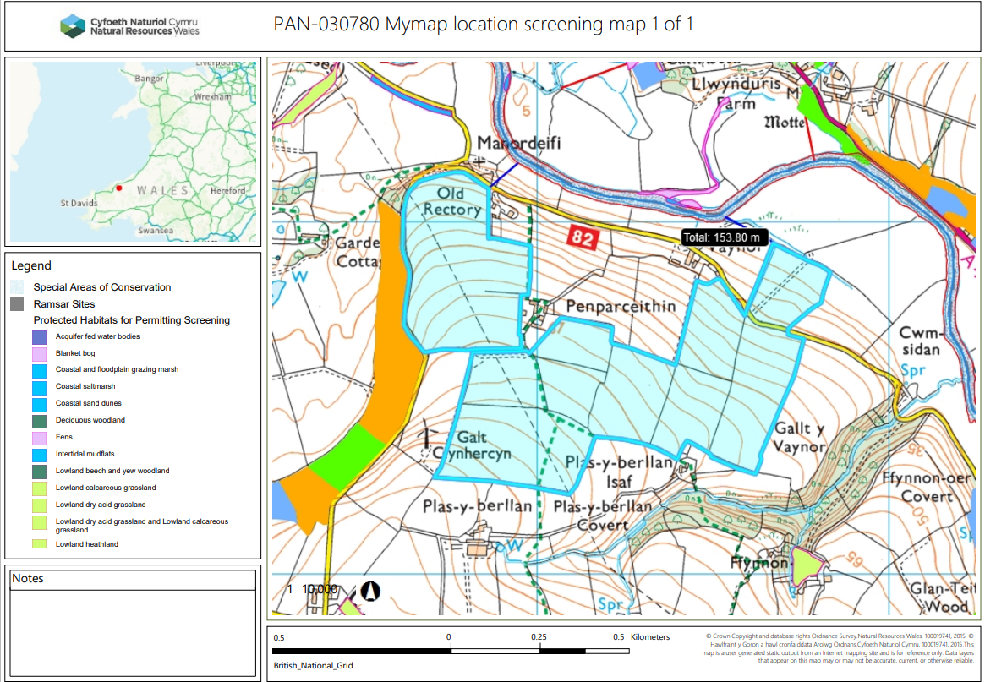

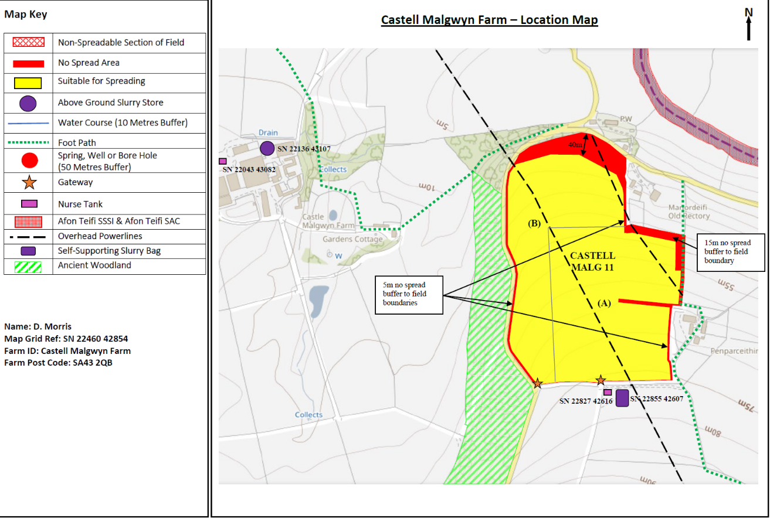
Submitted maps:
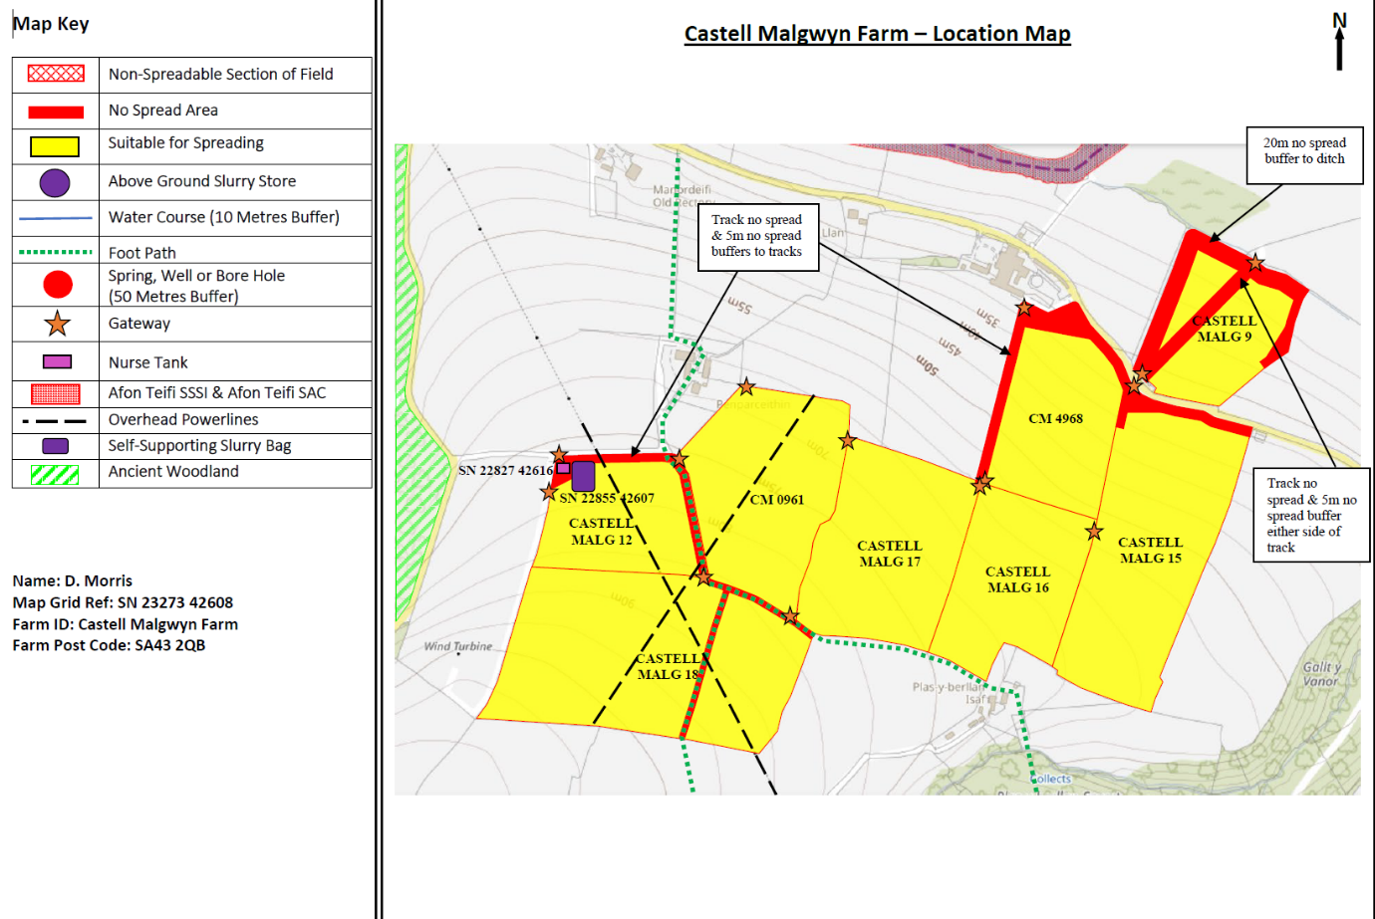

Detailed river network:
Field Malg 9 borders a water course that is hydrologically connected to the Afon Teifi over a distance of 170 meters. There is a 20 meter no spread buffer zone in place to prevent nutrients and/or PTES from entering the water course.
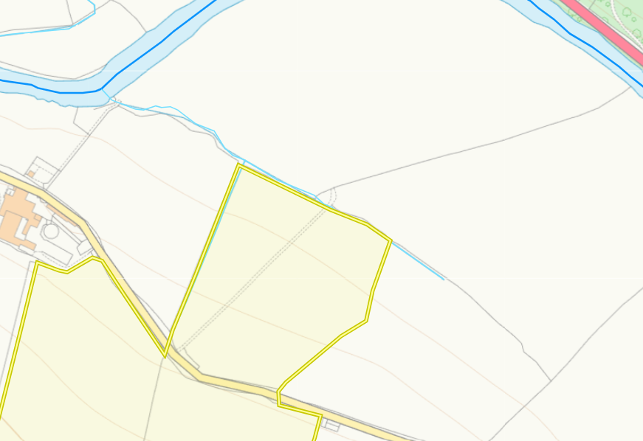
Groundwater protection zones (source) None in range.

Wells, springs or boreholes used for the supply of water for human consumption including from a private water supply or supplies
None in range.

any springs wells or boreholes not used to supply water for domestic or food production purposes within 50m None in range.

None in range.

European designated sites- Natura 2000 (SPA, pSPA, SAC or cSAC) or Ramsar- or SSSI within 500m
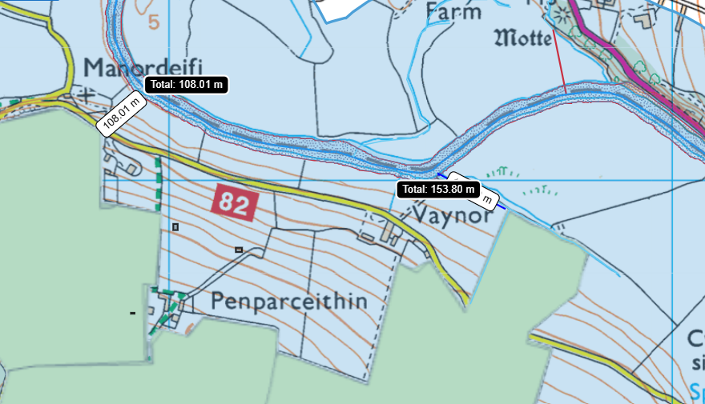
Field Malg 11 is the closest field to the River Teifi SSSI and SAC located 108 meters from the designated sites. There is a 40 meter buffer zone in place where the fields closest point is to the SSSI and SAC to prevent nutrients and/or PTES from entering the water course.

Malg 9 borders a water course that is hydrologically connected to the Afon Teifi over a distance of 170 meters.

Other protected sites:
- Protected Species- None in range.

- Protected Habitats- None in range.

- Scheduled Ancient Monument- None in range.

- Local Nature Reserve- None in range.

- National Nature Reserve- None in range

- Public rights of ways – mapped correctly

- Ancient Woodlands-
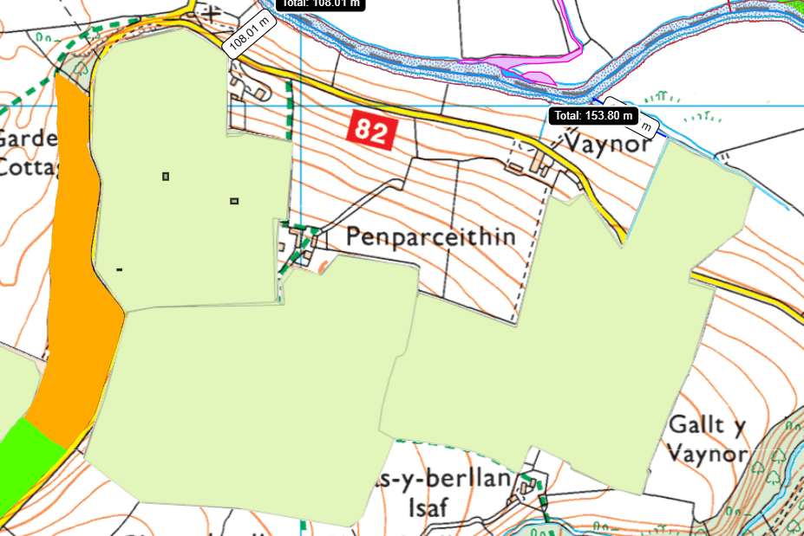
Field Malg 11 & Malg 12 borders ancient woodland site: Restored Ancient Woodland Site. There is a 5 meter no spread buffer zone along the field boundary and the ancient woodlands to prevent nutrients and/or PTES from entering the site.

- Local Wildlife Sites (SINC)- None in range.

- National Park- None in range

- Groundwater Safeguard Zone- None in range.

- Hedges- Nothing of concern.

- Ditches- see slope map below.

- Local residents, Housing, schools, Workplaces, Recreational facilities

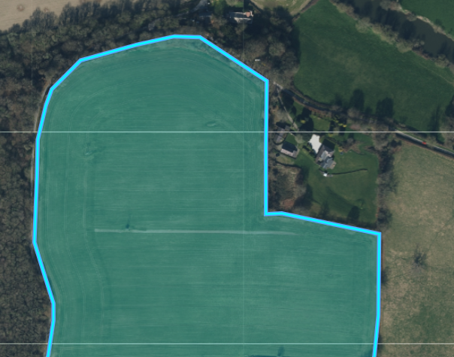
Field Malg 11 borders a residential property to where odorous wastes are being spread. The submitted OMP has correctly identified this as a nearby sensitive receptor.

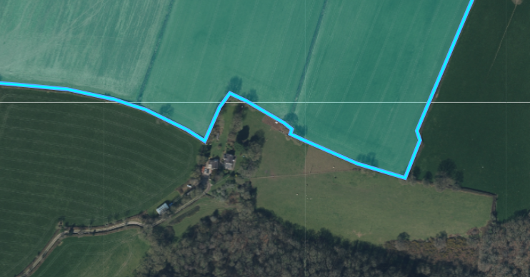

Field Malg 16 borders a residential property to where odorous wastes are being spread. The submitted OMP has correctly identified this as a nearby sensitive receptor.

Flood maps
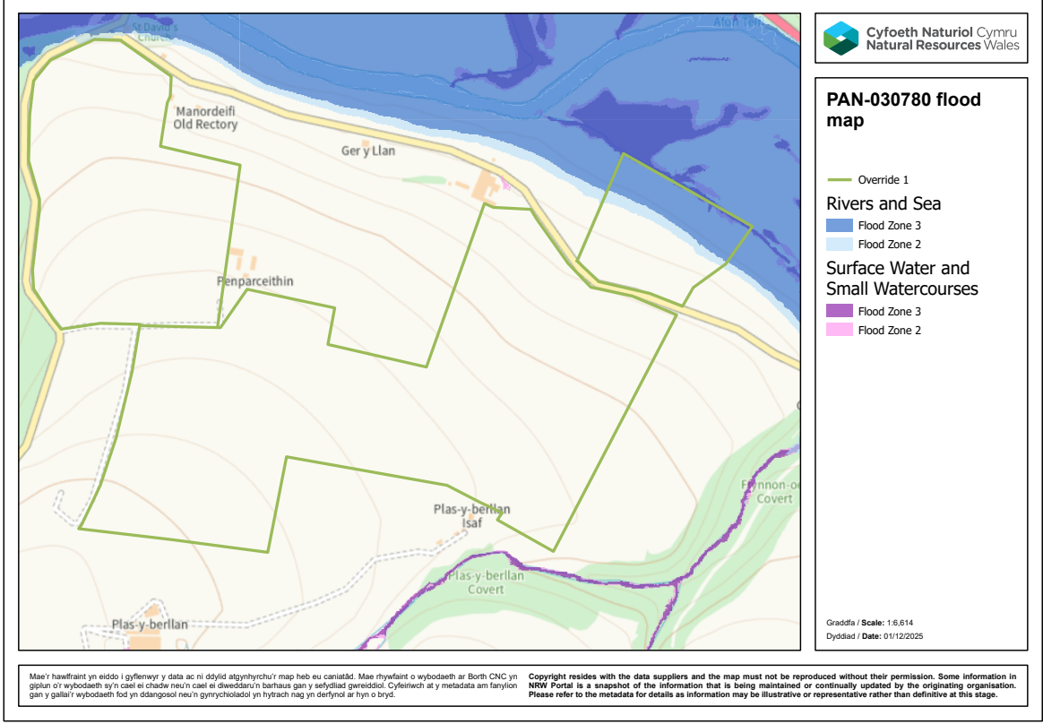
Field Malg 9 encroaches on a flood plain from the River Teifi SAC/SSSI. There is a 20 meter no spread buffer zone that largely removes this area of high risk flooding.

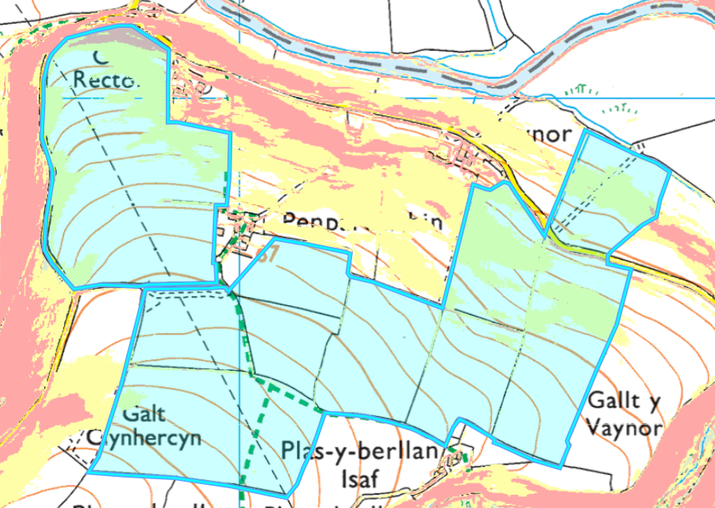
Slope Map
Field Malg 11 contains areas of highly sloping land. This has been buffered out of the deployment. The moderately sloping areas also have been buffered by 15 meters at the field boundary to mitigate the risk of runoff, no action needed.
Field Malg 9 contains areas of moderately sloping land. However a large section of this has been buffered out by the 20 meter no spread buffer zone in place in the field. In combination with a suitable application method of a dribble bar. The moderately sloping land is largely contained to the spreading fields. In addition the maximum application rate for each field over 50t/ha will be split into multiple applications and will not exceed 50t/ha in any one application to a field lowering surface runoff risk. No further action needed.
Field CM 4968 and Malg 15 contain areas of land that contain moderately sloping. These fields contain no spread buffer zones along the boundary of the fields to mitigate the risk of surface runoff. No action needed.

