Annex (iv) – SSSI Assessment Form
SSSI Assessment for permit/licence and deployment applications | 
To be completed by Permitting Officers for any applications for a permission which Natural Resources Wales has considered under S28I duty to notify SNCB and take their advice into account. This applies to all proposed permissions within a SSSI, and to operations outside the SSSI boundary which are likely to damage its special features.
NRW as a Section 28G authority has, when exercising its functions, a general duty to take reasonable steps, consistent with the proper exercise of its functions, to further the conservation and enhancement of the flora, fauna or geological or physiological features by reason of which the site is of special interest’

Part 1 – SSSI Assessment
Part 2 – Formal notification to SNCB (to be completed if part 1 assessment concludes likely damage, not likely to damage because of conditions or you cannot conclude no likely damage)
Part 3 – Decision
Pink text – drafting notes, to be deleted before completion/consultation.
Blue text – examples, to be replaced with permission-specific information and text turned to black.

Part 1 – SSSI Assessment

- Permitting officer/team | Owen Clee, Waste Permitting Officer 2
- Permit application reference and site name | PAN-030780 Castell Malgwyn Farm
- a. SSSI name(s)  b. location  c. NRW Operational Area/Environment Team | a. Afon Teifi SSSI  b. Castell Malgwyn Farm, Llechryd, Cardigan, Pembrokeshire SA43 2QB  Farm location: SN 22107 43065  CASTELL MALG 9 SN 23710 42800  CASTELL MALG 11 (A) SN 22824 42796  CASTELL MALG 11 (B) SN 22693 42954  CASTELL MALG 12 SN 22910 42550  CASTELL MALG 15 SN 23630 42510  CASTELL MALG 16 SN 23450 42460  CASTELL MALG 17 SN 23280 42500  CASTELL MALG 18 SN 22930 42360  CM 4968 SN 23500 42680  CM 0961 SN 23090 42610  Storage:  1 SN 22043 43082  2 SN 22827 42616  3 SN 22136 43107  4 SN 22855 42607  c. Pembrokeshire Environment Team
- Brief description of proposal | A land spreading application to spread 6 waste streams (EWC 19 09 02, & 02 05 02 ) at Castell Malgwyn Farm, Pembrokeshire. Wastes are to be spread on 10 fields which contain grass and winter barely. The application rate of the wastes ranges from 37-250 tonnes per ha, with a total tonnage to spread a maximum of 10,010.  The waste will be spread over 47.70 ha hectares of land within the listed fields at Castell Malgwyn Farm.  The waste spread under this deployment are composed of non-stackable liquids. The wastes under this deployment will be spread via low trajectory dribble bar applicator. The application method used is an appropriate method to apply the wastes to the fields.  The wastes will be spread on fields: Field CM 4968 will be spread into the growing grass crop in February - April 2026 prior to first cut silage, and  immediately after silage cuts and in advance of periods of grazing May – September 2026. Spreading of this grass field  may be split into up to 5 separate applications.  Fields CASTELL MALG 10 & CM 7886 will be spread in March – May 2026 into the growing winter barley crops with up to two separate applications of liquid sludge.  Fields CASTELL MALG 12, 17, 18 & CM 0961 will be spread in March – May 2026 into the growing winter barley crops with up to two separate applications of liquid sludge.  Fields CASTELL MALG 9, 11 (A), 15 & 16 will be spread in March – May 2026 with one application of liquid sludge up to 50t/ha prior to cultivations and the forage maize crops being planted. The field may be spread again into the growing forage maize crops in May to June 2026 with one application of liquid sludge up to 50t/ha. The total of all applications  will not exceed the max application rates for the fields as listed in the submitted ABS.  Field CASTELL MALG 11 (B) will be spread in March – May 2026 with one application of liquid sludge up to 50t/ha prior to  cultivations and the spring barley crop being planted. The field may be spread again into the growing spring barley crop  in May to June 2026 with one application of liquid sludge up to 50t/ha.  Each individual application will not exceed 50t/ha in any one application to a field (or the maximum application rate given in ABS where lower).  The wastes under this deployment will be stored in two nurse tanks, a concrete above ground slurry store and a slurry bag.  The nurse tanks are impermeable purpose built AW Trailers alloy nurse tanks featuring internal bracing, an anti-corrosive interior coating, designated fill and empty valves that can be shut by gate valves. The tank is sealed with roof to prevent odour.  The slurry bag is self-supporting slurry bag is purpose built, sealed, can be vented and has designated fill and empty valves and is sited on a suitable flat area. The bag has a 10 year manufacturer guarantee: 100% against all material (technical fabric) and manufacturing (welding) defects. The technical fabric is composed of polyester coated with PVC and protected with an anti UV treatment on both sides. The bag has a life expectancy of 20 years +.The slurry bag will have a soil bund around the perimeter and will be fenced to prevent access & damage.  The concrete above ground slurry store at the farmyard is impermeable with concrete sides and base and has fill and empty valves. The tank has an open top and a 30cm minimum freeboard will be maintained at all times.  The nurse tanks, slurry bag and concrete above ground slurry store will be completely empty before use. Only waste as specified in this deployment will be stored in the nurse tanks and slurry bag. The concrete above ground slurry store at the farmyard will be completely empty of any cattle slurry before use, with no cattle slurry added whilst in use to store  waste under this deployment.  Spreading of the waste will be carried out in accordance with the CoGAP and the Control of Agricultural Pollution) (Wales) Regulations 2021)  Waste streams Volac Sensient & DCWW Bontgoch have a high RAN content of 54% & 66% respectively these wastes are not being spread in the nitrogen closed periods.  Waste stream Strata Florida ( EWC 19 09 02) contains high aluminium flocculates. The deployment application is complying with TGN 8.01 where alum rich wastes are not being spread on fields below a field p.H of 6. have no land applications on fields that are < pH 6.0. For ferric flocculated sludges, no applications on fields that are < pH 5.5 to comply with TGN 8.01.  Documents related to this deployment can be found on the DMS.  The fields are within 500 meters of the SSSIs Afon Teifi SSSI:  The closest field (Malg 11) is located 108 meters from the SSSI.  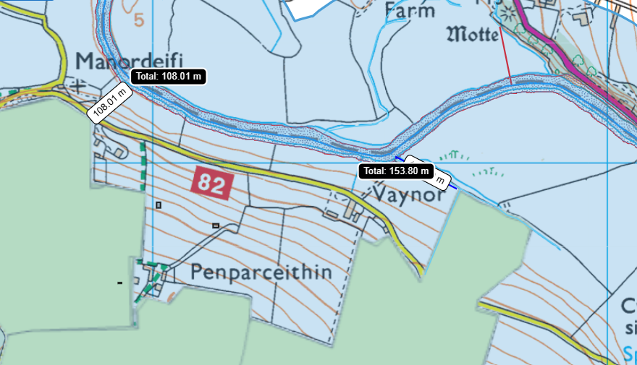
- What aspects of the proposed permission are likely to damage the SSSI features of special interest?

Afon Teifi SSSI

The following activities are likely to cause damage:

5.Application of manure, slurry, silage liquor, fertilisers and lime to agriculturally unimproved permanent grass, forestry and all other unimproved riparian habitats.

6. Dumping, spreading or discharging of any materials.

22. Storage of materials.

26. Use of vehicles, or craft within the control of the owner or occupier.

The following SSSI(s) features and potential impacts have been considered to assess the likelihood of damage:

- A range of river plant communities including those characterised by water crowfoot.
- Associated riverside habitats, including marshy grassland, swamp, saltmarsh and broadleaved woodland.
- Nutrient-poor, mildly acidic upland lakes (the Teifi Pools). Fish, including Atlantic salmon, bullhead, and three species of lamprey.
- Otters.
- A range of unusual flowering plants and mosses, including floating water plantain, northern yellow-cress and multi-fruited river moss.
- A range of rare and scarce insects and other invertebrates, including club tailed dragonfly and freshwater pearl mussel.
- Breeding river and wetland birds.
- Bottle-nosed dolphins (which sometimes come into the lower estuary).

Assessment of impact pathways: None have been identified due to the proximity the SSSI is from closest spreading fields. Field Malg 11 is located 108 meters from the Afon Teifi SSSI. In addition to this the deployment application has included large buffer zones in places facing the SSSI which has been explained below in the recommendation section of this assessment.

- Summary of any informal advice received from internal experts (if required and including pre-app advice) | n/a
- Recommendation | The proposed permission is not likely to damage any of the flora, fauna or geological or physiological features which are of special interest  Field Mag 11 (closest field) is located 108 meters from the Afon Teifi SSSI. In addition to this there is a large 40 metre no spread buffer zone in place in the northern area of the field facing the Afon Teifi to mitigate the risk of surface runoff into nearby water courses, areas of highly sloping land have also have no spread buffer zones in place, as well as no spread buffer zones for areas of high risk of flooding.  Field Malg 9 is located 153 metres from the Afon Teifi SSSI. And contains a 20 metre no spread buffer zone around the perimeter of the field to mitigate the risk of surface runoff into nearby water courses hydrologically connected to the SSSI.  All proposed waste streams are non-stackable liquids therefore dust is not a potential impact pathway.  Wastes high in RAN (VOLAC Sensient & DCWW Bontgoch) are not being spread in nitrogen closed periods. Storage area associated with this deployment are also further than 200 meters from both SSSI reducing risk of nitrogen volatilisation risks.  The submitted site plan includes the appropriate no spread buffer zones around water courses to mitigate the risk of nutrients and PTEs entering nearby water course / SSSI. These no spread buffer zones comply with the SRP and in cases for fields closest to the SSSI the buffer zones exceed the limits set out in SR2010no4.  Wastes will be spread via a low trajectory dribble bar that applies waste directly to the crop/grass minimising surface runoff.  EWC 19 09 02 waste streams that contain high aluminium flocculates have no land applications on fields that are < pH 6.0. For ferric flocculated sludges, no applications on fields that are < pH 5.5 to comply with TGN 8.01.  Spillages: all spillages will be reported immediately to NRW.  Regular servicing of all machinery is conducted and spreading equipment is annually calibrated. To prevent waste being held in faulty machinery replacement spreading equipment will be available.  Spreading machinery will travel over the field in a direction which will most easily allow the machinery to turn within the boundaries of the field. Any spreading equipment will be turned off prior to turning at the end of each run.  Machinery turns will be routed to avoid rutting and wheel slip. The turns will not be executed on any buffer strips.  There will be sufficient trained staff available to ensure that the operation continues throughout operational hours (i.e.  there will be sufficient cover for illness, holiday etc.).  Weather conditions will be monitored prior to spreading with wind speed and direction assessed.  A site-specific risk assessment has been provided by the operator to take into account any potential issues and provided appropriate mitigation measures.  Natural Resources Wales is minded to: Issue the permission.
- Signature and date assessment made | Owen Clee 08/12/2025
- Officers name and job title | Owen Clee, Waste Permitting Officer 2.

