Annex (iv) – SSSI Assessment Form
SSSI Assessment for permit/licence and deployment applications | 
To be completed by Permitting Officers for any applications for a permission which Natural Resources Wales has considered under S28I duty to notify SNCB and take their advice into account. This applies to all proposed permissions within a SSSI, and to operations outside the SSSI boundary which are likely to damage its special features.
NRW as a Section 28G authority has, when exercising its functions, a general duty to take reasonable steps, consistent with the proper exercise of its functions, to further the conservation and enhancement of the flora, fauna or geological or physiological features by reason of which the site is of special interest’

Part 1 – SSSI Assessment
Part 2 – Formal notification to SNCB (to be completed if part 1 assessment concludes likely damage, not likely to damage because of conditions or you cannot conclude no likely damage)
Part 3 – Decision
Pink text – drafting notes, to be deleted before completion/consultation.
Blue text – examples, to be replaced with permission-specific information and text turned to black.

Part 1 – SSSI Assessment

- Permitting officer/team | Bryan Burn
- Permit application reference and site name | PAN-030957
- a. SSSI name(s)  b. location  c. NRW Operational Area/Environment Team | a. SSSI Aberarth - Carreg Wylan  b. Fields at Ffrwdwenith Ganol  Felinwynt, Cardigan, Ceredigion. SA43 1RW  c. Mid / Env Team 5 - Ceredigion
- Brief description of proposal | Landspreading deployment under SR2010No4 Mobile plant permit. Spreading 02 05 02 Waste from the dairy products industry – sludges from onsite effluent treatment, from 3 sites.  The waste from Volac/Sensient–Felinfach is high in readily available nitrogen and is proposed to be spread on field F Ganol 12 which is the only field within 500 metres of Aberarth - Carreg Wylan.  The activity is not wholly or partly within the SSSI boundaries.  The fields will be spread in February – April 2026 prior to first cut silage, and following silage cuts May – September 2026. Spreading of these grass fields may be split into up to 4 applications & the total of all applications will not exceed the max application rate for each field as listed in table 1. Each individual application will not exceed 50t/ha in any one application to a field (or the maximum application rate given in Table 1 of the benefit statement where lower).  The Volac / Sensient liquid sludge has high readily available nitrogen (over 30% RAN). Spreading is in line with good practice and regulations with the liquid sludge spread into the growing grass crops at stated timings with a low trajectory precision dribble bar applicator which places the liquid sludge in bands on the surface of the ground. This method of application minimises contact with the air reducing ammonia volatilization. The fields are all in a nitrate vulnerable zone (areas designated as being at risk from agricultural nitrate pollution) which applies across Wales. The closed period for spreading organic manures with high readily available nitrogen (Volac / Sensient liquid sludge) on the grass fields is 15th  October – 15th January under The Water Resources (Control of Agricultural Pollution) (Wales) Regulations 2021. The stated spreading timings in this deployment for all fields with all liquid sludges are from February to September when there is crop nutrient requirement and not in the closed periods. The liquid sludges apply far less than the crop requirements for nitrogen with the balance required to grow the crops applied as fertiliser by the farmer.  The liquid wastes are delivered by HGV road tankers which are discharged into a nurse tank. The liquid waste is either spread from a nurse tank, or for Ffrwdwenith Ganol pumped from nurse tank via umbilical hose to the self-supporting slurry bag for temporary storage prior to spreading. The wastes aren’t mixed and are spread on separate fields. Only wastes as specified in this deployment are to be stored in the nurse tanks & slurry bag prior to spreading  The nurse tanks are purpose built AW Trailers nurse tanks with designated fill and empty valves that can be shut by gate valves and locked off in the event of temporary overnight storage if the tank contains liquid to ensure secure storage.  The tank fills from the top via internal pipework with a ‘swanneck’ reducing chances off any spills when decoupling connecting pipes after filling. The empty valve allows the tank to be completely emptied to the bottom. The tank is sealed with roof to prevent odour, rainwater entering the tank and for safety, and can be vented if required. A lifting axle in the middle allows the tank to positioned and lowered so the whole tank is on the ground.  The Labaronne Citaf self-supporting slurry bag is for temporary storage and is purpose built, sealed, can be vented and has designated fill and empty valves and is sited on a suitable flat area. The bag has a 10 year manufacturer guarantee 100% against all material (technical fabric) and manufacturing (welding) defects. The technical fabric is composed of polyester coated with PVC and protected with an anti UV treatment on both sides. The bag has a life expectancy of 20 years +. The liquid is transferred to the bag from a nurse tank via tractor and tanker, or pumped via lay flat hose across fields and connected to the bag fill valve. There are 2 gate valves in sequence over a metre apart and a non return valve.  The bag features a number of degassers with anti-odour filters. The slurry bag has a soil bund around the perimeter and is fenced to prevent access & damage.  Each liquid sludge is spread from a nurse tank or the slurry bag onto the deployed fields at the required timings as stated above. This is done by either umbilical method with the liquid delivered to tractor in deployed fields pumped through hose and spread by dribble bar applicator mounted onto the back of the tractor, or a tractor and vacuum tanker with dribble bar applicator. The dribble bar applicator places the liquid in bands onto the surface of the ground. This spread method is effective in limiting odour generation & nutrient losses associated with higher trajectory spread methods such as splash plate. Spreading is undertaken with the use of flow meters to ensure correct rates are applied.  Spreading of the waste will be carried out in accordance with the Code of Good Agricultural Practice, The Water  Resources (Control of Agricultural Pollution) (Wales) Regulations 2021 and in accordance with the requirements of the deployment and Environmental Permitting Regulations.  NRW will be informed at least 48 hours prior to any spreading commencing and no spreading will occur within 48 hours of forecasted heavy rainfall.  Each individual application will not exceed 50t/ha in any one application to a field.  Waste will not be stored or spread in combination (i.e. only one waste stream per field).  The following fields and storage are in the deployment but only one field is within 500 metre range.  Fields:  F Ganol 1 SN 23655 50554  F Ganol 2 SN 23543 50732  F Ganol 3 SN 23470 50829  F Ganol 4 SN 23414 50922  F Ganol 6 SN 23157 50875  F Ganol 7 SN 23197 50786  F Ganol 8 SN 23294 50654  F Ganol 9 SN 23142 50972  F Ganol 10 SN 23083 51101  F Ganol 11 SN 23047 51288  F Ganol 12 SN 23163 51350  F Ganol 13 SN 23346 51026  Camp 1 SN 24994 49168  Camp 2 SN 25262 49107  Camp 3 SN 25328 49208  Camp 4 SN 25368 49273  Camp 5 SN 25429 49311  Storage:  1 SN 23406 50713  2 SN 24835 49716  3 SN 24881 49746  4 SN 24887 49080  5 SN 24883 49097  6 SN 23462 50531  7 SN 23791 50552  8 SN 24794 49644  Distances from F Ganol 12 which is the only field within range.  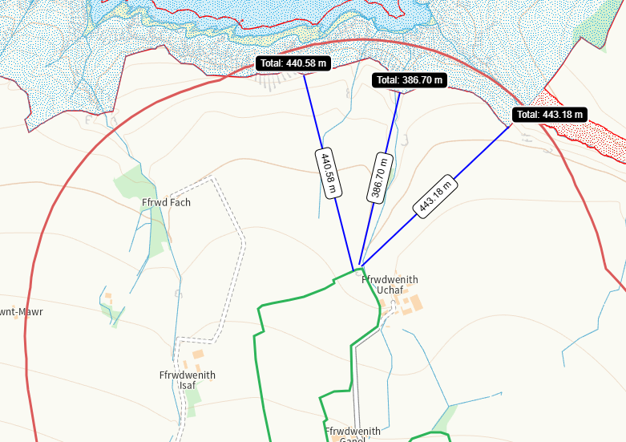
- What aspects of the proposed permission are likely to damage the SSSI features of special interest?

The following activities are likely to cause damage:

Aberarth – Carreg Wylan
- Application of manure, slurry, silage liquor, fertilisers and lime.
- Dumping, spreading or discharging of any materials.

The following SSSI(s) features and potential impacts have been considered to assess the likelihood of damage:

Aberarth - Carreg Wylan
https://cdn.cyfoethnaturiol.cymru/641362/SSSI_0355_SMS_EN0017c63.pdf
https://cdn.cyfoethnaturiol.cymru/641262/SSSI_0355_Citation_EN0018c6a.pdf
- Zonation of intertidal communities, honeycomb worm reefs and overhangs and caves
- Rare and uncommon plant species
- Bottlenose dolphin and seals
- Kittiwake
- Chough
- Rare and uncommon invertebrates species
- Caledonian structures exposed in the sea cliffs and foreshore (Traeth Penbryn and Cwmtudu)
- Pleistocene / Quaternary sedimentary profiles exposed in the sea cliffs and foreshore (Mwnt and Poppit)
- As well as the features listed above, Aberarth – Carreg Wylan SSSI has other habitats that contribute to the special wildlife interest. These include sand dune, continuous bracken and woodland, dense scrub, acid grassland, marshy grassland, together with other elements such as hedgerows, streams, springs, flushes, small rock outcrops and individual trees.

As the fields are not wholly or partly within the SSSI, suitable no spread buffers are in place where required, method of delivery is inline with guidance and with the applicants adherence to their permit conditions, regulations and guidance; the risk of transference of the applied waste to the SSSI is highly unlikely to impact the features mentioned above.

- Summary of any informal advice received from internal experts (if required and including pre-app advice) | Nil
- Recommendation | The proposed permission is not likely to damage any of the flora, fauna or geological or physiological features which are of special interest  Aberarth - Carreg Wylan  Field F Ganol 12 is approximately 390 metres South of the SSSI. And is gently sloping 0-7 degrees, method of application is dribble bar and single applications will not exceed 50t/Ha, run off risk negligible.  The wastes will be applied to the fields with an appropriate application method for the types of waste (dribble bar) which is an effective way of applying the wastes to the soils directly which improve spreading accuracy, maximising nutrient use and minimising nutrient losses.  Watercourses/springs/issues have been appropriately buffered.  A site-specific risk assessment has been provided by the operator to take into account any potential issues and has provided appropriate mitigation measures to protect the SSSI’s and other sensitive sites from harm.  To mitigate against surface runoff/leachate further the wastes will be split into multiple applications and will not exceed 50t/ha in any one application. This allows for the soils to effectively uptake the wastes.  Any spillages will be reported immediately to NRW.  Operators will aim to empty spreading equipment before the end of each working day to avoid overnight storage of waste in machinery.  Regular servicing of all machinery is conducted and spreading equipment is annually calibrated. To prevent waste being held in faulty machinery replacement spreading equipment will be available.  Spreading machinery will travel over the field in a direction which will most easily allow the machinery to turn within the boundaries of the field. Any spreading equipment will be turned off and/or lifted out of the soil prior to turning at the end of each run.  Machinery turns will be routed to avoid rutting and wheel slip. The turns will not be executed on any buffer strips.  Weather conditions will be monitored prior to spreading with wind speed and direction assessed.
- Signature and date assessment made | Bryan Burn 11/12/25
- Officers name and job title | Bryan Burn, Permitting Officer



