Permit
The Environmental Permitting (England & Wales) Regulations 2016

S P Power Systems Ltd

Fford Bronwydd
Treborth
Bangor
Gwynedd
LL57 2NX

Permit number

EPR/JP3794FS/V002

Permit
The Environmental Permitting (England and Wales) Regulations 2016
Permit number

EPR/JP3794FS/V002

The Natural Resources Body for Wales (“Natural Resources Wales”) authorises, under regulation 13 of the Environmental Permitting (England and Wales) Regulations 2016

S P Power Systems Ltd (“the operator”),

whose registered office is

320 St. Vincent Street

Glasgow

Scotland

G2 5AD

company registration number SC215841

to operate waste operations at

Fford Bronwydd

Treborth

Bangor

Gwynedd

LL57 2NX

to the extent authorised by and subject to the conditions of this permit.

Under regulation 27(2) of the Regulations, standard rules SR2012No15 are conditions of this permit.

Name | Date
Huw Davies | 18/12/2025

Authorised on behalf of Natural Resources Wales

Schedule 1 - Site plan

This is the plan referred to in the standard rules SR2012No15

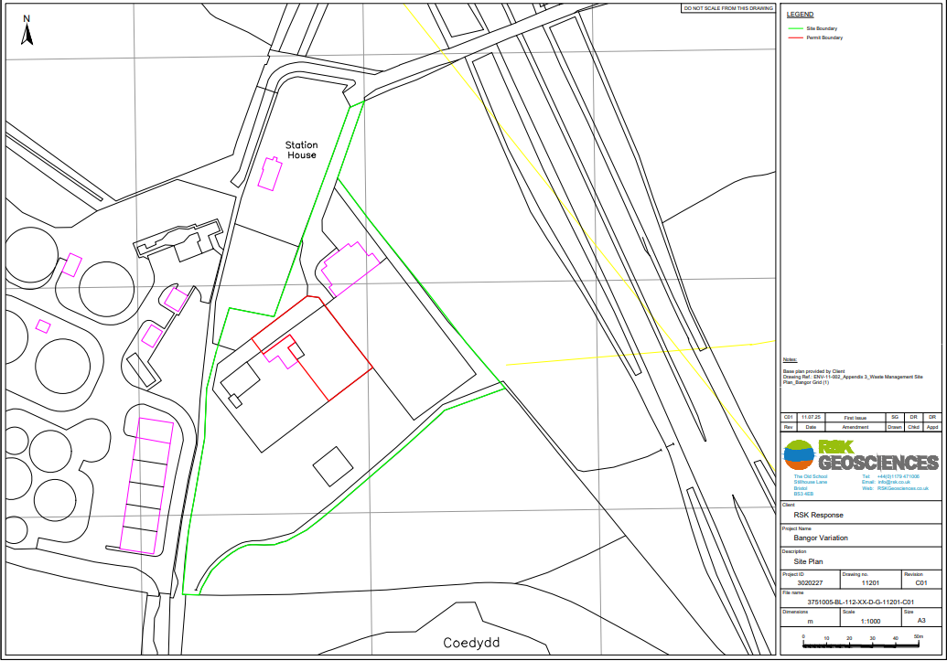

END OF PERMIT

