PAN-031032 My Map Report:
Application maps
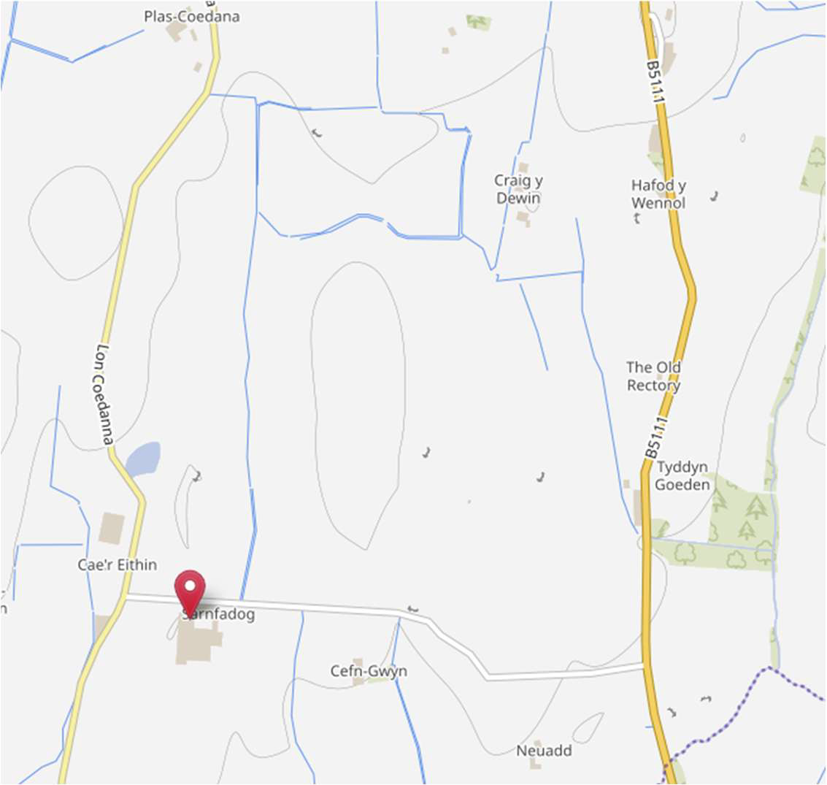
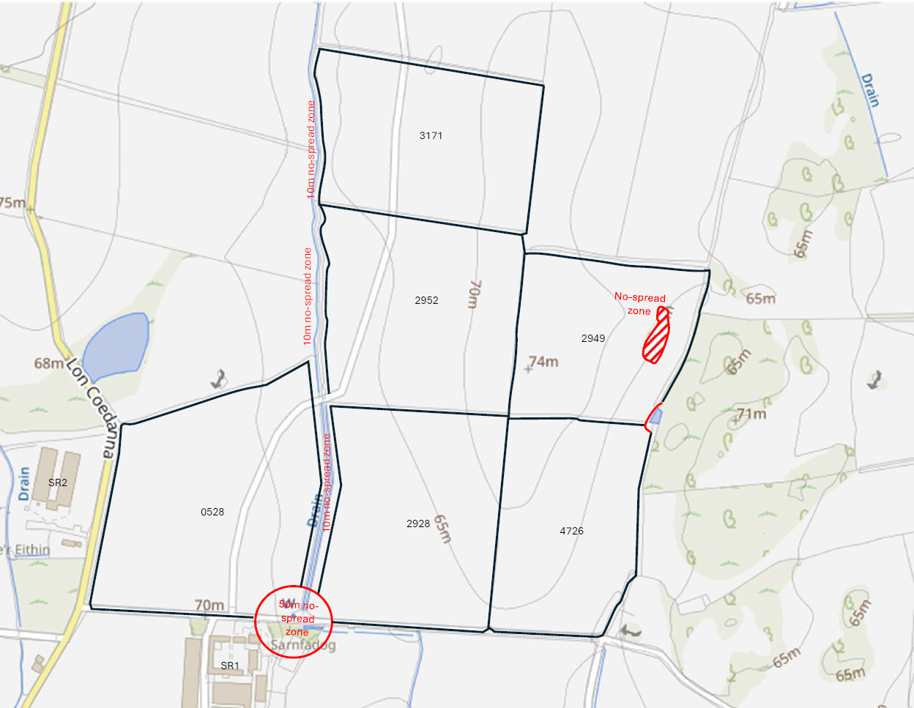
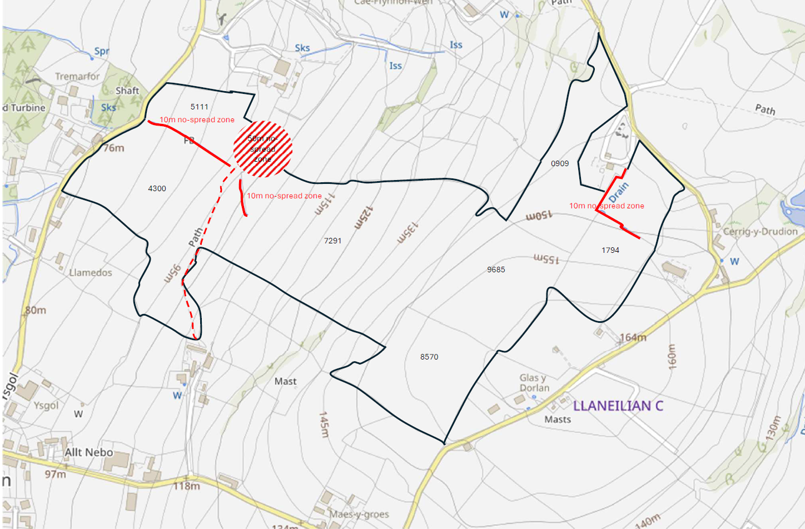
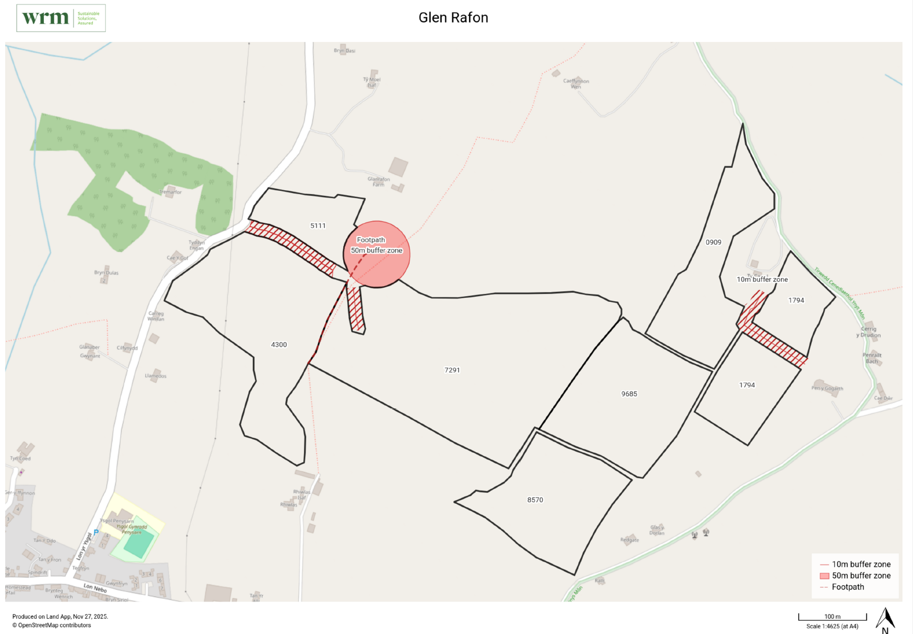
Deployment Boundaries and storage
Lagoon not shown on application map RFI
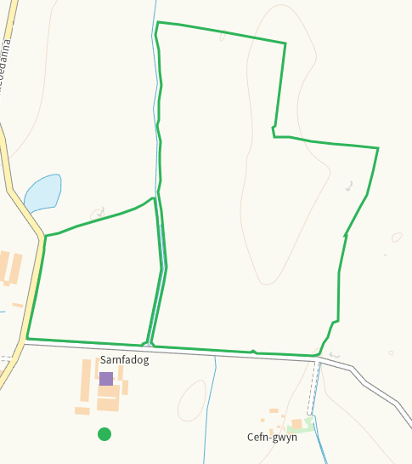
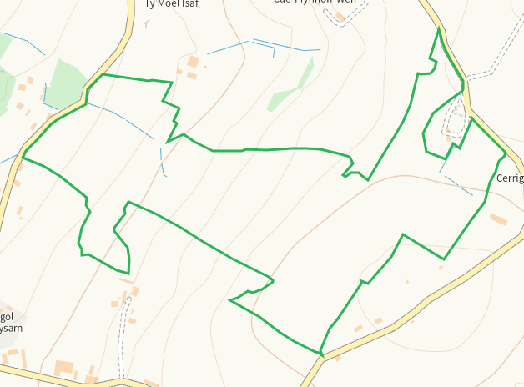
Detailed river network 10m
Watercourse adjacent to 0528,2928,2952,3171. On application map with and buffered
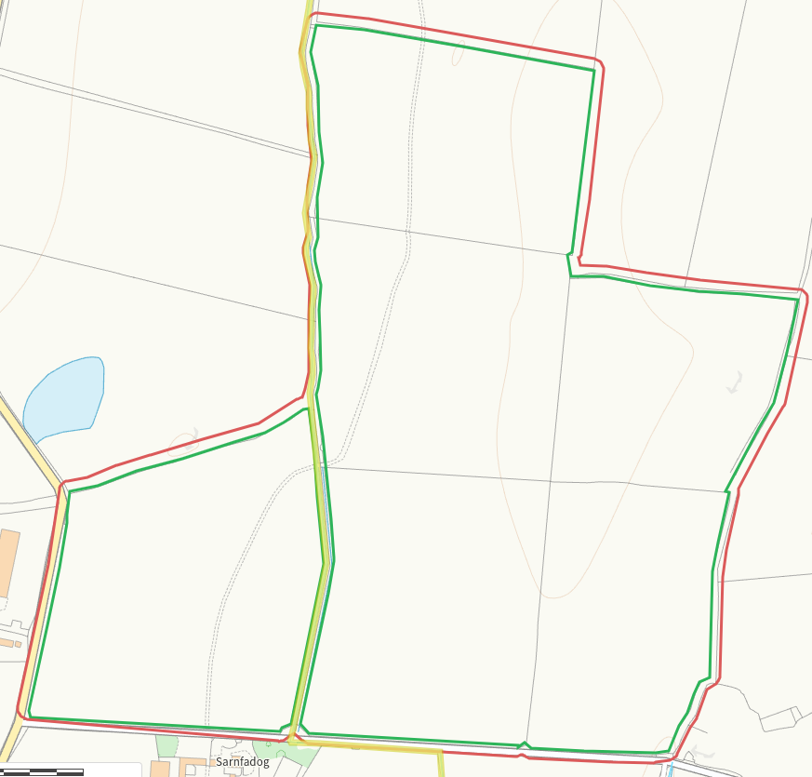
Pond E of 2949, on application map and buffered
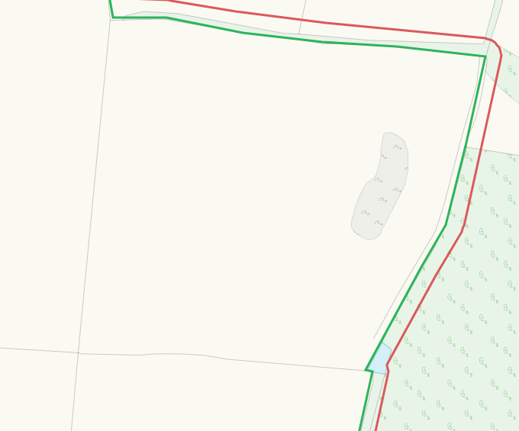
Watercourse within 5111, on application map and buffered
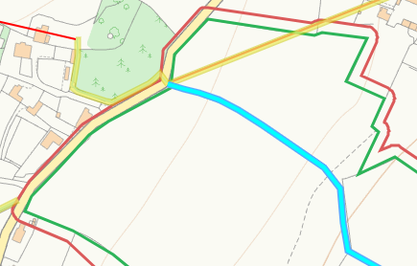
Watercourse within 1794, on application map and buffered
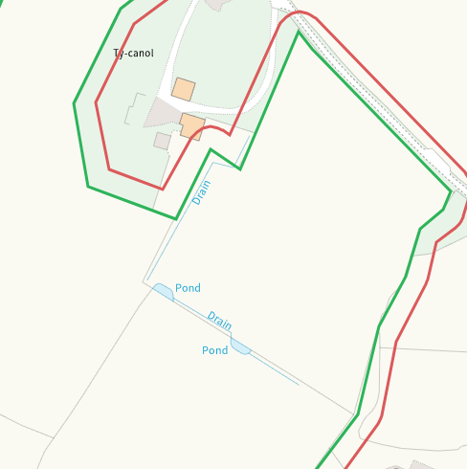
Groundwater source protection zones
none
Any well, spring (or issue) or borehole used for the supply of water for human consumption including from a private water supply or supplies within 50m.
Well S of 0528, on application map and buffered
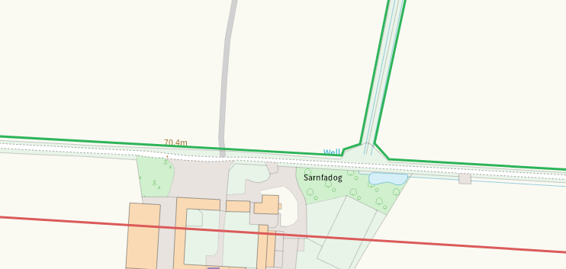
Well E of 5111, on application map and buffered
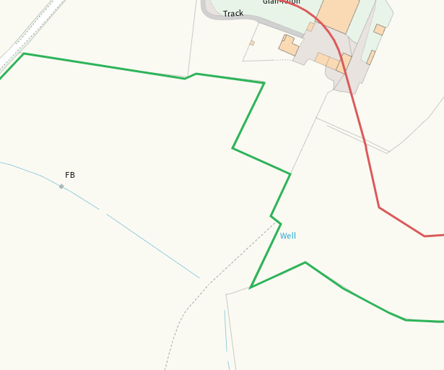

Any well, spring (or issue) or borehole used for the supply of water for human consumption including from a private water supply or supplies within 250m.
Well W of 4300, not on application map, nil risk
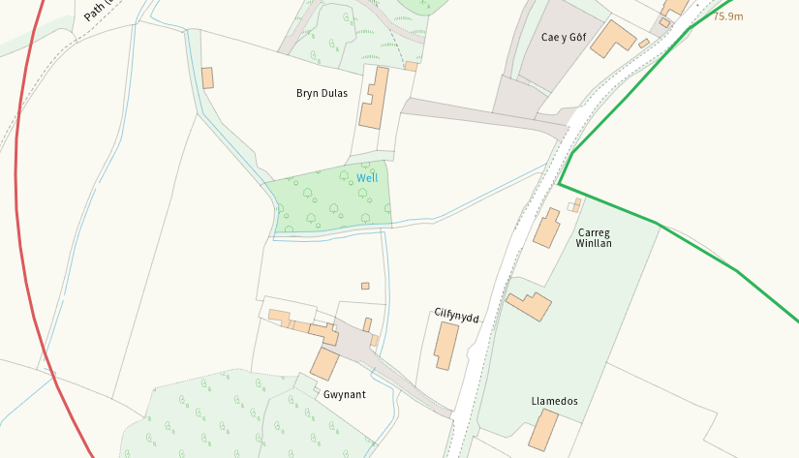
Spring W of 5111, on application map
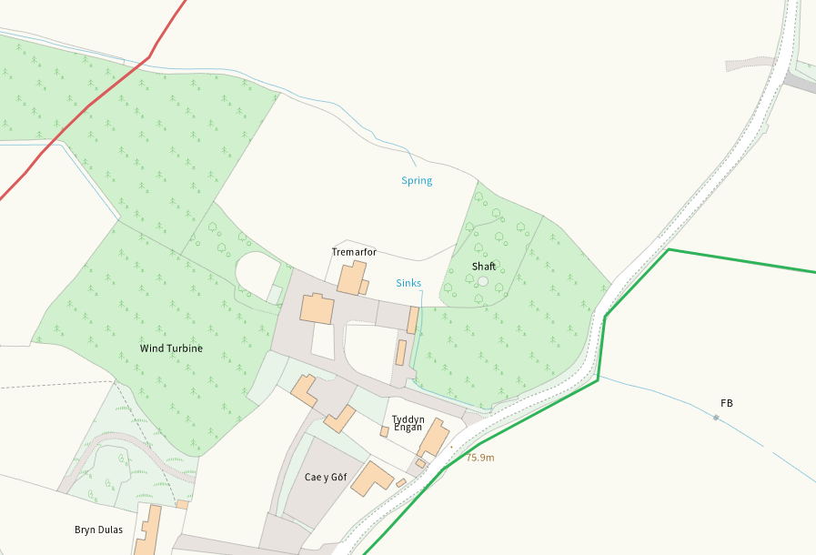
Issues N of 7291, on application map
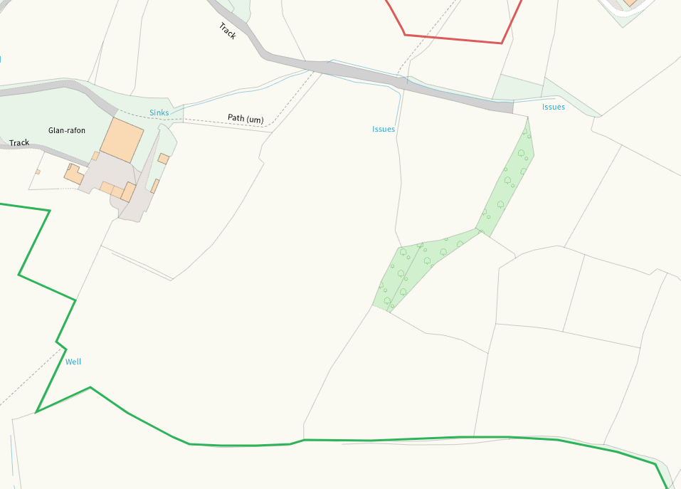
Well NW of 0909, on application map
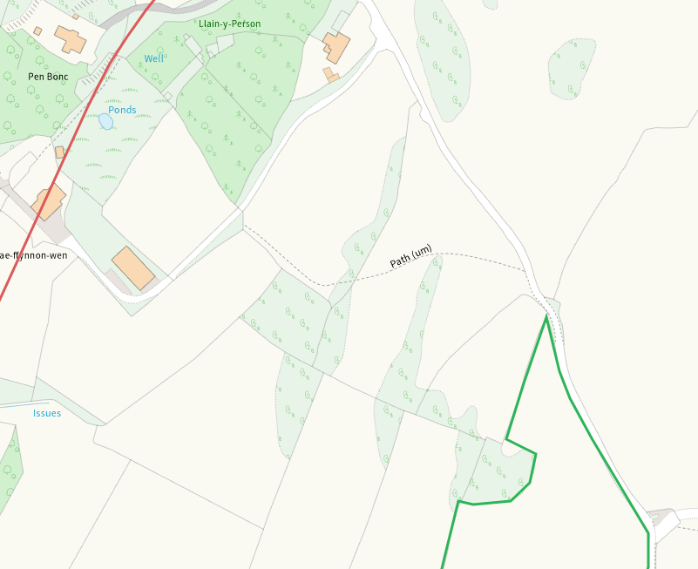
Well E of 1794, on application map
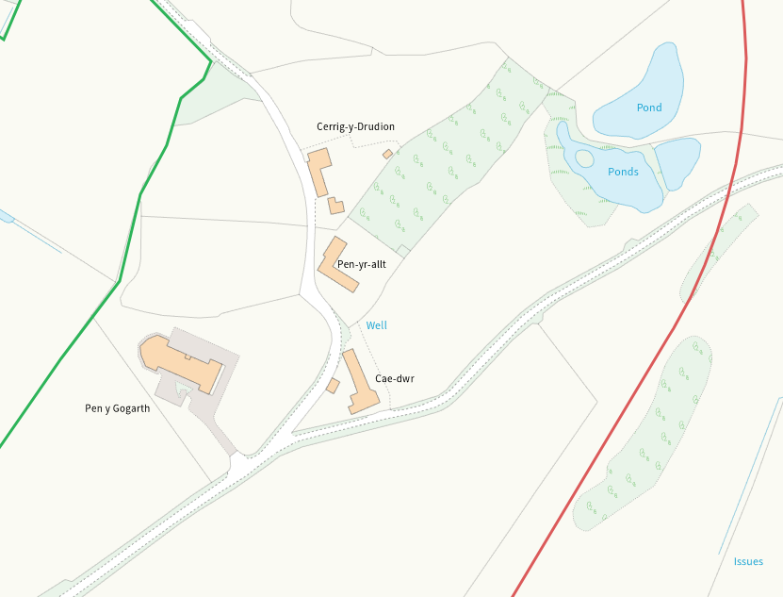

Within Groundwater Safeguard Zone
None
European designated sites- Natura 2000 (SPA, pSPA, SAC or cSAC) or Ramsar- or SSSI within 500m
None in range
Other protected sites within 500m:
- Protected Species-
Some within range, nil risk from the activity
- Protected Habitats-
Several areas of Purple moor grass and rush pastures and Lowland dry acid grassland and Lowland calcareous grassland within range and adjacent, nil risk
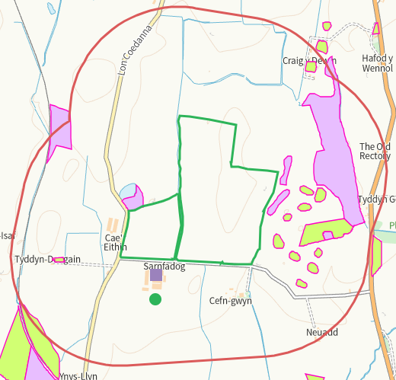

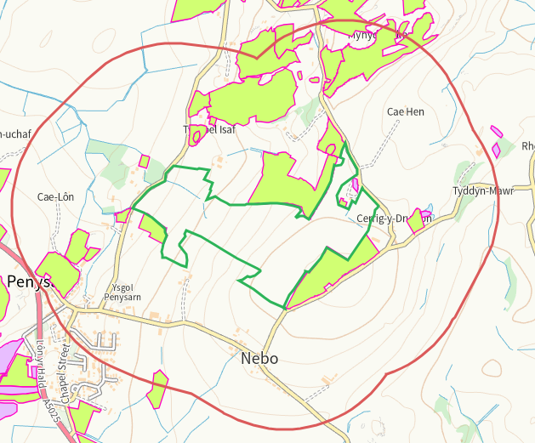
- Scheduled Ancient Monument- none
- Local Nature Reserve- none
- National Nature Reserve- none
- Ancient Woodlands-
E of 1794, nil risk
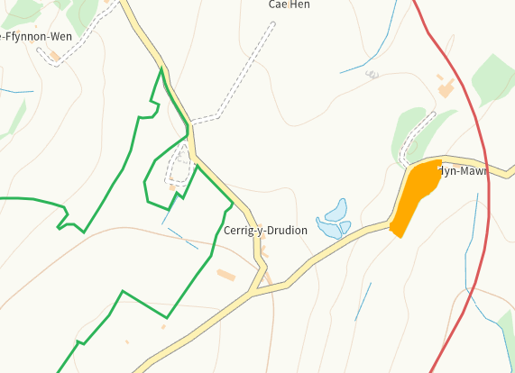
- Local Wildlife Sites (SINC)-
SINC Mynydd Eilian N of 0909, nil risk
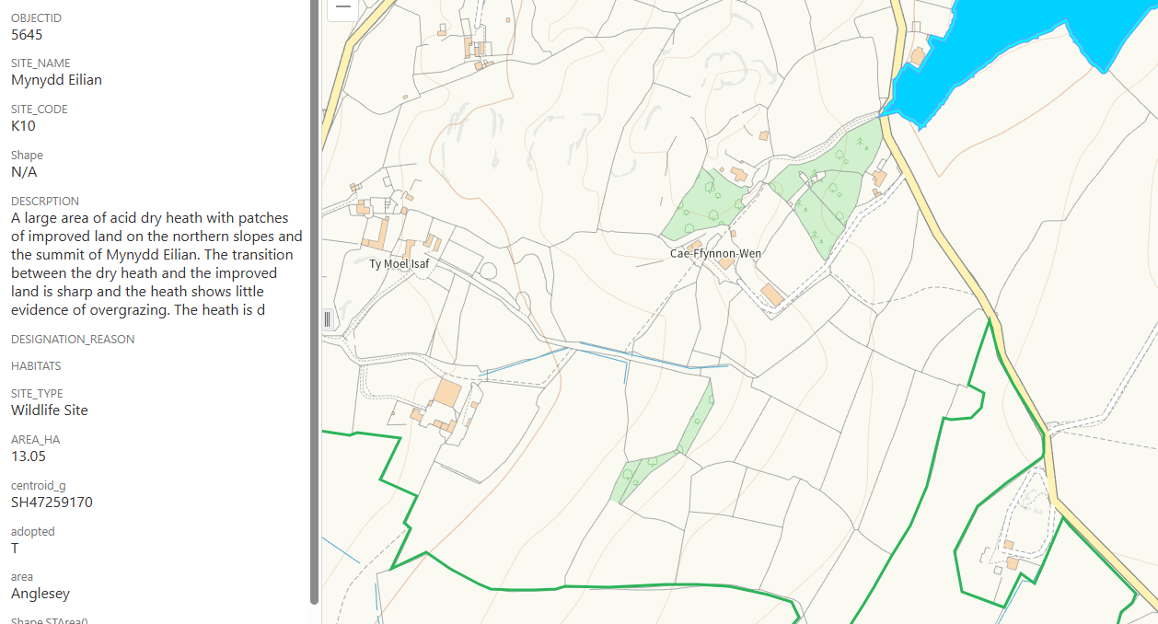

- National Park- none
- Nitrate Vulnerable Zone (NVZ)- ALL Wales
- Groundwater Safeguard Zone- none

Flood risk
none
Public rights of way
Footpath in field 4300, shown on application map.
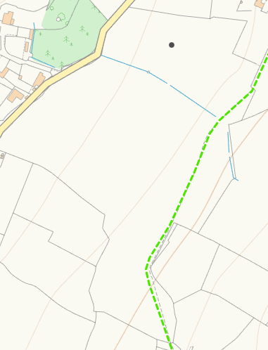
None at other feilds
Distance from Main Farm Address
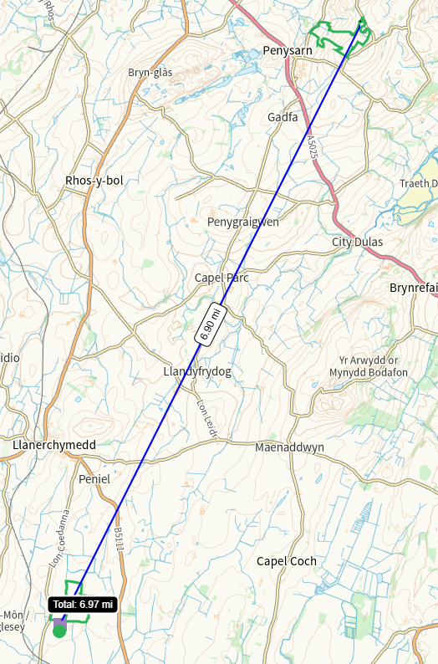
Slope Map
2949, 0-7 with a small portion of 12+ which is buffered
0528, 2928, 2952, 3171, 4726, 0-7
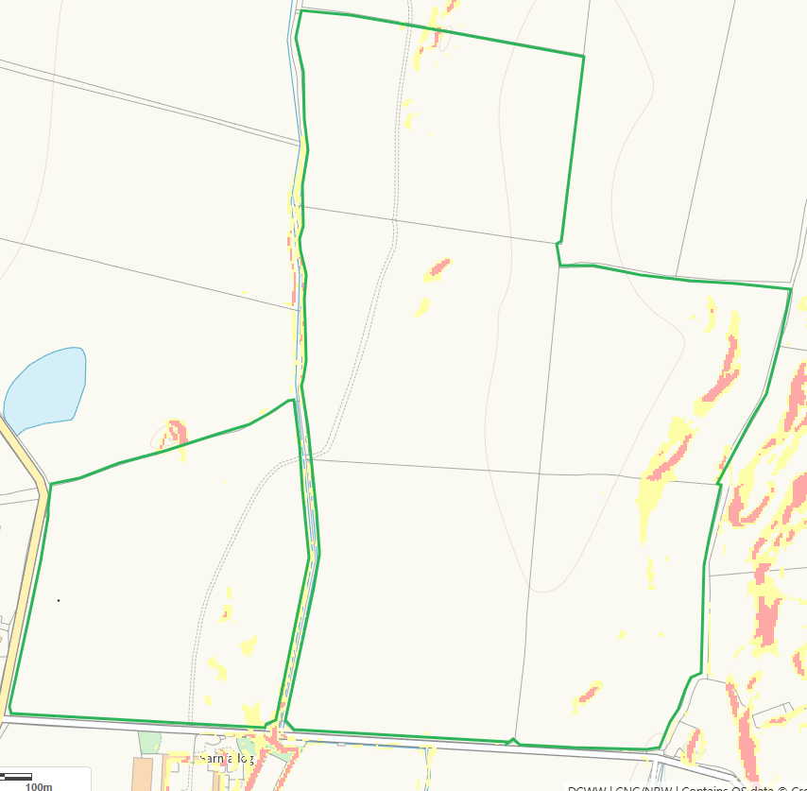
1794,8570,0909,5111, 0-7
7291,9685,4300, 7-12 with portions of 12+
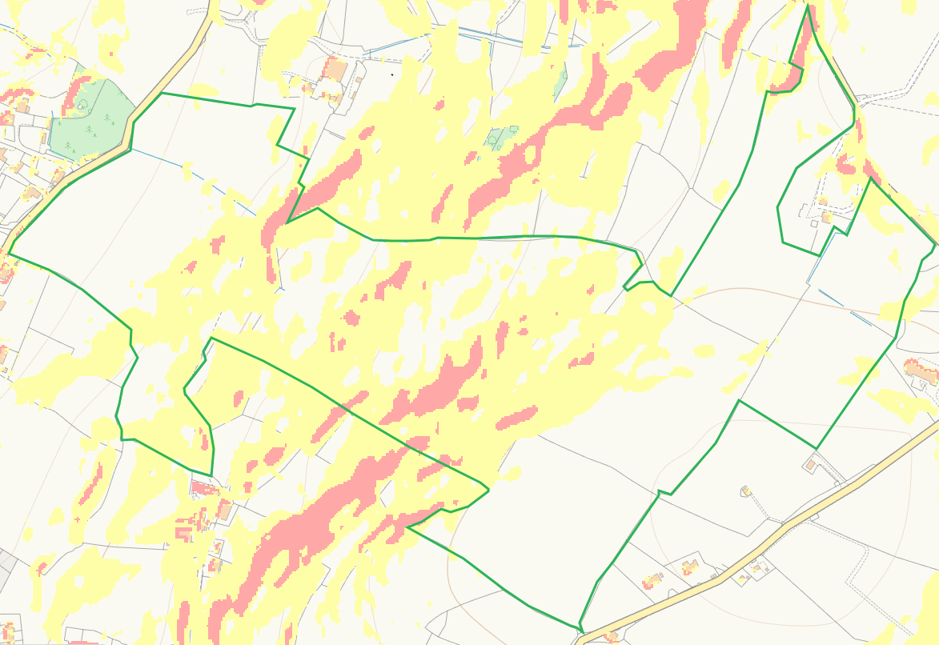

END

