PAN-031145 My Map Report:
Application maps
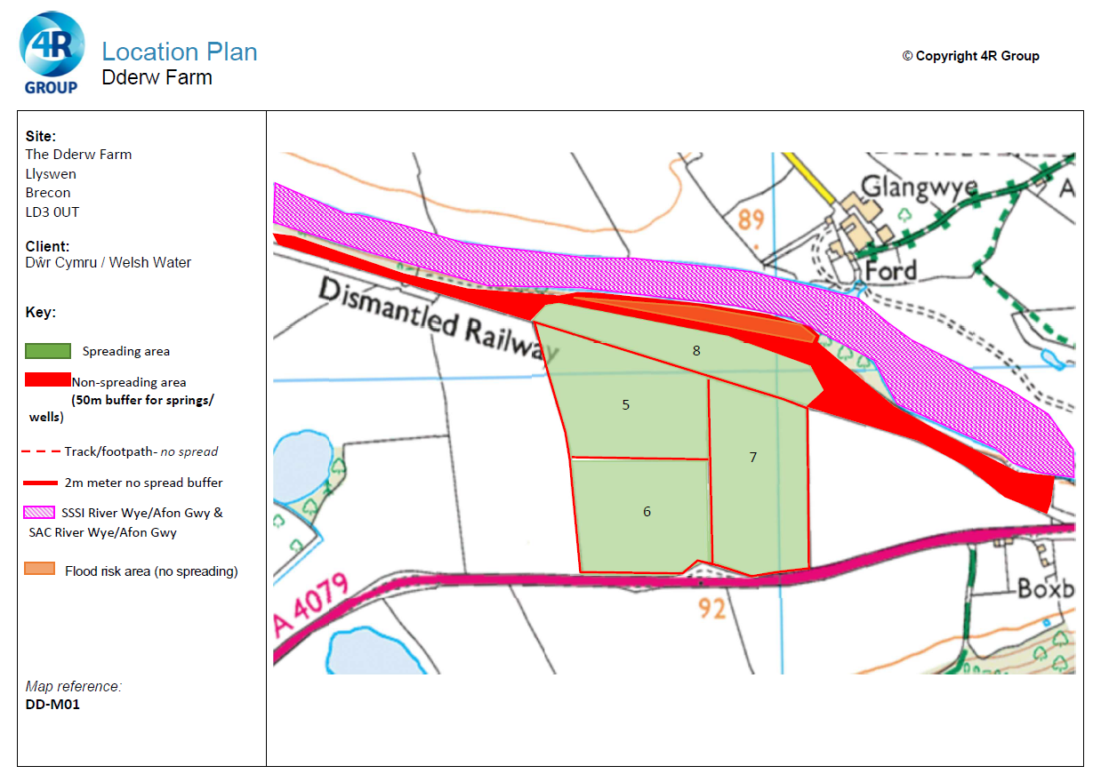
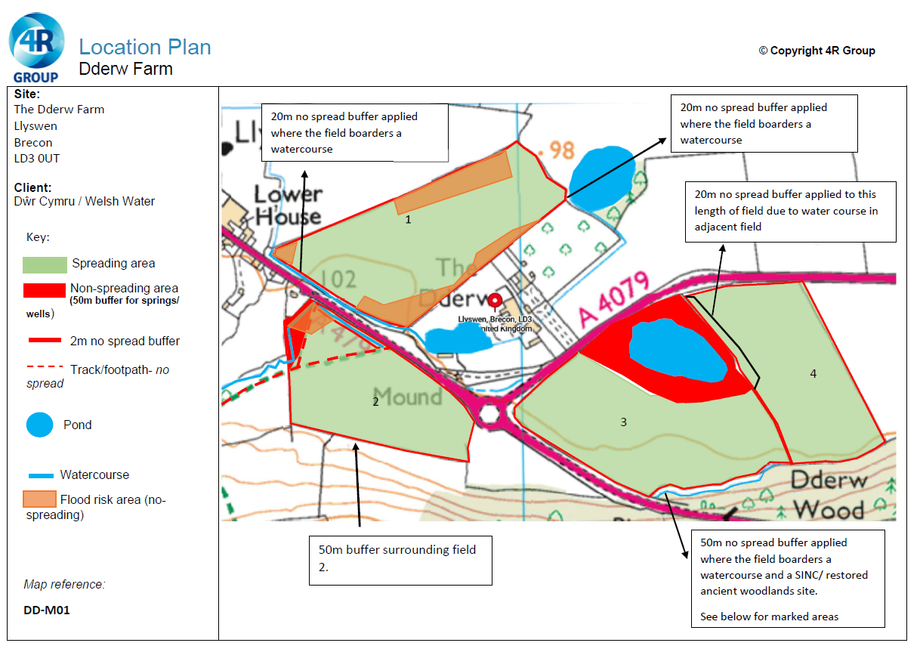
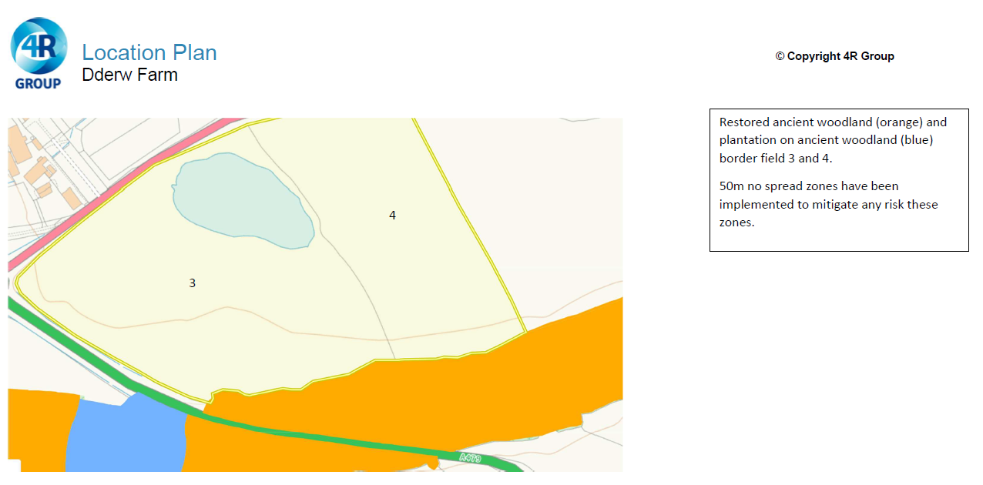
Deployment Boundaries and farm location
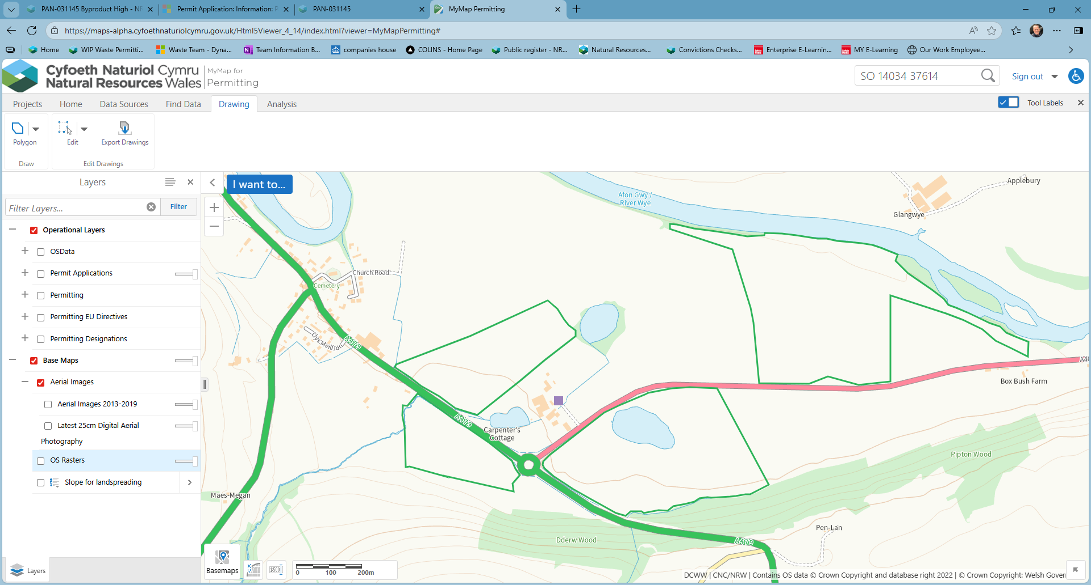
Detailed river network 10m
Watercourse flows subsurface though 7 & 8, nil risk. River Wye to the N, field 8 is substantially buffered to the N boundary
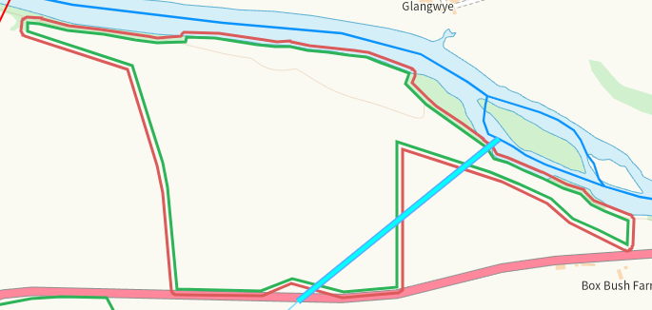
Watercourse S of 3 flowing subsurface through 2, buffered on maps where required
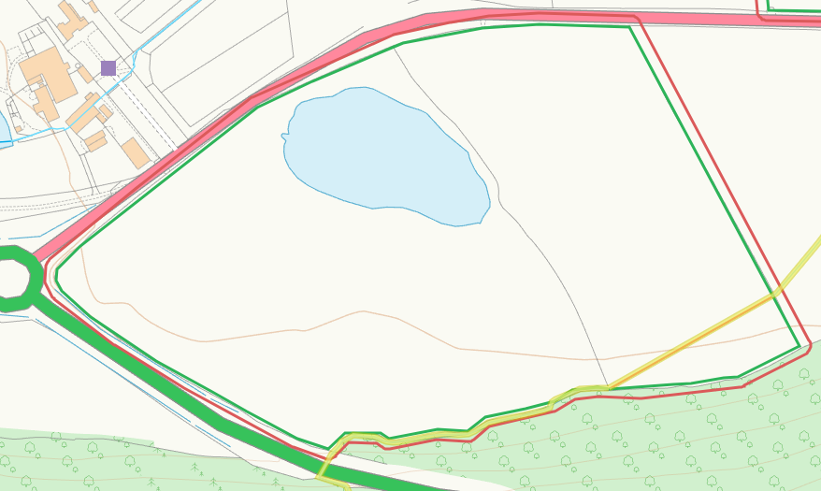
Watercourse SW of 1, buffered
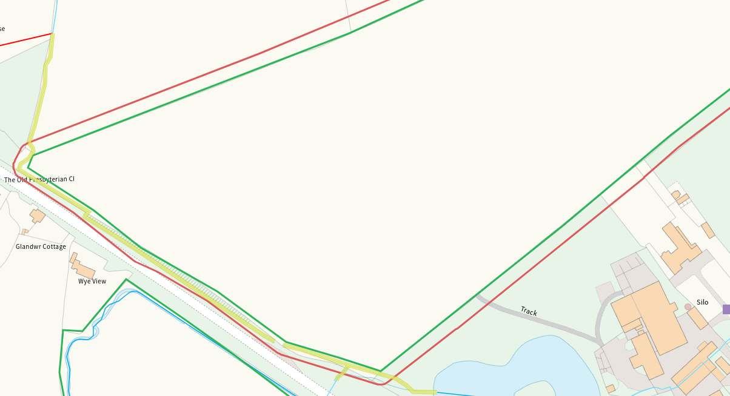
Watercourse within 2, buffered
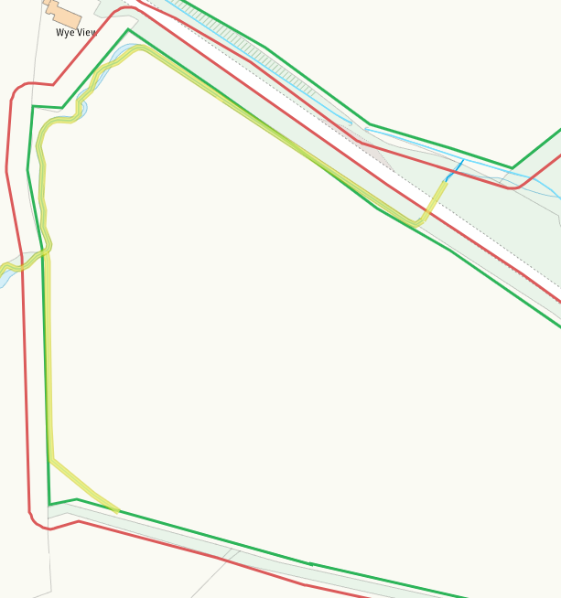
Groundwater source protection zones
none
Any well, spring (or issue) or borehole used for the supply of water for human consumption including from a private water supply or supplies within 50m.
none
Any well, spring (or issue) or borehole used for the supply of water for human consumption including from a private water supply or supplies within 250m.
none
Within Groundwater Safeguard Zone
none
European designated sites- Natura 2000 (SPA, pSPA, SAC or cSAC) or Ramsar- or SSSI within 500m
SSSI River Wye (Upper Wye) / Afon Gwy (Gwy Uchaf) adjacent N to field 8 and within range of other fields. Field 8 is substantially buffered as are all watercourses in range of fields. Low risk.
SAC River Wye / Afon Gwy (Wales), same as above.
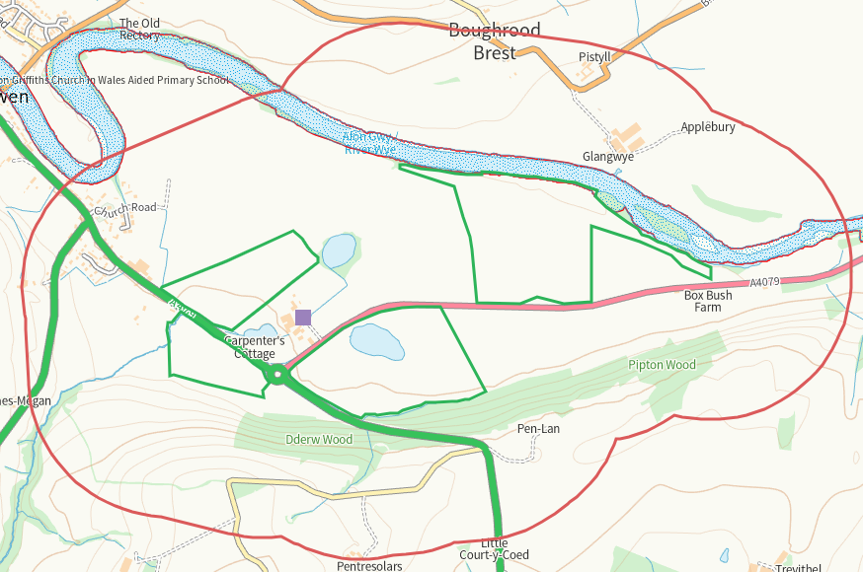
Other protected sites within 500m:
- Protected Species-
Multiple in range of all fields, predominantly birds. Nil risk from this activity
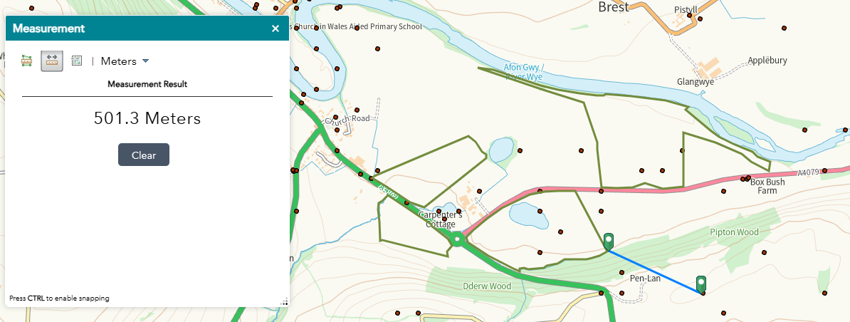
- Protected Habitats- none
- Scheduled Ancient Monument-
Round Barrow 400m S of Church is W of 2, nil risk
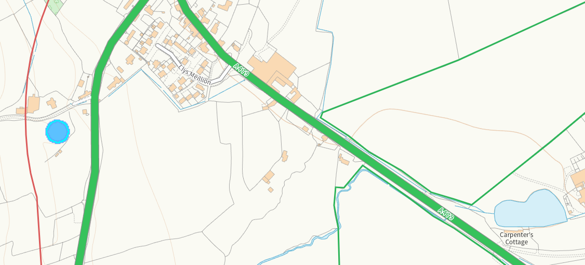
- Local Nature Reserve- none
- National Nature Reserve- none
- Ancient Woodlands-
Ancient woodland adjacent S of 3 and in range of othe fields, 3 is well buffered, woodland is on higher ground.
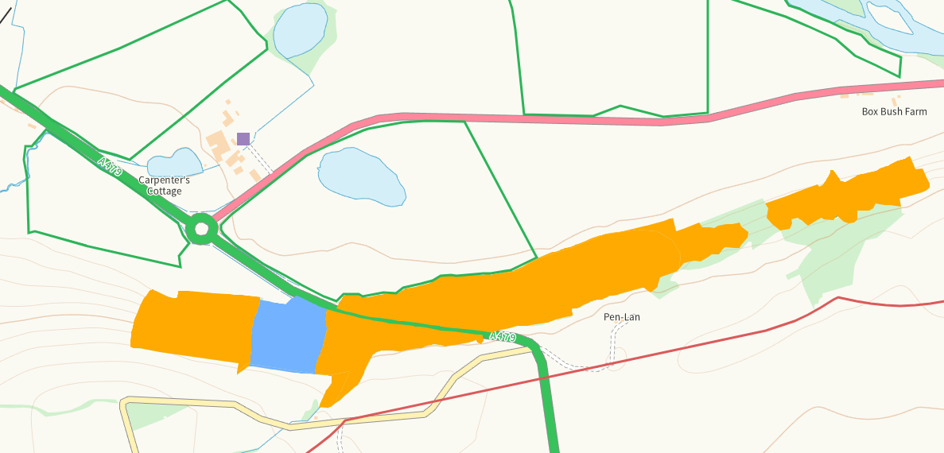
- Local Wildlife Sites (SINC)-
SINC Dderw Wood A is adjacent S of 2 and range of other fields, 2 is well buffered.
SINC Dderw Wood B is adjacent S of 3 and within range of other fields, 3 is well buffered
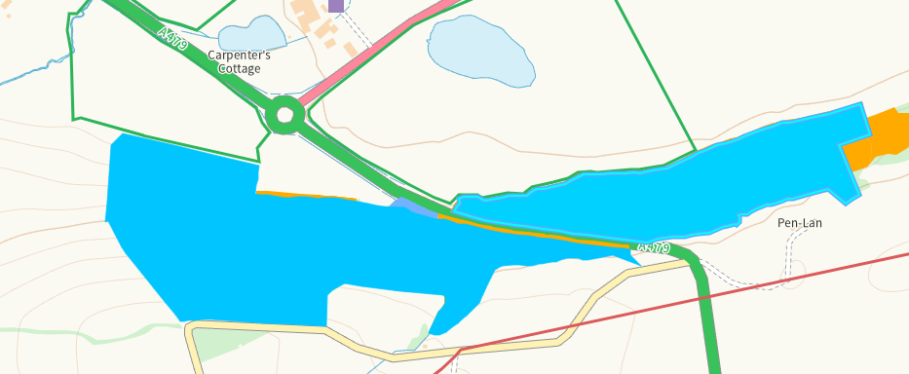
- National Park- none
- Nitrate Vulnerable Zone (NVZ)- ALL Wales
- Groundwater Safeguard Zone- none

Flood risk
At risk areas for fields 1, 2 & 3 shown on application map and buffered. Field 2 has 50m buffer at boundary.
At risk areas for fields 5 & 6 not shown or buffered. RFI
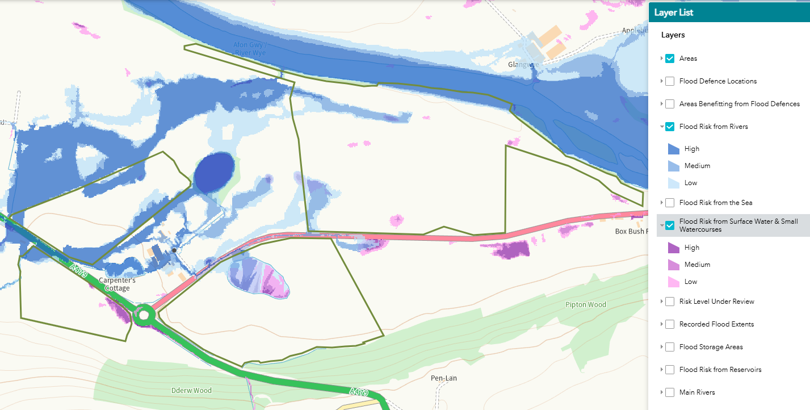
Public rights of way
none
Any buildings or houses within 250m
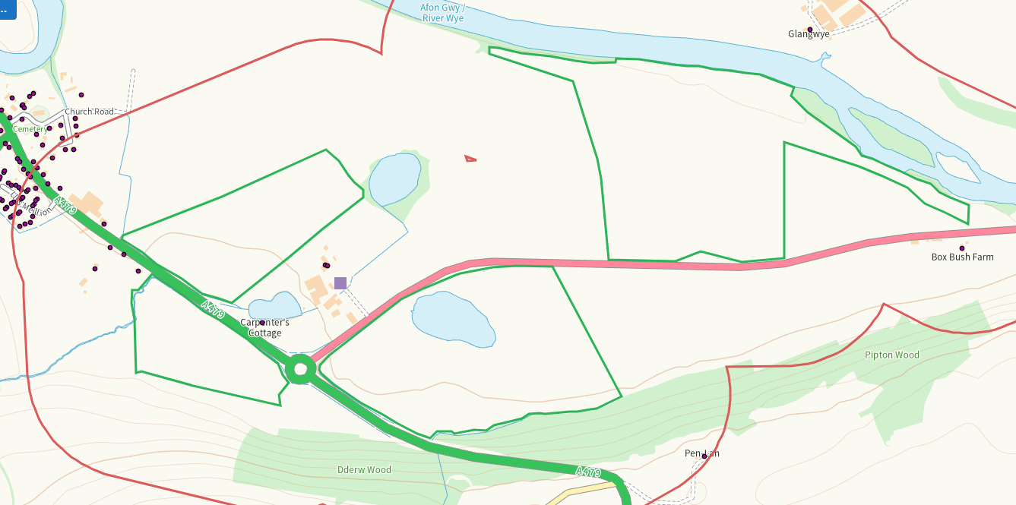
Distance from Main Farm Address
Adjacent
Slope Map
All fields 0-7, where minor 7-12 and 12+ exist these areas are substantially buffered.
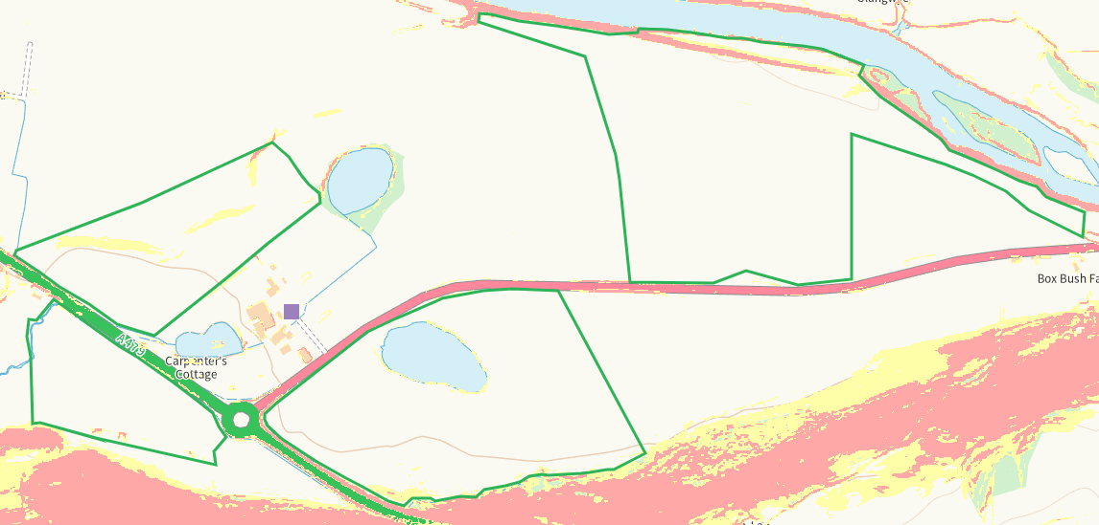
END

