Annex (iv) – SSSI Assessment Form
SSSI Assessment for permit/licence and deployment applications | 
To be completed by Permitting Officers for any applications for a permission which Natural Resources Wales has considered under S28I duty to notify SNCB and take their advice into account. This applies to all proposed permissions within a SSSI, and to operations outside the SSSI boundary which are likely to damage its special features.
NRW as a Section 28G authority has, when exercising its functions, a general duty to take reasonable steps, consistent with the proper exercise of its functions, to further the conservation and enhancement of the flora, fauna or geological or physiological features by reason of which the site is of special interest’

Part 1 – SSSI Assessment
Part 2 – Formal notification to SNCB (to be completed if part 1 assessment concludes likely damage, not likely to damage because of conditions or you cannot conclude no likely damage)
Part 3 – Decision
Pink text – drafting notes, to be deleted before completion/consultation.
Blue text – examples, to be replaced with permission-specific information and text turned to black.

Part 1 – SSSI Assessment

- Permitting officer/team | Bryan Burn, Waste Permitting
- Permit application reference and site name | PAN-031145  The Dderw, Llyswen, Brecon. LD3 0UT
- a. SSSI name(s)  b. location  c. NRW Operational Area/Environment Team | a. River Wye (upper Wye) / Afon Gwy (Gwy Uchaf) SSSI  b. Brecon  c. South Powys
- Brief description of proposal | Landspreading deployment under standard rules permit SR2010 No4  The activity is not wholly or partly within the SSSI boundaries.  A land spreading application to spread a total of 5 non stackable waste streams coded EWC 19 09 02 and 19 06 06 on land at The Dderw, Llyswen, Brecon LD3 0UT. The fields are within a 10-mile radius of the main farm address. The wastes will be spread on grass fields. The maximum application rate is 250 tonnes per ha, with a maximum tonnage to spread of 8387 tonnes.  The waste will be spread over 44.4 ha hectares of land within the listed fields. The wastes will be spread on delivery. The wastes will be spread via low trajectory splash plate bar which is an appropriate application method for the waste type.  Spreading will only take place subject to ground conditions and following the Code of Good Agricultural Practice (Defra,2011), NVZ regulations and the permit holder’s Environmental Management System (EMS).  Spreading activities will also comply with The Water Resources (Control of Agricultural Pollution) (Wales) Regulations 2021.  Targeted periods of spreading on grass fields will occur between February-May, and after silage cuts, June through October. This is to allow for grassland fields to have use of late autumn grazing.  No spreading will occur outside of the target periods unless agreed upon by the local area officer and only taking place if weather and ground conditions permit the farmer to do so.  No more than 50t/ha of liquid sludge will be spread on a field in any 3-week period in accordance with CoGAP, and no more than 250t/ha will be spread within any 12-month period.  The waste may be applied separately or in combination. If the wastes are applied in combination the total combined amount applied will not exceed 250 t/ha, the total nitrogen loading will be less than 250 kg/ha, and the amount of available nitrogen and total or available phosphate and potash (whichever is appropriate) will not exceed the fertiliser recommendation or the amount removed in crop offtake, whichever is the greater.  Alum flocculated sludges will not be spread on fields where pH <6.0.  Suitable no spread buffers are in place where appropriate for field boundaries and watercourses.  The closest field, 8 which is adjacent, has a substantial no spread buffer to its Northen boundary.  Notification will be given prior to the commencement of spreading.  The landspreading activity will comply with CoGAP.  Farm Location  SO 14034 37614  Field Locations  - SO 1384 3774  - SO 1370 3746  - SO 1424 3742  - SO 1451 3748  - SO 1474 3793  - SO 1475 3777  - SO 1496 3781  - SO 1492 3803  Location Plan  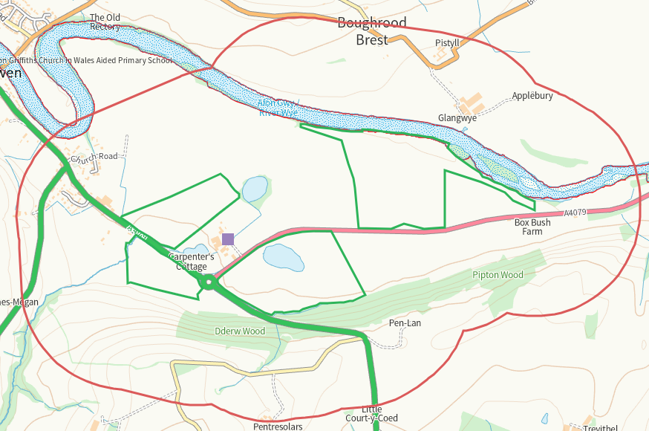  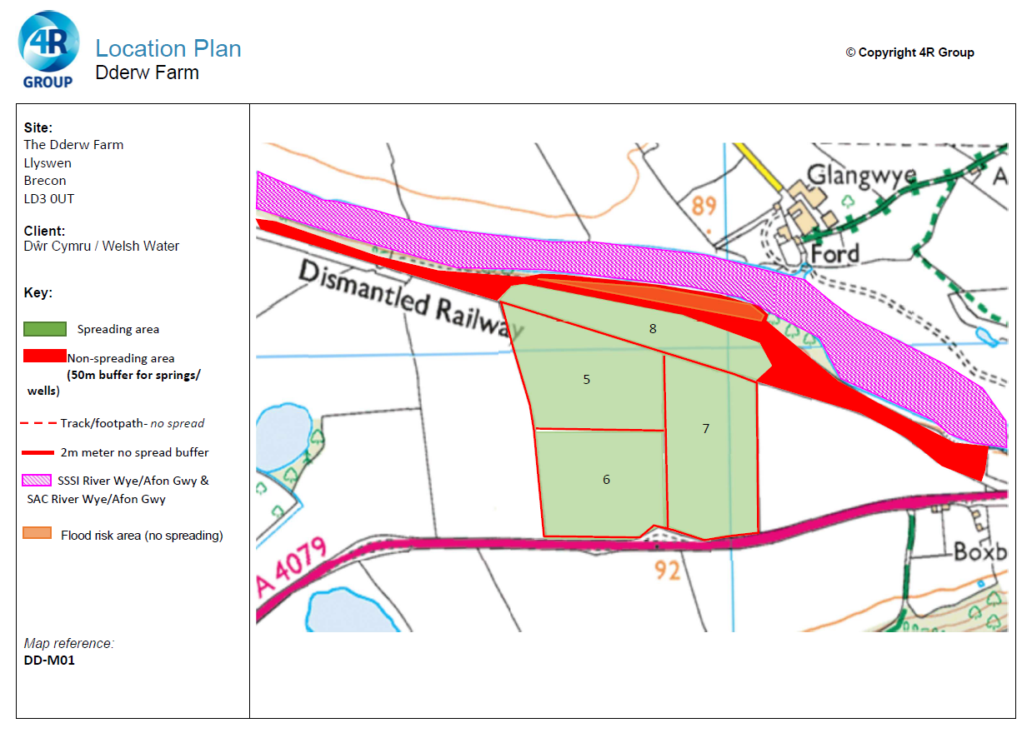  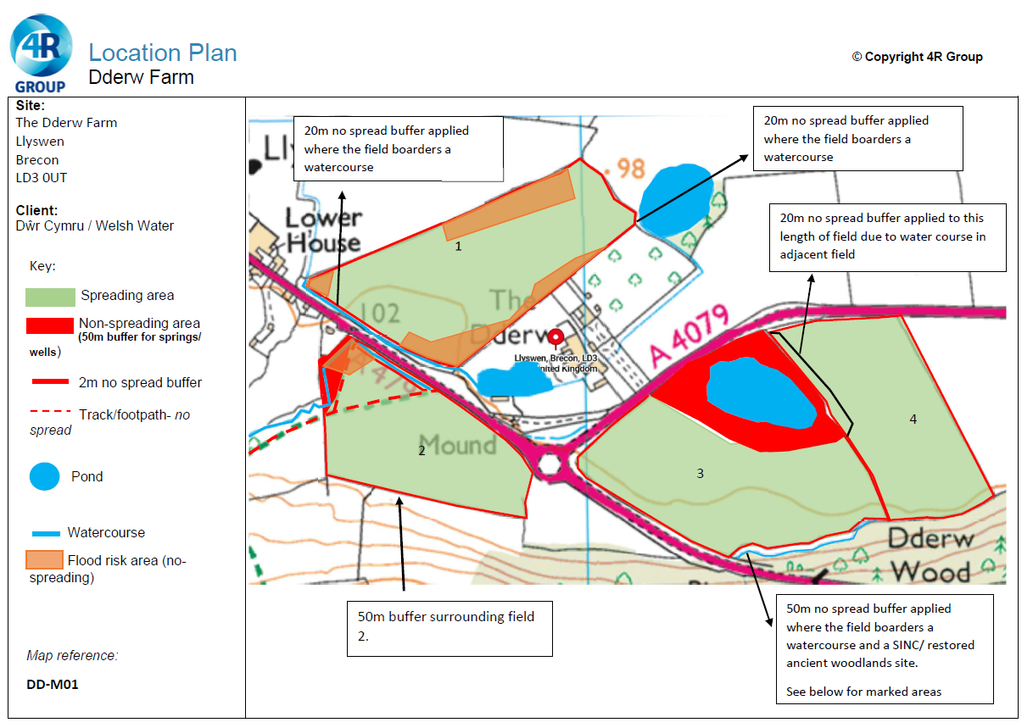  Documents relating to this activity can be found on the DMS
- What aspects of the proposed permission are likely to damage the SSSI features of special interest?

The following activities are likely to cause damage:

5. Application of manure, fertilisers and lime except to agriculturally improved permanent grass, forest and all other unimproved riparian habitats (NOTE- Including woodland and any other natural or semi-natural vegetation).
7. Dumping, spreading, discharging or storage of any materials.
26. Use of vehicles, vessels or craft likely to damage semi-natural habitats or disturb species of interest.

The following SSSI(s) features and potential impacts have been considered to assess the likelihood of damage:
https://cdn.cyfoethnaturiol.cymru/663017/SSSI_1342_Citation_EN00132f4.pdf
https://cdn.cyfoethnaturiol.cymru/663112/SSSI_1342_SMS_EN001f5f7.pdf
• River with moderate nutrient status
• water crowfoot
• rock cinquefoil
• wild chives
• whorled water-milfoil.
• A variety of rare and scarce mosses and liverworts
• Gravel grimmia Grimmia lisae
• Spruce’s bristle moss Orthotrichum sprucei.
• River-jelly lichen.
• Porocyphus kenmorensis.
• Pterigiopsis lacustris.
• Otter
• Wintering goosander.
• Atlantic salmon.
• twaite shad.
• sea lamprey.
• brook lamprey.
• river lamprey.
• bullhead.
• mayfly Potamanthus luteus.
• shingle dwelling invertebrates.

There are a number of factors that could damage the features of the Wye if not properly managed which could be relevant to the proposal as a mechanism of impact.

Water quality, there is potential to damage the listed feature though surface run off and/or leaching from improper spreading methods/accidental spillages close to the SSSI boundary (field 8) which could result in an influx of additional nutrients and/or PTE which could disturb the natural state of the river. Potential detrimental effects include nutrient enrichment leading to changes to the natural flora and fauna and as such harmful impact to the habitat of species present. There is a 20m no spread buffer zone implemted on the border of the field adjacent to the SSSI. This additional distance between the spreading area and the SSSI boundary reduces the risk of run off and the potential for leaching into the watercourse and effecting the water quality. There is a limited section of slope, all of which is within the buffer zone reducing the run-off risk.

Water Quantity has no risk of being affected by this proposal.

Obstructions to migration notes ‘Barriers can also take the form of polluted reaches or reaches subject to noise disturbance.’ As noted above there is a 20m no spread buffer zone in place which would mitigate the potential for tun off into the SSSI and as such an influx of nutrients/ PTE’s to the waterway. In addition this physical barrier would reduce the noise pollution imposed on the SSSI, machinery turns are not executed in the buffer strips which would minimise the noise and vibration.

Management of River banks, Engineering works/ gravel extraction, Fishery management and Invasive alien species have no relevance to this activity.

Disturbance is noted as a mechanism of impact. This specifically relates to the Noise sensitive Shads and the Otters at sensitive breeding times. As noted above the buffer zones would reduce the noise disturbance to the Shad with a physical barrier. In addition, the Site Specific Risk Assessment states ‘Sensitive breeding seasons for species relevant will be avoided as well as COGAP advice limiting spreading in winter.’

Recreation and Alder disease have no relevance to this proposal.

Catchment management states ‘Fertilizer application to land adjacent to watercourses in the wider river catchment may result in nutrient run-off and enrichment of the river system.’
Due to the mitigation described in the application any impact to catchment management is removed.

The activities are not likely to damage the SSSI.
- Summary of any informal advice received from internal experts (if required and including pre-app advice) | N/A
- Recommendation | The proposed permission is not likely to damage any of the flora, fauna or geological or physiological features which are of special interest.  No impact pathways have been identified to SSSI River Wye (Upper Wye) due to the waste types, method and timing of spreading, low application rate and suitable no spread buffers to field boundaries and watercourses.  The application method of low trajectory splash plate is appropriate for the nature of the waste.  The wastes will be applied following the Codes of Good Agricultural Practice.  All handling of the wastes will be done in accordance to current regulations and relevant mitigation strategies will be adopted.  No waste will be spread within 10m of any ditch, pond or surface water, within 50m of any spring, well, borehole, or reservoir that supplies water for human consumption or farm dairies.  No waste will stored during the activity.  Mitigation measures (in addition to permit requirements and following the EMS) to reduce potential negative impacts of the proposed spreading operation will be as follows:  Where potential flood risk exists suitable no spread buffers are in place.  Spreading will only be undertaken when weather conditions are suitable within restrictions outlined in CoGAP and any relevant closed periods.  Spreading will not be carried out in any areas of a field that will be sub-soiled.  Machinery operations will take account of soil conditions, slopes etc.  Liquid spreading machinery will be turned off and lifted away from soil prior to turning at the end of each run.  Machinery will be checked daily when in use, regularly serviced and spreading equipment calibrated. Umbilical hoses will be regularly checked for damage to prevent leaks.  Machinery turns will not be executed in the buffer strips.  All spillages will be reported immediately to NRW.  Buffer zones as depicted in the spreading maps have been implemented and will be abided by to protect adjacent sites.
- Signature and date assessment made | Bryan Burn, 30/12/25
- Officers name and job title | Bryan Burn, Permitting Officer

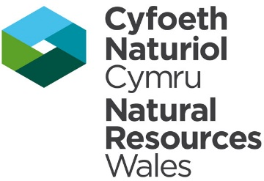
Permitting
Formal Notification under Section 28I of the Wildlife and Countryside Act 1981

Part 2 Formal notification under S28I – To be completed for all permit applications assessed as: not likely to damage because of conditions, likely to damage SSSI and those where we are unable to conclude no likely damage.

- Date Notice of intention to permit activity likely to damage SSSI sent to NRW (SCNB)  If you assess activity as being likely to damage even if you think this can be mitigated by conditioning you need to formally notify SNCB send them a copy of this notice with part 1 of this form. Environment teams have 28 days to respond.  Environment teams please complete question 11 and 12 using the information in questions 1-9 | Insert date  We have assessed that [permit ref/name of site] is likely to damage [insert name of SSSI] and request your formal advice. We have assessed that this damage could be mitigated by including conditions[remove if not applicable].  Or  We are unable to conclude that [permit ref/name of site] is not likely to damage [insert name of SSSI] and request your formal advice.  Information on the permit application can be found in Part 1 of this form and [include link to DMS documents if required]
- Advice received from NRW (SNCB)

Environment Teams and Marine Area Management and Advice Teams are expected to log and issue formal statutory advice through our CAMS system. The advice letter generated can simply by attached/appended here. ET/MAAMT can just refer to that here or write a summary of advice here too.

To be completed by environment officers.
Within 28 days of receiving notice from a permitting/licensing regime, you should advise whether the operation:
• Should be allowed to proceed.
• Should be allowed to proceed with certain conditions.
• Should not proceed.

Please ensure all advice provided is evidenced and comprehensive. Advice provided may be scrutinised as part of a formal appeal.

- Name and job title of conservation/marine officer (sign and date)
Part 3 – To record NRW decision following SNCB Advice
- DECISION  Provide reasoning for your decision and how you have considered advice from NRW(SNCB) in the box opposite and delete text in blue that is not relevant. This might be the same as the info and decision in part 1 of the form  Large amounts of supporting information can be appended to this form. | The proposed permission is not likely to damage any of the flora, fauna or geological or physiological features which are of special interest  The permission is not likely to damage any of the flora, fauna or geological or physiological features which are of special interest because of conditions  The permission is likely to damage
- Natural Resources Wales (Section 28G Authority) (permitting service) is minded to  Delete as appropriate  If this decision is not in line with advice received from NRW(SNCB) please outline your reasoning (please note that you should try to resolve any differences in opinion) | Issue the permission  Issue the permission with conditions to ensure no damage to SSSI  Refuse the permission due to likely damage to SSSI
- Is decision in line with advice from SNCB  If your decision is not in line with the recommendations from SNCB you must formally notify them using the appropriate online form or letter.  Record the date the notice/letter was sent opposite and save a link. The permitted operation cannot commence for 21 days following service of this notice. | Yes/No  If No record date notice was sent to SNCB
- Signature and date assessment completed
- Officers name and job title

