Annex (iv) – SSSI Assessment Form
SSSI Assessment for permit/licence and deployment applications | 
To be completed by Permitting Officers for any applications for a permission which Natural Resources Wales has considered under S28I duty to notify SNCB and take their advice into account. This applies to all proposed permissions within a SSSI, and to operations outside the SSSI boundary which are likely to damage its special features.
NRW as a Section 28G authority has, when exercising its functions, a general duty to take reasonable steps, consistent with the proper exercise of its functions, to further the conservation and enhancement of the flora, fauna or geological or physiological features by reason of which the site is of special interest’

Part 1 – SSSI Assessment
Part 2 – Formal notification to SNCB (to be completed if part 1 assessment concludes likely damage, not likely to damage because of conditions or you cannot conclude no likely damage)
Part 3 – Decision
Pink text – drafting notes, to be deleted before completion/consultation.
Blue text – examples, to be replaced with permission-specific information and text turned to black.

Part 1 – SSSI Assessment

- Permitting officer/team | Bryan Burn, Waste Permitting
- Permit application reference and site name | PAN-031163 Henllys  Llanfair TH, Abergele , Conwy. LL22 8TF
- a. SSSI name(s)  b. location  c. NRW Operational Area/Environment Team | a. Coedydd Derw Elwy  b. Conwy  c. North West / Environment team 15
- Brief description of proposal | Landspreading deployment under standard rules permit SR2010 No4  The activity is not wholly or partly within the SSSI boundaries. The SSSI is approximately 456metres NE of field 21.  Land spreading application to spread a total of 10 non stackable waste streams coded EWC 19 09 02 on land at Henllys, Llanfair TH, Abergele , Conwy. LL22 8TF. The fields are within a 10-mile radius of the main farm address. The wastes will be spread on grass fields. The maximum application rate is 250 tonnes per ha, with a maximum tonnage to spread of 12500 tonnes across all feilds.  The waste will be spread over 50 ha hectares of land within the listed fields. One waste will stored in a lagoon under a separate permit prior to spread and other wastes spead on delivery. The wastes will be spread via tractor and tanker with dribble bar which is an appropriate application method for the waste type.  Spreading activities will also comply with the Spreading activities will also comply with The Water Resources (Control of Agricultural Pollution) (Wales) Regulations 2021.  Targeted periods of spreading on grass fields are from February, through May and after cutting of silage (June-October) as per the RB209 (2023).  No more than 50t/ha of waste will be spread on a field in any 3-week period in accordance with CoGAP, and no more than 250t/ha will be spread within any 12-month period. The number of times a waste will be spread will be dependent on the total tonnage divided by the max application rate (50t/ha in 3 weeks).  The waste may be applied separately or in combination. If the wastes are applied in combination the total combined amount applied will not exceed 250 t/ha, the total nitrogen loading will be less than 250 kg/ha, and the amount of available nitrogen and total or available phosphate and potash (whichever is appropriate) will not exceed the fertiliser recommendation or the amount removed in crop offtake, whichever is the greater.  Only fields which have soil pH 6 or above can receive alum-based sludge. Therefore, there will be no application of alum-based sludge on fields 3,5,11,12,15,17,20 and 21 in this deployment.  Notification will be given prior to the commencement of spreading.  The landspreading activity will comply with CoGAP.  Farm location  SH 90856 69553  Field locations  1 SH 89879 67828  2 SH 89952 67762  3 SH 89760 67671  5 SH 90003 67569  7 SH 90128 67258  11 SH 89801 67059  12 SH 89684 67282  13 SH 89623 67140  14 SH 89683 66937  15 SH 90419 67561  17 SH 90094 67992  18 SH 90212 68300  19 SH 90203 68539  20 SH 90466 68572  21 SH 90533 68931  Fields 12 & 15 will be requested to be removed from the application due to considerable steeply sloping ground but only field 21 is within range.  Storage location under separate permit  SH 90012 67791  Location map  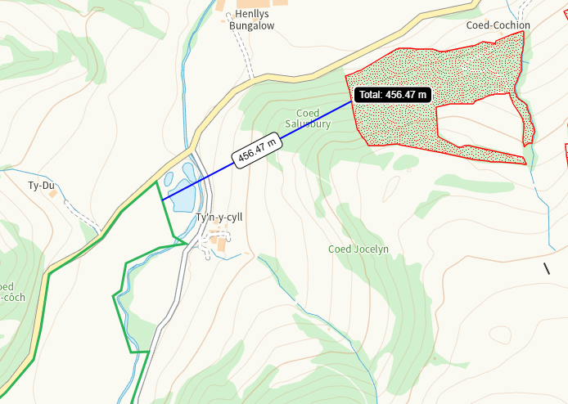  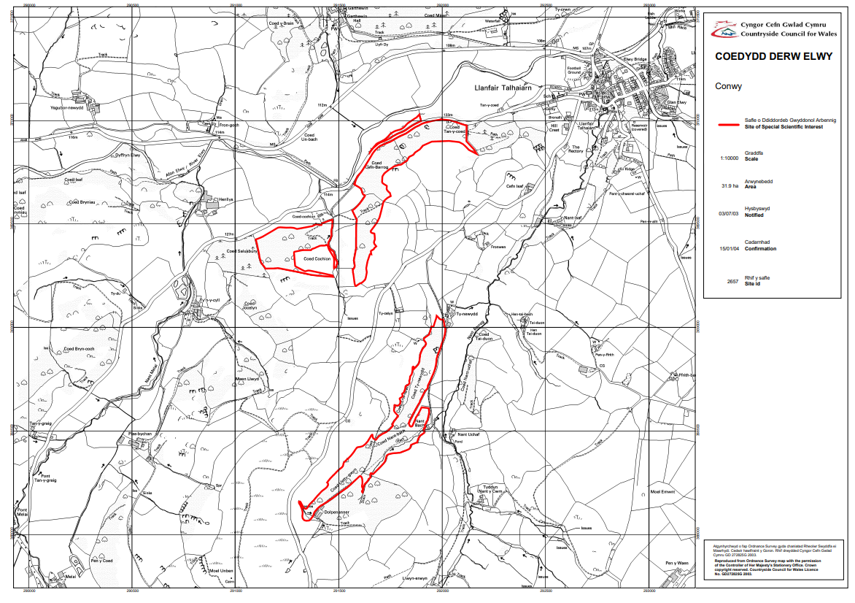  Documents relating to this activity can be found on the DMS
- What aspects of the proposed permission are likely to damage the SSSI features of special interest?

The following activities are likely to cause damage:
https://cdn.cyfoethnaturiol.cymru/668647/SSSI_2657_Citation_EN0012eac.pdf
https://cdn.cyfoethnaturiol.cymru/668672/SSSI_2657_SMS_EN001bf86.pdf

4. Mowing or cutting vegetation, the introduction of mowing
5. Application of manure, slurry, silage liquor, fertilisers and lime
7. Dumping, spreading or discharging of any materials
22. Storage of materials.
26. Use of vehicles likely to damage woodland vegetation.

The following SSSI(s) features and potential impacts have been considered to assess the likelihood of damage:

• Semi-natural broadleaved woodland
As well as the feature shown above, Coedydd Derw Elwy has other habitats that are essential
to the maintenance of the special wildlife interest. These include streams, scrub and small
rock outcrops. This diversity of habitats similarly supports a wide range of species and these
too are a key component of the special interest of the site

The nearest spreading areas is approximately 456m downslope of the SSSI.

The activities are not likely to damage the SSSI.
- Summary of any informal advice received from internal experts (if required and including pre-app advice) | n/a
- Recommendation | The proposed permission is not likely to damage any of the flora, fauna or geological or physiological features which are of special interest  No impact pathways have been identified to the SSSI due to the waste types, method and timing of spreading, distance and local topography and suitable no spread buffers to field boundaries and watercourses.  The application method of dribble bar is appropriate for the nature of the waste.  The wastes will be applied following the Codes of Good Agricultural Practice.  All handling of the wastes will be done in accordance to current regulations and relevant mitigation strategies will be adopted.  No waste will be spread within 10m of any ditch, pond or surface water, within 50m of any spring, well, borehole, or reservoir that supplies water for human consumption or farm dairies as per permit conditions.  Spreading will only be undertaken when weather conditions are suitable within restrictions outlined in CoGAP and any relevant closed periods.  Spreading will not be carried out in any areas of a field that will be sub-soiled.  Machinery operations will take account of soil conditions, slopes etc.  Liquid spreading machinery will be turned off and lifted away from soil prior to turning at the end of each run.  Machinery will be checked daily when in use, regularly serviced and spreading equipment calibrated. Umbilical hoses will be regularly checked for damage to prevent leaks.  Machinery turns will not be executed in the buffer strips.  Waste deliveries to field/stores will be supervised.  All spillages will be reported immediately to the NRW.
- Signature and date assessment made | Bryan Burn 02/01/26
- Officers name and job title | Bryan Burn, Permitting Officer


Permitting
Formal Notification under Section 28I of the Wildlife and Countryside Act 1981

Part 2 Formal notification under S28I – To be completed for all permit applications assessed as: not likely to damage because of conditions, likely to damage SSSI and those where we are unable to conclude no likely damage.

- Date Notice of intention to permit activity likely to damage SSSI sent to NRW (SCNB)  If you assess activity as being likely to damage even if you think this can be mitigated by conditioning you need to formally notify SNCB send them a copy of this notice with part 1 of this form. Environment teams have 28 days to respond.  Environment teams please complete question 11 and 12 using the information in questions 1-9 | Insert date  We have assessed that [permit ref/name of site] is likely to damage [insert name of SSSI] and request your formal advice. We have assessed that this damage could be mitigated by including conditions[remove if not applicable].  Or  We are unable to conclude that [permit ref/name of site] is not likely to damage [insert name of SSSI] and request your formal advice.  Information on the permit application can be found in Part 1 of this form and [include link to DMS documents if required]
- Advice received from NRW (SNCB)

Environment Teams and Marine Area Management and Advice Teams are expected to log and issue formal statutory advice through our CAMS system. The advice letter generated can simply by attached/appended here. ET/MAAMT can just refer to that here or write a summary of advice here too.

To be completed by environment officers.
Within 28 days of receiving notice from a permitting/licensing regime, you should advise whether the operation:
• Should be allowed to proceed.
• Should be allowed to proceed with certain conditions.
• Should not proceed.

Please ensure all advice provided is evidenced and comprehensive. Advice provided may be scrutinised as part of a formal appeal.

- Name and job title of conservation/marine officer (sign and date)
Part 3 – To record NRW decision following SNCB Advice
- DECISION  Provide reasoning for your decision and how you have considered advice from NRW(SNCB) in the box opposite and delete text in blue that is not relevant. This might be the same as the info and decision in part 1 of the form  Large amounts of supporting information can be appended to this form. | The proposed permission is not likely to damage any of the flora, fauna or geological or physiological features which are of special interest  The permission is not likely to damage any of the flora, fauna or geological or physiological features which are of special interest because of conditions  The permission is likely to damage
- Natural Resources Wales (Section 28G Authority) (permitting service) is minded to  Delete as appropriate  If this decision is not in line with advice received from NRW(SNCB) please outline your reasoning (please note that you should try to resolve any differences in opinion) | Issue the permission  Issue the permission with conditions to ensure no damage to SSSI  Refuse the permission due to likely damage to SSSI
- Is decision in line with advice from SNCB  If your decision is not in line with the recommendations from SNCB you must formally notify them using the appropriate online form or letter.  Record the date the notice/letter was sent opposite and save a link. The permitted operation cannot commence for 21 days following service of this notice. | Yes/No  If No record date notice was sent to SNCB
- Signature and date assessment completed
- Officers name and job title

