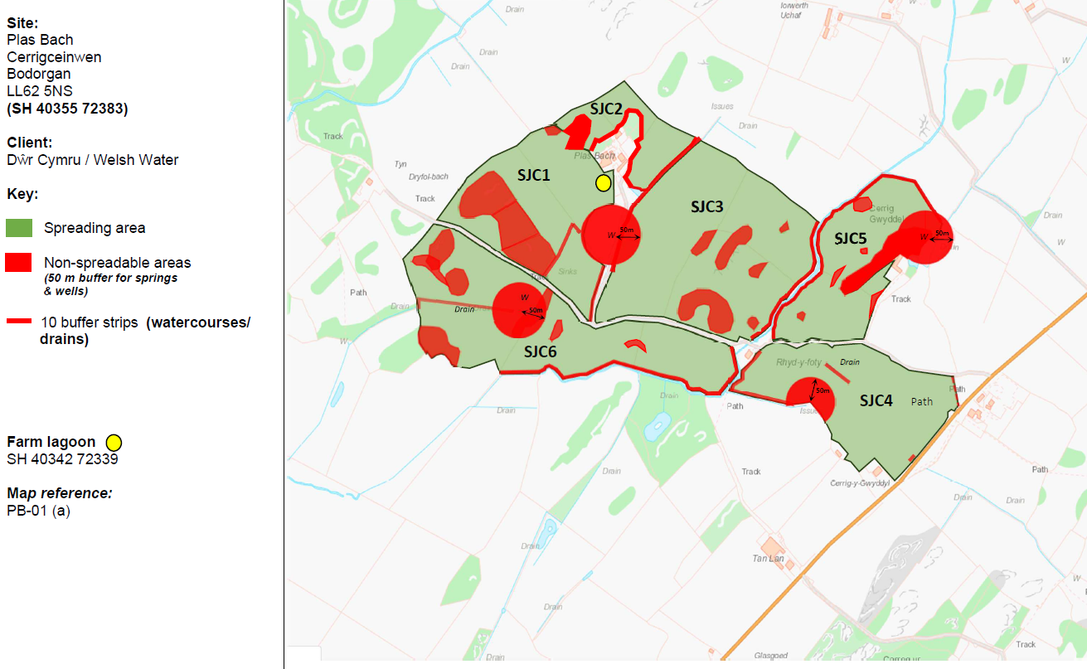
PAN-031280 My Map Report:

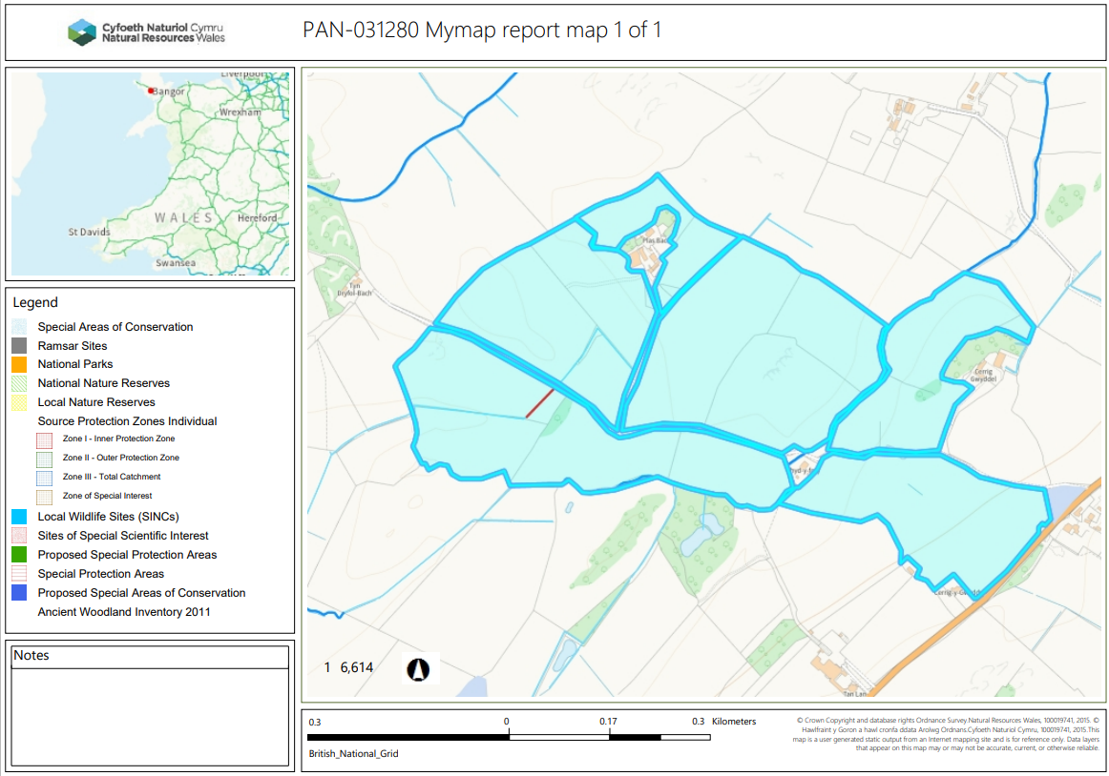
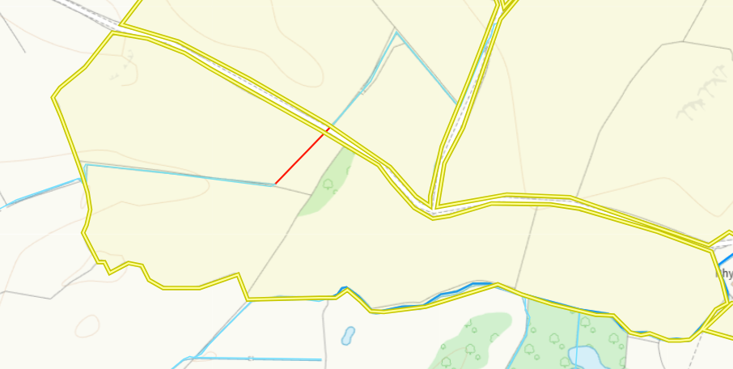
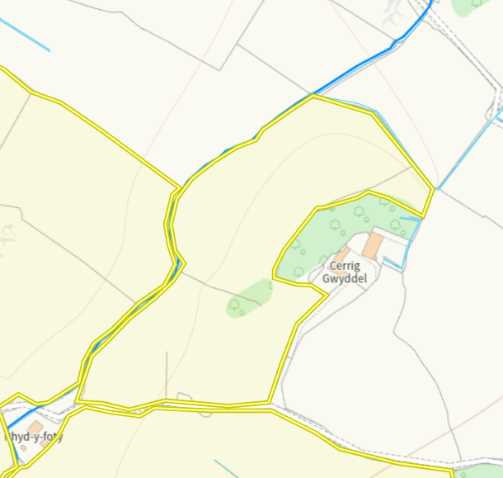
Detailed river network:
Fields SJC3 & SJC5 border a water course. These field boundaries contain a 10 meter no spread buffer zone to prevent wastes entering the watercourse.
Field SJC6 contains a water course and also borders one. There are 10 meter no spread buffer zone to prevent wastes entering the watercourse.

Groundwater protection zones (source) none in range.

Wells, springs or boreholes used for the supply of water for human consumption including from a private water supply or supplies
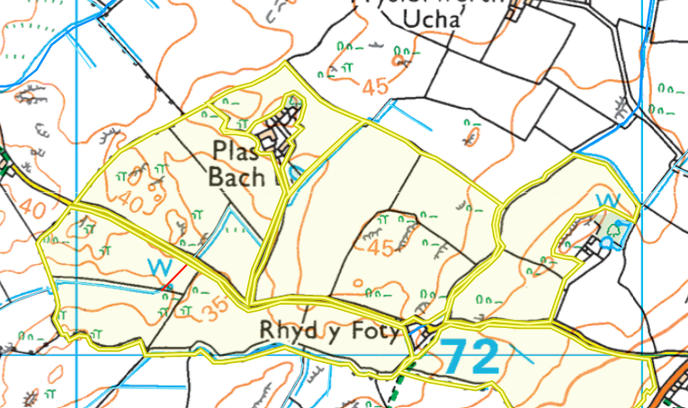
Fields SJC6, SJC5 & SJC1 contain wells. There are 50 meter no spread buffer zones to mitigate waste contaminating the wells in accordance with SR2010no4.

any springs wells or boreholes not used to supply water for domestic or food production purposes within - 50m - None in range.

European designated sites- Natura 2000 (SPA, pSPA, SAC or cSAC) or Ramsar- or SSSI within 500m

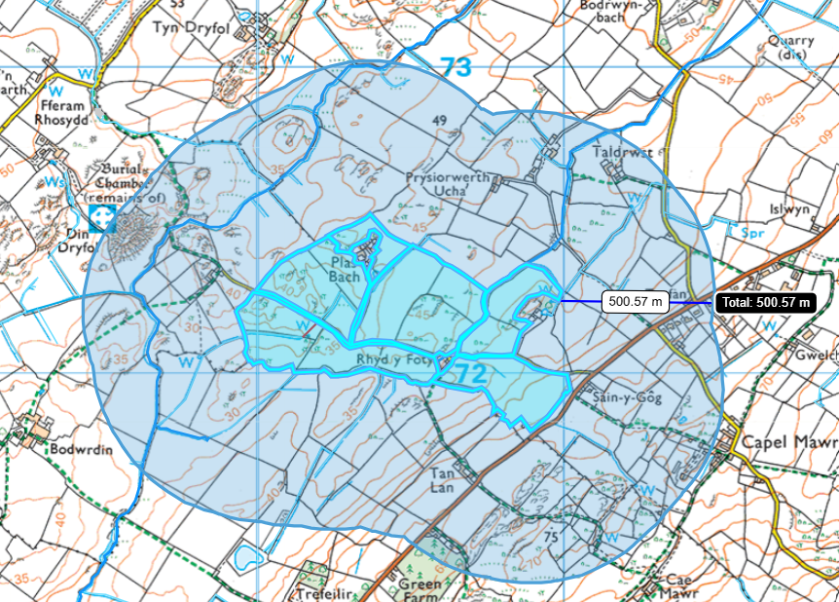
The fields are not within 500 meters of a SSSI, SAC, SPA or Ramsar. The deployment is therefore a medium risk (1) deployment. A partial refund will be required as the applicant has paid for a high risk deployment.

Other protected sites:
- Protected Species- None in range.

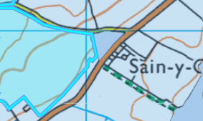
- Protected Habitats-
Field SJC4 borders a protected habitat: Lowland dry acid grassland and Lowland calcareous grassland. There is an 10 meter no spread buffer zone in place along the border top prevent wastes entering the habit. No further action required.

- Scheduled Ancient Monument- None in range.

- Local Nature Reserve- None in range.

- National Nature Reserve- None in range.

- Ancient Woodlands- None in range.

- Local Wildlife Sites (SINC)- None in range.

- National Park- None in range.

- Groundwater Safeguard Zone- None in range.

- Hedges- nothing of concern.

- Ditches- see slope map below.

Flooding risk
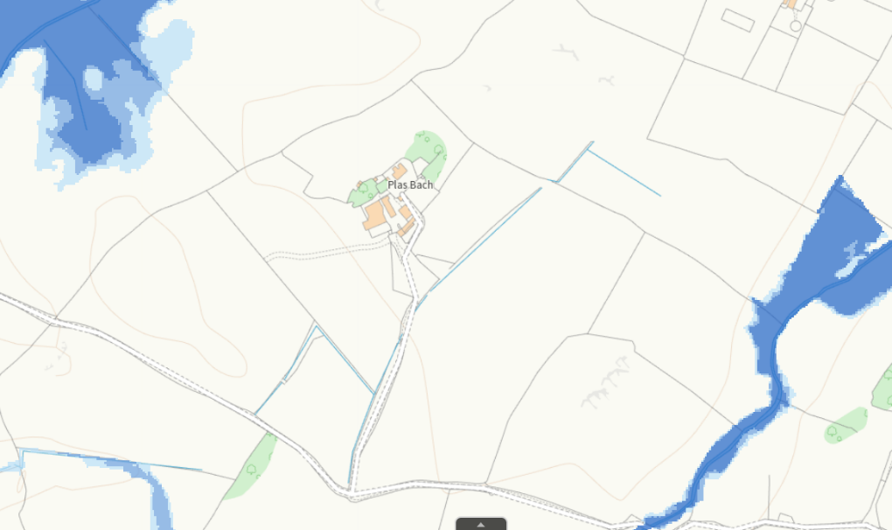

Field SJC3 & fields SJC5 contains an area that is high risk of flooding from small water courses. The deployment application has included a 10 meter no spread buffer zone around the watercourse to mitigate the risk of potential flood waters encroaching on the spreading fields. The mitigation given has been concluded as appropriate requiring no further action required.

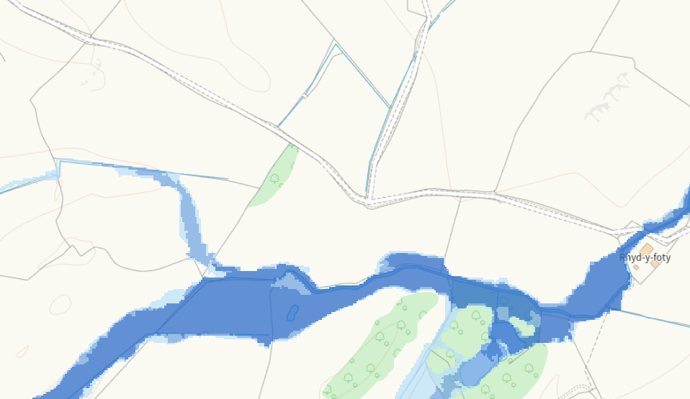

Field SJC6 contains an area that is high risk of flooding from small water courses. The deployment application has included a 10 meter no spread buffer zone around the watercourse to mitigate the risk of potential flood waters encroaching on the spreading fields. The mitigation given has been concluded as appropriate requiring no further action required.

Slope Map
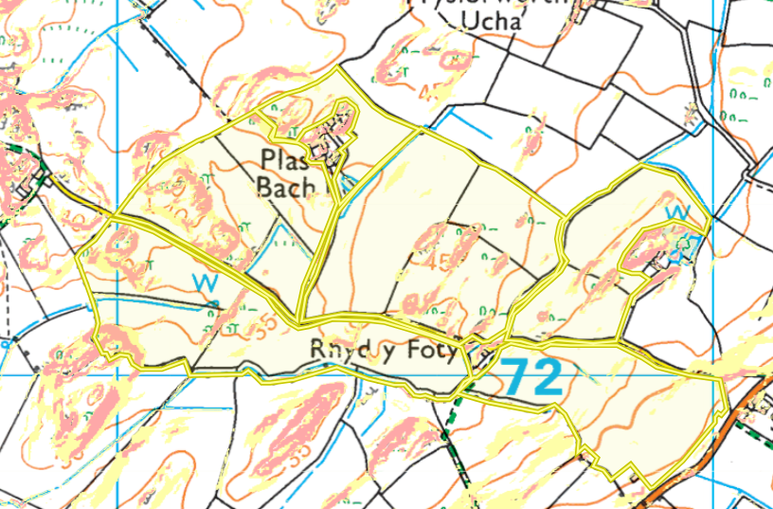
Field SJC1, SJC2, SJC3, SJC5 and SJC6 contains partial areas of highly sloping land 12º+. Theses areas have been buffered out of the deployment with no spread buffer zones to mitigate runoff risk. No further action required.

Field SJC1, SJC3, SJC5 and SJC6 contains partial areas of moderately sloping land 7-12º. These areas have been buffered out of the deployment with no spread buffer zones to mitigate runoff risk. No further action required.
Field SJC4 also contains small areas of moderately sloping land 7-12º but are minimal and contained within the fields. It has been determined runoff risk is low due to this reason.
The deployment will operate in a way to reduce surface runoff and includes:
Using the appropriate application methods for the stackable and non-stackable 19 09 02 waste streams which are rear discharge spreader and low trajectory splash plate respectively. All the fields in this deployment contain partial areas of either highly sloping or moderately sloping land (which have been buffered out the deployment) the majority of the land is in fact located on flat to gently sloping land (0-7º). Due to this runoff risk has been determined as low requiring no further action.
No more than 50t/ha of waste will be spread on a field in any 3-week period in accordance with CoGAP, and no more than250t/ha will be spread within any 12-month period.

