PAN-031341 My Map Report:
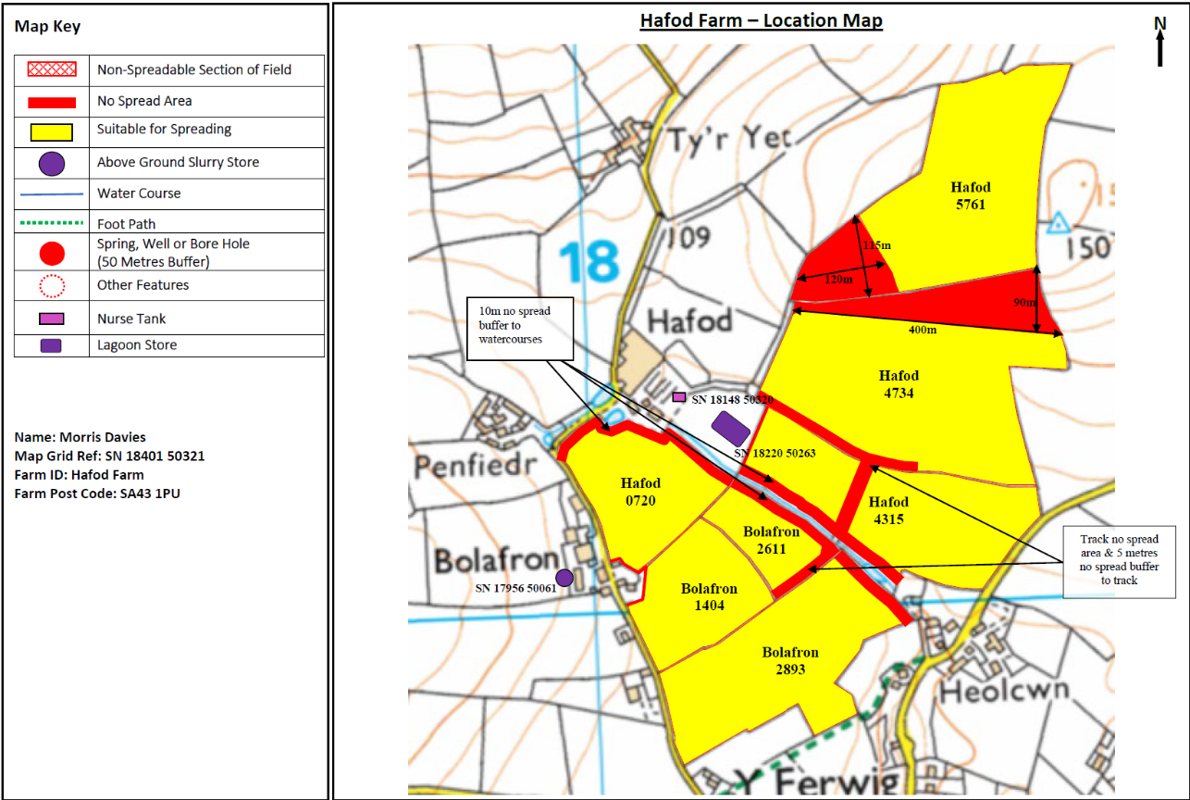
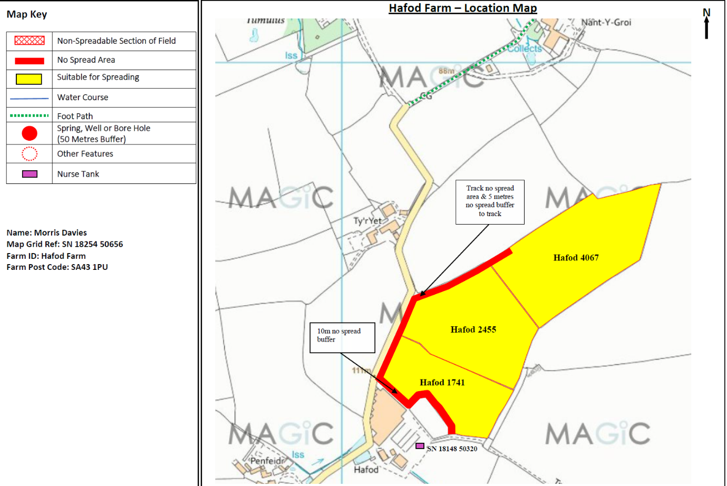

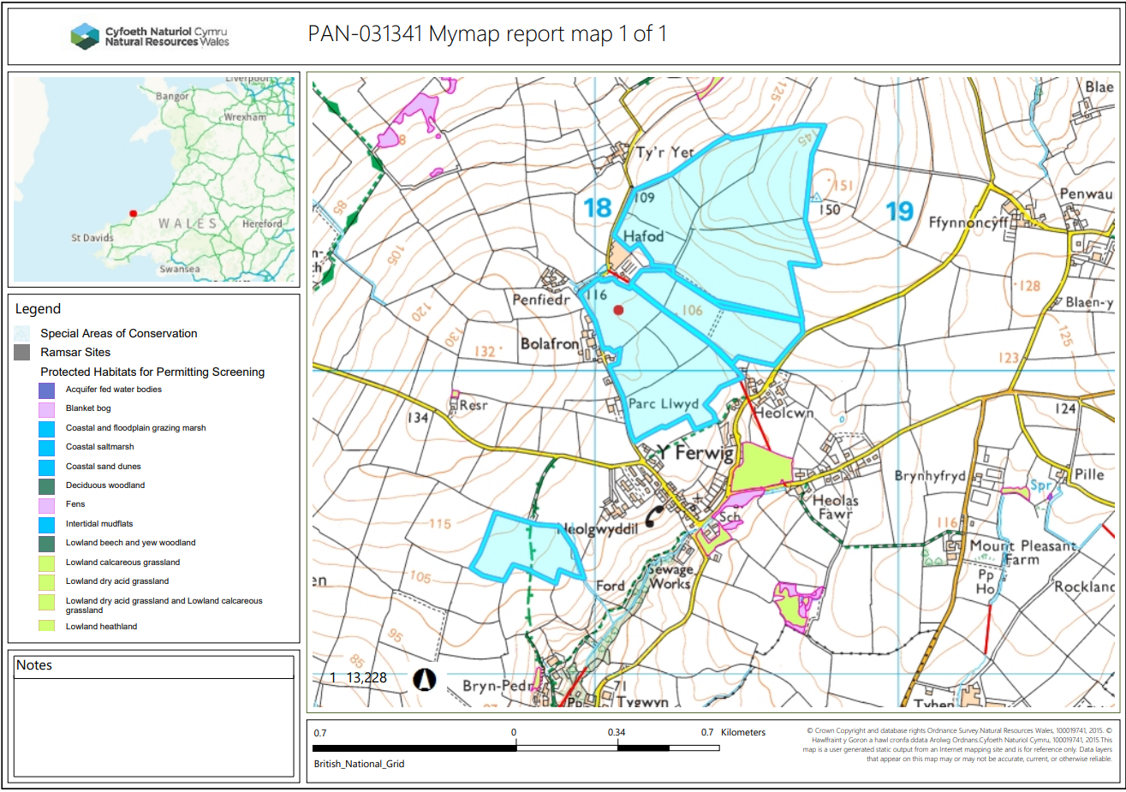
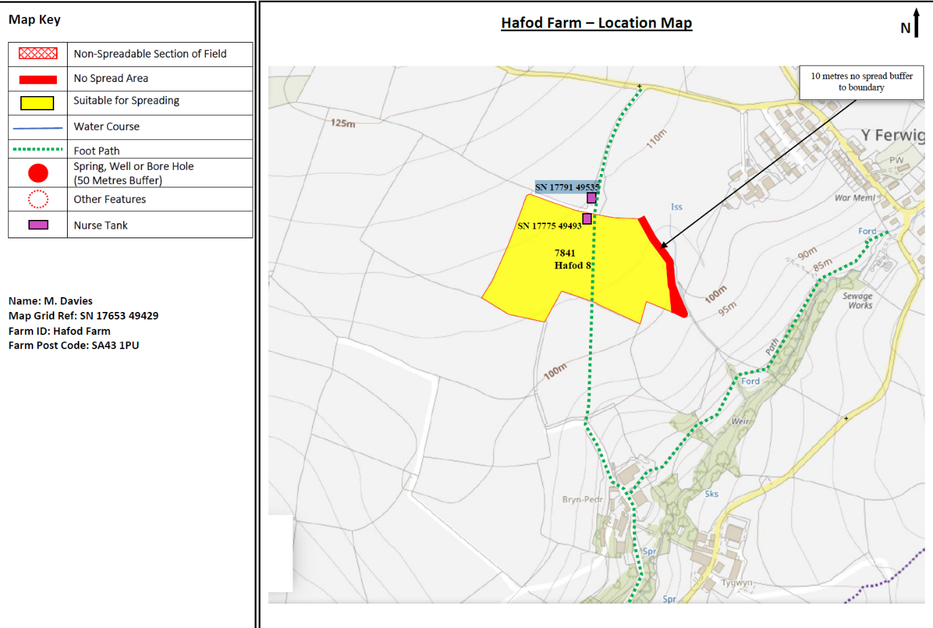
Detailed river network:
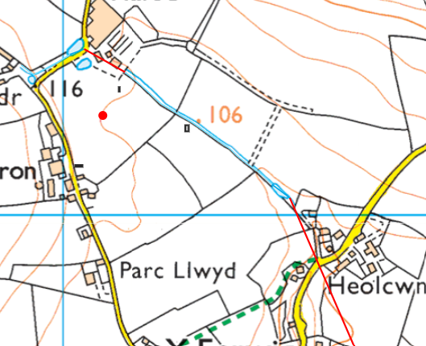
Fields Halford 0720, Bolafron 2611, Bolafron 2893 and Hafod 4315 border a water course. There is a 10 meter no spread buffer zone in place to mitigate the risk of nutrients and or PTEs from entering the water course. This is compliant with the permit conditions of SR2010 no4.

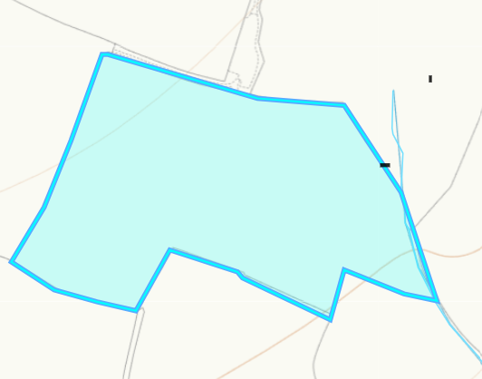
Field 7841 Hafod 8 borders a water course. There is a 10 meter no spread buffer zone in place to mitigate the risk of nutrients and or PTEs from entering the water course. This is compliant with the permit conditions of SR2010 no4.

Groundwater protection zones (source)
None in range.

Wells, springs or boreholes used for the supply of water for human consumption including from a private water supply or supplies
None in range.

Any springs wells or boreholes not used to supply water for domestic or food production purposes within 50m

None in range.

European designated sites- Natura 2000 (SPA, pSPA, SAC or cSAC) or Ramsar- or SSSI within 500m
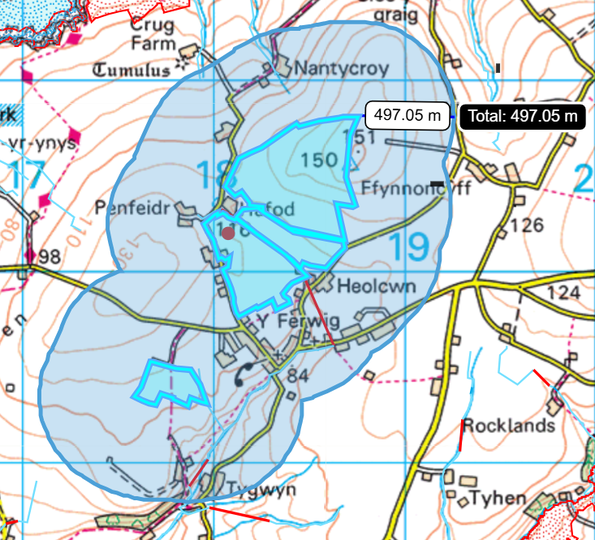
The fields are not within 500 meters of SPA, pSPA, SAC or cSAC) or Ramsar- or SSSI.

Other protected sites:
- Protected Species- None in range.

- Protected Habitats- None in range.

- Scheduled Ancient Monument- None in range.

- Local Nature Reserve- None in range.

- National Nature Reserve- None in range.

- Ancient Woodlands- None in range.

- Local Wildlife Sites (SINC)- None in range.

- National Park- None in range.

- Groundwater Safeguard Zone- None in range.

- Hedges- Nothing of concern.

- Public rights of way – correctly identified in spreading maps above.

- Local residents, Housing, schools, Workplaces, Recreational facilities (odour)
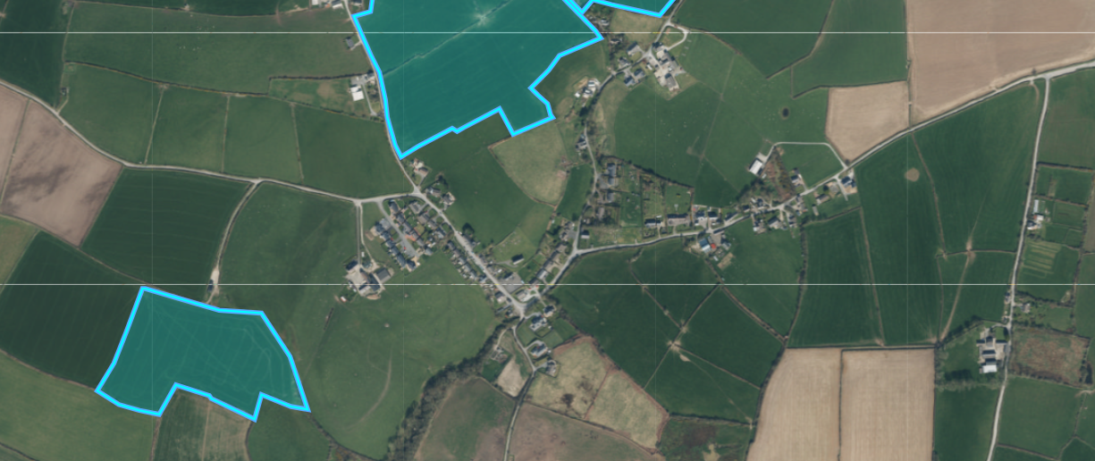
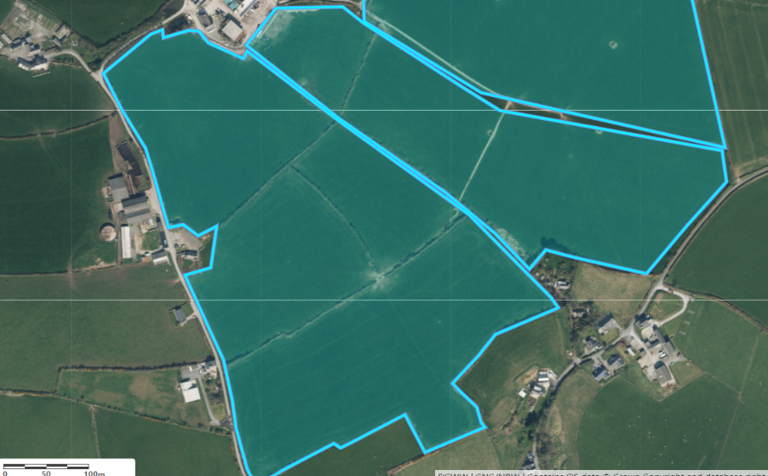
This deployment is proposing to spread odorous wastes (EWC 02 05 02) . Fields 0720, 2893 and 1404 are located close to residential receptors that are likely to be sensitive to odour. The applicant has submitted a odour management plan as part of this deployment application as recommended by TGN 8.01. The submitted odour management plan has been assessed as part of the determination of this deployment and is compliance with the odour guidance. If spreading occurs as outlined in the deployment application and the submitted odour management plan the odour risk can be mitigated.
Field 2893 is located 360 meters from Y Ferwig village which contain a church and a school and various residential receptors which will be sensitive to odour. The applicant has submitted a odour management plan as part of this deployment application as recommended by TGN 8.01. The submitted odour management plan has been assessed as part of the determination of this deployment and is compliance with the odour guidance. If spreading occurs as outlined in the deployment application and the submitted odour management plan the odour risk can be mitigated.

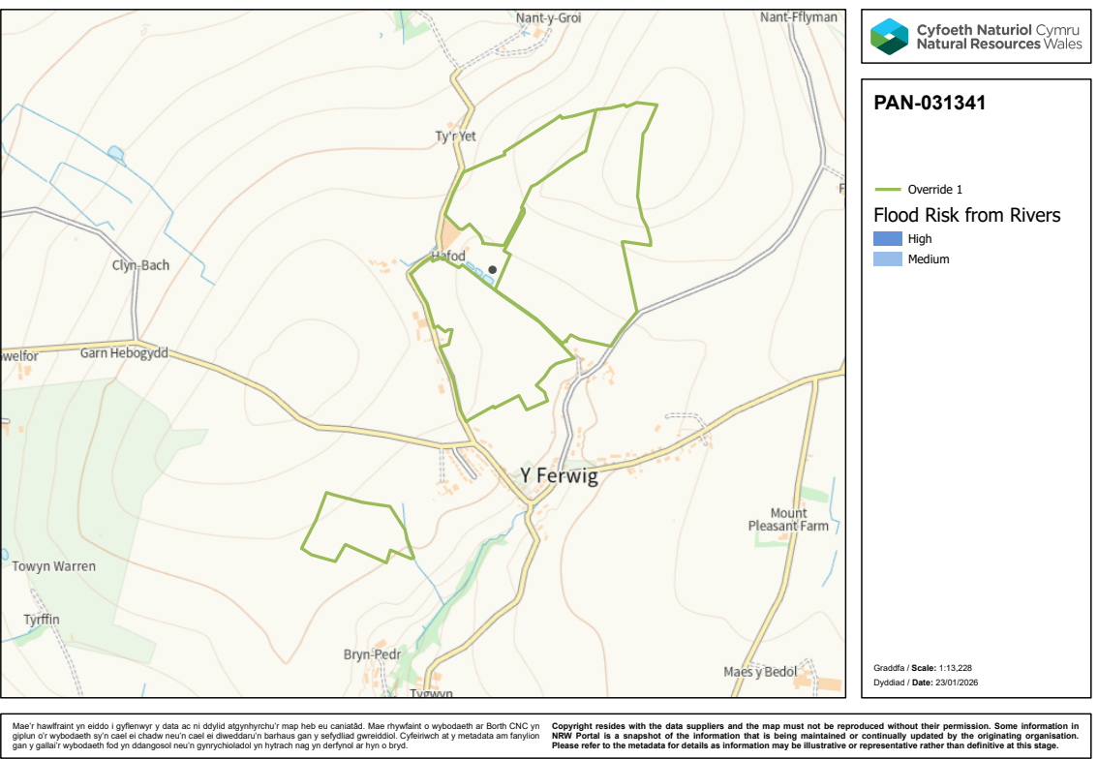
Flood risk
None of the fields proposed for the deployment are located on a flood risk from rivers or seas no action needed.

Slope Map
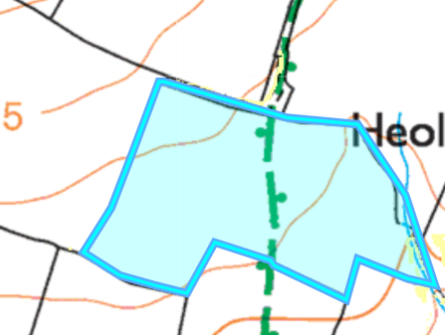
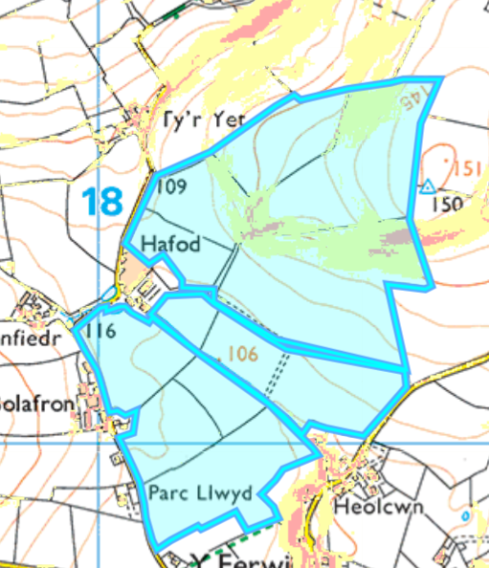
Field 5761, 4315, 2455 have a slope of 7-12º. The surface runoff risk has been determined as low as the majority of the moderately sloping land has implemented no spread buffer zones in the fields. No further action required.

Field 5761 has a slope of 12º + (partially). The surface runoff risk has been determined as low as the highly sloping land has implemented no spread buffer zones in the field. No further action required.
Fields 0720, 1404,1741, 7841, 4077, 2611, 2893 & 4315 are located on flat to gently sloping land (0-7º) and do not pose a surface runoff risk. In addition the wastes to be spread will have an application rate of no more than 50t/ha and will be split into multiple applications. The fields will be spread using precision spreading dribble bar equipment in conjunction with the implemented no spread buffer zones this deployment does not pose a surface runoff risk.

