TASK / JOB | Washing Down Post Dredging Campaign – Grab Dredger (Cherry Sand)
ASSESSED BY | Jac Williams | REFERENCE NUMBER | UKD/BIO/002
DATE OF ASSESSMENT | 23rd January 2026 | REVIEW DUE DATE | 23rd January 2027

Indicate Areas of Ship “at risk” of Carrying INNS due to Dredging or Marine Works
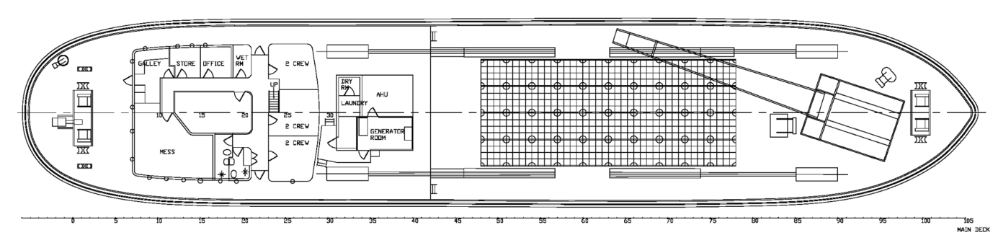
Hopper Area
Crane bucket grab
Deck areas around hopper

Job Step | Risks Identified | Method Statement
On completion of final dredge, wash down of hopper tops and deck areas | Transfer of INNS outside of dredge area. | - Inspect any dredge mud if accessible for flora and fauna, photograph and forward to Bio-Security Manager for identification and recording.  - Remain secured in position if possible and conduct wash down of decks and hopper tops, grid and dredged waste (tyres etc) using buckets of clean water and deck hoses as appropriate.  - Inspect and repeat as necessary.  - Secure crane boom and bucket grab.
En route to deposit, Bucket Grab | INNS within dredge debris contained within grab | - Inspect grab for debris, if necessary use hose to wash grab debris into hopper ensuring that any waste on flow forge is also removed to the hopper.
Prior to Depositing Cargo | Transfer of INNS outside of dredge/deposit area. | - Ensure ship is within deposit area, at no time during depositing cargo is the ship to navigate out of deposit area.
Hopper area | INNS within dredge debris left within hopper | - Open bottom doors to deposit cargo.  - As hopper cannot be pumped dry, leave doors open and if possible steam within deposit area at a speed of less than 5 knots.  - For stubborn material, proceeding full astern will create turbulence within the hopper and will act to clean beneath the waterline.
Post wash down | N/A | - Inspect all areas for debris and hose off.  - Close bottom doors prior to leaving deposit area.  - Record in Logbook

