Date of Plan / Last Review | 23rd January 2026
Date of Next Review | 23rd January 2027

Fleet Composition
UKD Bluefin |  | Type: Trailing Suction Hopper Dredger  IMO Number: 9143427  LOA: 98m  Breadth: 18m  Draft: 5.97m  Hopper Cap: 3900m³ |  | 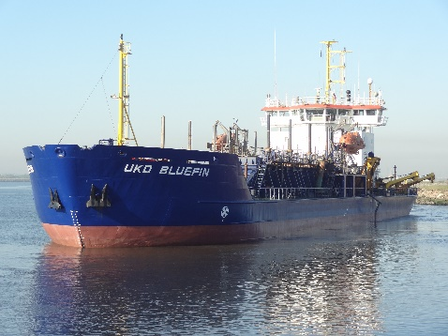
UKD Orca |  | Type: Trailing Suction Hopper Dredger  IMO Number: 9491355  LOA: 78m  Breadth: 15.85m  Draft: 5.953m  Hopper Cap: 2373m³ |  | 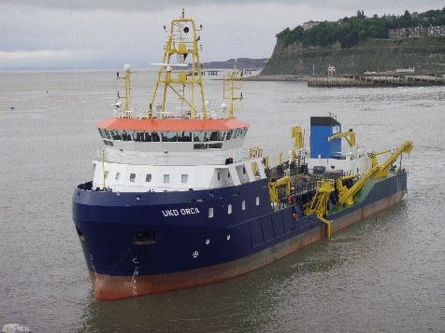
UKD Marlin |  | Type: Trailing Suction Hopper Dredger  IMO Number: 9064176  LOA: 84.6m  Breadth: 16m  Draft: 5.909m  Hopper Cap: 2968m³ |  | 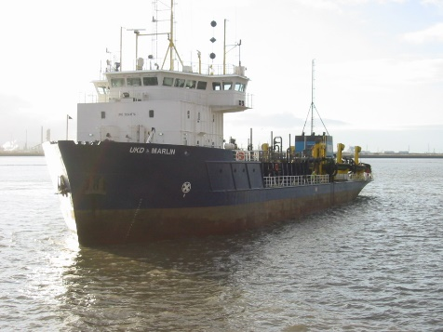
Cherry Sand |  | Type: Hopper Grab Dredger  IMO Number: 6811059  LOA: 62.5m  Breadth: 12.04m  Draft: 54.02m  Hopper Cap: 765m³ |  | 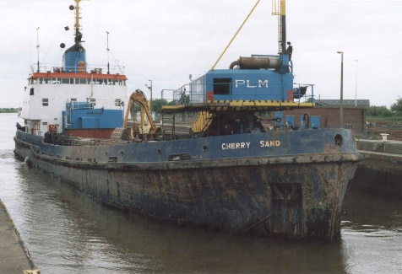
UKD Sealion |  | Type: Multi-cat Workboat with Plough  IMO Number: 9267314  LOA: 25.97m  Breadth: 10m  Draft: 2.24m  Hopper Cap: N/A |  | 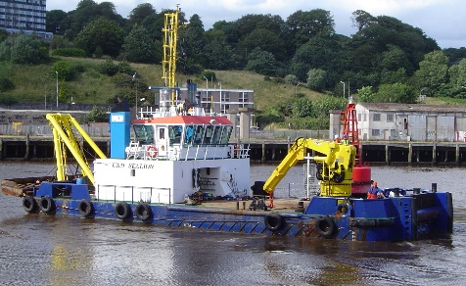
UKD Seahorse |  | Type: Multi-cat Workboat with Plough  IMO Number: 9066655  LOA: 25.97m  Breadth: 10m  Draft: 2.24m  Hopper Cap: N/A |  | 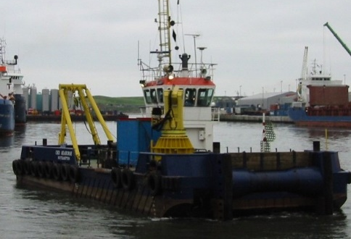
UKD Resolution |  | Type: Coded Survey Vessel (Kept out of water)  LOA: 5.80m  Breadth:  Draft: 0.60m  Hopper Cap: N/A |  | 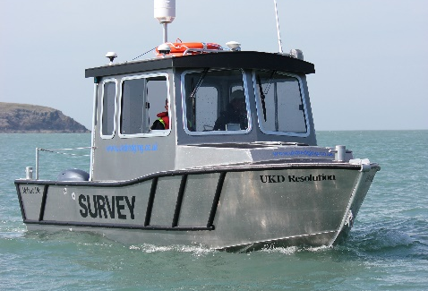
UKD Seadragon | Type: Plough and water injection  IMO Number: 1020370  LOA: 27.05m  Breadth: 11.6m  Draft: 2.55m  Hopper Cap: N/A |  | 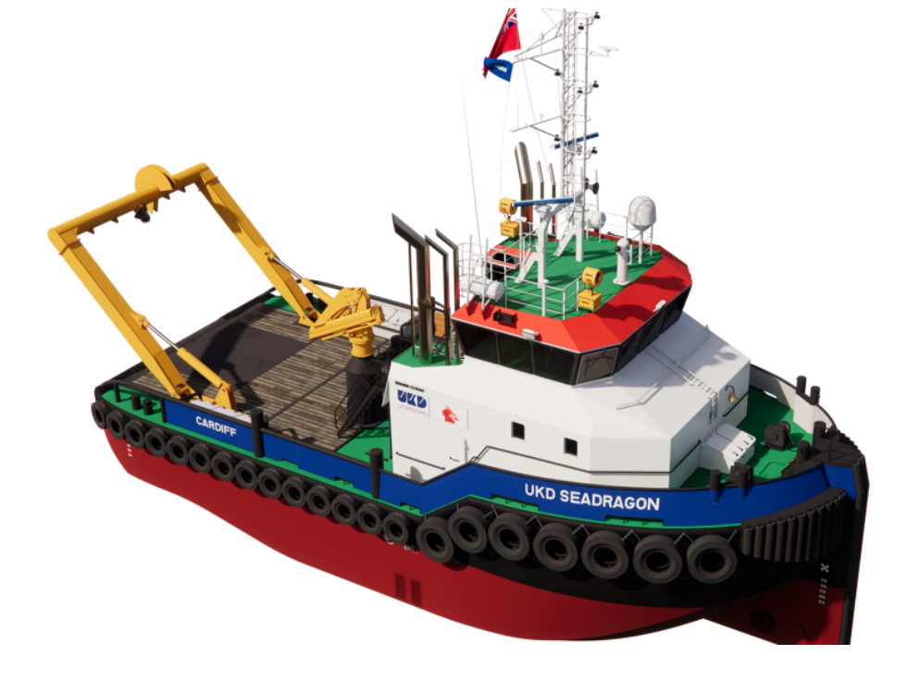

On-board Biosecurity Responsibilities
Master | Overall Responsibility for Biosecurity on-board. Accommodation, Food & Water Inspections.
Mate | Deck Maintenance, Potable Water Hygiene, Ballast Water Management.
Chief Engineer | Machinery and Plant Maintenance.
Head Office Responsibilities
General Manager | Assigning Biosecurity Functions, Signing Off Biosecurity Plans.
Safety & Compliance Manager | Responsibilities as Biosecurity Manager
Technical Manager | Control of Maintenance Budgets, Dry Dock Management.
Interested Parties | Contact Details | Specific Interest / Knowledge
ABP Group Compliance | atinline@abports.co.uk | Advice and guidance on INNS
ABP Clients | Various | Prevention of vessel as a pathway for INNS
Third Part Clients | Various | Prevention of vessel as a pathway for INNS
Port State | MCA in UK, otherwise various | Compliance with relevant legislation
MMO | info@marinemanagement.org.uk | Control of Marine INNS / Licensing
NRW | enquiries@naturalresourceswales.gov.uk | Control of Marine INNS / Licensing
GB NNS Secretariat | nnss@apha.gsi.gov.uk | Recording of INNS

Bio-Security Risk Assessment
Source | Pathway | Untreated Risk | Legislation | Preventative Measures | Responsibility | Residual Risk
Ballast Water  (Bluefin, Marlin, Cherry Sand, Sealion & Seahorse) | Discharge directly to Sea | Medium | BWMC and associated national legislation | Follow approved ballast water management plan. | Master, Mate | Low
Ballast Water (Orca) | Discharged to Sea via Treatment plant | Low | BWMC and associated national legislation | No further measures required |  | Low
Ballast Sediment | Discharged during docking | Low | BWMC and associated national legislation | Follow approved ballast water management plan. | Master, Technical Manager | Low
Clean Hopper Water Carried as Ballast | Discharge directly to Sea | Low |  | Limiting amount carried. Before each new dredging campaign/and or when moving to a different region, once clear of harbour and outside shallow waters, conduct full exchange of hopper water so that at least 95% volume exchange is achieved. If unable to empty hopper due to weather, 95% volumetric exchange can be achieved by pumping through three times the volume of the hopper in accordance with the ballast water Management convention. Pump water out prior to arrival at destination port. | Master, Mate | Low
Mud Residues from Dredging Operations | Discharge directly to sea | High |  | Clean hopper, dredge equipment and plough prior to sailing from port before each new dredging campaign/and or when moving to a different region. Photograph and report any fauna & flora dredged up. Identify, record and report if INNS discovered. | Master, Bio-security Manager | Low
Fresh (Potable) Water | Discharge directly to Sea | Low | International Health Regulations 2005 | Application of chlorine, monitoring levels in accordance with Integrated Management System 3.1.18 – Fresh Water Management. | Mate | Low
Biofouling of Ships Hull | In water | Medium | MS (Bio-Fouling Systems) Reg 2009 | Use of certified anti-foul paint system, maintenance and reapplication every 2 years (which is over and above Class requirement of 3 yearly) | Technical Manager | Low
Biofouling of seawater intakes and strum boxes | Discharged with waste, thrown overboard | Low |  | Copper anodes in sea-boxes or in sea-box flush systems prevents build-up of biofouling. Any biofouling removed from filters is disposed of or incinerated. | Chief Engineer | Low
Biofouling of Survey Boat | In water | Low |  | Boat is usually kept out of water on the trailer. When kept in water for any period, hull is inspected and if necessary, washed down before removal from site. | Surveyor | Low
Pests / Rodents carried in Food Stores | Gangway, mooring ropes | Low | MS (Crew Accommodation) Regs 1997  International Health Regs 2005 | Masters weekly inspection of accommodation & food storage areas  Ship Sanitation Inspection (6 monthly) | Master  Port Health | Low

