TASK / JOB | Washing Down Post Dredging Campaign – Workboats (Valid for Seadragon Water Injection or Plough)
ASSESSED BY | Jac Williams | REFERENCE NUMBER | UKD/BIO/004
DATE OF ASSESSMENT | 23/01/2026 | REVIEW DUE DATE | 23/01/2027

Indicate Areas of Ship “at risk” of Carrying INNS due to Dredging or Marine Works
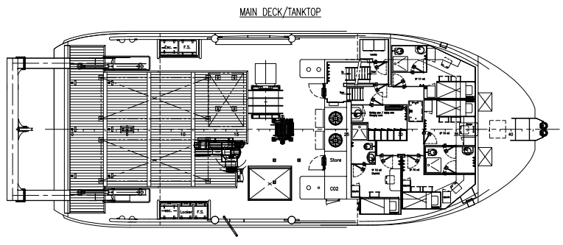
Water Injection pump or plough

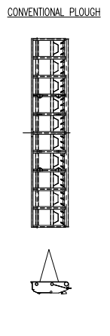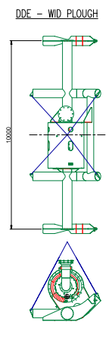

Job Step | Risks Identified | Method Statement
On completion of water injection | N/A | - Lift the pump clear of the bottom and run for 2 minutes mid water collum clear of the sea bed to flush the system  - Recover system and secure if necessary.  - Inspect any injection system mud if accessible for flora and fauna, photograph and forward to Bio-Security Manager for identification and recording.
Prior to departure of dredge area | Transfer of INNS outside of dredge area. | - Using either hoses or prop wash, wash down the injection system.  - Inspect and repeat as required.  - Inspect deck areas around injection system and wash down if required.  - Record in diary

