Permit
The Environmental Permitting (England & Wales) Regulations 2016

Areera Ltd
Unit 2, Park stromy
Stormy Down
Bridgend
CF33 4RS

Permit number

EPR/DB3691CU

Permit
The Environmental Permitting (England and Wales) Regulations 2016
Permit number

EPR/DB3691CU

The Natural Resources Body for Wales (“Natural Resources Wales”) authorises, under regulation 13 of the Environmental Permitting (England and Wales) Regulations 2016

Areera Ltd (“the operator”),

whose registered office is

C/O Buy it direct Ltd Trident business park

Neptune way

Huddersfield

England

HD2 1UA

company registration number 12574362

to operate waste operations at

Areera Parc Stormy

Unit 2, Park stromy

Stormy Down

Bridgend

CF33 4RS

to the extent authorised by and subject to the conditions of this permit.

Under regulation 27(2) of the Regulations, standard rules SR2008No23 are conditions of this permit.

Name | Date
Huw Davies | 23/01/2026

Authorised on behalf of Natural Resources Wales

Schedule 1 - Site plan

This is the plan referred to in the standard rules SR2008No23

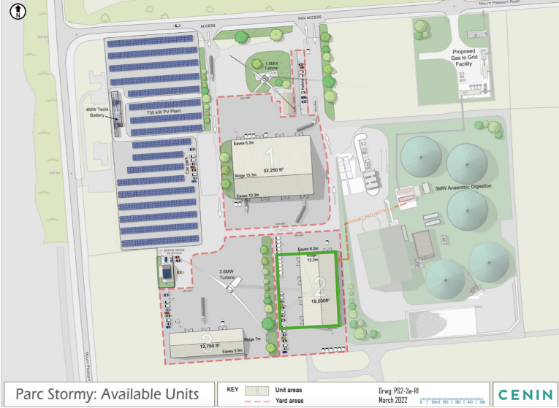

END OF PERMIT

