PAN-031282 My Map Report:
Application maps
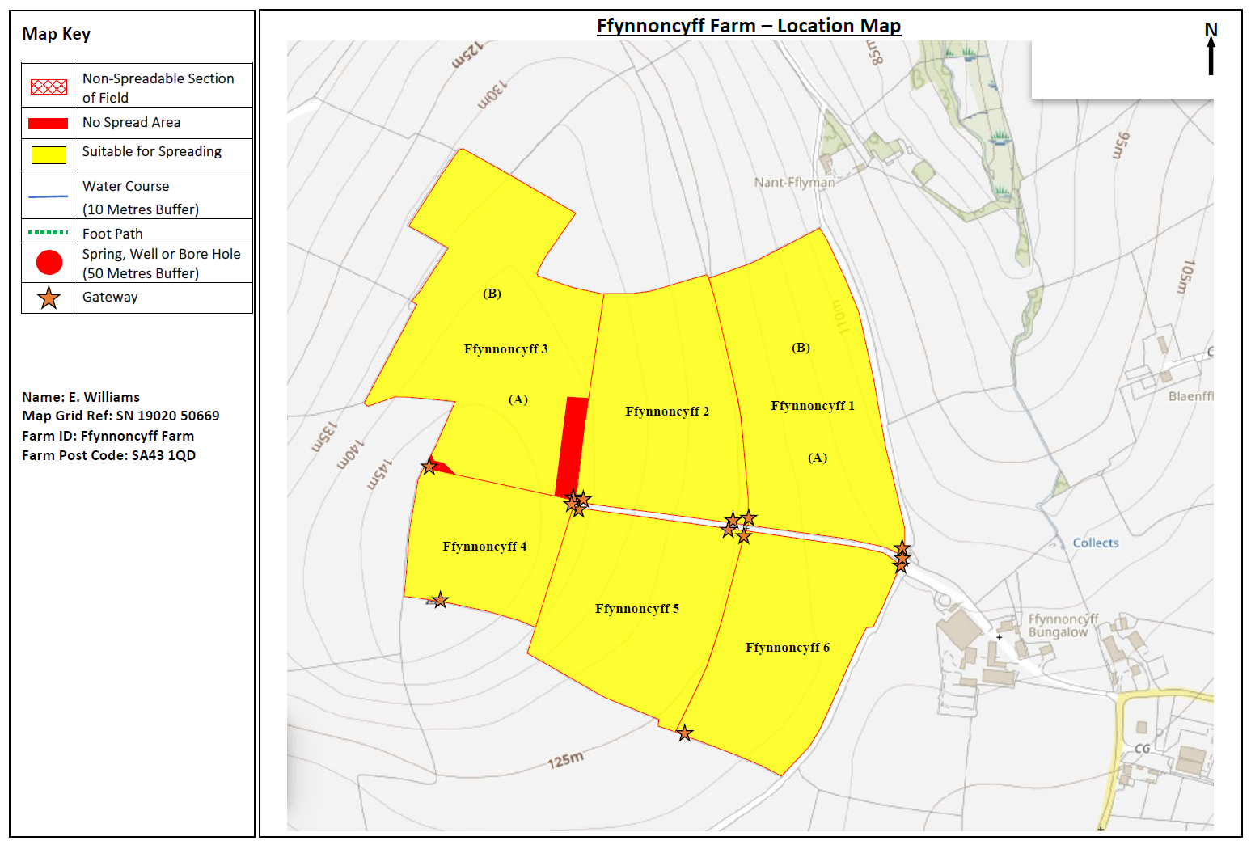
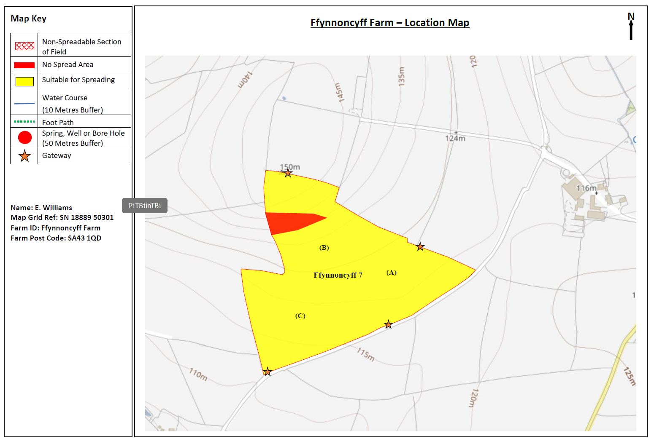
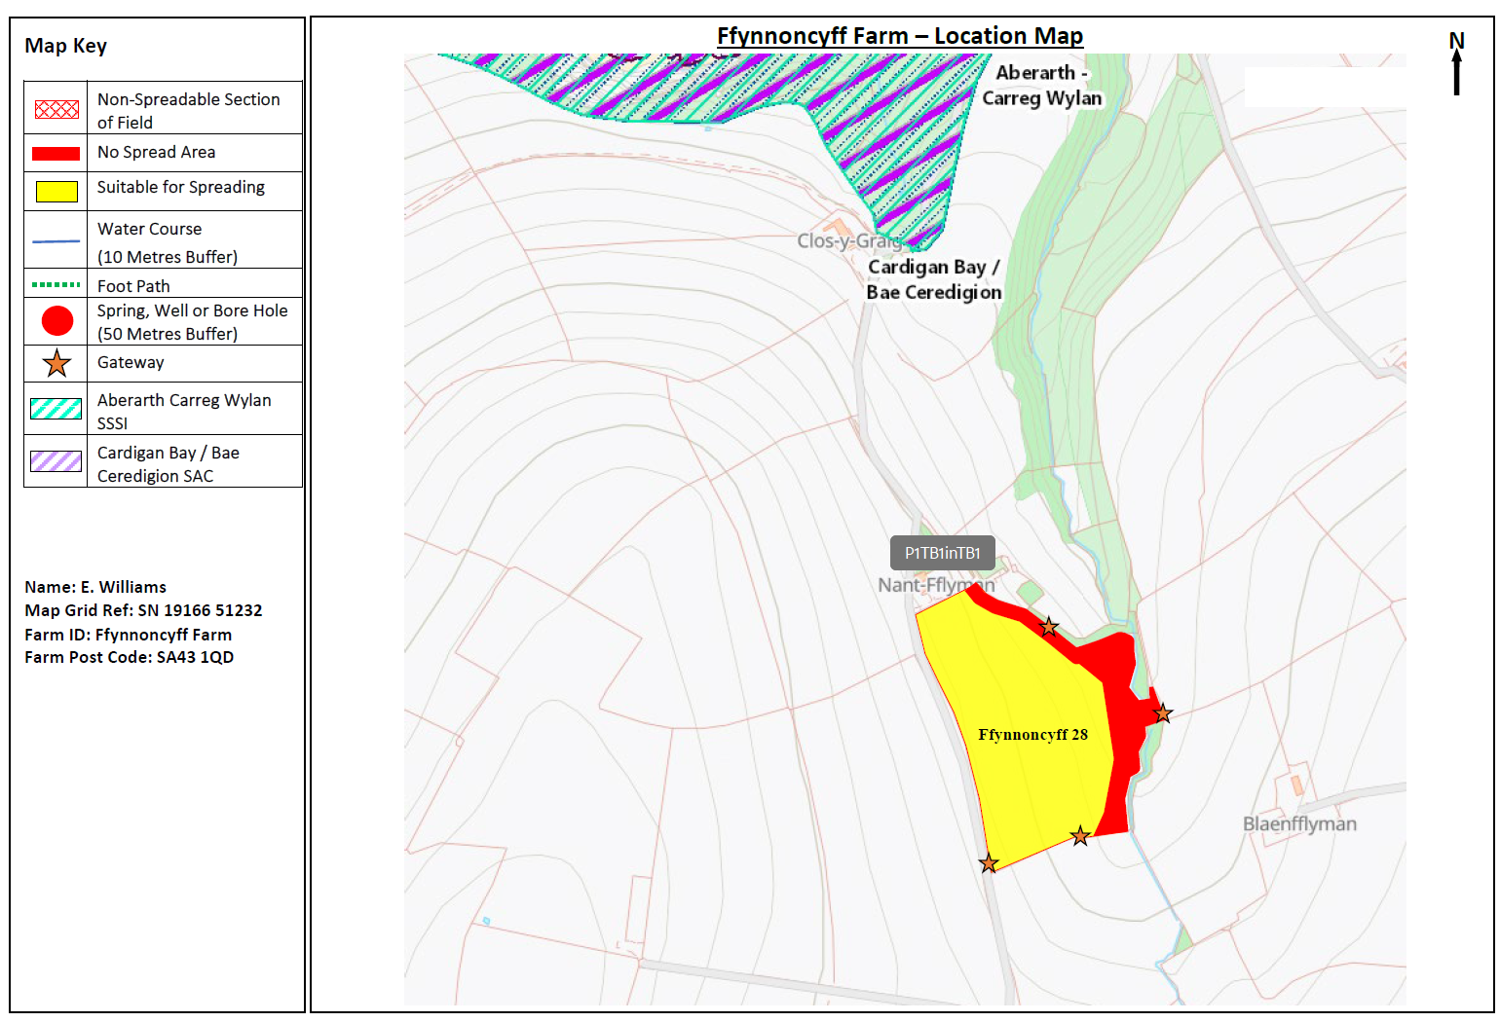

Deployment Boundaries
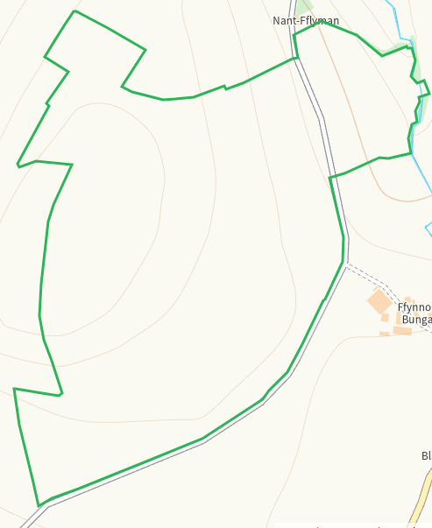
Detailed river network 10m
Pond within 3 buffered on application map
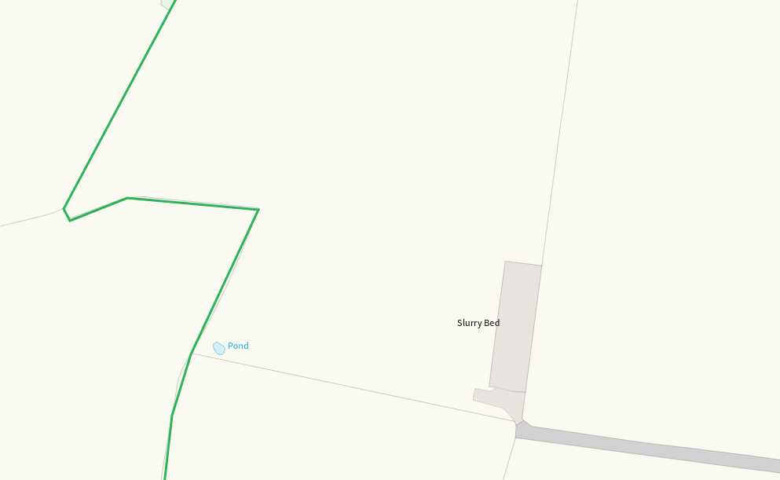
Watercourse E of 28 buffered on application map
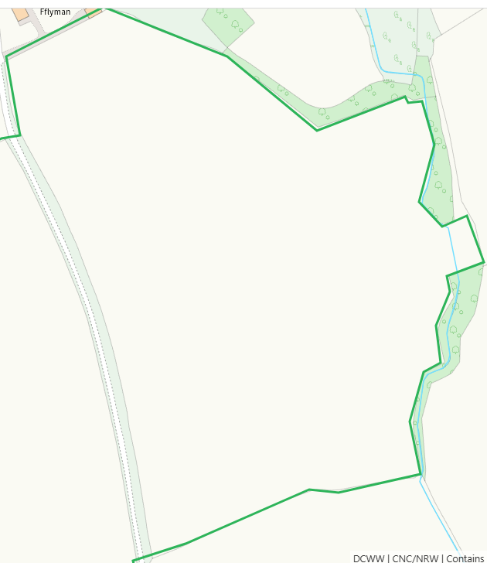
Groundwater source protection zones
none

Any well, spring (or issue) or borehole used for the supply of water for human consumption including from a private water supply or supplies within 50m.
none
Any well, spring (or issue) or borehole used for the supply of water for human consumption including from a private water supply or supplies within 250m.
none
Within Groundwater Safeguard Zone
none
European designated sites- Natura 2000 (SPA, pSPA, SAC or cSAC) or Ramsar- or SSSI within 500m
Cardigan Bay / Bae Ceredigion SAC
Aberarth - Carreg Wylan SSSI
Both on application map and addressed in SSRA
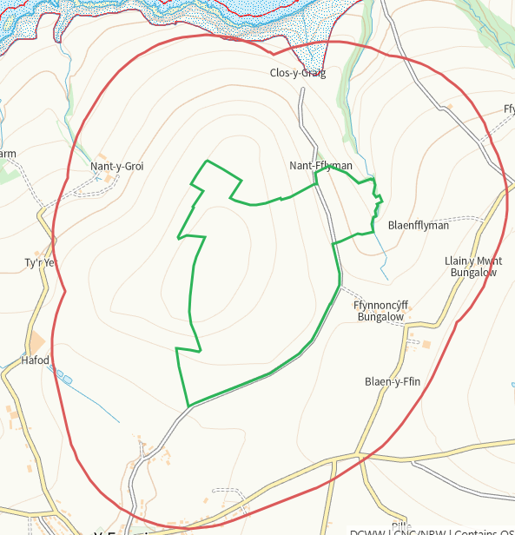
Other protected sites within 500m:
- Protected Species-
Some recorded within range, predominantly birds
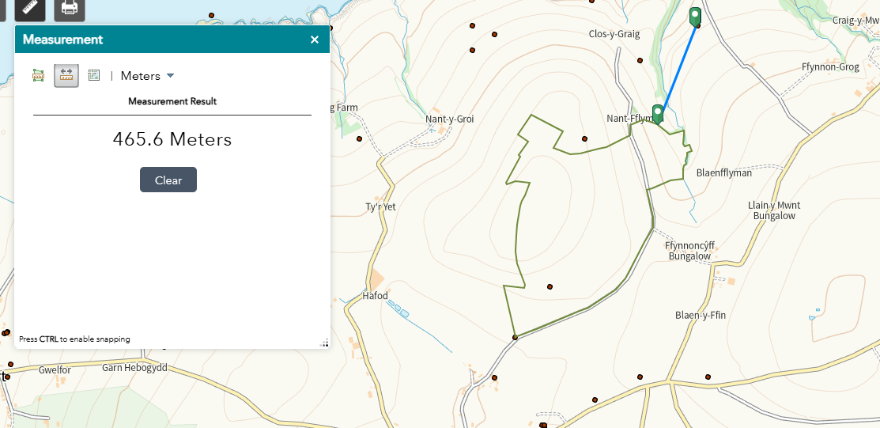

- Protected Habitats-
Some within range, nil risk
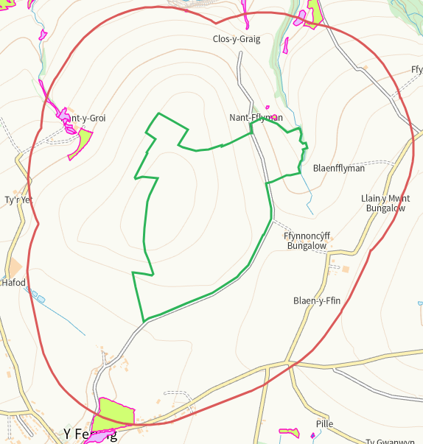
- Scheduled Ancient Monument- none
- Local Nature Reserve- none
- National Nature Reserve- none
- Ancient Woodlands- none
- Local Wildlife Sites (SINC)- none
- National Park- none
- Nitrate Vulnerable Zone (NVZ)- ALL Wales
- Groundwater Safeguard Zone- none

Flood risk
Risk E of 28 buffered on application map
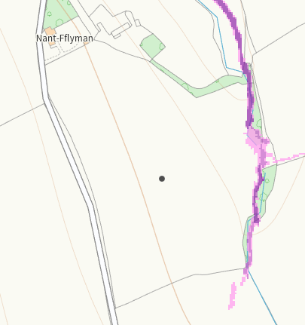
None at other fields
Public rights of way
none
Distance from Main Farm Address
adjacent
Slope Map
All fields mainly 0-7, where areas of 7-12 and 12+ exist they are suitably buffered.
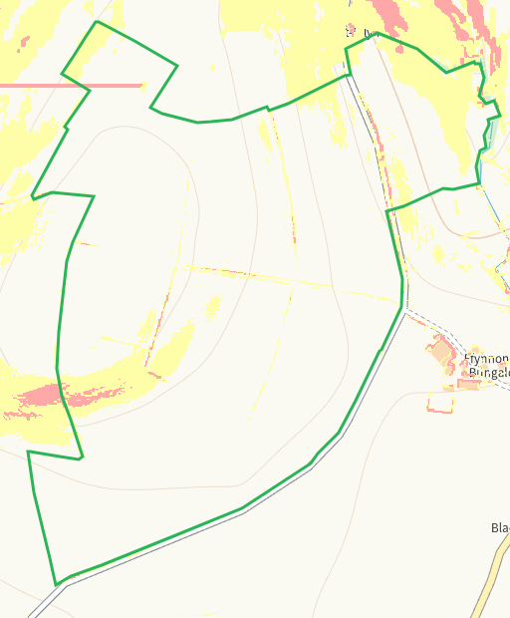
END

