PAN-031314 My Map Report:
Application maps
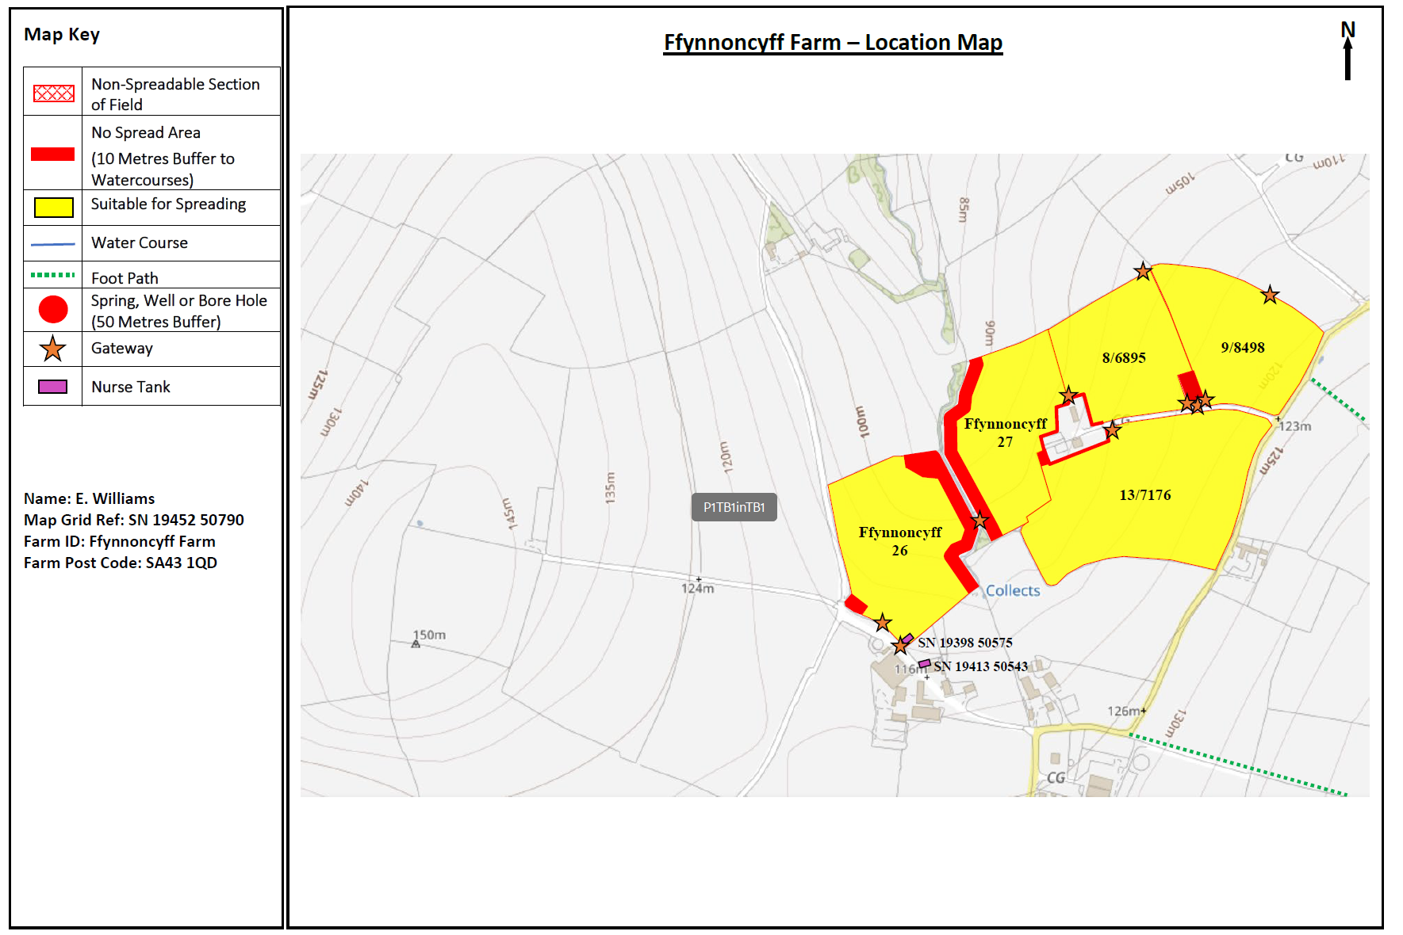
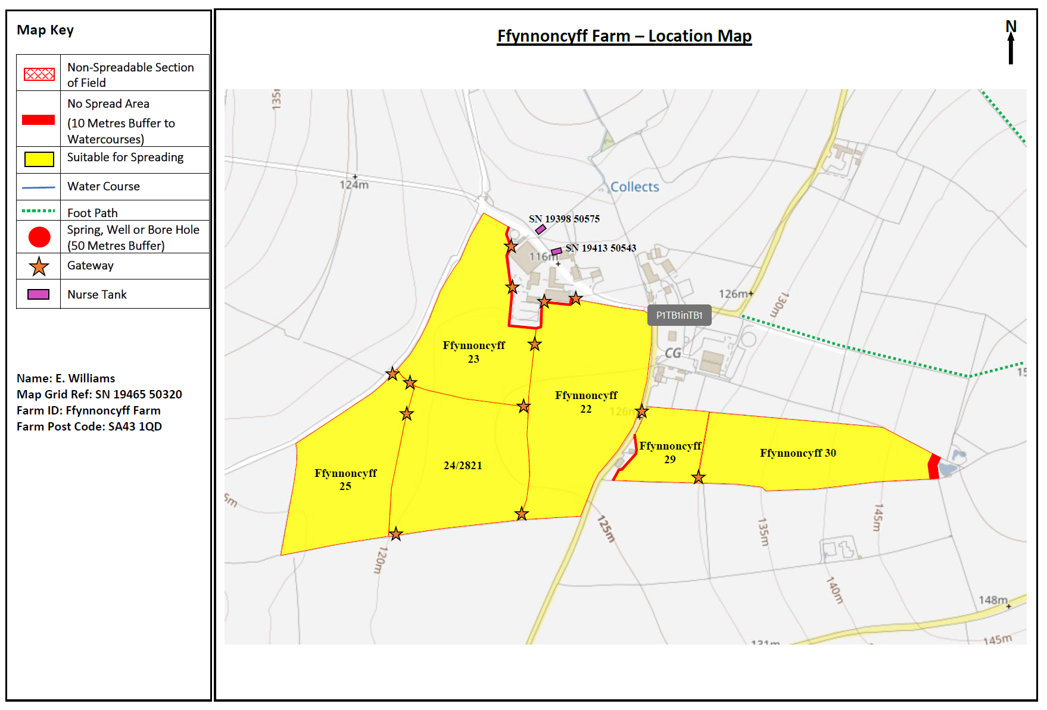
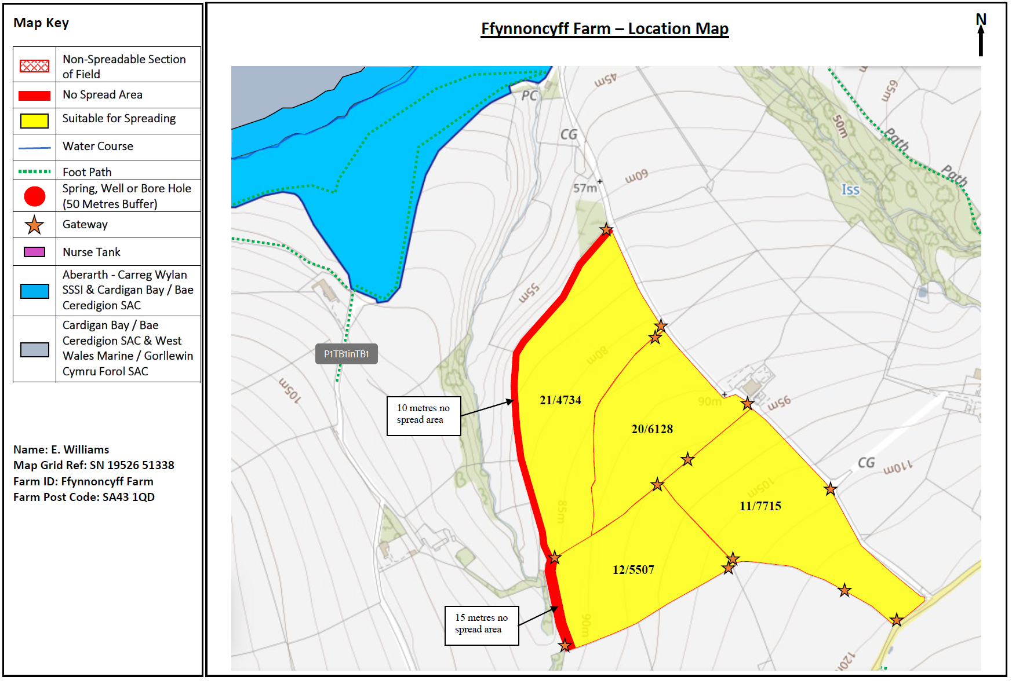
Deployment Boundaries and storage
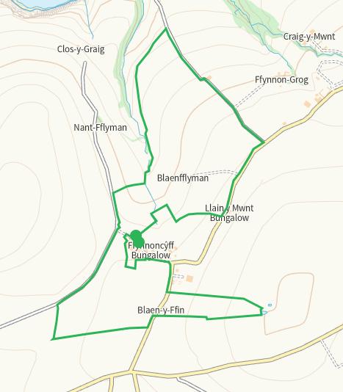
Detailed river network 10m
Pond E of 30 buffered on application map
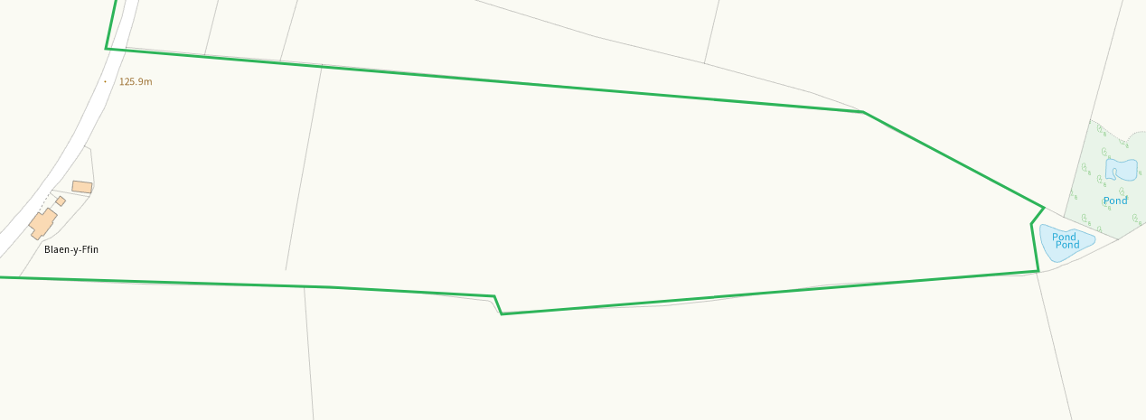
Watercourse adjacent to 26/27 buffered on application map
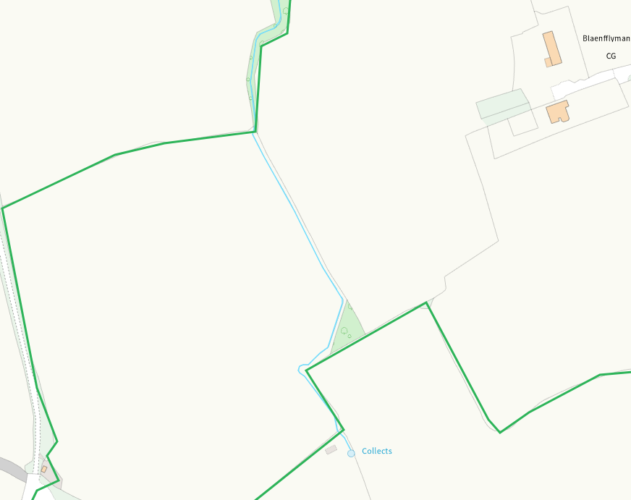
None at other feilds

Groundwater source protection zones
none
Any well, spring (or issue) or borehole used for the supply of water for human consumption including from a private water supply or supplies within 50m.
none
Any well, spring (or issue) or borehole used for the supply of water for human consumption including from a private water supply or supplies within 250m.
none
Within Groundwater Safeguard Zone
none
European designated sites- Natura 2000 (SPA, pSPA, SAC or cSAC) or Ramsar- or SSSI within 500m
Aberarth - Carreg Wylan SSSI
Cardigan Bay / Bae Ceredigion SAC
West Wales Marine / Gorllewin Cymru Forol SAC
Shown on application map and covered in SSRA
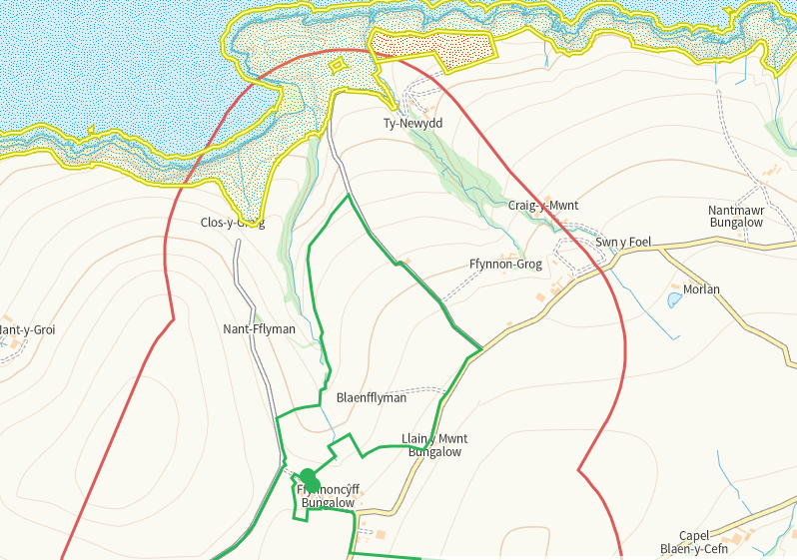
Other protected sites within 500m:
- Protected Species-
Multiple in range though nil risk from this activity.
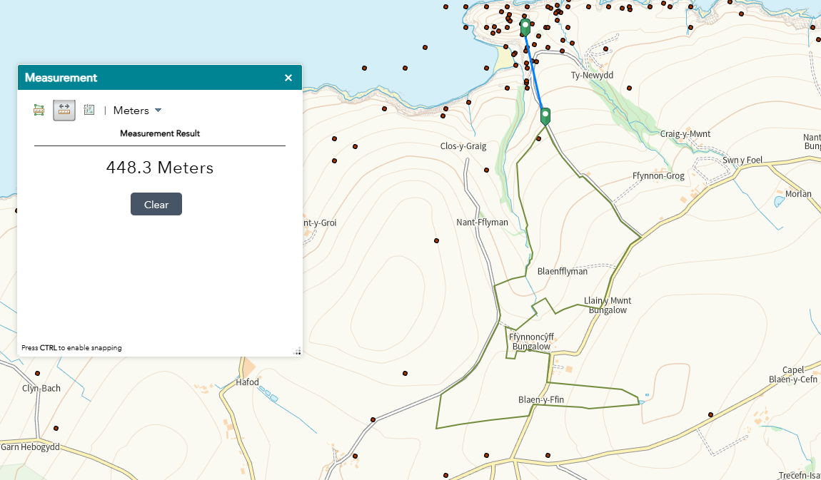
- Protected Habitats-
Some within range but nil risk from this activity. buffers in place where required.
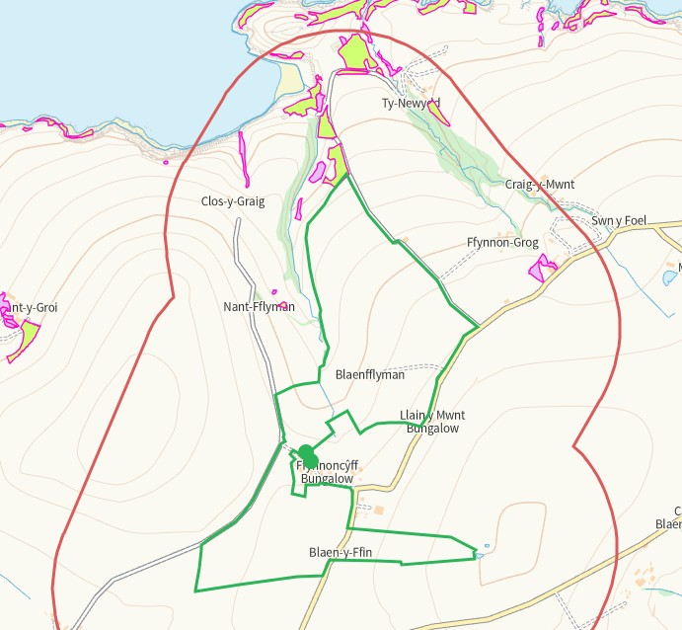
- Scheduled Ancient Monument-
- Local Nature Reserve-
- National Nature Reserve-
- Ancient Woodlands-
- Local Wildlife Sites (SINC)-
- National Park-
- Nitrate Vulnerable Zone (NVZ)- ALL Wales
- Groundwater Safeguard Zone-
None of the above

Flood risk
none
Public rights of way
None
Distance from Main Farm Address
adjacent
Slope Map
All fields 0-7 except 21/4734 which has an area of 12+ to the W boundary, this is buffered on application map
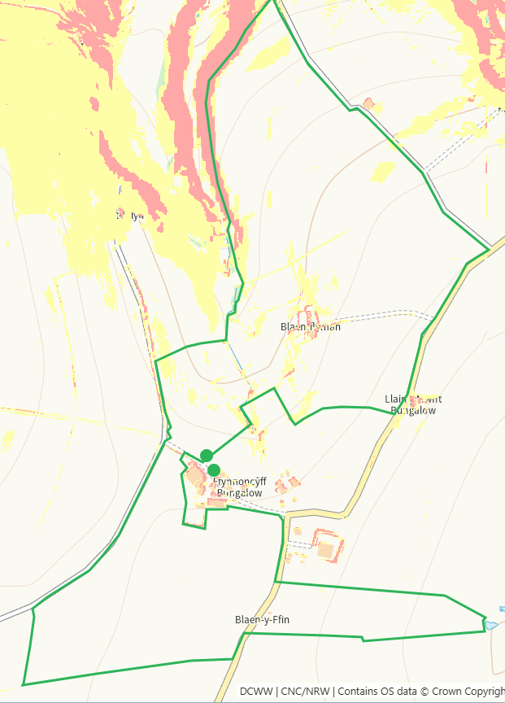

END

