Permit
The Environmental Permitting (England & Wales) Regulations 2016

Sundorne Products (Llanidloes) Limited

Newtown Household Waste Recycling Centre
Unit 4
Dyffryn Industrial Estate
Pool Road
Newtown
SY16 3BD

Permit number

EPR/BB3196CL

Permit
The Environmental Permitting (England and Wales) Regulations 2016

Permit number

EPR/BB3196CL

The Natural Resources Body for Wales (“Natural Resources Wales”) authorises, under regulation 13 of the Environmental Permitting (England and Wales) Regulations 2016

Sundorne Products (Llanidloes) Limited (“the operator”),

whose registered office is

Potter House

Henfaes Lane

Welshpool

Powys

Wales

SY21 7BE

company registration number 03353423

to operate waste operations at

Newtown Household Waste Recycling Centre

Unit 4

Dyffryn Industrial Estate

Pool Road

Newtown

SY16 3BD

to the extent authorised by and subject to the conditions of this permit.

Under regulation 27(2) of the Regulations, standard rules SR2008 No13 are conditions of this permit.

Name | Date
Huw Davies | 11/03/2019

Authorised on behalf of Natural Resources Wales

Schedule 1 - Site plan

This is the plan referred to in the standard rules SR2008 No13

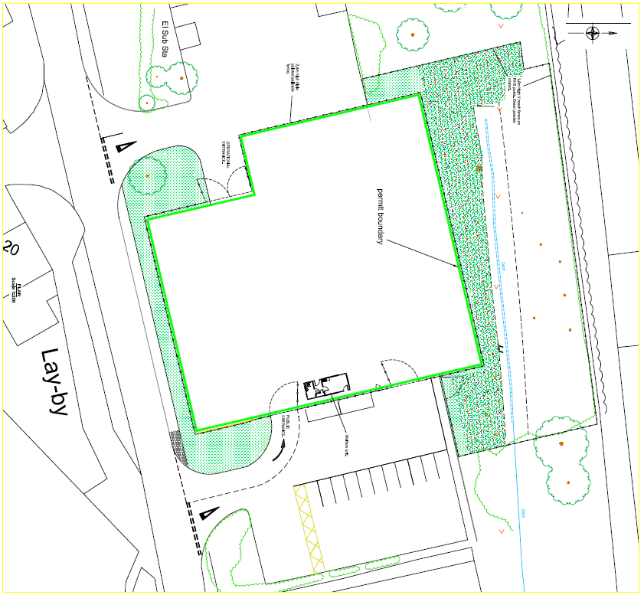

© Copyright and database right 2019. Ordnance Survey licence number 100019741.

END OF PERMIT

