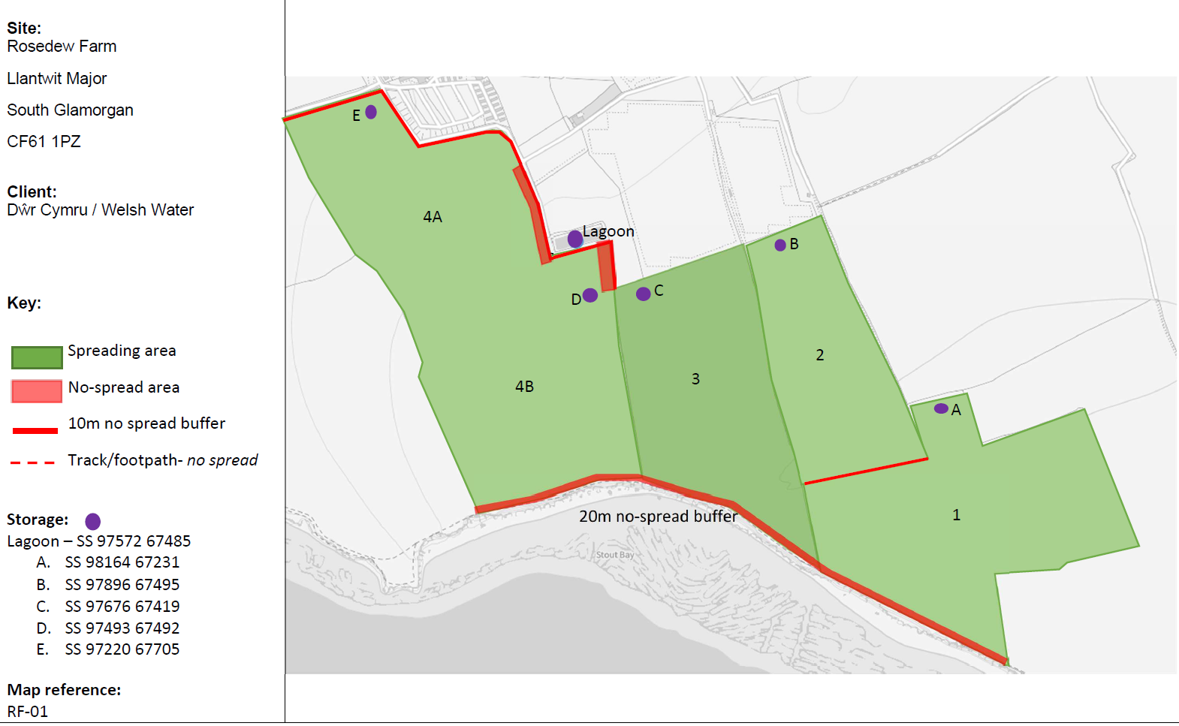
PAN-031460 My Map Report:
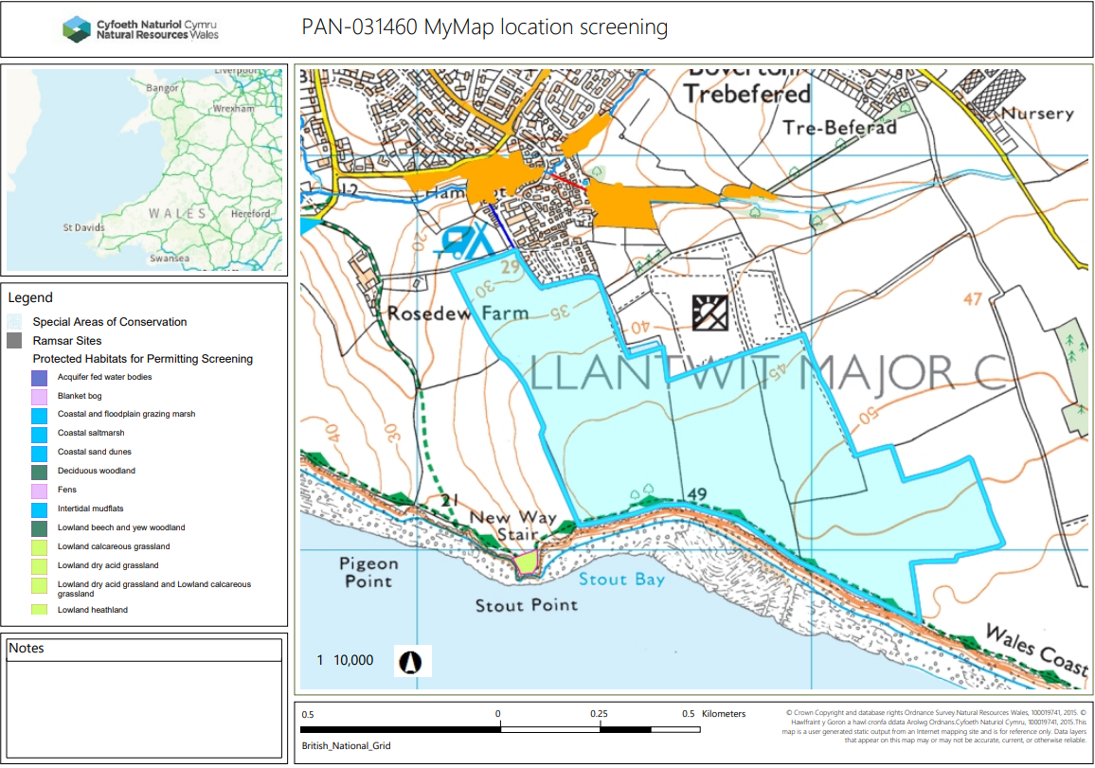
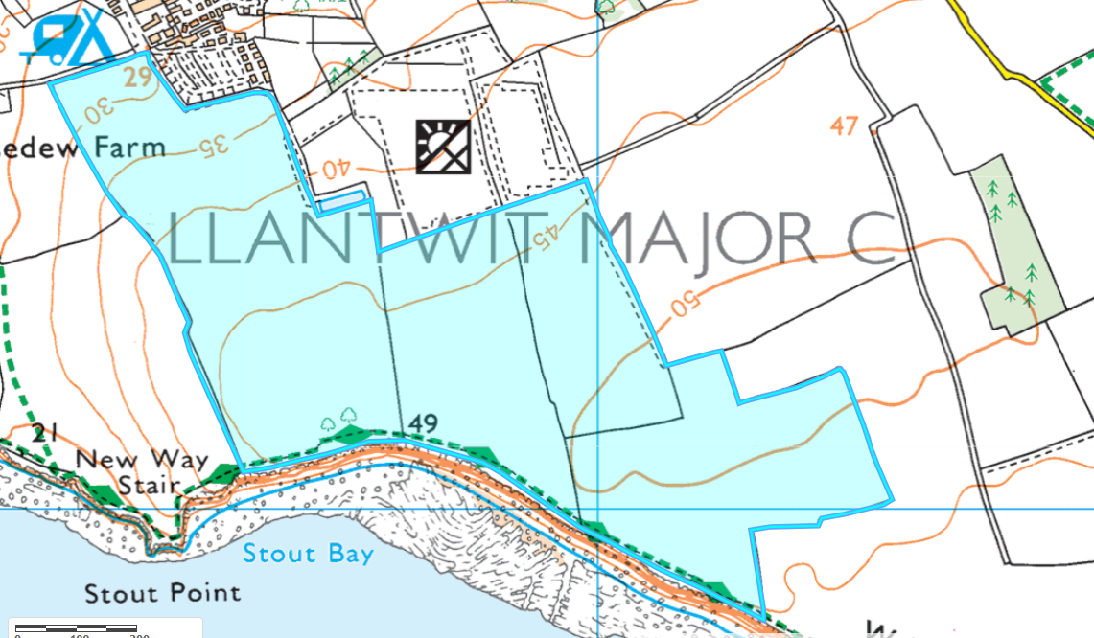
Detailed river network:
No surfaces waters in range.
Groundwater protection zones (source) None in range

Wells, springs or boreholes used for the supply of water for human consumption including from a private water supply or supplies - None in range

any springs wells or boreholes not used to supply water for domestic or food production purposes within 50m - None in range

European designated sites- Natura 2000 (SPA, pSPA, SAC or cSAC) or Ramsar- or SSSI within 500m

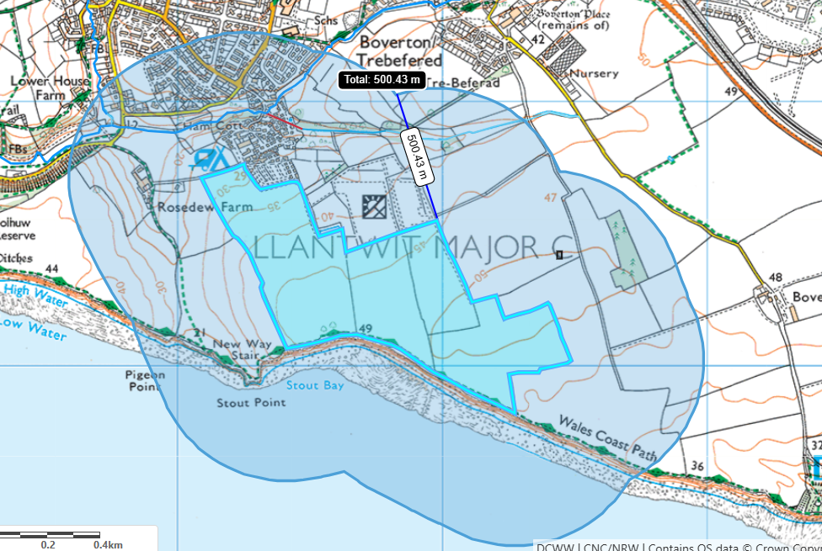
No European sites, SSSIs , Ramsar’s within 500 meters of the spreading fields.

Other protected sites:
- Protected Species- None in range

- Protected Habitats- None in range

- Scheduled Ancient Monument- None in range

- Local Nature Reserve- None in range

- National Nature Reserve- None in range

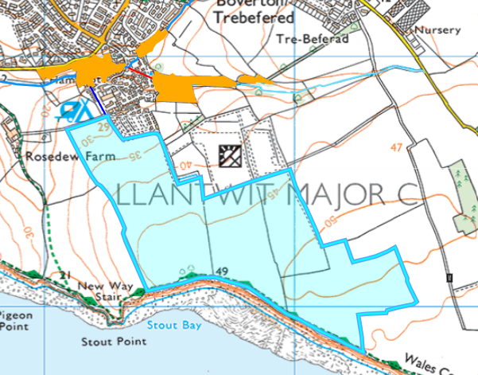
- Ancient Woodlands-
Fields 4A 3 & 2 are located approximately 130 meters from: Restored Ancient Woodland Site. Due to the distance this ancient woodland is from the spreading fields no further action is required.

- Local Wildlife Sites (SINC)- None in range

- National Park- None in range

- Groundwater Safeguard Zone- None in range

- Hedges- nothing of concern.

- Ditches- see slope map below.

- location of any public rights of way – Yes displayed on submitted site plan.

- Local residents, Housing, schools, Workplaces, Recreational facilities
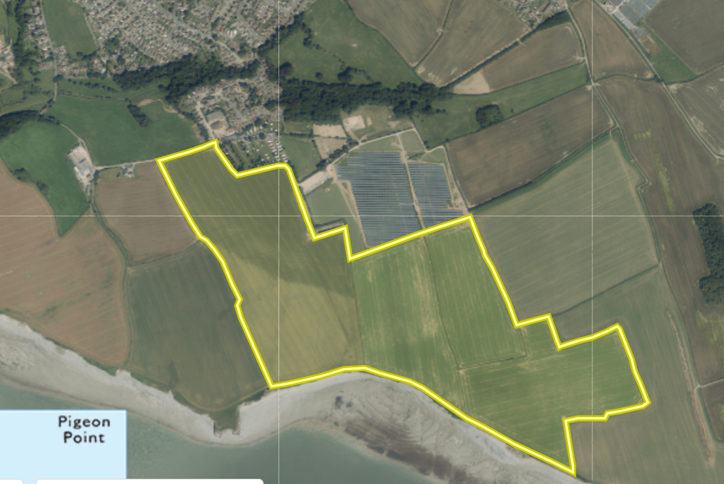

There are numerous odour sensitive receptors located nearby this includes Acorn camping and caravan site & residential properties (Mill lay lane) in Llantwit Major all located north of the proposed spreading fields. As the applicant is proposing to spread EWC 19 06 06 which has the potential for odour the applicant has provided an odour management plan from the request for information 1 response. This has been assessed against the H4 odour guidance and if waste is applying as outlined in the odour management plan NRW are confident the risk of odour can be managed effectively. No further action was needed.

- Flood risk
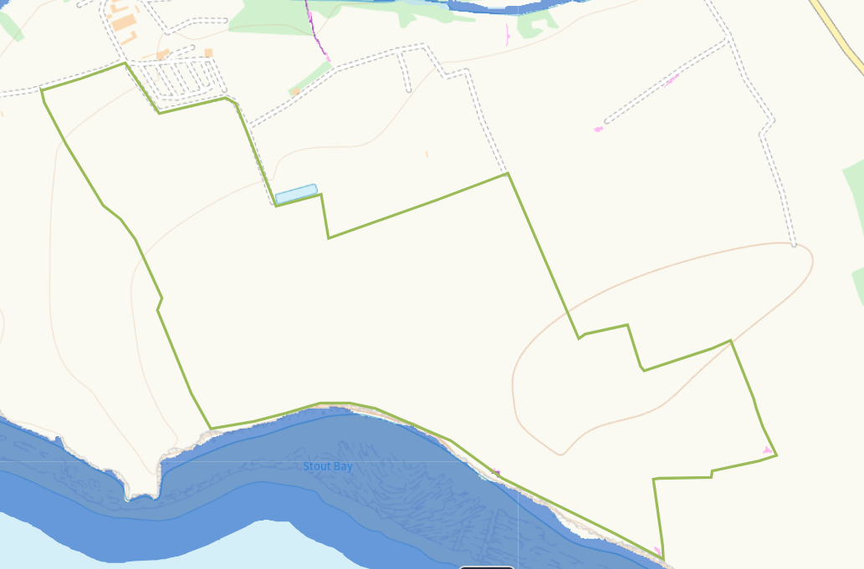
The fields in this deployment are not at risk of flooding from small water courses or from rivers and seas. The southern boundaries of fields 4B, 3, 2 & 1 are located near stout bay that does contain a high risk of flooding from the sea. However these fields have a 20 meter no spread buffer zone in place to mitigate the risk of flooding from the sea. No further action needed.

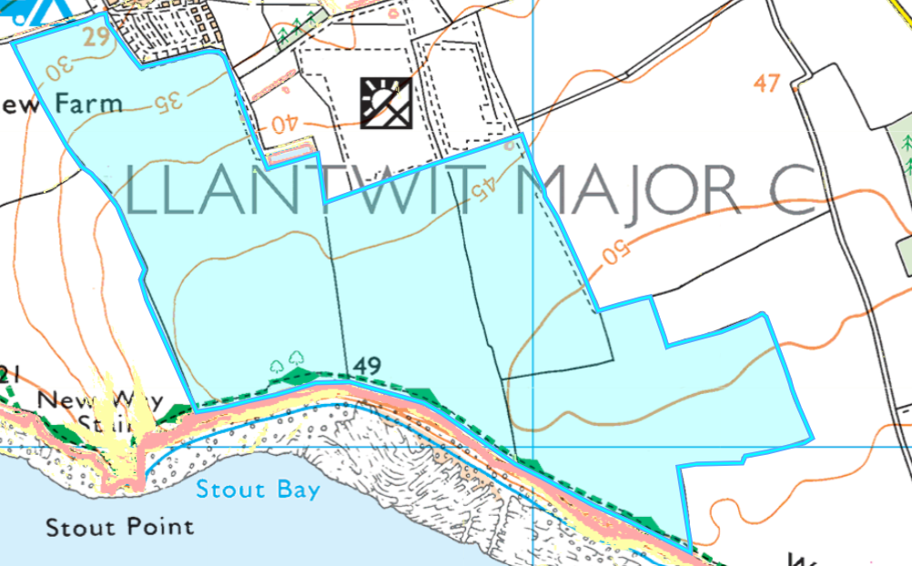
Slope Map
All fields located in this deployment are located on flat to gently sloping land 0-7º. The run off risk has been determined as low due to the fields being located on flat to gently sloping land. The deployment is using appropriate application methods to apply to land. The deployment will also split application rates of wastes higher than 50 t/ha to further reduce the risk of surface runoff. There is also a 20 meter no spread buffer zone implemented in the southern edges of fields 1, 3, 4b located close to stout bay. No further action required.

