Deployment consultation response record

If you do not want to comment, please indicate a nil response by a tick in the No Comment column.
Please ensure the record is completed by all relevant officers within ten working days of the consultation email.
Note:
- If the final record has not been completed by a particular Environment/Regulatory officer, as set out in the table, by the deadline, this will be taken as a ‘No comment’ response.
- Once the deadline has passed, the record will be updated to show that the consultation period has closed. We will accept comments after this period has passed, where there is good reason to do so, and as long as it has been agreed with the determining officer before the consultation closing date
Examples of information we need:
- Please refer to Table 2 on the next page- this is not an exhaustive list.
- You may include all comments you feel we need to be aware of.
- Please be clear about the outcome you want from your comments, and the evidence for your comments. For example; if you are requesting an increase in buffer area, you will need to specify by how much, and the reason why.
- We will take all relevant comments (as per our remit under the Environmental Permitting Regulations) into account when making our decision.

Table 1:
Comments from | No comment (tick) | Comments/information and requested actions | Name & date | Time recording (minutes)
Environment team |  | Comments from previous application (PAN-030738) – Some will be reiterated  Comments from new application (PAN-031732)  Water discharge points  The proposed drainage is unacceptable as it would need to be sealed and impermeable. The proposed drainage discharges off site. No discharge of treated or untreated site drainage to watercourses will be permissible under any circumstances without an appropriate discharge consent, of which the site does not currently hold.  - Now indicated that the lagoons will be lined with either clay or an impermeable layer. Use/discharge hierarchy as follows:  - Re use for dust suppression on site  - Discharge via NRW permit to watercourse  - Discharge to DCWW sewer via a trade effluent consent  - Disposal off site via tankering  - What evidence is there to support that each method is permissible and the applicant has taken the appropriate steps to gain the required consents to undertake each method?  From Plan 1 it does not appear that there are any surface water discharge points intended for Phase 2, the only surface water discharge points noted are for Phase 1A & 1B (2 options). The only drainage point identified on Phase 2 is for foul sewage on the southern boundary of the site (presumably to the mains).  However, from Plan 2 (as seen below), it is unclear if the surface water discharge from phase 2 is going to use the discharge point denoted for Phase 1A & 1B or the foul sewage discharge point on the southern boundary of the site, with pathways seemingly denoting use of both. As a result, I am concerned that there is an intention to discharge untreated site drainage to watercourses.  - Plan 2 has now been revised as seen below. One discharge point (pending a NRW discharge permit – separate pre-app for discharge permit submitted) and contained drainage. What contingencies are in place should this plan be deemed inappropriate?  - Outlined lagoon structure (as seen below). Total storage volume to be 1450m³. Question on capacity? How was this volume calculated and found to be appropriate?  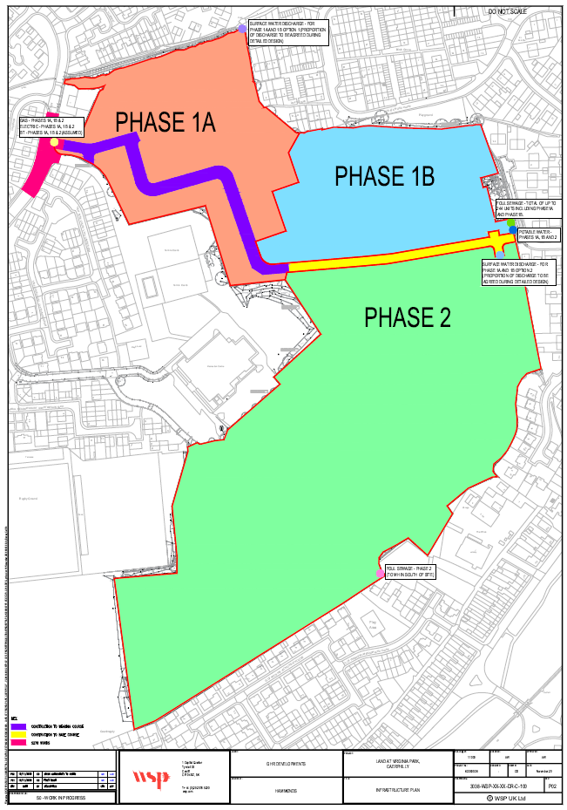  Plan 1:  Plan 2:  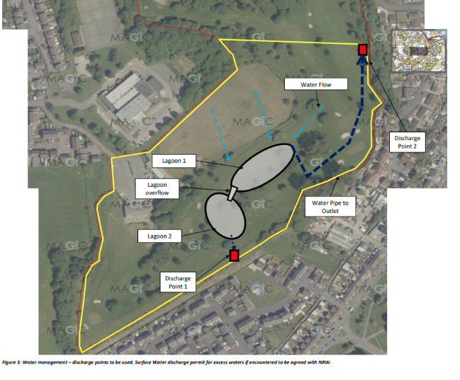  Plan 2 (Revised)  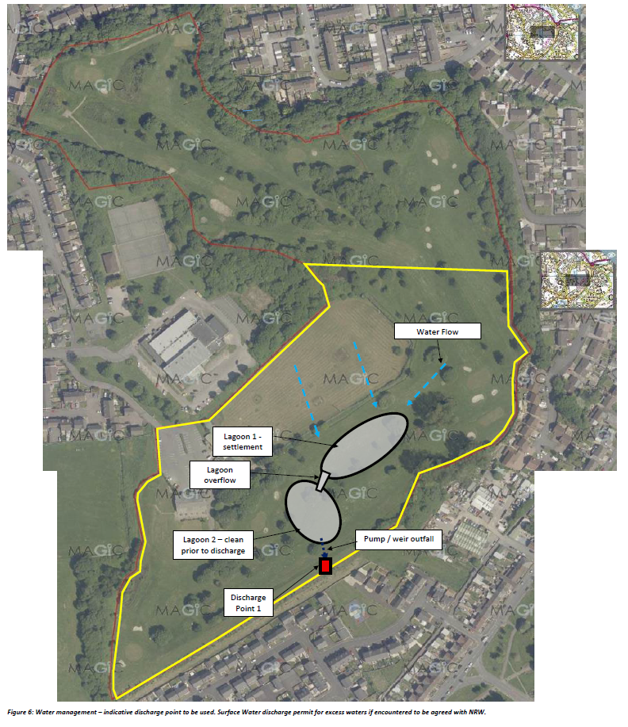  Lagoon Structure Layout  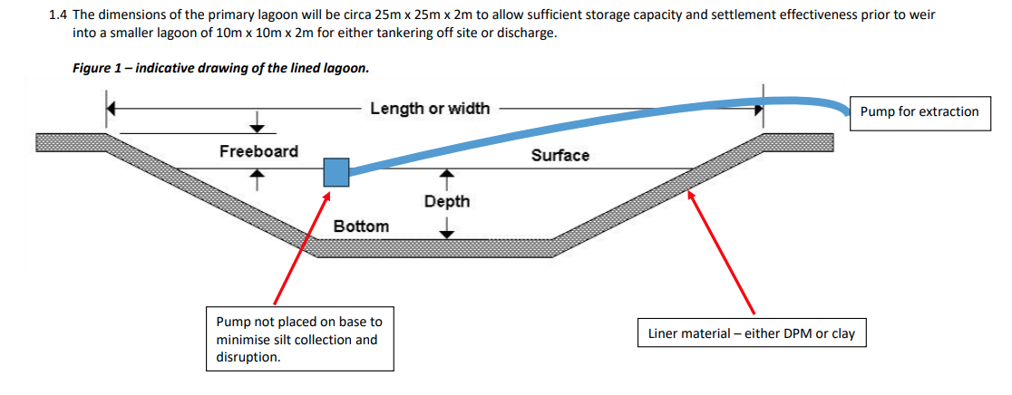  How will water be removed to install a lining and what are the safeguards to ensure only water will be entering the lagoon and not plastics, knotweed, oils etc? The provision of a silt buster/treatment will not treat or remove these contaminants.  Further concerns are raised by the composition and contamination of plastics within the soil that would be entering the watercourse if discharged as nothing is lined. In addition to this, it is clear that the site water is contaminated with suspended solids so cannot be discharged directly from the site.  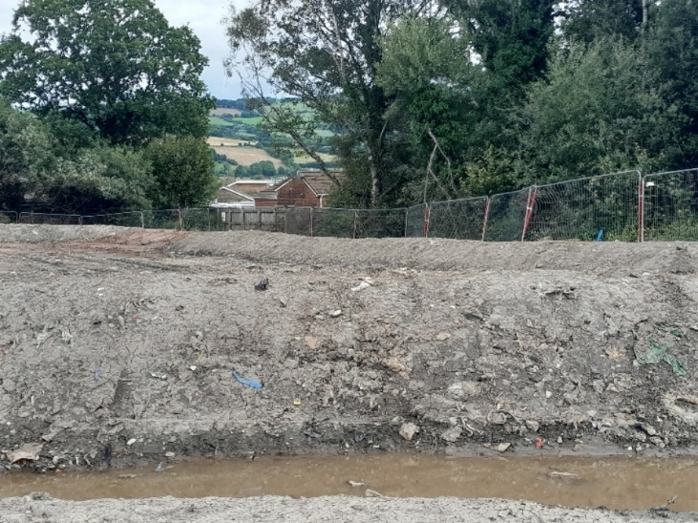  Plastics can be seen in the soil from a visit in July 2023  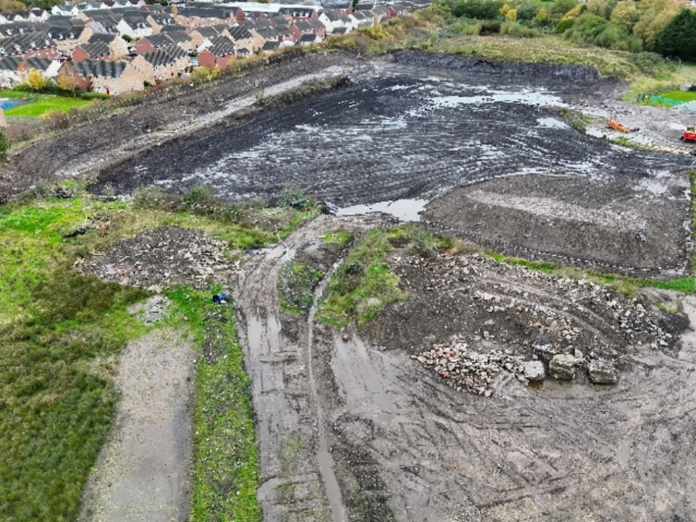  Site water clearly contaminated with suspended solids  In addition, from plan 3 it is clear that the haul road runoff will enter the settlement lagoons, increasing the suspended solids concentration, where water is not undergoing any treatment prior to discharge.  - Now state that silt fencing will be established around “watercourses” and lagoons to manage silt on site. No indication on where this intercepted silt will go or how it will be managed, only that road sweepers will be used. Also contradicts that haul road runoff will enter the lagoon as silt fencing will prevent entry. Concerns persist.  Plan 3:  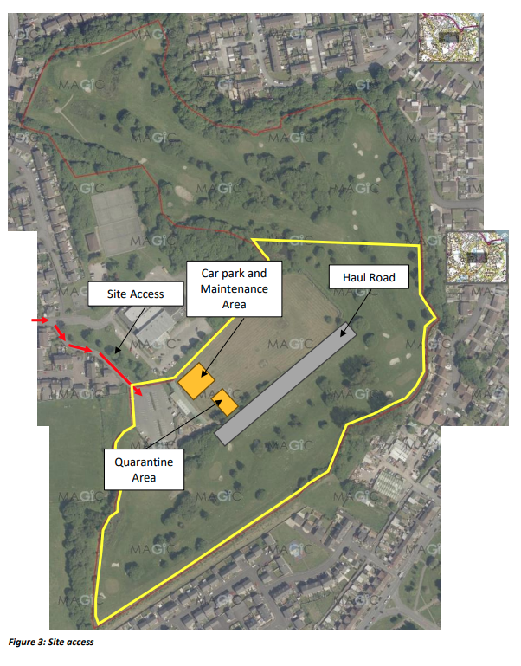  Plan 3 (Revised) – No new comments  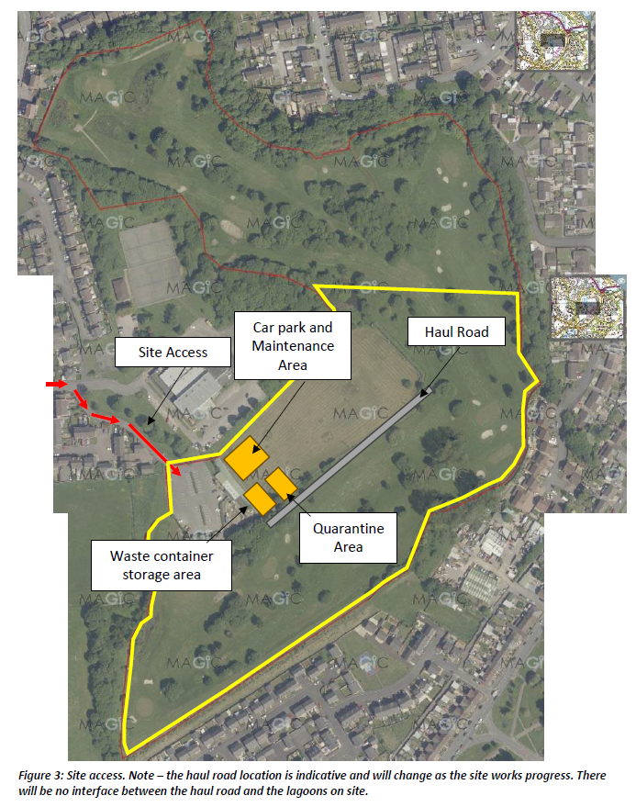  Operator competence – Concerns persist  I have concerns based on several incidents of water pollution as a result of operator negligence and deliberate discharges, 2 of which are the subject of ongoing enforcement cases.  - Prichard Remediation Limited – (Accepted for prosecution: In progress)  - Incident date: 14/07/2023  - Offence: EPR Regulations 2016 – Reg 38(1)(a) & 38 Water Quality  Did cause a water discharge activity, namely the discharge of poisonous, noxious or polluting matter to an inland freshwater contrary to regulation 12(1)(b).  - Information gathered under caution and with police presence.  - Description:  The perimeter bund that was constructed from unsuitable waste material on the Virginia Park site failed during a rainstorm and high volumes of water run-off. This volume of water filled the secondary containment bund, causing it to fail and releasing contaminated water into a watercourse and flooded several neighbouring properties. The site manager noted under caution that there were no ongoing works at the time of this failure with no cutting of the bund to release water. In conclusion the operators were effectively unable to appropriately manage the site, raising concerns regarding operator competence.  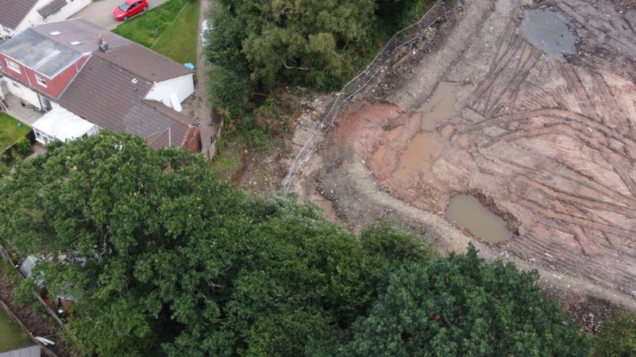  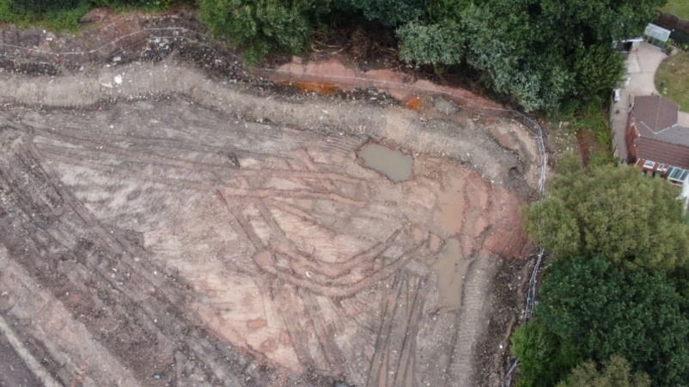  Area where containment bund failed.  - Prichard Remediation Limited – (Enforcement forthcoming)  - Incident date: 24/09/2025  - Offence: EPR Regulations 2016 – Reg 38(1)(a) & 38 Water Quality  Did cause a water discharge activity, namely the discharge of poisonous, noxious or polluting matter to an inland freshwater contrary to regulation 12(1)(b).  - Information gathered under caution (26/09/2025).  - Description:  A report of grey water in Porset Brook lead to Dwr Cymru tracing the source of pollution to the Virginia Park development, believed to be concrete/silt washings from an excavation pit. The site manager admitted they were pumping the contaminated water into a manhole cover knowing they did not know whether the manhole lead to sewer/ drain etc. Dwr Cymru told them to stop pumping which they have now done. Samples collected on the 24/09/2025. During a visit by Officer Summerhill on the 26/09/2025, under caution, the site manager admitted to pumping settlement water down an unidentified manhole on site. This adds to concerns regarding operator competence.  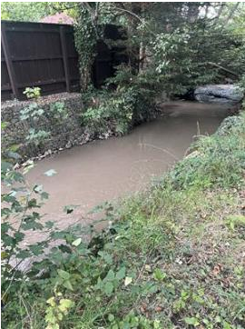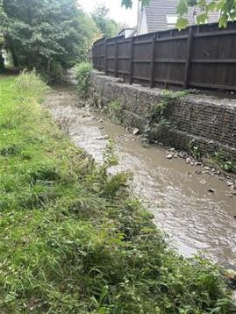  The pollution in Porset Brook on 24/09/2025  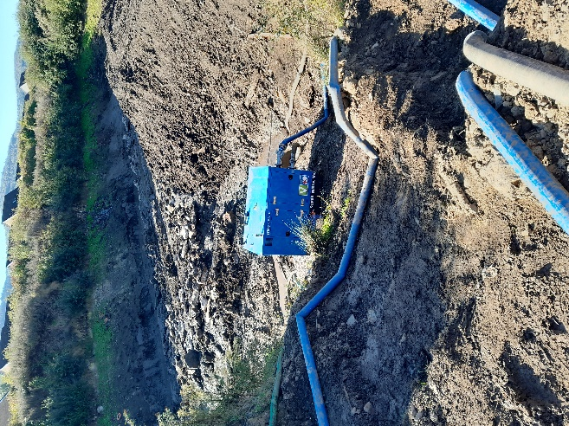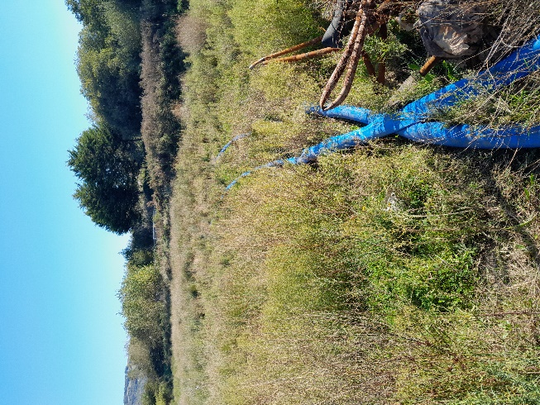  Pumping equipment on site 26/09/2025  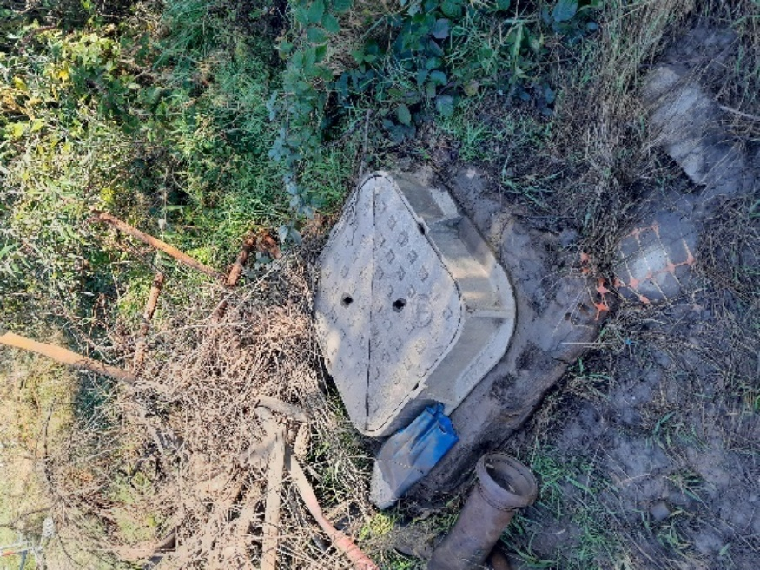  Unidentified chamber used to discharge settlement water 26/09/2025  “All site works will be supervised during operation hours”. – If this were true then we wouldn’t have had two incidents previously. More details required on what safeguards are in place.  Correspondence with NRW (reference email dated 10 February 2022) confirms relaxation of the requirement for hardstanding and that plant and machinery can be taken to the relevant material as the risk to the environment is low, relevant controls are in place and potential environmental impact of moving the material to the plant is greater than the other way round. – Query the relaxation of a hardstanding area. Refer to WL issued for Phase 1a.  - Commented on it after last consultation – historic – moving of vehicles would cause more harm than allowing them to be sited. NRW’s discretion – Waste Team to check. Pushed back against it previously.  Knotweed – Concerns persist, not addressed it.  How will they ensure no herbicides enter site drainage with rainfall runoff etc?  - Still follow protocol.  In a recent visit by Officer Burge, knotweed has been identified (on the vegetated area in the photo below) right within the phase 2 area. I have concerns with the potential mobilisation of the knotweed from this area and the previous buried knotweed mixing with the water on site, with the proposal suggesting discharge off site. This poses a risk to Porset Brook and the Rhymney River.  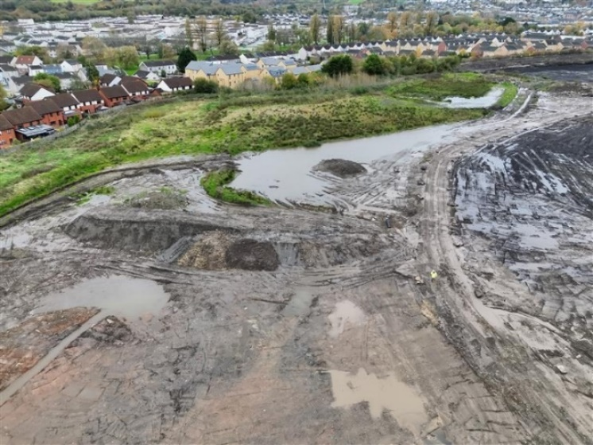  Vegetated area where knotweed has been identified  Environmental Management System  - NRW incident hotline number (p.5) is incorrect – Change to 03000 653 000.  - Advise that each item of plant has its own dedicated spill kit  Other  “All activities are covered currently under the EMS and emissions management plan but as the activities are low risk it is not envisaged any significant issues will be encountered”. – From a water perspective can we say it is low risk due to the two high level incidents that have occurred? Details above on these incidents. I would suggest that it is not categorised as low risk as a result.  - Competence ties in with this.  Wheel/vehicle washing – No indication where wash water/waste will be going – Will it enter the lagoons?  PPN-01510: Pre-application for the surface water discharge permit  Due to the applicant’s intention (as evidenced by their request for pre-application advice) to apply for a surface water discharge permit, they have identified that the drainage systems and plans are subject to change. Advice was provided to the applicant on the 13th of February 2026 with a significant amount of information advised for submission in the full application. Due to the nature of the site and the myriad conditions that may be implemented (which may require extensive changes to plans) I advise that the deployment application is not granted until the drainage system plans are finalised. | Elis Nuttall | 200
Waste regulation team
National lead officer
Land remediation deployments only
Geoscience | X | We have been involved in the planning process for this site with site investigations, risk assessment, remediation strategy and verification report of other phases of the site. The remediation strategy was agreed for the whole site (Phases 1A, 1B and 2) under planning conditions – this deployment consulation supports this remedation strategy – we have no further comment.  Note: Condition 32 of planning permission 17/0804/OUT requests a verification report which details what happened on site during remedication works and post works sampling. | Kay Roberts  17/02/26 | 120
Water quality/ Water resources
Note-
- Local authority contaminated land and EA based National lead officer comments will be saved onto the DMS separately
- if formal consultation as part of a CRoW assessment (Appendix 4) or a Habitats Regulations Assessment is required, it will be completed and sent separately to this consultation.

Table 2:
Internal Consultations
Who we consult with | Why we consult | How we consult
NLO (National Lead Officer)  For the permit the deployment sits under. This can be NRW or EA depending on the location of the permit holder | To get information on:  - compliance and enforcement issues.  - any common or significant issues with previous deployments.  We communicate with the NLO to ensure we are getting good quality applications. | Email is sent direct to the named National Lead Officer  The name is taken from the NLO contacts list held by permitting.  Follow the instructions on the list to inform permitting of any NLO changes.
Environment Team  This will be the team in the area where the deployment is taking place | To get local (location) information on:  - biodiversity issues e.g. protected site and species  - conservation issues e.g. SAC, SPA, Ramsar, SSSI  - presence of sensitive receptors which don’t show on current mapping systems (e.g., springs, wells or boreholes etc.) which could be affected by the activity  - if there is a nearby failing WFD stretch of river, and the reasons why it is failing, and how the deployment could be altered to ensure no harm  - if any materials have been spread to land  N.B. this is not an exhaustive list | Email is sent to the Environment team inbox.
Waste Regulation Team  This will be the team in the area the deployment activity is taking place | To get local information on:  - previous activities carried out by the operator in your area re: compliance (note: these issues should be fed back to the relevant NLO at the time they occur)  - location information as per NRM team comments  - if any materials have been spread to land | Email is sent the inbox for the waste regulation team.
Geoscience Team (Land remediation deployments only)  This will be the team in the area where the deployment is taking place | To see if pre application advice has been provided prior to determining the application. As Consultants and developers often seek advice from Geoscience on land and groundwater remediation schemes.  Geoscience will have agreed the remediation strategy and remediation objectives for a site under Part 2A, planning, other regulatory requirements or as a voluntary remediation if the site is a priority for us. They will then review the verification report submitted on completion of a scheme to determine if the remediation objectives have been met.  These activities are carried out independently of the deployment assessment so Permitting Service only need to look at the potential for the treatment process to cause pollution at that particular location.  Geoscience will advise permitting officer of potential impact on groundwater and groundwater monitoring requirements.  The operator can submit an application without pre-application but does so at their own risk of not having remediation targets pre-agreed. | Email is sent to the Geoscience team inbox.
External Consultations
Local Authority Contaminated Land Officer  This will be the team in the area where the deployment is taking place  Land remediation deployments only | To inform the local authority of the application.  To get information on local issues that NRW are not aware of. | Email direct to the local authority contaminated land officer.

Table 3:
What We (Permitting) Do- Landspreading deployments
We will assess (for landspreading deployments):
- if the permit is still live.
- if the waste codes are in the SRP
- if the risk banding is correct.
- If he spreading area is 50 hectares or less
- if land has been treated in the last 12 months
- waste storage locations
- that the grid references match the map locations
- buffer zones are in place where necessary
- locations of sensitive receptors
- agricultural benefit statement- cropping, waste application rate, timing of application, method of application, total nutrients supplied by the waste, the nutrient requirement for the crop etc.
- waste and soil analysis - age of testing, what has been tested for, are nutrients additions relevant?
- site specific risk assessment- does it consider all potential receptors and risk, and does it include mitigation measure on how to deal with them?
What We (Permitting) Do- Mobile Plant treatment
- Check if the permit is still live.
- Confirm if pre-application discussions have taken place, and if geoscience have approved the remediation strategy.
- Check the site address and grid reference
- Assess if the site plan meets the requirements
- Review the contaminants being treated and how they are connected to one another
- Confirm it meets the requirements of mobile plant.
- Check if the technology(s) listed are appropriate for the waste type(s) listed
- Check if the permit allows the proposed technology
- Assess if the technically competent manager has the appropriate qualifications for the proposed activity
- Assess if the site specific risk assessment considers all potential receptors
- Check if the pollution control measures are fit for purpose
- Check if the emissions monitoring plan is fit for purpose
- If relevant, completes an Appendix 4 and/or HRA assessment, and consult with the NRM team if necessary.
Request further information if necessary
What We (Permitting) Do- Land remediation deployments
- Check if the permit is still live.
- Confirm if pre-application discussions have taken place, and if geoscience have approved the remediation strategy.
- Check the site address and grid reference
- Assess if the site plan meets the requirements
- Review the contaminants being treated and how they are connected to one another
- Confirm it meets the requirements of mobile plant.
- Check if the technology(s) listed are appropriate for the waste type(s) listed
- Check if the permit allows the proposed technology
- Assess if the technically competent manager has the appropriate qualifications for the proposed activity
- Assess if the site specific risk assessment considers all potential receptors
- Check if the pollution control measures are fit for purpose
- Check if the emissions monitoring plan is fit for purpose
- If relevant, completes an Appendix 4 and/or HRA assessment, and consult with the NRM team if necessary.
Request further information if necessary

