PAN-031541 Mapping Report:
Application maps
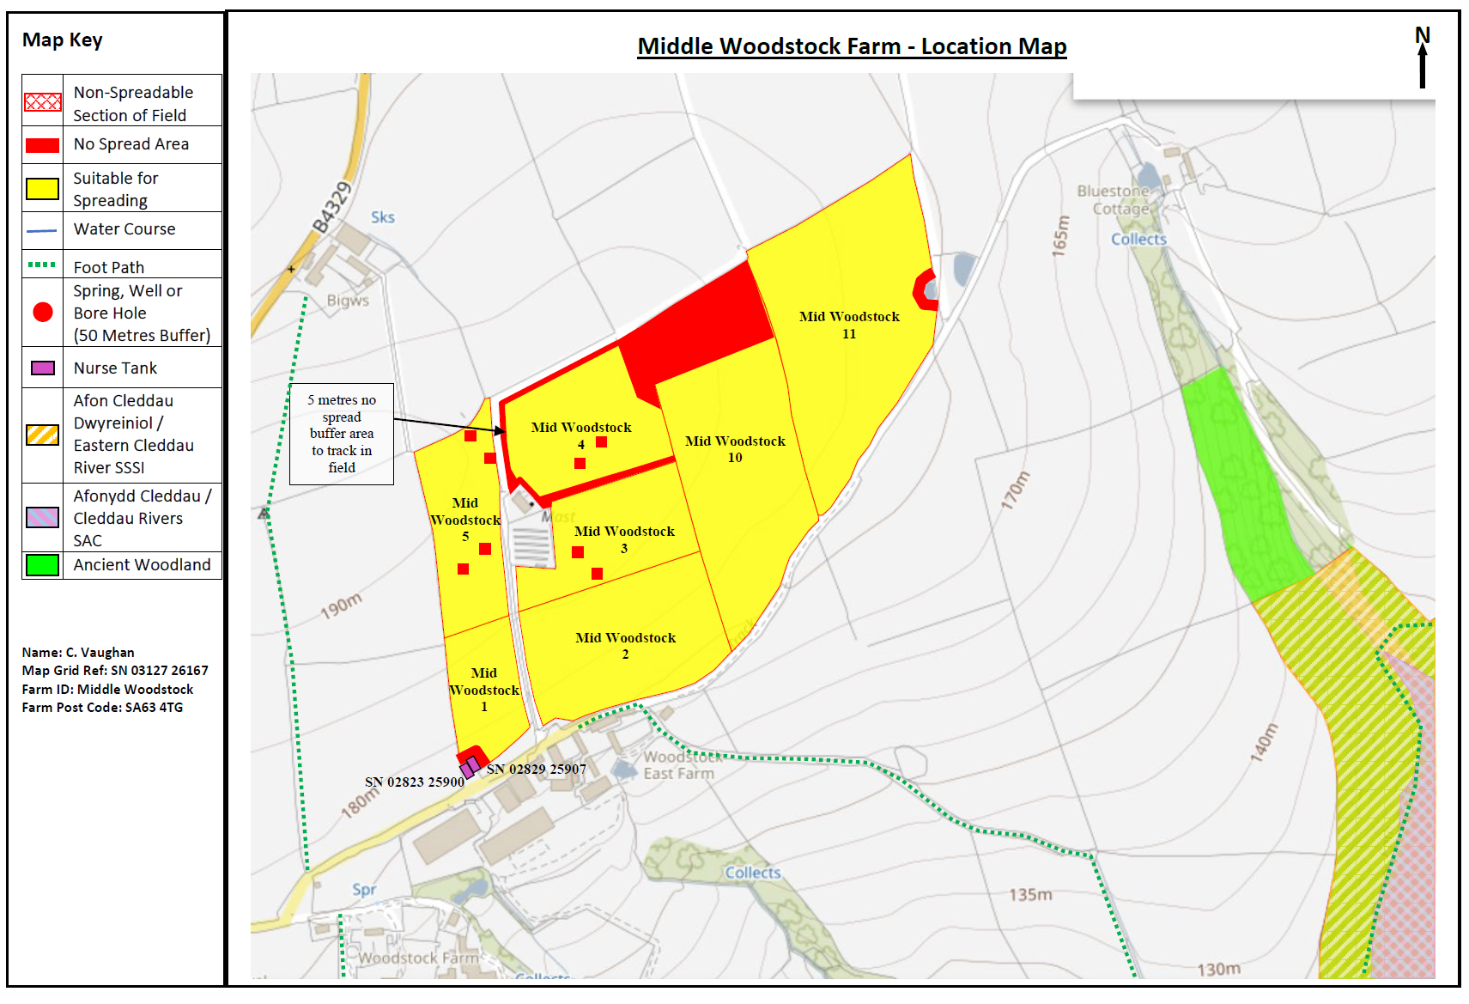
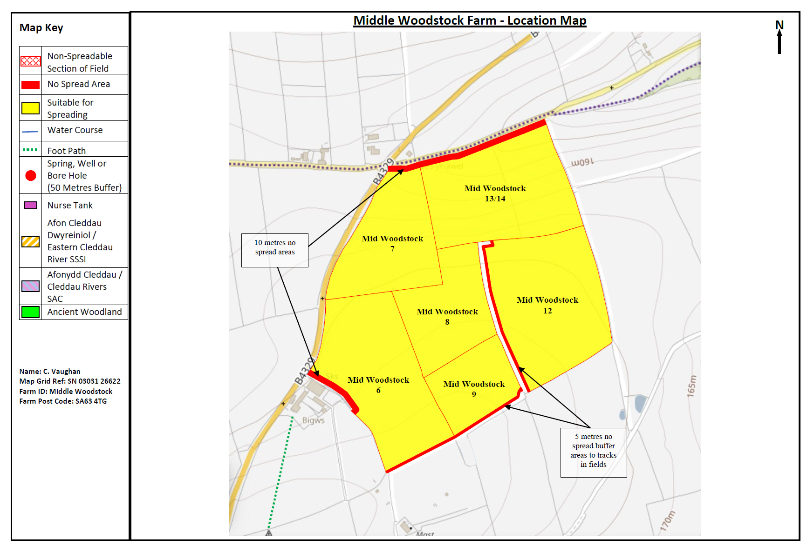
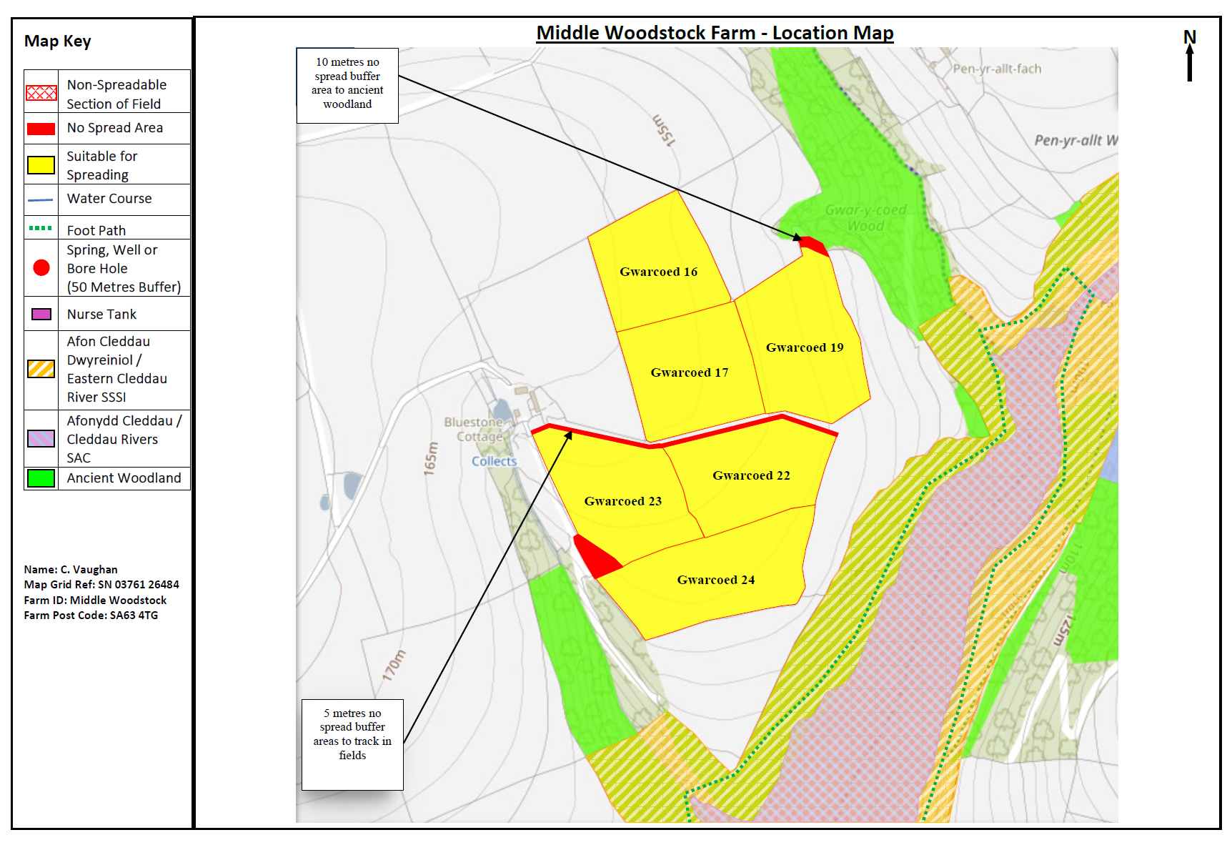
Deployment Boundaries and storage
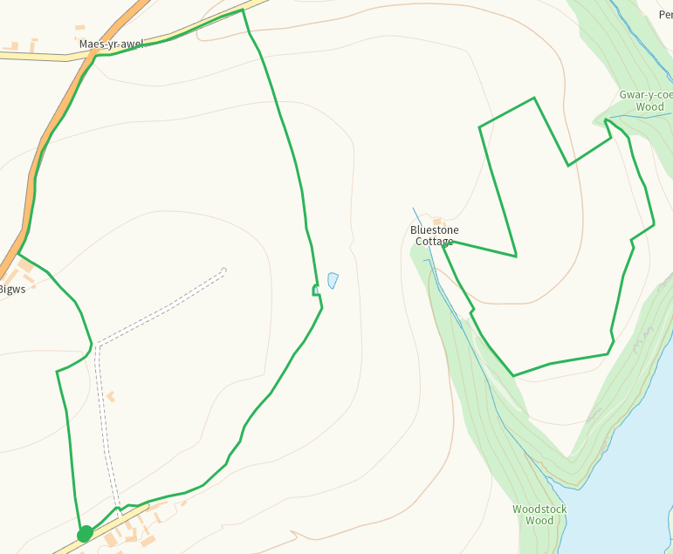
Detailed river network 10m
Pond within Mid Woodstock 4 no spread area in place
Pond E of Mid Woodstock 11 shown and buffered on application map.
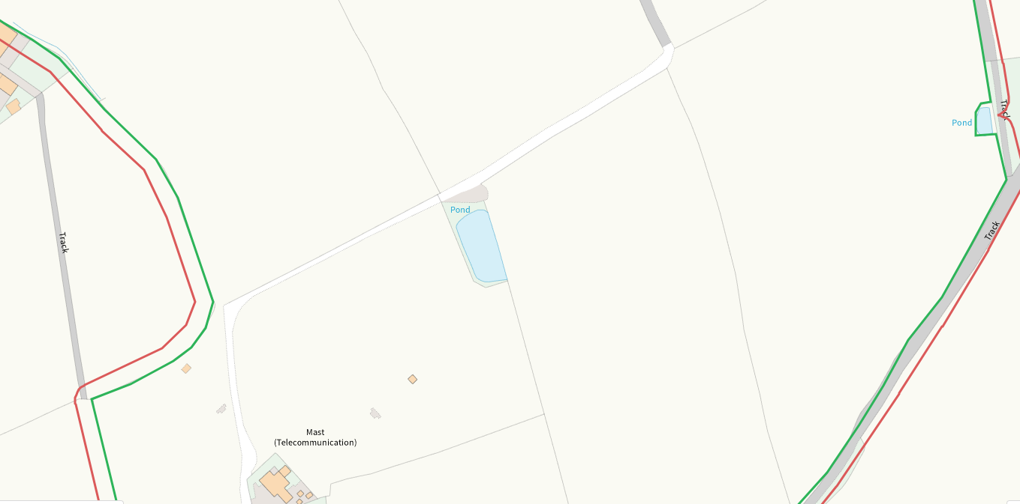
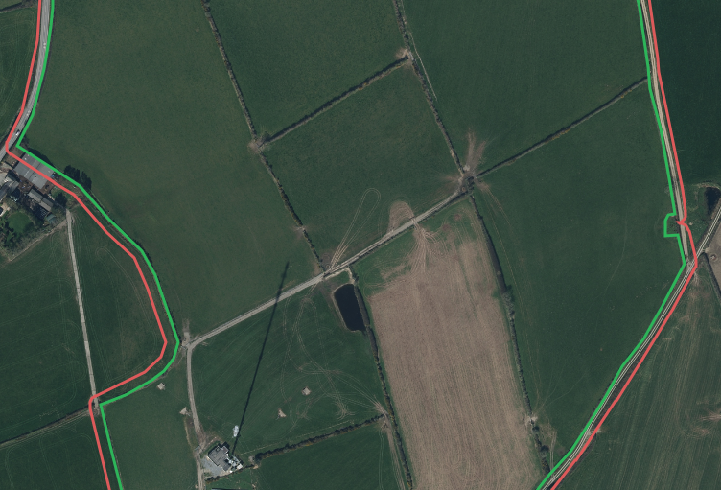
Pond adjacent N of Gwarcoed 19. 10m buffer in place.
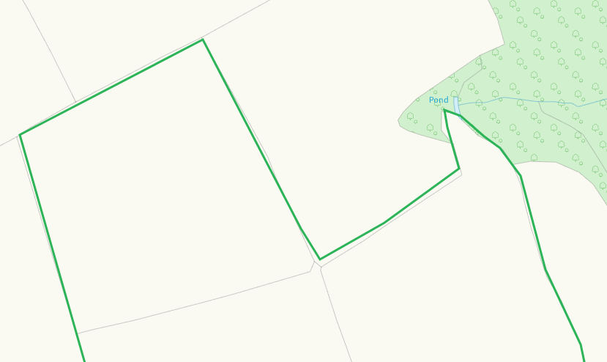
None at other feilds
Groundwater source protection zones
none
Any well, spring (or issue) or borehole used for the supply of water for human consumption including from a private water supply or supplies within 50m.
none
Any well, spring (or issue) or borehole used for the supply of water for human consumption including from a private water supply or supplies within 250m.
none
Within Groundwater Safeguard Zone
none
European designated sites- Natura 2000 (SPA, pSPA, SAC or cSAC) or Ramsar- or SSSI within 500m

Afon Cleddau Dwyreiniol / Eastern Cleddau River SSSI
Afonydd Cleddau / Cleddau Rivers SAC
Both identified on maps and mitigation given in SSRA

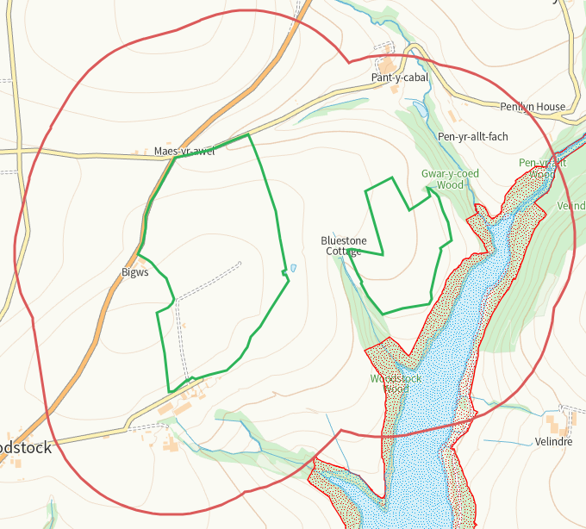
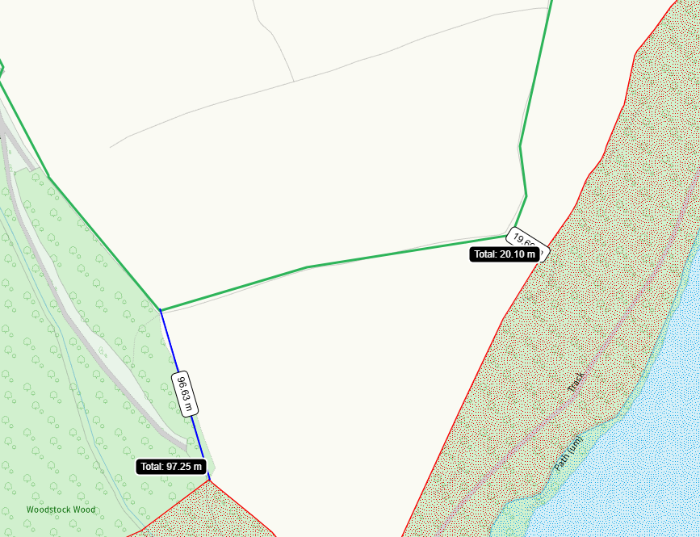
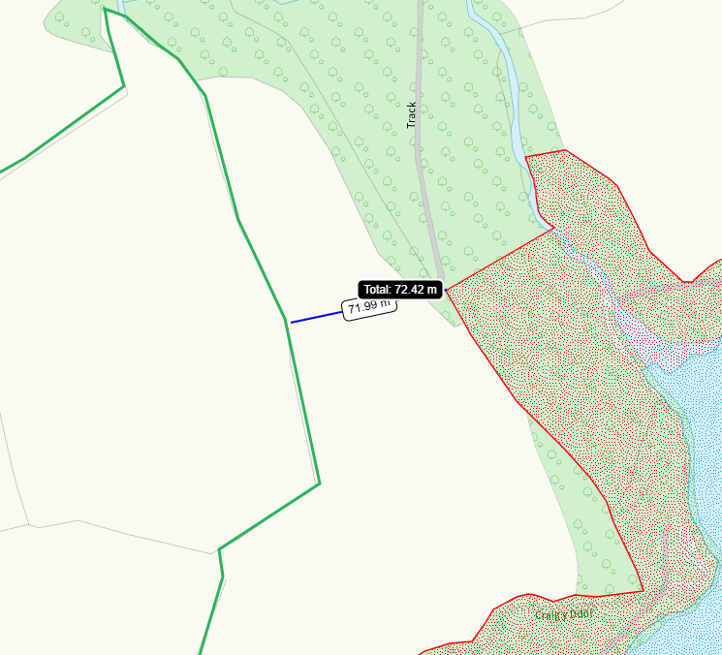
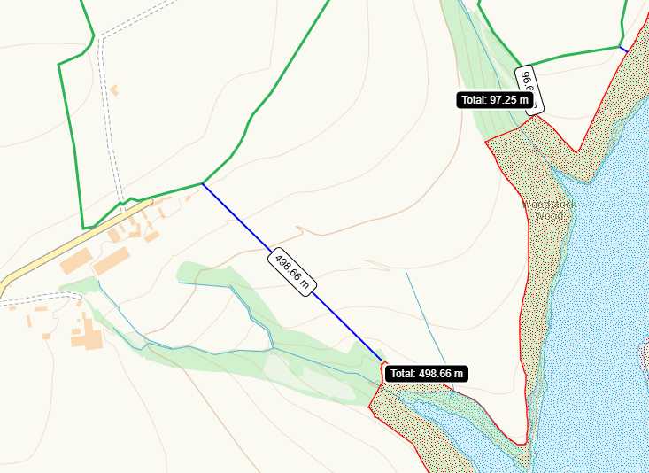
Other protected sites within 500m:
- Protected Species-
Some within range predominantly mammal species. no recent records. Nil risk from the activity.
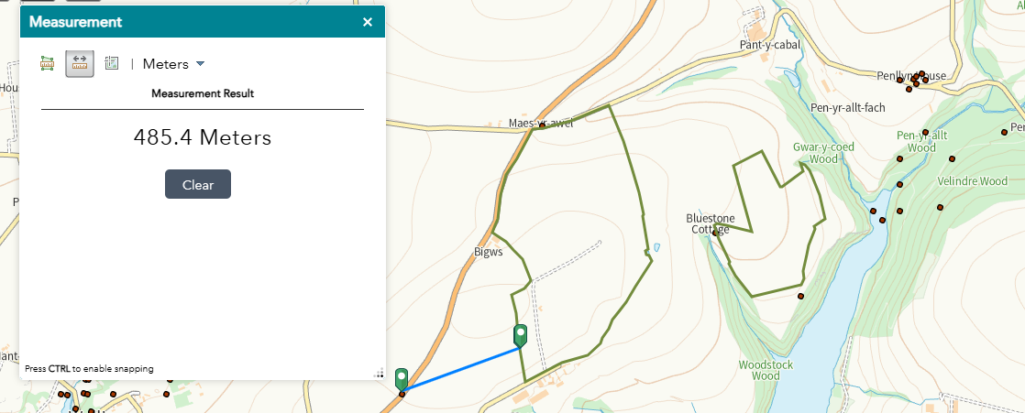
- Protected Habitats-
Some within range, nil risk from the activity
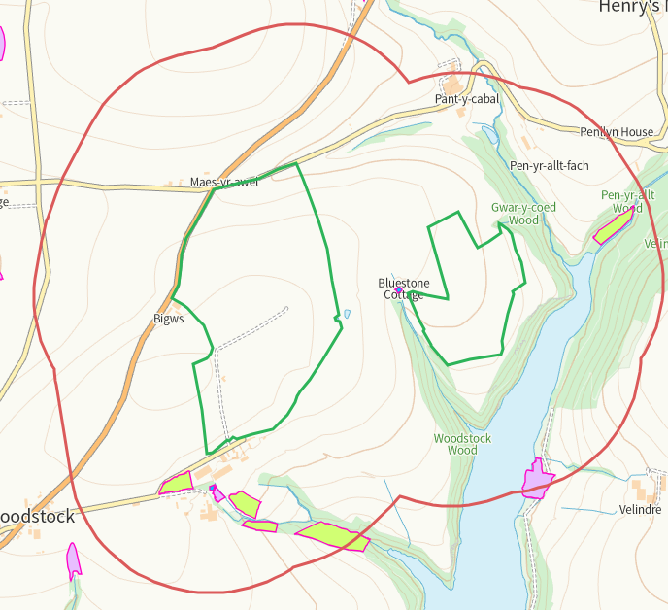

- Scheduled Ancient Monument- none
- Local Nature Reserve- none
- National Nature Reserve- none
- Ancient Woodlands-
On application maps and buffered when adjacent
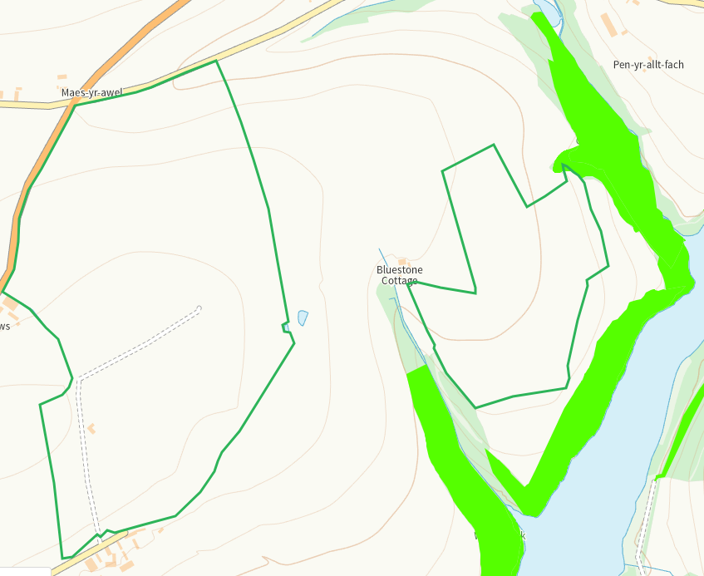
- Local Wildlife Sites (SINC)- none
- National Park- none
- Nitrate Vulnerable Zone (NVZ)- ALL Wales
- Groundwater Safeguard Zone- none

Flood risk
none
Public rights of way
None in feilds
Distance from Main Farm Address
adjacent
Slope Map
All fields 0-7 with very minor zones of 7-12 which are buffered
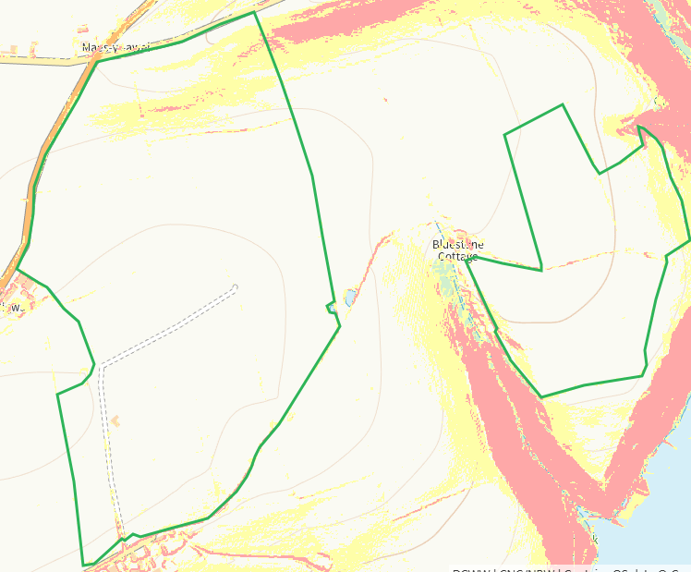

END

