Annex (iv) – SSSI Assessment Form
SSSI Assessment for permit/licence and deployment applications | 
To be completed by Permitting Officers for any applications for a permission which Natural Resources Wales has considered under S28I duty to notify SNCB and take their advice into account. This applies to all proposed permissions within a SSSI, and to operations outside the SSSI boundary which are likely to damage its special features.
NRW as a Section 28G authority has, when exercising its functions, a general duty to take reasonable steps, consistent with the proper exercise of its functions, to further the conservation and enhancement of the flora, fauna or geological or physiological features by reason of which the site is of special interest’

Part 1 – SSSI Assessment
Part 2 – Formal notification to SNCB (to be completed if part 1 assessment concludes likely damage, not likely to damage because of conditions or you cannot conclude no likely damage)
Part 3 – Decision
Pink text – drafting notes, to be deleted before completion/consultation.
Blue text – examples, to be replaced with permission-specific information and text turned to black.

Part 1 – SSSI Assessment

- Permitting officer/team | Bryan Burn / Permitting Officer
- Permit application reference and site name | PAN-031541  Middle Woodstock, Clarbeston Road, Woodstock, Pembrokeshire, SA63 4TG
- a. SSSI name(s)  b. location  c. NRW Operational Area/Environment Team | a. Afon Cleddau Dwyreiniol / Eastern Cleddau River SSSI  b. Pembrokeshire  c. South West Waste Regulation Team/Pembrokeshire Environment Team
- Brief description of proposal | Deployment application to spread waste under standard rules mobile plant permit SR2010 No4.  The fields will be spread in February – April 2026 prior to first cut silage and following silage cuts May – September 2026. Spreading of these grass fields will be split into up to 5 applications. Each individual application will not exceed 50t/ha in any one application to a field.  Spreading of the waste will be carried out in accordance with the Code of Good Agricultural Practice, The Water Resources (Control of Agricultural Pollution) (Wales) Regulations 2021 and in accordance with the requirements of the deployment and Environmental Permitting Regulations.  The fields aren’t to be cut for at least 3 weeks following applications.  NRW will be informed at least 48 hours prior to any spreading commencing and no spreading will occur within 48 hours of forecasted heavy rainfall.  The liquid sludge is either to be spread from EPR/DB3590ZP Middle Woodstock Lagoons for this waste stream, or for the other waste streams they will be delivered and placed into temporary storage in nurse tanks before being spread.  Spreading is done by either umbilical method with the liquid delivered to tractor in deployed fields pumped through hose and spread by dribble bar applicator mounted onto the back of the tractor, or a tractor and vacuum tanker with dribble bar applicator. The dribble bar applicator places the liquid in bands onto the surface of the ground. This spread method is effective in limiting odour generation & nutrient losses associated with higher trajectory spread methods such as splash plate. Spreading is undertaken with the use of flow meters to ensure correct rates are applied.  The nurse tanks do not have secondary containment, but are impermeable purpose built AW alloy nurse tanks featuring internal bracing, an anti-corrosive interior coating, designated fill and empty valves that can be shut by gate valves. These valves can be locked off in the event of temporary overnight temporary storage if the tank contains liquid to ensure secure temporary storage. The tanks are only for temporary storage and are normally rarely in use other than just prior to or when spreading activity is being undertaken. In most cases the nurse tanks are unlikely to contain liquid overnight. The tank fills from the top via internal pipework with a ‘swanneck’ reducing chances off any spills when decoupling connecting pipes after filling. The empty valve allows the tank to be completely emptied to the bottom. The tank is sealed with roof to prevent odour, rainwater entering the tank and for safety, and can be vented if required. A hydraulic lifting axle in the middle allows the tank to positioned and lowered, then locked into position so the whole tank is on the ground.  The locations of these nurse tanks for temporary storage are detailed on the application field maps & within the LPD1 form. The nurse tanks will be completely empty before and after use for temporary storage of wastes under this deployment.  The wastes may be applied separately or in combination to a field.  The maximum application rates for each field listed in Table 1 in the benefit statement apply to an individual waste being applied to a field and have been made on a field by field basis using The Nutrient Management Guide (RB209).  The maximum application rate in Table 1 of the benefit statement for each field will be split into multiple applications where it’s over 50t/ha. Each individual application will not exceed 50t/ha in any one application to a field.  Farm  SN 02894 25883  Fields:  Mid Woodstock 1 SN 02844 25991  Mid Woodstock 2 SN 02979 26043  Mid Woodstock 3 SN 02973 26152  Mid Woodstock 4 SN 02939 26265  Mid Woodstock 5 SN 02823 26153  Mid Woodstock 6 SN 02832 26466  Mid Woodstock 7 SN 02856 26725  Mid Woodstock 8 SN 02965 26573  Mid Woodstock 9 SN 03010 26446  Mid Woodstock 10 SN 03098 26232  Mid Woodstock 11 SN 03215 26360  Mid Woodstock 12 SN 03150 26608  Mid Woodstock 13/14 SN 03060 26810  Gwarcoed 16 SN 03700 26681  Gwarcoed 17 SN 03748 26553  Gwarcoed 19 SN 03888 26585  Gwarcoed 22 SN 03818 26429  Gwarcoed 23 SN 03660 26397  Gwarcoed 24 SN 03776 26298  Storage:  SN 02829 25907  SN 02823 25900  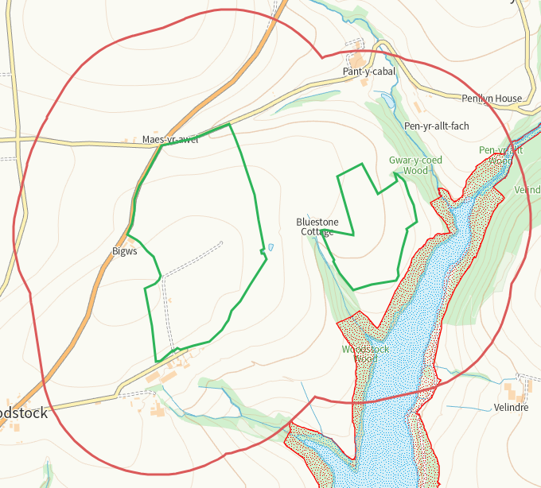  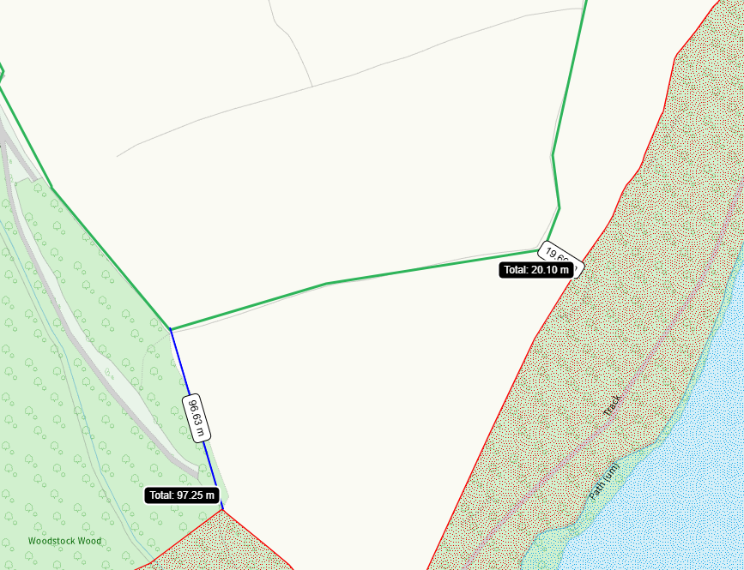  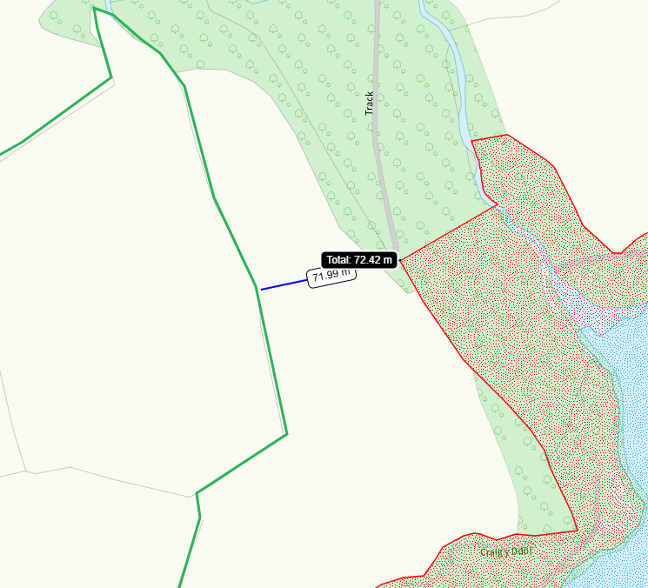  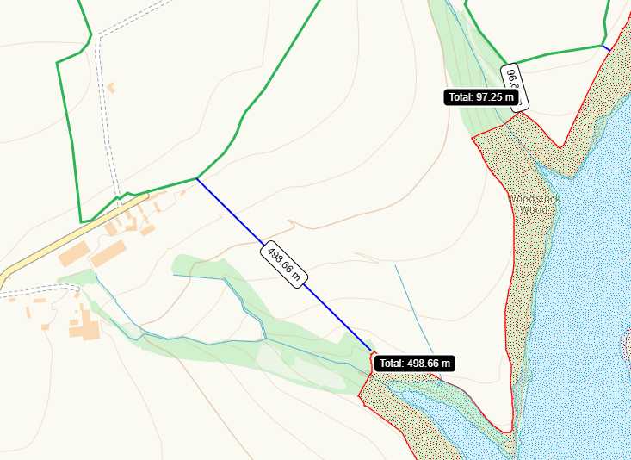
- What aspects of the proposed permission are likely to damage the SSSI features of special interest?

The following activities are likely to cause damage:

Afon Cleddau Dwyreiniol / Eastern Cleddau River SSSI
5. Application of manure, slurry, silage liquor, fertilisers and lime
7. Dumping, spreading or discharging of any material

The following SSSI(s) features and potential impacts have been considered to assess the likelihood of damage:

1. River habitats including water crowfoot habitat
2. Potamogeton berchtoldii x P. polygonifolius (cf.)
3. Associated riverside habitats (including semi-natural broadleaved woodland, scrub, mire and marshy grassland).
4. Otter
5. Fish (bullhead, brook lamprey, river lamprey, sea lamprey)
- Summary of any informal advice received from internal experts (if required and including pre-app advice) | n/a
- Recommendation | The proposed permission is not likely to damage any of the flora, fauna or geological or physiological features which are of special interest  The proposed activity in not wholly or partially within the SSSI.  The fields in this deployment have been designated as ‘high risk’ following site checks on the proximity to surrounding protected  areas (e.g. SSSIs) and groundwater source protection zones as some fields are within 500m of Afon Cleddau Dwyreiniol / Eastern  Cleddau River SSSI. On the basis of ‘high risk’ the proposed operation will be subject to a site-specific risk assessment for deploying mobile plant under a SR2010 No.4. The potential risks associated with the application  of waste on this deployment have been identified as;  Potential run-off after application: The wastes will be applied following the Code of Good Agricultural Practice. The maximum application rate for each field over 50t/ha where spread with liquid sludges will be split into multiple applications and will not exceed 50t/ha in any one application to a field. The fields will be spread using precision spreading dribble bar equipment with no spreading areas enforced as per maps.  All handling of the wastes will be in accordance to current regulations and relevant mitigation strategies will be adopted.  The liquid water clarification sludges are considered to have no noticeable odour.  Spillages: all spillages will be reported immediately to NRW.  No waste will be spread within 10m of any ditch, pond or surface water, within 50m of any spring, well, borehole, or reservoir that supplies water for human consumption or farm dairies.  Liquid sludges will be spread on delivery or temporarily securely stored as stated above. Operators will aim to empty spreading equipment before the end of each working day to avoid overnight storage of waste in machinery.  Regular servicing of all machinery is conducted and spreading equipment is annually calibrated. To prevent waste being  held in faulty machinery replacement spreading equipment will be available.  Spreading machinery will travel over the field in a direction which will most easily allow the machinery to turn within the boundaries of the field. Any spreading equipment will be turned off prior to turning at the end of each run.  Machinery turns will be routed to avoid rutting and wheel slip. The turns will not be executed on any buffer strips.  There will be sufficient trained staff available to ensure that the operation continues throughout operational hours (i.e. there will be sufficient cover for illness, holiday etc.).  Rights of way have been marked on the spread risk maps. There are no public rights of way in the fields to be spread.  Weather conditions will be monitored prior to spreading with wind speed and direction assessed.  Consideration for the public and local residential receptors will be taken into account.
- Signature and date assessment made | Bryan Burn 17/02/26
- Officers name and job title | Bryan Burn Permitting Officer


Permitting
Formal Notification under Section 28I of the Wildlife and Countryside Act 1981

Part 2 Formal notification under S28I – To be completed for all permit applications assessed as: not likely to damage because of conditions, likely to damage SSSI and those where we are unable to conclude no likely damage.

- Date Notice of intention to permit activity likely to damage SSSI sent to NRW (SCNB)  If you assess activity as being likely to damage even if you think this can be mitigated by conditioning you need to formally notify SNCB send them a copy of this notice with part 1 of this form. Environment teams have 28 days to respond.  Environment teams please complete question 11 and 12 using the information in questions 1-9 | Insert date  We have assessed that [permit ref/name of site] is likely to damage [insert name of SSSI] and request your formal advice. We have assessed that this damage could be mitigated by including conditions[remove if not applicable].  Or  We are unable to conclude that [permit ref/name of site] is not likely to damage [insert name of SSSI] and request your formal advice.  Information on the permit application can be found in Part 1 of this form and [include link to DMS documents if required]
- Advice received from NRW (SNCB)

Environment Teams and Marine Area Management and Advice Teams are expected to log and issue formal statutory advice through our CAMS system. The advice letter generated can simply by attached/appended here. ET/MAAMT can just refer to that here or write a summary of advice here too.

To be completed by environment officers.
Within 28 days of receiving notice from a permitting/licensing regime, you should advise whether the operation:
• Should be allowed to proceed.
• Should be allowed to proceed with certain conditions.
• Should not proceed.

Please ensure all advice provided is evidenced and comprehensive. Advice provided may be scrutinised as part of a formal appeal.

- Name and job title of conservation/marine officer (sign and date)
Part 3 – To record NRW decision following SNCB Advice
- DECISION  Provide reasoning for your decision and how you have considered advice from NRW(SNCB) in the box opposite and delete text in blue that is not relevant. This might be the same as the info and decision in part 1 of the form  Large amounts of supporting information can be appended to this form. | The proposed permission is not likely to damage any of the flora, fauna or geological or physiological features which are of special interest  The permission is not likely to damage any of the flora, fauna or geological or physiological features which are of special interest because of conditions  The permission is likely to damage
- Natural Resources Wales (Section 28G Authority) (permitting service) is minded to  Delete as appropriate  If this decision is not in line with advice received from NRW(SNCB) please outline your reasoning (please note that you should try to resolve any differences in opinion) | Issue the permission  Issue the permission with conditions to ensure no damage to SSSI  Refuse the permission due to likely damage to SSSI
- Is decision in line with advice from SNCB  If your decision is not in line with the recommendations from SNCB you must formally notify them using the appropriate online form or letter.  Record the date the notice/letter was sent opposite and save a link. The permitted operation cannot commence for 21 days following service of this notice. | Yes/No  If No record date notice was sent to SNCB
- Signature and date assessment completed
- Officers name and job title

