Permit
The Environmental Permitting (England & Wales) Regulations 2016

Aggregates Express Quarry Ltd

Forest Wood Quarry
Talygarn
Pontyclun
Rhondda Cynon Taff
CF72 9XD

Permit number

EPR/ DB3691ZM

Permit
The Environmental Permitting (England and Wales) Regulations 2016
Permit number

EPR/ DB3691ZM

The Natural Resources Body for Wales (“Natural Resources Wales”) authorises, under regulation 13 of the Environmental Permitting (England and Wales) Regulations 2016

Aggregates Express Quarry Ltd (“the operator”),

whose registered office is

Forest Wood Quarry

Brynsadler

Rhondda Cynon Taff

Wales

CF72 9XD

company registration number 02968375

to operate waste operations at

Forest Wood Quarry

Talygarn

Pontyclun

Rhondda Cynon Taff

CF72 9XD

to the extent authorised by and subject to the conditions of this permit.

Under regulation 27(2) of the Regulations, standard rules SR2008No11 are conditions of this permit.

Name | Date
Huw Davies | 17/02/2026

Authorised on behalf of Natural Resources Wales

Schedule 1 - Site plan

This is the plan referred to in the standard rules SR2008No11

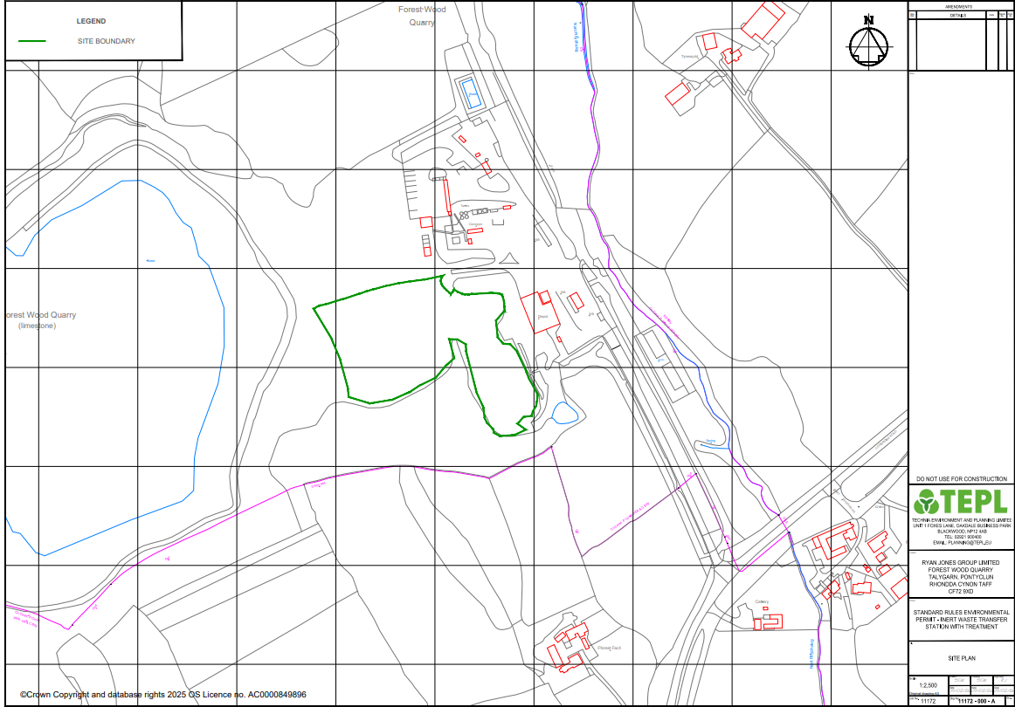.

END OF PERMIT

