

Permit with introductory note
The Environmental Permitting (England & Wales) Regulations 2016

Morgan Sindall Construction And Infrastructure Ltd

Construction site at
King Henry VIII Comprehensive School
Old Hereford Road
Abergavenny
Monmouthshire
NP7 6EP

Variation application number
PAN-031149

Permit number

EPR/CB3997ZY

Construction site at

King Henry VIII School

Permit Number EPR/CB3997ZY

Introductory note

This introductory note does not form a part of the notice.

The following notice gives notice of the variation and consolidation of an environmental permit.

Due to the location of Phase 2 works, Morgan Sindall have applied to vary the permit to update the location of treatment systems and, ultimately, the discharge point (to the Afon Cibi).These proposed changes are a direct result of logistical and operational challenges of the Phase 2 works in relation to the school being operational following the completion of Phase 1 construction activities. No changes are proposed to the treatment process, discharge rates, or the environmental risk profile of the activity.

The schedules specify the changes made to the permit.

The status log of a permit sets out the permitting history, including any changes to the permit reference number. It is not backdated before 6 April 2010.

Status log of the permit
Description | Date | Comments
Application PAN-019858 | Duly made 08/11/2022 | Application for discharge of trade effluent consisting of site drainage.
Additional information received | 12/05/2023 | Information about new treatment system received.
Additional information received | 25/05/2023 | Schedule 5 response: clarification of amount of flocculant used and residual left in discharge, new treatment system, amended management plan and why trade effluent consent could not be continued with.
Permit determined | 06/09/2023 | Permit issued to Morgan Sindall Construction Infrastructure Ltd
Application PAN-031149 | Duly made  07/01/2026 | Application to change the location of the discharge point.
Variation determined EPR/CB3997ZY | 20/02/2026 | Varied and consolidated permit issued.

End of introductory note

Notice of variation and consolidation
The Environmental Permitting (England and Wales) Regulations 2016

The Natural Resources Body for Wales (“Natural Resources Wales”) in exercise of its powers under regulation 20 of the Environmental Permitting (England and Wales) Regulations 2016 varies and consolidates

permit number

EPR/CB3997ZY

issued to:

Morgan Sindall Construction and Infrastructure Ltd (“the operator”),

whose registered office is

Kent House

14-17 Market Place

London

W1W 8AJ

company registration number limited liability partnership 04273754

to operate a water discharge activity at

Abergavenny 3 -19 King Henry III School

King Henry VIII Comprehensive School

Old Hereford Road

Abergavenny

Monmouthshire

NP7 6EP

to the extent set out in the schedules.

The notice shall take effect from 20/02/2026.

Name | Date
Katrin Raynor | 20/02/2026

Authorised on behalf of Natural Resources Wales

Schedule 1
The following conditions were varied as a result of the application made by the operator: Table S3.2 and Table S3.3.

Schedule 2 – consolidated permit

Consolidated permit issued as a separate document
Permit

The Environmental Permitting (England and Wales) Regulations 2016

Permit number

EPR/CB3997ZY

This is the consolidated permit referred to in the variation and consolidation notice for application PAN-031149 authorising,

Morgan Sindall Construction and Infrastructure Ltd (“the operator”),

whose registered office is

Kent House

14-17 Market Place

London

W1W 8AJ

company registration number limited liability partnership 04273754

to operate a water discharge activity at

Abergavenny 3 -19 King Henry III School

King Henry VIII Comprehensive School

Old Hereford Road

Abergavenny

Monmouthshire

NP7 6EP

to the extent authorised by and subject to the conditions of this permit.

Name | Date
Katrin Raynor | 20/02/2026

Authorised on behalf of Natural Resources Wales

Conditions

Management

General management

The operator shall manage and operate the activities:

in accordance with a written management system that identifies and minimises risks of pollution, including those arising from operations, maintenance, accidents, incidents, non-conformances and those drawn to the attention of the operator as a result of complaints; and

using sufficient competent persons and resources.

Records demonstrating compliance with condition 1.1.1 shall be maintained.

Any person having duties that are or may be affected by the matters set out in this permit shall have convenient access to a copy of it kept at or near the place where those duties are carried out.

2 Operations
2.1 Permitted activities

2.1.1 The operator is only authorised to carry out the activities specified in schedule 1 table S1.1 (the “activities”).

2.2 The site

2.2.1 The activities shall not extend beyond the site, being the land shown edged in green and the discharge shall be made at the point marked on the site plan at schedule 7 to this permit and as listed in table S3.2 (discharge points).

2.3 Operating techniques
2.3.1 (a) The activities shall, subject to the conditions of this permit, be operated using the techniques and in the manner described in the documentation specified in schedule 1, table S1.2, unless otherwise agreed in writing by Natural Resources Wales.
(b) If notified by Natural Resources Wales that the activities are giving rise to pollution, the operator shall submit to Natural Resources Wales for approval within the period specified, a revision of any plan or other documentation (“plan”) specified in schedule 1, table S1.2 or otherwise required under this permit which identifies and minimises the risks of pollution relevant to that plan, and shall implement the approved revised plan in place of the original from the date of approval, unless otherwise agreed in writing by Natural Resources Wales.

3 Emissions and monitoring

3.1 Emissions to water

3.1.1 There shall be no point source emissions to water except from the sources and emission points listed in schedule 3.

3.1.2 The limits given in schedule 3 shall not be exceeded.

Emissions of substances not controlled by emission limits

Emissions of substances not controlled by emission limits (excluding odour) shall not cause pollution. The operator shall not be taken to have breached this condition if appropriate measures, including, but not limited to, those specified in any approved emissions management plan, have been taken to prevent or where that is not practicable, to minimise, those emissions.

3.2.2 The operator shall:

(a) if notified by Natural Resources Wales that the activities are giving rise to pollution, submit to Natural Resources Wales for approval within the period specified, an emissions management plan which identifies and minimises the risks of pollution from emissions of substances not controlled by emission limits;

(b) implement the approved emissions management plan, from the date of approval, unless otherwise agreed in writing by Natural Resources Wales.

3.2.3 All liquids in containers, whose emission to water or land could cause pollution, shall be provided with secondary containment, unless the operator has used other appropriate measures to prevent or where that is not practicable, to minimise, leakage and spillage from the primary container.

3.3 Monitoring

3.3.1 The operator shall, unless otherwise agreed in writing by Natural Resources Wales, undertake the monitoring specified in the following tables in schedule 3 to this permit:

(a) point source emissions specified in tables S3.1 and S3.3.

3.3.2 The operator shall maintain records of all monitoring required by this permit including records of the taking and analysis of samples, instrument measurements (periodic and continual), calibrations, examinations, tests and surveys and any assessment or evaluation made on the basis of such data.

3.3.3 Monitoring equipment, techniques, personnel and organisations employed for the emissions monitoring programme and the environmental or other monitoring specified in condition 3.3.1 shall have either MCERTS certification or MCERTS accreditation (as appropriate), where available, unless otherwise agreed in writing by Natural Resources Wales.

3.3.4 Permanent means of access shall be provided to enable sampling/monitoring to be carried out in relation to the emission points specified in schedule 3 tables S3.1, S3.2 and S3.3 unless otherwise agreed in writing by Natural Resources Wales.

4 Information

4.1 Records

All records required to be made by this permit shall:

be legible;

be made as soon as reasonably practicable;

if amended, be amended in such a way that the original and any subsequent amendments remain legible, or are capable of retrieval; and

be retained, unless otherwise agreed in writing by Natural Resources Wales, for at least 6 years from the date when the records were made.
4.1.2 The operator shall keep on site all records, plans and the management system required to be maintained by this permit, unless otherwise agreed in writing by Natural Resources Wales.

4.2 Reporting

4.2.1 The operator shall send all reports and notifications required by the permit to Natural Resources Wales using the contact details supplied in writing by Natural Resources Wales.

4.2.2 Within 28 days of the end of the reporting period the operator shall, unless otherwise agreed in writing by Natural Resources Wales, submit reports of the monitoring and assessment carried out in accordance with the conditions of this permit, as follows:
(a) in respect of the parameters and emission points specified in schedule 4 table S4.1;
(b) for the reporting periods specified in schedule 4 table S4.1 and using the forms specified in schedule 4 table S4.2; and
(c) giving the information from such results and assessments as may be required by the forms specified in those tables.

4.3 Notifications

4.3.1 Natural Resources Wales shall be notified without delay following the detection of:

any malfunction, breakdown or failure of equipment or techniques, accident, or emission of a substance not controlled by an emission limit which has caused, is causing or may cause significant pollution;

the breach of a limit specified in the permit; or

any significant adverse environmental effects.

4.3.2 Any information provided under condition 4.3.1 shall be confirmed by sending the information listed in schedule 5 to this permit within the time period specified in that schedule.

4.3.3 Where Natural Resources Wales has requested in writing that it shall be notified when the operator is to undertake monitoring and/or spot sampling, the operator shall inform Natural Resources Wales when the relevant monitoring and/or spot sampling is to take place. The operator shall provide this information to Natural Resources Wales at least 14 days before the date the monitoring is to be undertaken.

4.3.4 Natural Resources Wales shall be notified within 14 days of the occurrence of the following matters, except where such disclosure is prohibited by Stock Exchange rules:

Where the operator is a registered company:

any change in the operator’s trading name, registered name or registered office address; and

(b) any steps taken with a view to the operator going into administration, entering into a company voluntary arrangement or being wound up.

Where the operator is a corporate body other than a registered company:

any change in the operator’s name or address; and

any steps taken with a view to the dissolution of the operator.

4.3.5 Where the operator proposes to make a change in the nature or functioning, or an extension of the activities, which may have consequences for the environment and the change is not otherwise the subject of an application for approval under the Regulations or this permit:

(a) Natural Resources Wales shall be notified at least 14 days before making the change; and

(b) the notification shall contain a description of the proposed change in operation.

4.4 Interpretation

4.4.1 In this permit the expressions listed in schedule 6 shall have the meaning given in that schedule.

4.4.2 In this permit references to reports and notifications mean written reports and notifications, except where reference is made to notification being made “without delay”, in which case it may be provided by telephone.

Schedule 1 - Operations

Table S1.1 Activities
Description of activity | Limits of specified activity
Discharge of trade effluent consisting of site drainage via Stream Outfall | N/A

Table S1.2 Operating techniques
Description of documentation | Parts | Date Received
“PAN-019858 info re new treatment system” | All | 12/05/2023

Schedule 2 - Waste types, raw materials and fuels

Wastes are not accepted as part of the permitted activities and there are no restrictions on raw materials or fuels under this schedule.

Schedule 3 – Emissions and monitoring

Table S3.1 Point Source emissions to water (other than sewer) – emission limits and monitoring requirements
Discharge source and discharge point ref. & location | Parameter | Limit (including unit) | Reference Period | Limit of effective range | Monitoring frequency | Compliance Statistic
Trade effluent consisting of site drainage via Stream outfall | Maximum daily discharge volume | 432 m³/day | Total daily volume | N/A | N/A | Maximum
 | Maximum rate of discharge | 15 litres per second | Instantaneous (spot sample) | N/A | Continuous | Maximum
 | Suspended solids (measured after drying at 105º C) | 30 mg/l | Instantaneous (spot sample) | N/A | N/A | Maximum
 | Total Iron as Fe | 1,000 µg/l | Instantaneous (spot sample) | N/A | N/A | Maximum
 | pH | 6 to 9 | Instantaneous (spot sample) | N/A |  | Minimum and maximum
 | Visible oil or grease | No significant trace present | Instantaneous (spot sample) | N/A | N/A | No significant trace

Table S3.2 Discharge points
Effluent Name | Discharge Point | Discharge point NGR | Receiving water
Trade effluent consisting of site drainage | Stream outfall | SO 29822 15155 | Unnamed tributary of the Afon Cibi

Table S3.3 Monitoring points
Effluent and discharge point | Monitoring type | Monitoring point NGR | Monitoring point reference
Trade effluent consisting of site drainage via Stream outfall | Effluent sample point | SO 29822 15155 | Stream outfall
 | Flow monitoring Point | SO 29822 15155 | Stream outfall

Schedule 4 – Reporting

Determinands, for which reports shall be made, in accordance with conditions of this permit, are listed below.

Table S4.1 Reporting of monitoring data
Determinand | Monitoring point reference | Reporting period | Period begins
Maximum rate of discharge | Stream outfall | On request | Upon request by Natural Resources Wales

Table S4.2 Reporting forms
Determinand | Reporting format
Maximum rate of discharge | Form as agreed in writing by Natural Resources Wales
Schedule 5 - Notification

These pages outline the information that the operator must provide.

Units of measurement used in information supplied under Part A and B requirements shall be appropriate to the circumstances of the emission. Where appropriate, a comparison should be made of actual emissions and authorised emission limits.

If any information is considered commercially confidential, it should be separated from non-confidential information, supplied on a separate sheet and accompanied by an application for commercial confidentiality under the provisions of the EP Regulations.

Part A
Permit Number | EPR/CB3997ZY

Name of operator
Location of Facility | Abergavenny 3—19 King Henry III School. King Henry VIII School, Old Hereford Road, Abergavenny, NP7 6EP

Time and date of the detection

(a) Notification requirements for any malfunction, breakdown or failure of equipment or techniques, accident, or emission of a substance not controlled by an emission limit which has caused, is causing or may cause significant pollution

To be notified within 24 hours of detection

Date and time of the event

Reference or description of the location of the event

Description of where any release into the environment took place

Substances(s) potentially released

Best estimate of the quantity or rate of release of substances

Measures taken, or intended to be taken, to stop any emission

Description of the failure or accident.

(b) Notification requirements for the breach of a limit

To be notified within 24 hours of detection unless otherwise specified below

Emission point reference/ source

Parameter(s)

Limit

Measured value and uncertainty

Date and time of monitoring

Measures taken, or intended to be taken, to stop the emission

Time periods for notification following detection of a breach of a limit
Parameter | Notification period

(c) Notification requirements for the detection of any significant adverse environmental effect

To be notified within 24 hours of detection

Description of where the effect on the environment was detected

Substances(s) detected

Concentrations of substances detected

Date of monitoring/sampling

Part B - to be submitted as soon as practicable

Any more accurate information on the matters for notification under Part A.

Measures taken, or intended to be taken, to prevent a recurrence of the incident

Measures taken, or intended to be taken, to rectify, limit or prevent any pollution of the environment which has been or may be caused by the emission

The dates of any unauthorised emissions from the facility in the preceding 24 months.

Name*

Post

Signature

Date

* authorised to sign on behalf of the operator

Schedule 6 - Interpretation
"accident" means an accident that may result in pollution.
"annually" means once every year.
“application” means the application for this permit, together with any additional information supplied by the operator as part of the application and any response to a notice served under Schedule 5 to the EP Regulations.
“EP Regulations” means The Environmental Permitting (England and Wales) Regulations SI 2016 No.1154 and words and expressions used in this permit which are also used in the Regulations have the same meanings as in those Regulations.

“emissions of substances not controlled by emission limits ” means emissions of substances to air, water or land from the activities, either from the emission points specified in schedule 3 or from other localised or diffuse sources, which are not controlled by an emission limit.
“groundwater” means all water, which is below the surface of the ground in the saturation zone and in direct contact with the ground or subsoil.

“MCERTS” means Natural Resources Wales’s Monitoring Certification Scheme.
“Natural Resources Wales” means the Natural Resources Body for Wales established by article 3 of the Natural Resources Body for Wales (Establishment) Order 2012. The Natural Resources Body for Wales (Functions) Order 2013 transferred the relevant functions of the Countryside Council for Wales, and functions of the Environment Agency and the Forestry Commission in Wales to the Natural Resources Body for Wales
"quarter" means a calendar year quarter commencing on 1 January, 1 April, 1 July or 1 October.

“year” means calendar year ending 31 December.

Schedule 7 - Site plan
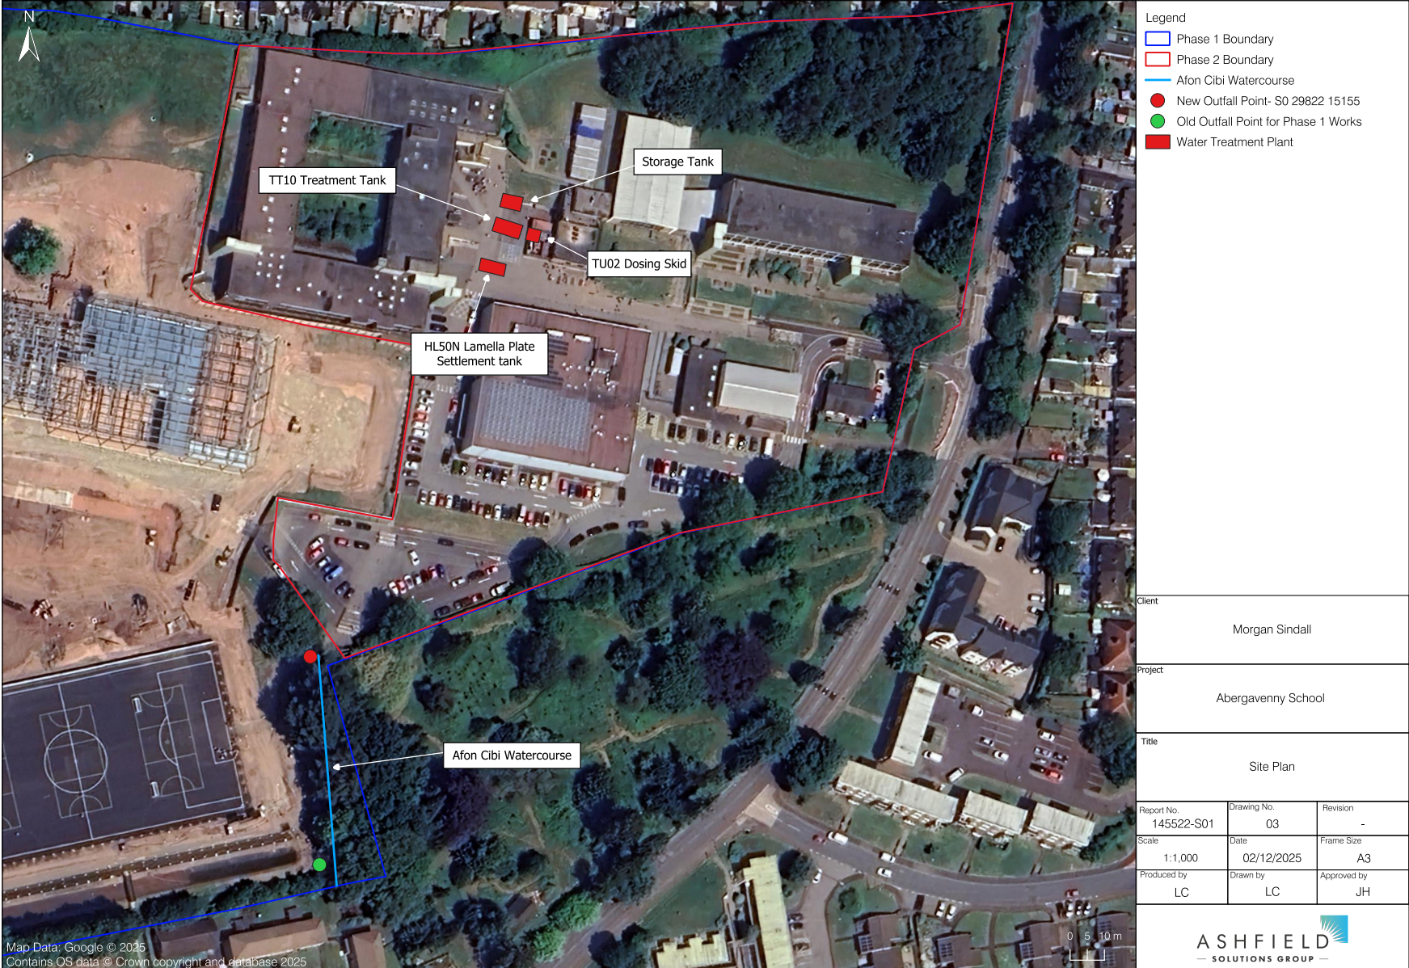

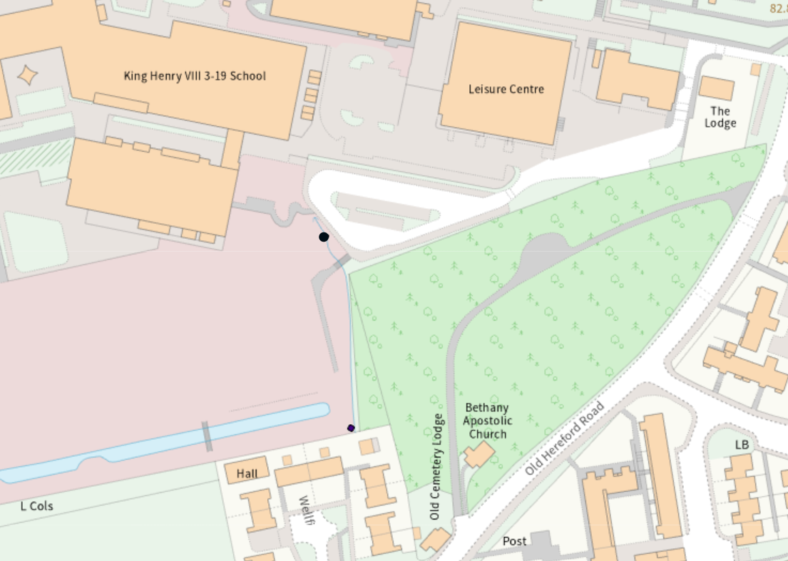
Stream outfall

© Crown Copyright and database right 2026. Ordnance Survey licence number 100019741.

END OF PERMIT

