PAN-0315373 My Map Report:
Application maps
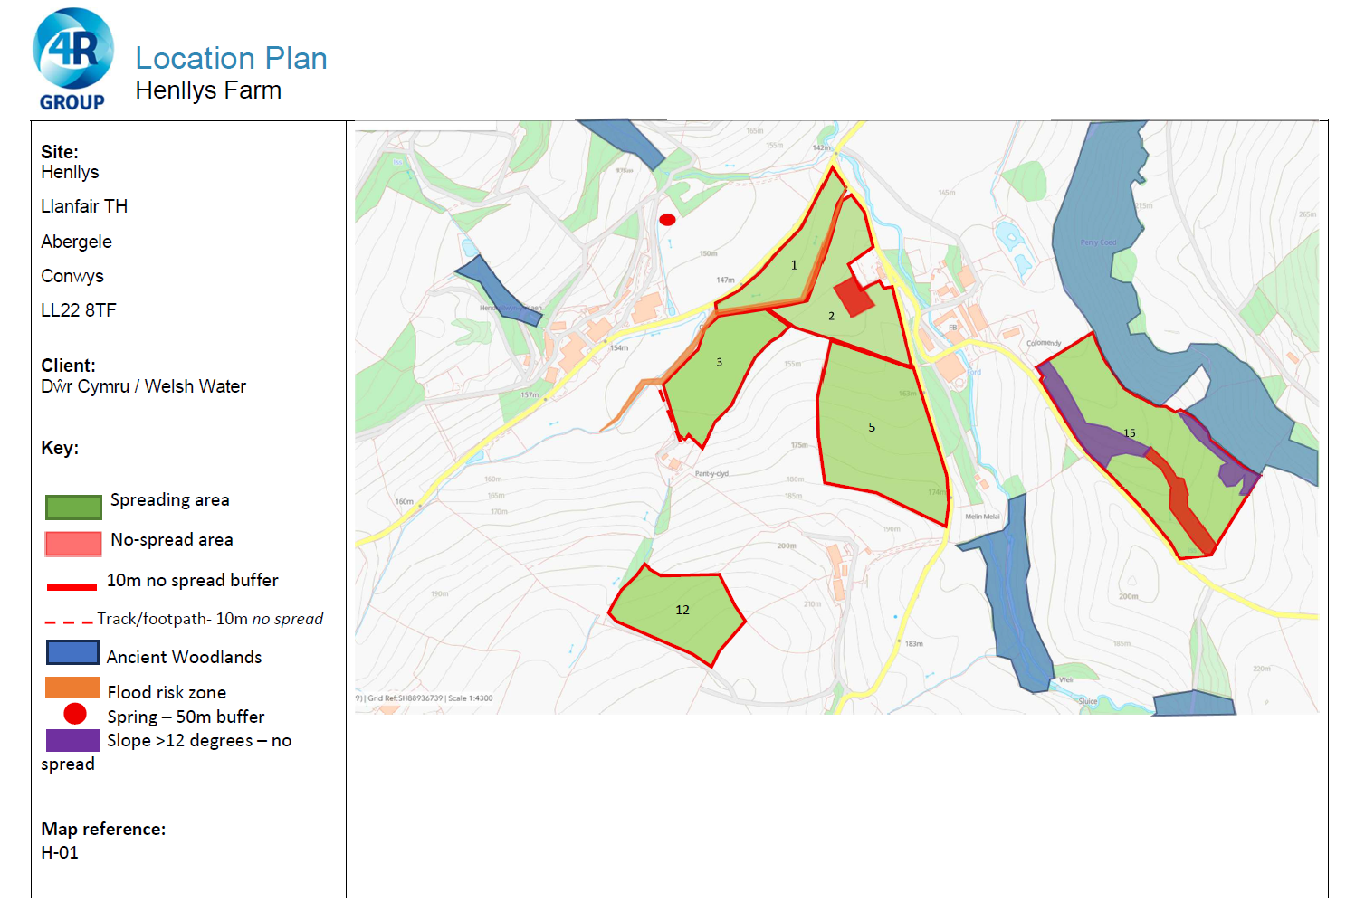
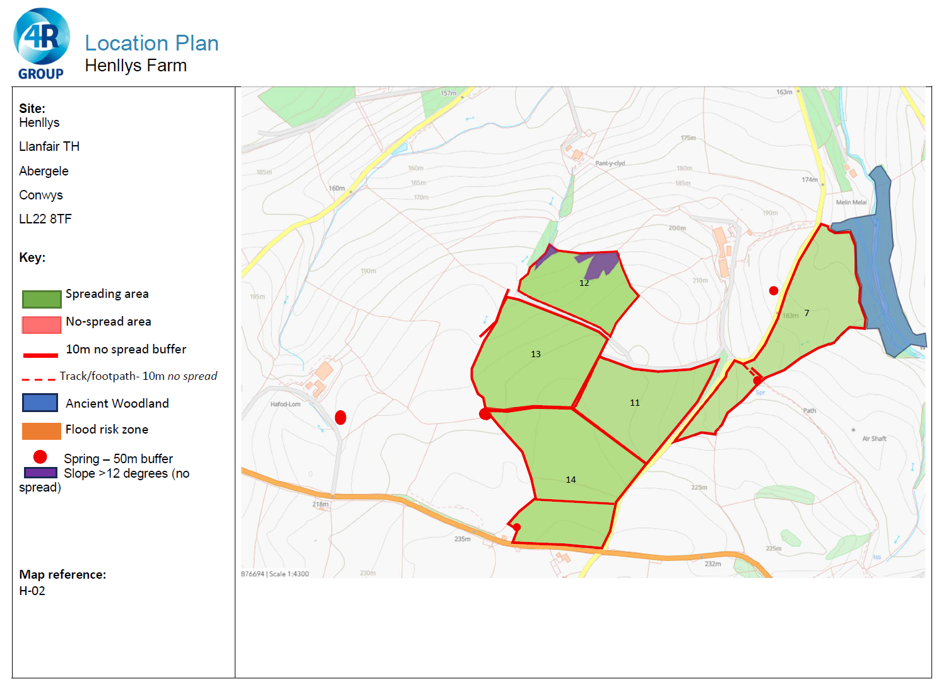
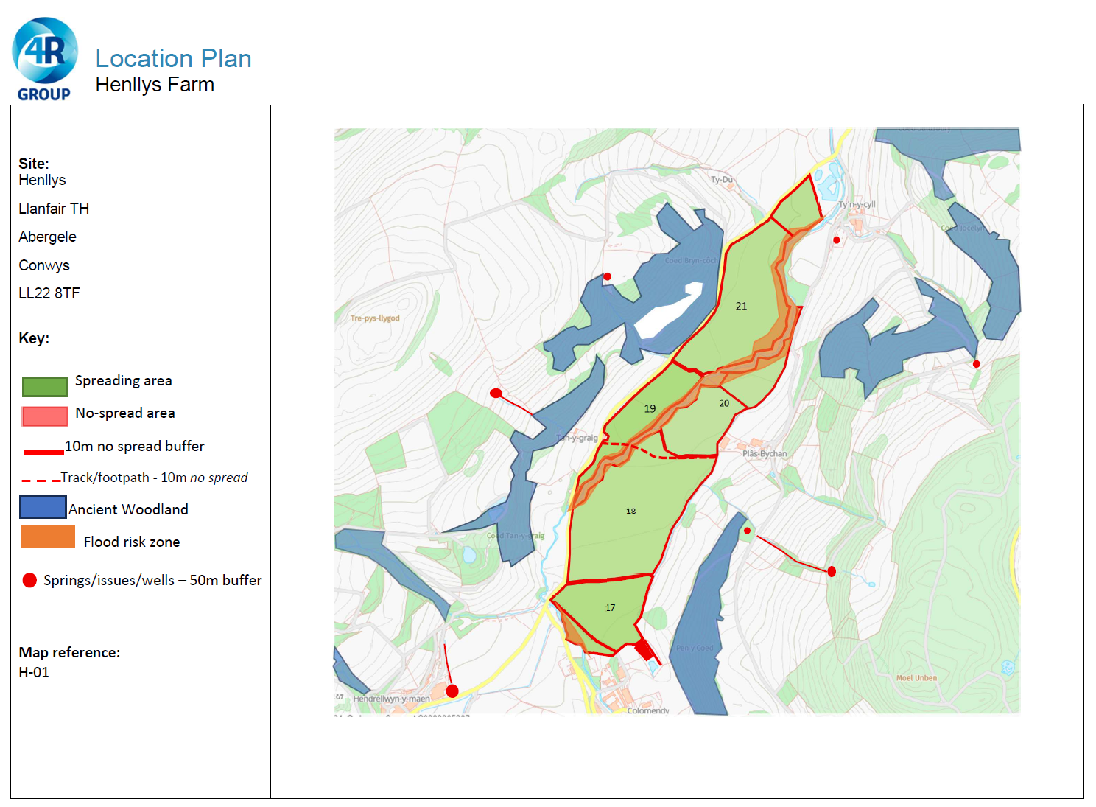
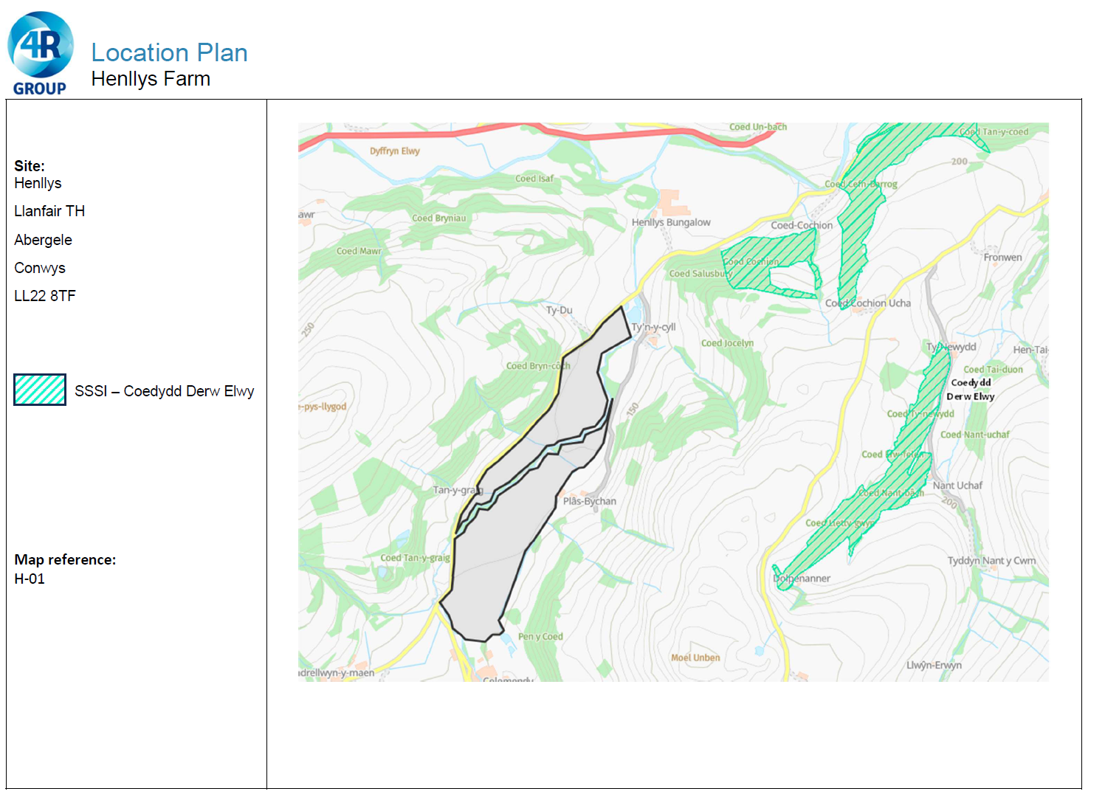
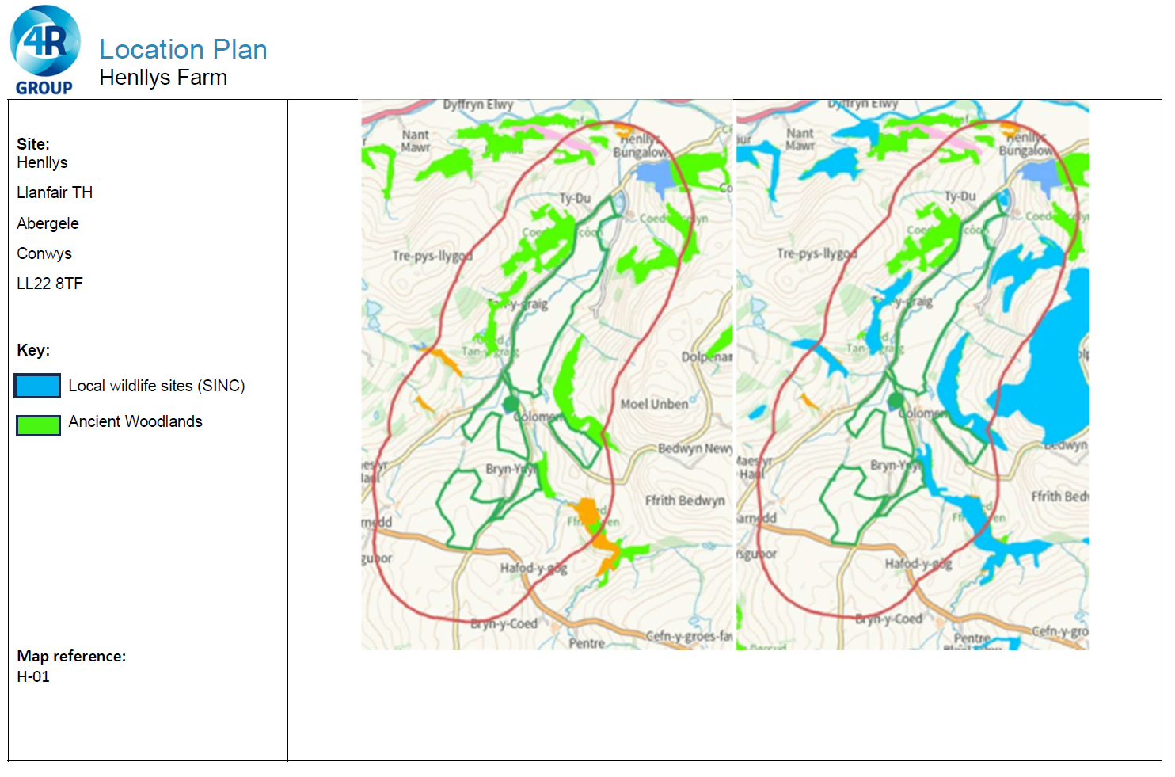
Deployment Boundaries
Area in blue below is a permitted lagoon.
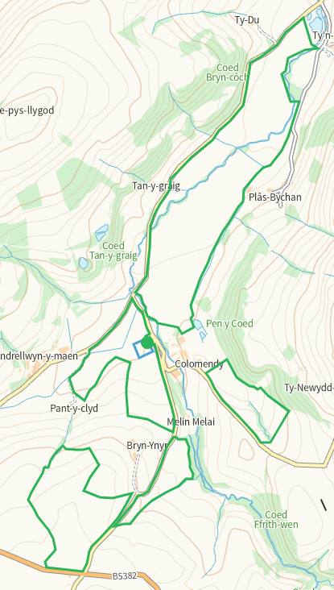
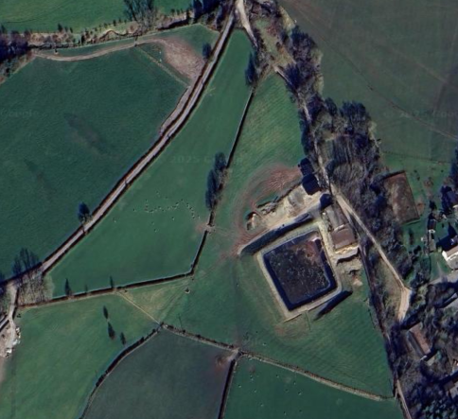
Detailed river network 10m
Watercourse at boundary of 3 and within 1, buffered on application map
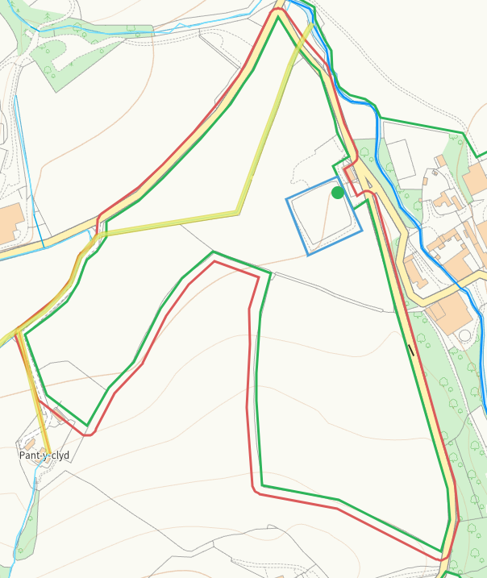
Watercourse within 15, buffered on application map
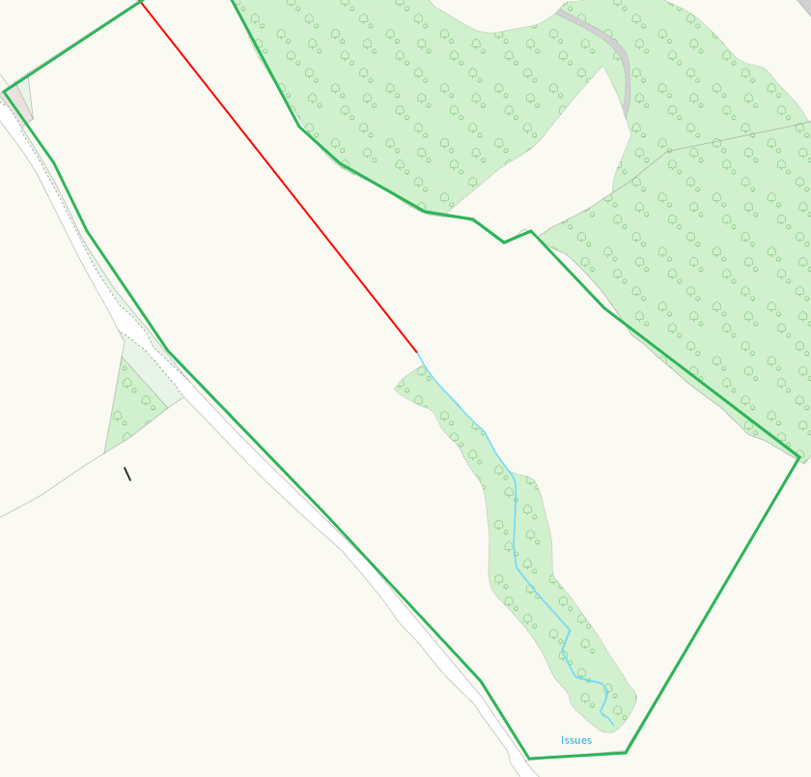
Pond W of 13, appears to be buffered on application map
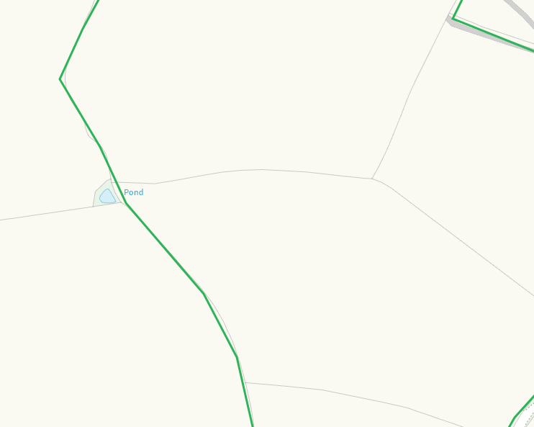
Watercourse within 7, buffered on application map
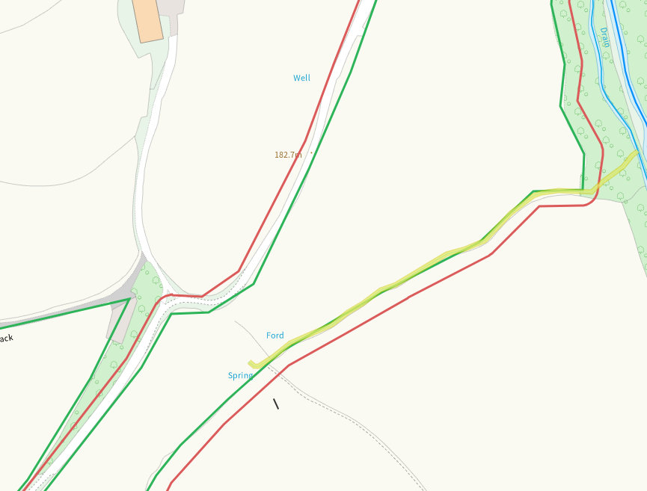
Multiple watercourses including Nant Melai at 17-21, buffered
Watercourse within 17, buffered
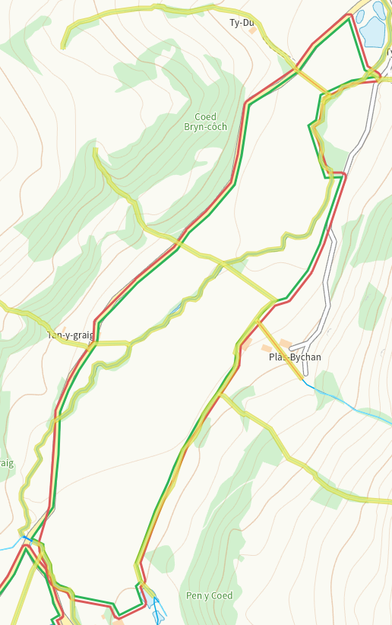
Groundwater source protection zones
none
Any well, spring (or issue) or borehole used for the supply of water for human consumption including from a private water supply or supplies within 50m.
Well W of and Spring within 7, buffered.
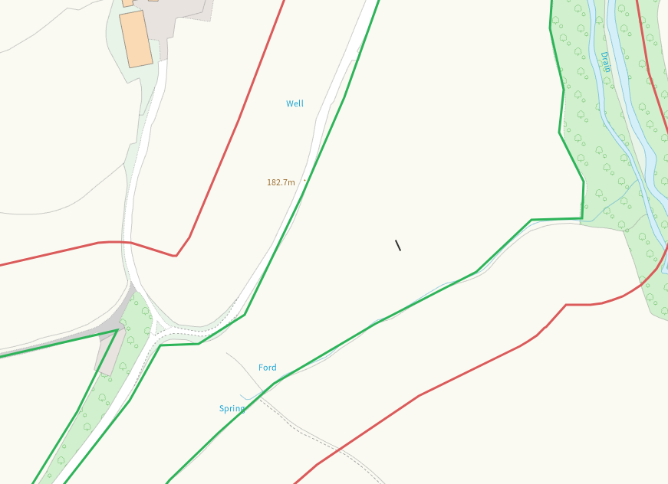
Well within 14, buffered
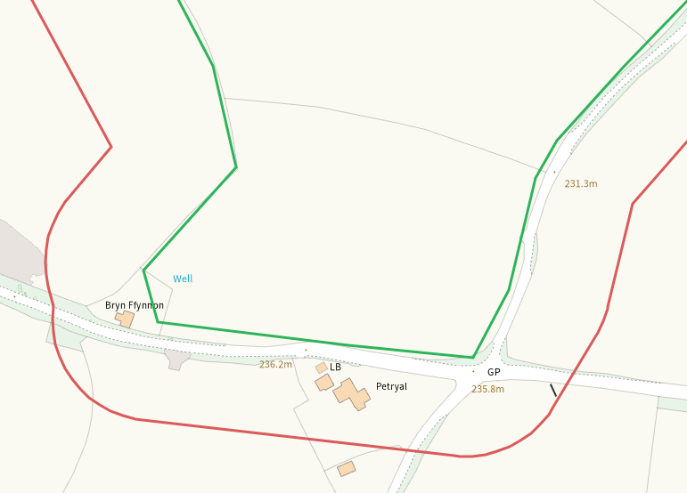
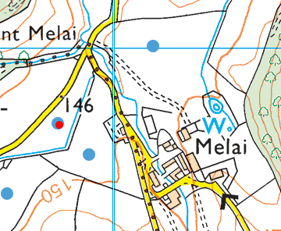
None at other feilds
Any well, spring (or issue) or borehole used for the supply of water for human consumption including from a private water supply or supplies within 250m.
Issue NW of 1, shown on application map
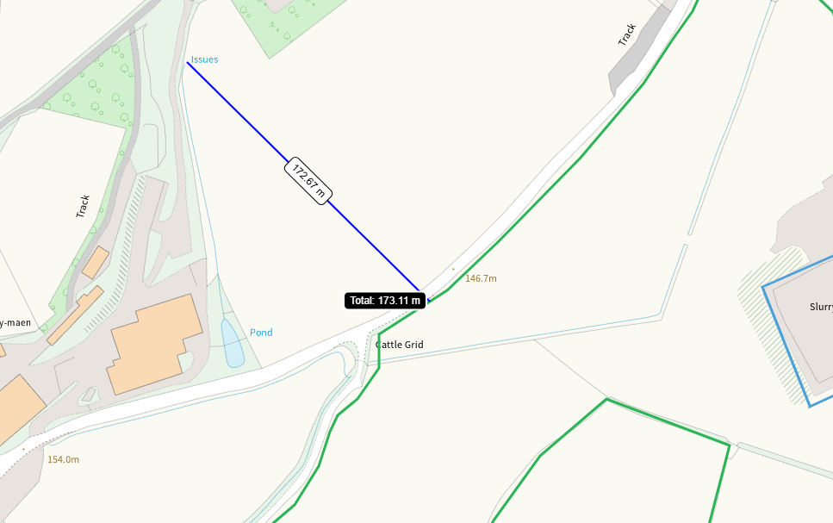
Issue E of 18, shown on application map
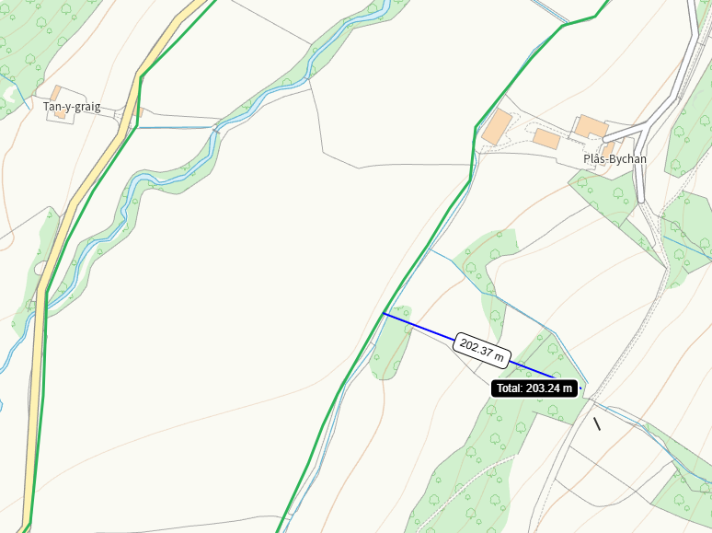
None at other feilds
Within Groundwater Safeguard Zone
none
European designated sites- Natura 2000 (SPA, pSPA, SAC or cSAC) or Ramsar- or SSSI within 500m
SSSI Coedydd Derw Elwy, NE of 21. Shown on application map and identified in SSRA.
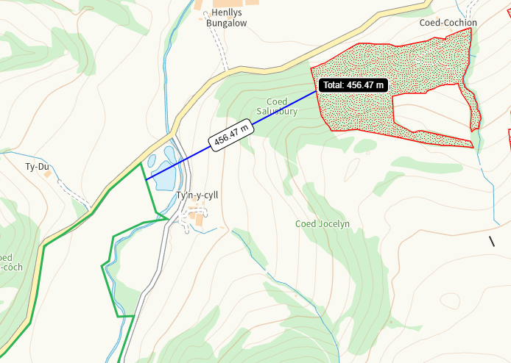
Other protected sites within 500m:
- Protected Species-
Multiple within range including bat, otter, eel and salmon. Nil risk from the activity.
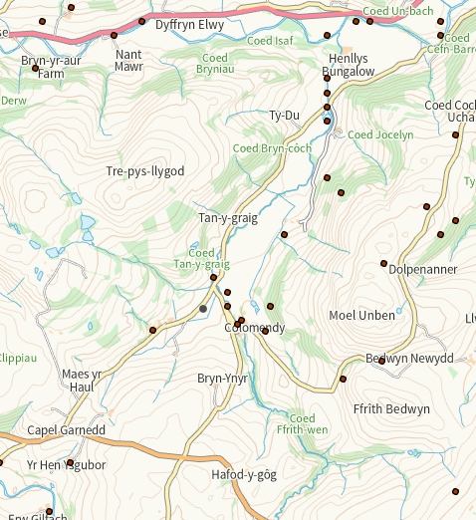
- Protected Habitats-
Lowland dry acid grassland and Lowland calcareous grassland within range. Nil risk
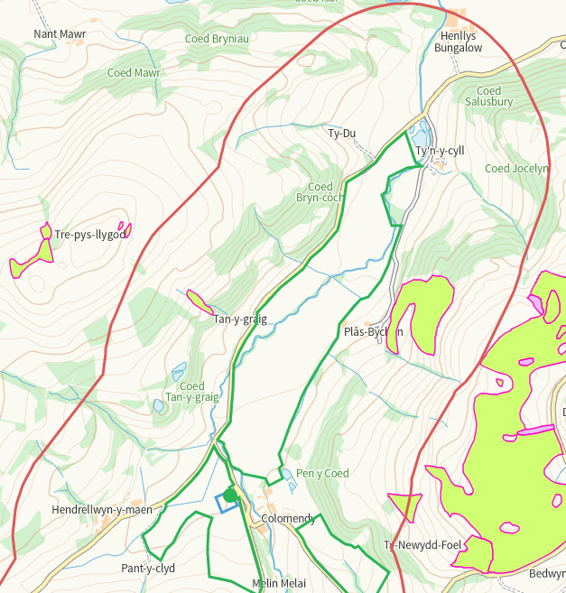
- Scheduled Ancient Monument- none
- Local Nature Reserve- none
- National Nature Reserve- none
- Ancient Woodlands-
Multiple areas of ancient woodland in range, those adjacent are buffered.
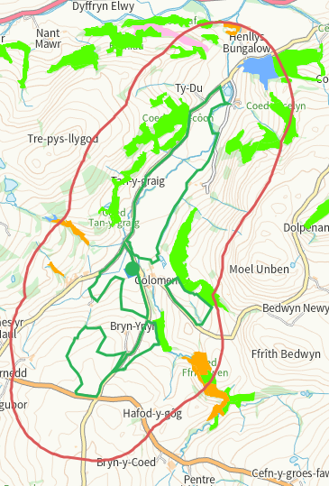
- Local Wildlife Sites (SINC)-
SINC identified in application maps and SSRA

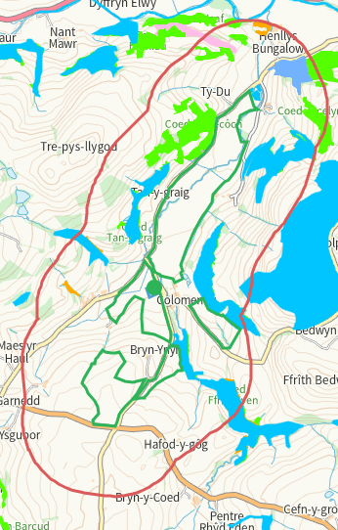

- National Park- none
- Nitrate Vulnerable Zone (NVZ)- ALL Wales
- Groundwater Safeguard Zone- none

Flood risk
Risks shown in application maps match NRW mapping system
Public rights of way
Footpath S of 3, on application map
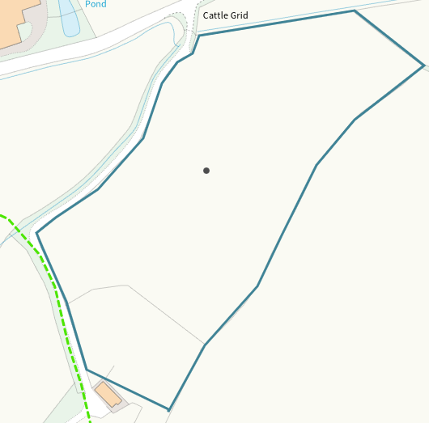
Footpath within 7 on application map
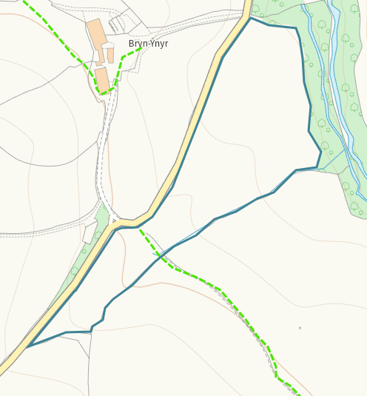
Footpath within 18 & 19 on application map
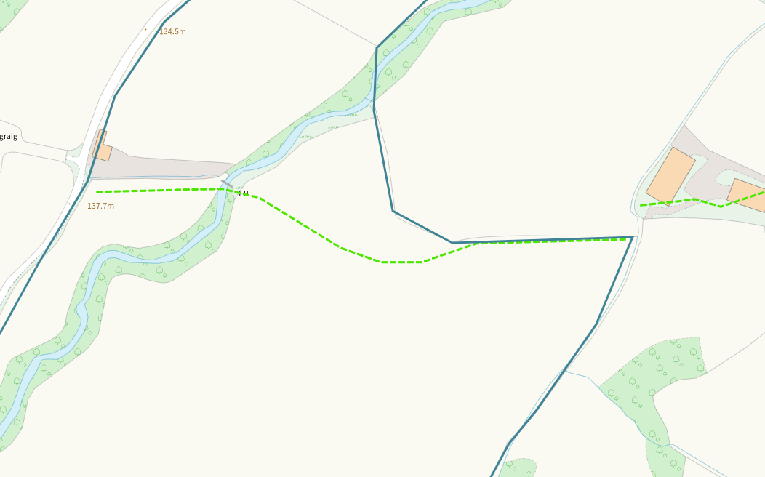
None at other feilds
Distance from Main Farm Address
Adjacent
Slope Map
Mainly 0-7, areas of 12+ buffered on application map.
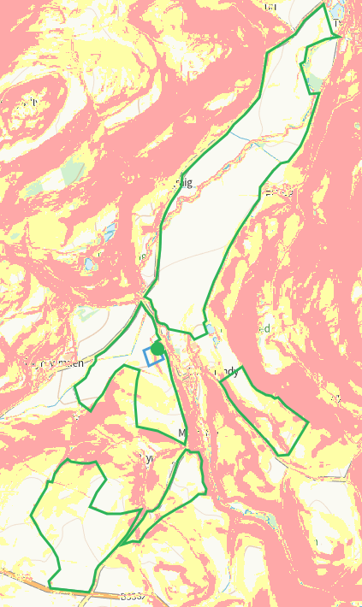
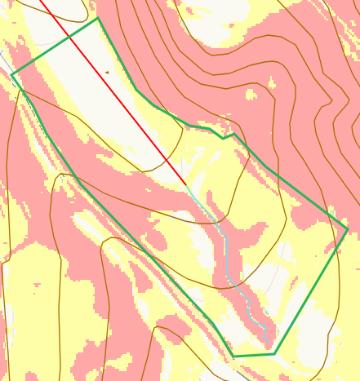
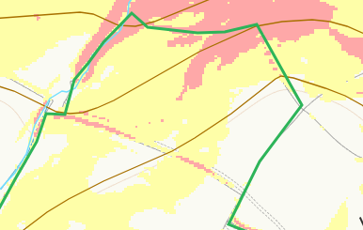
END

