Natural Resources Wales permitting decisions

Bespoke permit/Variation

We have decided to issue the variation for ST Nicholas Waste Water Treatment Works operated by Dŵr Cymru Cyfyngedig.
The application number is PAN-025611
The permit number is AG0013201
The variation is to increase the DWF of the discharge from 67 m³/day to 111 m³/day.
We consider in reaching that decision we have taken into account all relevant considerations and legal requirements and that the permit will ensure that the appropriate level of environmental protection is provided.

Purpose of this document

This decision document:
- explains how the application has been determined
- provides a record of the decision-making process
- shows how all relevant factors have been taken into account
- justifies the specific conditions in the permit other than those in our generic permit template.
Unless the decision document specifies otherwise we have accepted the applicant’s proposals.

Modelling Justification

Through the use of RQP we have allowed 13% deterioration in line with the modelling conducted by DCWW PAN-025611 RQP modelling.doc
for BOD and Suspended solids.

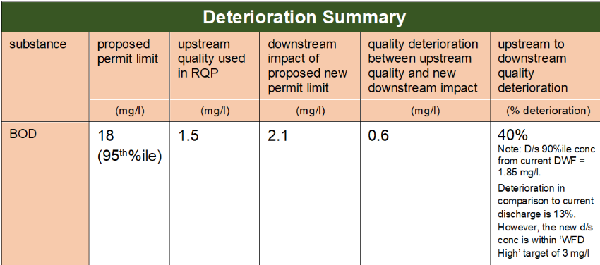

The upstream target of the increase in DWF with BOD at 18 mg/l is 1.5 mg/l which is within the WFD high status target of 3 mg/l.

The downstream impact of BOD remaining at 18 mg/l is 2.1 mg/l which is within the 3 mg/l target to keep the waterbody within high status.

As it will not cause a deterioration in the classification of the waterbody under the Water Environment (Water Framework Directive) (England and Wales) Regulations 2017) or the Conservation of Habitats and Species Regulations (2017) we can accept the proposed figures by DCWW. However we decided to keep their UT for BOD and SS in line with their previous permit to prevent deterioration.

In regards to Ammoniacal Nitrogen we decided on the limit being 5.5 mg/l as modelled by Dean PAN-025611 NRW Modelling ST NICHOLAS STW (006).docx as if the same level of deterioration was applied to Ammoniacal Nitrogen it would impact the classification of the water course.

Phosphorus was modelled by both NRW and DCWW as 3 mg/l to prevent deterioration to the water course.

