Permit
The Environmental Permitting (England & Wales) Regulations 2016

4R Recycling Ltd

Hellys
Llanfairtalhaiarn
Conwy
Abergele
LL22 8TF

Permit number

EPR/ DB3597HD

Permit
The Environmental Permitting (England and Wales) Regulations 2016
Permit number

EPR/ DB3597HD

The Natural Resources Body for Wales (“Natural Resources Wales”) authorises, under regulation 13 of the Environmental Permitting (England and Wales) Regulations 2016

4R Recycling Ltd(“the operator”),

whose registered office is

Control House A1 Buisness Park

Knottingley Road

Knottingley

West Yorkshire

England

WF11 0BU

company registration number 05747690

to operate waste operations at

Henllys,

Llanfairtalhaiarn

Conwy

Abergele

LL22 8TF

to the extent authorised by and subject to the conditions of this permit.

Under regulation 27(2) of the Regulations, standard rules SR2010No17 are conditions of this permit.

Name | Date
Huw Davies | 03/10/2025

Authorised on behalf of Natural Resources Wales

Schedule 1 - Site plan

This is the plan referred to in the standard rules SR2010No17

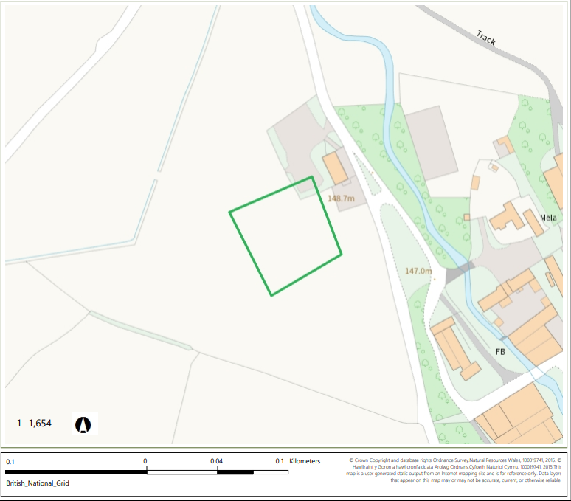
© Crown Copyright and database right 2025. Ordnance Survey licence number 100019741.

END OF PERMIT

