National Grid Electricity Transmission
National Grid HVDC Offshore Cable: Western Link 2
Natural Resources Wales Geotechnical Survey Technical Note
81535

RSK General Notes
Project No.: 81535

Title: National Grid HVDC Offshore Cable: Western Link 2 – Natural Resources Wales Geotechnical Survey Technical Note

Client: National Grid Electricity Transmission

Date: 04 March 2026

Office: Helsby

Status: Final

Author | Josh Francis / Georgia Harris | Technical and quality reviewer | Dr Joe Green
Signature |   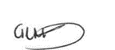 | Signature | 
Date | 04 March 2026 | Date | 04 March 2026

Project Manager | Dr Joe Green
Signature
Date | 04 March 2026

RSK Environment Ltd (RSK) has prepared this report for the sole use of the client, showing reasonable skill and care, for the intended purposes as stated in the agreement under which this work was completed. The report may not be relied upon by any other party without the express agreement of the client and RSK. No other warranty, expressed or implied, is made as to the professional advice included in this report.
Where any data supplied by the client or from other sources have been used, it has been assumed that the information is correct. No responsibility can be accepted by RSK for inaccuracies in the data supplied by any other party. The conclusions and recommendations in this report are based on the assumption that all relevant information has been supplied by those bodies from whom it was requested.
No part of this report may be copied or duplicated without the express permission of RSK and the party for whom it was prepared.
Where field investigations have been carried out, these have been restricted to a level of detail required to achieve the stated objectives of the work.
This work has been undertaken in accordance with the quality management system of RSK Environment Ltd.
Cover photo credit: Mark MacFeeters. https://www.flickr.com/photos/mac-sony-h5/
Contents
Acronyms and Definitions 4
1 Introduction 6
1.1 Purpose of this report 6
1.2 Marine licensing in Wales 6
1.3 Background to the Water Framework Directive 7
1.4 Designated site consideration 7
1.5 European Protected Species 9
2 Project Description 10
2.1 Overview 10
2.2 Geophysical survey 12
2.3 Benthic sampling survey 12
2.4 Geotechnical survey 13
3 Designated Site Consideration 15
3.1 Introduction 15
3.2 Screening boundary and predicted impacts 15
3.3 Identified sites 15
3.4 Potential for LSE 19
3.5 Assessment 20
3.6 EPS consideration 21
4 WFD Screening 22
5 WFD Waterbodies – Baseline information 23
5.1 Caernarfon Bay South (GB651010610000) – Baseline information 25
5.2 Caernarfon Bay North (GB621010380000) – Baseline information 26
6 WFD Scoping 28
6.1 Hydromorphology 29
6.2 Biology: habitats 29
6.3 Biology: fish 31
6.4 Water quality 32
6.5 WFD protected areas 33
6.6 Invasive, Non-native Species 34
6.7 Summary 34
7 WFD Impact Assessment 36
7.1 Introduction 36
7.2 Biology: habitats 36
7.3 Biology: fish 37
7.4 Water quality 38
7.5 Protected sites 39
7.6 Invasive, Non-native Species 40
8 Conclusion 42
9 References 44

Acronyms and Definitions
Acronym | Definition
ALARP | As Low as Reasonably Practicable
CEFAS | Centre for Environment, Fisheries and Aquaculture Science
COLREGs | International Regulations for Preventing Collisions at Sea
CPT | Cone penetration testing
cSAC | Candidate SACs
DDV | Drop-down video
EA | Environment Agency
EEZ | Exclusive Economic Zone
EPS | European Protected Species
EQSD | Environmental Quality Standards Directive
EU | European Union
FLO | Fisheries Liaison Officer
GN | Guidance Note
HRA | Habitats Regulations Assessment
HVDC | High Voltage Direct Current
IMO | International Maritime Organisation
INNS | Invasive non-native species
JNCC | Joint Nature Conservation Committee
JUB | Jack up barge
LSE | Likely significant effects
MARPOL | International Convention for the Prevention of Pollution from Ships
MBES | Multibeam echosounder
MCAA | Marine and Coastal Access Act
MCZ | Marine Conservation Zone
MHWS | Mean High Water Spring
MLT | Marine Licensing Team
MMO | Marine Mammal Observer
MPA | Marine Protected Area
MPCP | Marine Pollution Contingency Plan
NCMPA | Nature Conservation Marine Protected Areas
NGET | National Grid Electricity Transmission
NRW | Natural Resources Wales
OGN | Operational Guidance Note
PAM | Passive acoustic monitoring
PBDEs | Polybrominated diphenyl ethers
pSPA | Potential SPAs
pUXO | potential Unexploded Ordnance
RBMP | River Basin Management Plans
RIAA | Report to Inform the Appropriate Assessment
ROV | Remotely operated vehicle
SAC | Special Areas of Conservation
SBP | Sub bottom profilers
SCI | Sites of Community Importance
SPA | Special Protection Area
SSS | Side-scan sonar
SSSI | Sites of Special Scientific Interest
UK | United Kingdom
WFD | Water Framework Directive
WL2 | Western Link 2
ZOI | Zone of Influence

Introduction

Purpose of this report
This technical note has been prepared by RSK on behalf of National Grid Electricity Transmission (NGET, the applicant) in support of their application for a Marine Licence to carry a geotechnical survey campaign (hereafter referred to as the survey activities) for the Western Link 2 project (WL2, the project). The survey activities will comprise the geotechnical sampling along a 1500 m survey corridor, spanning multiple jurisdictions, with 172.84 km occurring within Welsh waters.
This technical note accompanies a Marine Licence application for the survey activities. It presents a Water Framework Directive (WFD) assessment and a summary of the designated sites with potential to be impacted by the survey activities, in order to satisfy the Habitats Regulations Assessment (HRA) requirements. Additional consideration has been given to European Protected Species (EPS) as part of this report.

Marine licensing in Wales
A Marine Licence is required for all “licensable marine activities” below Mean High Water Spring (MHWS) tides. “Licensable marine activities” are defined in Section 66 of the Marine and Coastal Access Act 2009 (MCAA). Under this regime the Marine Licensing Team (MLT) administers Part 4 of the MCAA on behalf of the Licensing Authority and the Welsh Ministers. The MLT is responsible for marine licensing and enforcement within the Welsh inshore region extending 12 nm seaward from MHWS to the territorial limit, as defined in Section 42 of the MCAA.
It is RSK’s understanding that the survey activities are likely to trigger the requirement for a Marine Licence. This is due to Section 66 of the MCAA stating that a licence is required “to construct, alter or improve any works within the UK marine licensing area either – (a) in or over the sea, or (b) on or under the sea bed”.
There are a range of assessments which may be required in support of a marine licence application depending on the nature and location of the survey activities.
Under the Water Framework Directive (England and Wales) Regulations 2017, a licensed project or activity seaward of MHWS must demonstrate that it will not cause deterioration of a water body quality or prevent it meeting its objectives. As all marine licence applications, (apart from band 1 low risk activity applications – not applicable to the survey activities), must be accompanied by a WFD assessment (see Section 4).
In addition, the European Union (EU) Habitats Directive (Council Directive 92/43/EEC), transposed in United Kingdom (UK) by the Conservation of Habitats and Species Regulations 2017, requires consideration of potential effects from plans or projects that may affect the integrity of designated sites (see Section 3).

Licence application process
Once the marine licence application has been received with all supporting documents and payment, the MLT will check and acknowledge the application within 21 days. Based on information provided to date, it is likely the survey activities will fall within Band 3 of the licencing fee structure due to the total value of the survey works. Payment by the applicant will accompany the application.

Discharge of conditions
Once the licence is issued, it may contain a number of conditions that will require discharge by the licence holder.

Background to the Water Framework Directive
The Directive of the European Parliament and of the Council 2000/60/EC establishing a framework for community action in the field of water policy (known as the Water Framework Directive, or WFD) was transposed into UK domestic law by the Water Environment (Water Framework Directive) (England and Wales) Regulations 2017.
A WFD assessment is required to identify the potential impact of certain activities undertaken in or around water on the immediate water body and any associated watercourses. This includes:
- identifying activities that could affect WFD waterbodies
- assessment of the potential direct or indirect impacts of the survey activities that may cause or contribute to deterioration of water body status and/or jeopardise the water body achieving its status objectives in the future
- determining the compliance of the project with the requirements of the WFD.
As part of the marine licence application to Natural Resources Wales (NRW), a WFD compliance assessment is required to be completed for the survey activities.
RSK has undertaken this assessment in accordance with NRW’s Operational Guidance Note (OGN) 072 (NRW, 2018), Guidance Note (GN) 078 (NRW, 2024) on WFD assessments, and WFD assessment guidance for estuarine and coastal waters, Clearing the Waters for All (EA, 2016). Publicly available datasets have been used to inform this assessment, including data from Welsh Government, NRW and the Environment Agency (EA), to enable a robust WFD scoping and impact appraisal.

Designated site consideration

Habitats Regulations Assessment
A network of protected areas for specific sensitive habitats and species of importance (known as designated sites) was established by the EU member states under the Habitats Directive and EU Birds Directive (Council Directive 2009/147/EC).
For this report, the relevant sections of the Habitats Directive are Articles 6(3) and 6(4), as implemented under Regulations 48 and 49 of the Conservation (Natural Habitats &c.) Regulations 1994 and similarly under the Conservation of Habitats and Species Regulations 2017 (as amended, known as the Habitats Regulations) in UK law.
Article 6(3) of the Habitats Directive states:
“Any plan or project not directly connected with or necessary to the management of the site but likely to have a significant effect thereon, either individually or in combination with other plans or projects, shall be subject to appropriate assessment of its implications for the site in view of the site's conservation objectives”.
The Habitats Regulations require consideration of potential effects from plans or projects that may affect the integrity of designated sites; in the UK these sites include Special Areas of Conservation (SACs), candidate SACs (cSACs), Special Protection Areas (SPAs), potential SPAs (pSPAs), Sites of Community Importance (SCIs) and Ramsar sites. This is commonly conducted as part of a HRA process (please refer to Section 3). Sites of Special Scientific Interest (SSSI) are not protected directly under the Habitats Regulations, and as a result do not form a strategic part of the HRA process. SSSI protection is underpinned by the Wildlife and Countryside Act 1981; sites are however noted within this report for completeness.
Aligned with the UK’s withdrawal from the EU in 2020, EU exit legislation was passed to ensure environmental protection with respect to habitats and species is aligned with EU environmental standards; this saw the implementation of the Conservation of Habitats and Species (Amendment) (EU Exit) Regulations 2019. Under this legislation, former Natura 2000 sites (also known as European sites) are referred to as designated sites within this report as part of the UK National Site Network. As a result, designated sites (coastal and offshore) contribute to the Marine Protected Area (MPA) network. Ramsar sites remain protected in the same way as SAC and SPA sites, however do not form part of the National Site Network.
This report focusses solely on the designated sites that fall within Welsh jurisdictional waters. It is appreciated that the survey corridor traverses a number of additional sites that fall within northern Irish inshore and offshore waters, Manx waters, and Scottish inshore waters. The consent pathways in relation to such sites has been sought out with the relevant regulatory bodies in the form of separate applications for the wider project.

Other marine designated sites
In addition to National Site Network sites, the survey corridor traverses additional designated sites including:
- Nature Conservation Marine Protected Areas (NCMPA), designated under the Marine (Scotland) Act 2010
- Marine Conservation Zone (MCZ), designated under the Marine and Coastal Access Act 2009 (in England) and Marine Act (Northern Ireland) 2013 (in Northern Ireland).
However it is acknowledged that such sites are not traversed within Welsh waters, as a result these MPA and MCZ sites are not included as part of this assessment. The relevant consent pathways for other jurisdictional waters have been sought out in separate applications to the relevant regulatory bodies.

European Protected Species
All species of cetacean, some species of marine turtle, otter (Lutra lutra) and sturgeon (Acipenser sturio/Acipenser oxyrinchus) in waters around the UK are considered European Protected Species (EPS) under Annex IV of the Habitats Directive, and associated Habitats Regulations. Under these, it is considered an offence to disturb, capture, injure or kill deliberately, or recklessly disturb a single individual of an EPS (including cetaceans). If it is determined that an activity would cause an offence under the above regulations, a licence may be granted which would allow otherwise illegal activities to go ahead in certain specified circumstances.
Under the basis of the provided methodology for the survey activities (Section 2), it has been determined that an EPS Licence is not required for the geotechnical survey campaign; nevertheless, a high-level consideration of EPS has been contained within this Section 3.6 to address this.
A separate EPS application has been prepared for the 2026 geophysical survey campaign associated with the project. A current EPS licence is held in relation to 2025 geophysical survey works (S095473/2).

Project Description

Overview
National Grid Electricity Transmission (NGET) is planning to conduct geophysical, geotechnical, and environmental habitat survey works in connection with Western Link 2 (hereafter referred to as WL2, or the project) which is a planned high voltage direct current (HVDC) electricity transmission reinforcement link between the west coast of Scotland to north Wales. The total proposed survey area across Welsh, Manx. Northern Irish and Scottish covers approximately 665 km². The survey area within Wales will be 250.17 km² within Welsh inshore (0 – 12 nm) and offshore waters (12 nm – Exclusive Economic Zone (EEZ) boundary). The survey contractor and associated survey vessels are yet to be determined. Detail of this will be provided approximately eight weeks before survey commencement.
Figure 2.1 shows the survey area within Welsh waters as well as the wider survey area across other jurisdictional waters, including the Isle of Man, Northern Ireland, and Scotland. The proposed period for the survey is between 1 March and 1 October 2026 with an expected duration of 90 days, including local mobilisation, transit, survey and local demobilisation. Survey activities may happen beyond this proposed period as contingency in the case of unexpected delays, such as weather, preventing survey activity from occurring as planned. Therefore, this assessment is to accompany a licence application spanning 1 March 2026 to 1 March 2027.

Embedded mitigation
The survey activities, including vessel movements, will adhere to a strict plan regarding mitigation strategies. Additionally, communication with relevant fisheries and maritime agencies will be organised throughout the survey duration. Fisheries Liaison Officers (FLO) will be utilised where appropriate and any notifications to Kingfisher Information Services will be made in sufficient time. Compliance with approved operating procedures will be monitored throughout the survey activities, and the survey vessel (contractor to be determined) and crew will also adhere to national and international regulations (e.g., International Maritime Organisation (IMO), COLREGs and MARPOL).

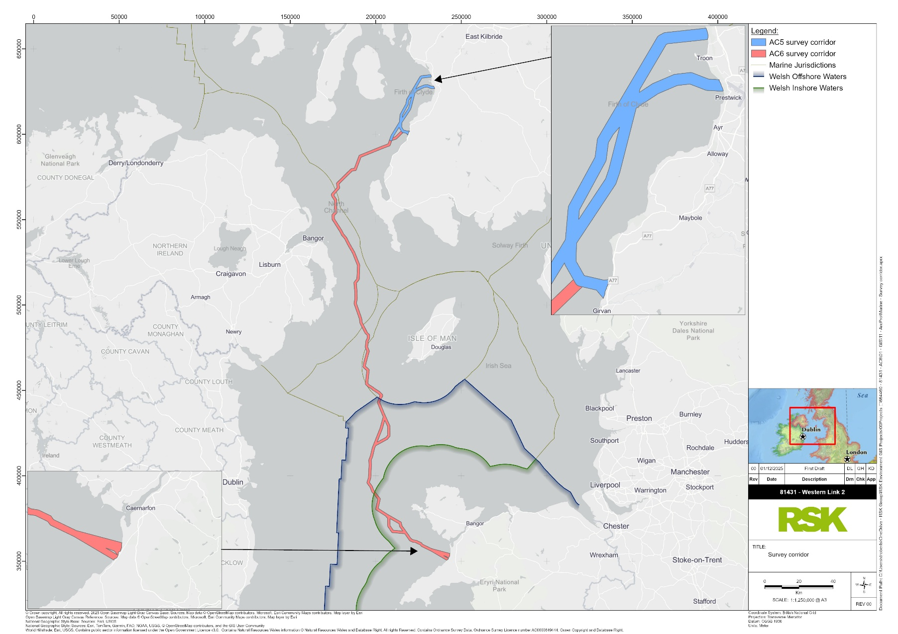
Figure 2.1: Survey corridor

Geophysical survey
Geophysical survey activities are also planned in association with the identified survey corridor. To date, geophysical survey activities, including the use of sub bottom profilers (SBP), side-scan sonar (SSS) and multibeam echosounder (MBES), have been carried out within Welsh waters in relation to WL2 under the marine EPS license S095473/1.
A second marine EPS license is being applied for in relation to geophysical survey activities for the 2026 WL2 survey campaign. A full assessment of the impact of the proposed geophysical, geotechnical, and benthic survey activities on EPS will be detailed in a supporting EPS Risk Assessment which will be submitted alongside the marine EPS licence application.
This technical note focusses on the geotechnical and benthic sampling activities. Please see the associated marine EPS licence (S095473/2) and marine EPS licence application for further information on the geophysical survey activities.

Embedded mitigation
Embedded mitigation in relation to geophysical survey activity is fully documented within the associated EPS Risk Assessment report. It is anticipated this will include compliance with the Joint Nature Conservation Committee (JNCC) guidelines for minimising risk to marine mammals (seismic survey guidelines). This will include the provision of a JNCC qualified Marine Mammal Observer (MMO) to provide observations during all seismic (i.e., SBP) operations during daylight hours. During times when conditions do not allow for reliable visual searches, primarily during the hours of darkness, the pre-watches searches will be conducted using passive acoustic monitoring (PAM).

Benthic sampling survey
The benthic sampling surveys will involve Drop-Down Video (DDV) and seabed grab samples, using either a day grab sampler or Harmon grab sampler for coarser material (Figure 2.2). It is anticipated that grab sampling will consist of two grab drops per sample location, increasing to three drops in sensitive areas. Within shallow water depths (< 10 m), the sampling frequency will be every 2 and 5 km. Within deeper water depths (> 10 m), the sampling frequency will be every 5 and 10 km.
Two replicates will be collected from the first sampling drop for macrobenthic faunal analysis. Two replicates will be collected from the second sampling drop for physio-chemical analysis. Additional samples will be stored for sensitive areas where additional data may be required to support project works.
DDV transects will be undertaken via a remotely operated vehicle (ROV) at 10 km intervals with a minimum length of 200 m, increasing to 500 m in sensitive areas.
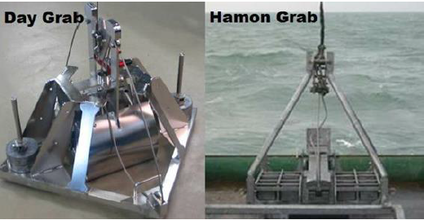
Figure 2.2: Examples of grab samplers

Embedded mitigation
To reduce risk associated with potential Unexploded Ordnance (pUXO) to As Low as Reasonably Practicable (ALARP) no environmental grab sampling will be undertaken until a pUXO survey has been carried out.
No environmental grab sampling will be undertaken in known sensitive habitats to reduce disturbance to such habitats. DDV sampling will be undertaken before grab samples to ensure habitat is suitable for sampling and no sensitive habitat is present.

Geotechnical survey
The geotechnical survey will include vibrocores, Cone penetration testing (CPT), and boreholes (Figure 2.3).
At the landfall area where water depths are from MHWS to 4 m, CPT will be carried out from a jack-up barge (JUB) with a target depth of 40 m below the seabed. No sediment will be retained from this operation. Within water depths > 10 m, between six and nine CPTs will be carried out from a seabed frame using the JUB. Again, no sediment sample will be retained. A multicat vessel will be used to undertake the VCs and CPTs, approximately every 1 km in water depths between 4 - 10 m, collecting up to 3 samples per technique within 4 – 10 m water depth. The total sample volume per vibrocore sample is anticipated to be up to 0.05 m3.
Additionally, at the landfall areas borehole drilling and sampling will be undertaken. It is anticipated that nine boreholes will be collected from a jack up barge within Welsh waters. The target depth for each borehole is up to 40 m below the seafloor. The sample diameter acquired from a borehole is approximately 100 mm. The estimated soil/rock sample recovered from each borehole is estimated to be 0.31 m³.
The indicative disturbance footprint varies depending on the sampling method. Boreholes undertaken from the JUB will disturb approximately 1.8 m² per location, generated by the four 0.76 m diameter legs. CPT sampling will disturb approximately 9 m². Vibrocore and grab samples will disturb <1 m² per event. These specific equipment details will be confirmed once the contractor and equipment specifications are finalised.
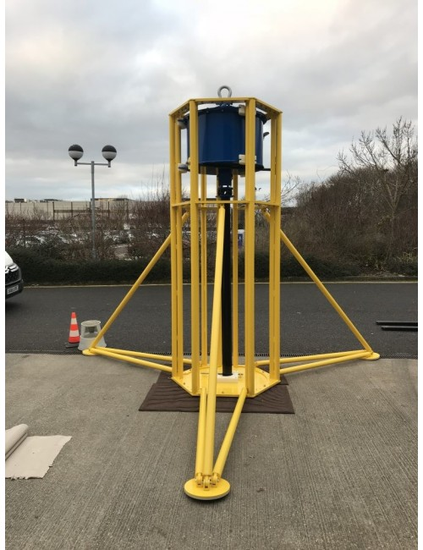
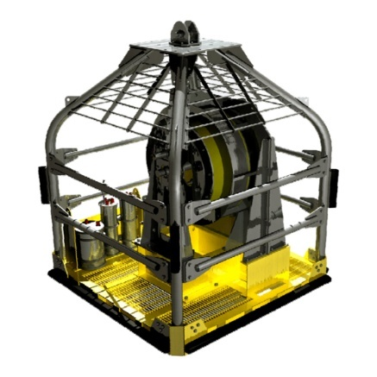
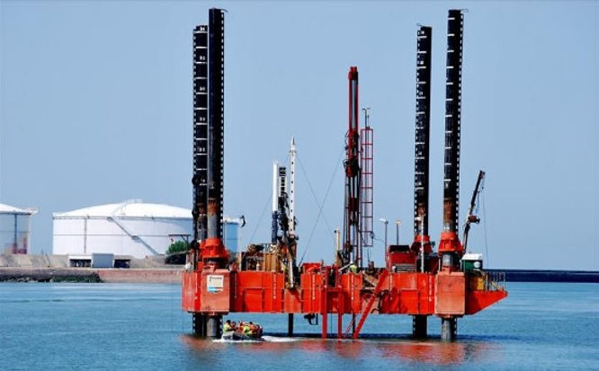
Figure 2.3: Example of a vibrocorer, CPT system, and borehole drilling rig
In summary, the proposed geotechnical locations and sampling techniques include:
- JUB (for use in water from MHWS to 4 m and water >10m):
  - 9 locations
  - up to 9 CPTs to be assessed per location
  - up to 9 boreholes to be assessed per location
- Multicat (for use in water 4 – 10 m depth)
  - Taken at locations every 1 km
  - up to 3 CPTs per location
  - up to 3 vibrocores per location
All other activities in the area beyond the 10m water depth contour are proposed to remain consistent with the initial submission.

Embedded mitigation
To reduce risk associated with pUXO to ALARP no vibrocore or CPT sampling will be done until a pUXO survey has been carried out.
No vibrocore or CPT sampling will be undertaken in known sensitive habitats to reduce disturbance to such habitats. DDV sampling will be undertaken before any intrusive sampling to ensure habitat is suitable for sampling and no sensitive habitat is present.

Designated Site Consideration

Introduction
This section presents a detailed assessment of the potential effects of the survey activities, in order to determine whether or not the activities could result (alone or in combination with other projects/plans) in an adverse effect on the integrity of a designated site (‘integrity test’). Consequently aiming to satisfy the requirements under the Habitats Regulations with respect to the survey.
This high-level, robust assessment has been undertaken in adherence with best practice guidance where relevant (Welsh Parliament Senedd Research, 2022; Welsh Government, 2021).

Screening boundary and predicted impacts
Based on the survey corridor, associated scope and embedded mitigation, limited significant impacts are envisaged. Considering this, a precautionary screening boundary of 10 km has been considered in relation to designated sites located in proximity to the survey corridor that have features below MHWS. This distance is considered to be highly conservative considering the temporary nature of the survey activities and localised expected Zone of Influence (ZOI) of potential impacts.
Based on the methodology provided in Section 2.4, Likely Significant Effects (LSE) have the potential to arise as follows:
- physical presence of survey vessel(s) and associated underwater noise impacts
- disturbance to the seabed.

Identified sites
Based on a 10 km screening boundary, designated sites within Welsh waters were identified whereby there is potential for connectivity with the survey activities. These are detailed within Table 3.1 and Figure 3.1.
Table 3.1: Identified designated sites of potential relevance to the survey activities
Designated site | Qualifying features | Distance (km)**
North Anglesey Marine/Goggled Môn Forol SAC [UK0030398] | Harbour porpoise* | 0
Anglesey Terns/Morwenoliaid Ynys Môn SPA [UK9013061] | Common tern, breeding  Arctic tern, breeding  Roseate tern, breeding  Sandwich tern, breeding | 0
Irish Sea Front SPA [UK9020328] | Manx shearwater, breeding | 0
Dinas Dinlle SSSI | Pleistocene/Quaternary landform assemblage and associated subsurface  stratigraphical profile. | 1.31
Abermanai to Aberffraw Dunes/Y Twyni o Abermenai SAC [UK0020021] | Embryonic shifting dunes*  Shifting dunes along the shoreline with Ammophila arenaria (white dunes)*  Fixed coastal dunes with herbaceous vegetation (grey dunes)*  Dunes with Salix repens ssp. argentea (Salicion arenariae)*  Humid dune slacks*  Natural eutrophic lakes with Magnopotamion or Hydrocharition - type vegetation  Petalwort  Shoredock | 3.51
Menai Strait and Conwy Bay/Y Fenai a Bae Conwy SAC [UK0030202] | Sandbanks which are slightly covered by sea water all the time*  Mudflats and sandflats not covered by seawater at low tide*  Reefs*  Large shallow inlets and bays  Submerged or partially submerged sea caves | 3.98
Croker Carbonate Slabs SAC [UK0030381] | Submarine structures made by leaking gas* | 4.37
Afon Gwyrfai a Llyn Cwellyn SAC [UK0030046] | Atlantic salmon  Otter  Oligotrophic to mesotrophic standing waters with vegetation of the Littorelletea uniflorae and/or of the Isoëto-Nanojuncetea  Water courses of plain to montane levels with the Ranunculion fluitantis and Callitricho-Batrachion vegetation  Floating water-plantain | 4.85
Anglesey Coast: Saltmarsh/Glannau Mon: Cors Heli SAC [UK0020025] | Salicornia and other annuals colonising mud and sand*  Atlantic salt meadows (Glauco-Puccinellietalia maritimae)*  Estuaries  Mudflats and sandflats not covered by seawater at low tide | 6.11
Holy Island Coast/Glannau Ynys Gybi SAC [UK0013046] | Vegetated sea cliffs of the Atlantic and Baltic Coasts*  European dry heaths*  Northern Atlantic wet heaths with Erica tetralix | 9.17
Notes: All qualifying features have been noted here, including terrestrial species/habitats for completeness. Only designated sites that are located below MHWS have been included as part of this assessment.
*primary reason for site selection.
**distances are approximate.
It is appreciated that mobile qualifying features (i.e., diadromous fish features, marine mammals and seabirds) originating from sites further afield have the potential to overlap with the survey activities site at any given time. The West Wales Marine/Gorllewin Cymru Forol SAC designated for harbour porpoise and the Pen Llyn a'r Sarnau/Lleyn Peninsula and the Sarnau SAC, designated for mobile features such as bottlenose dolphin, grey seal and otter are located approximately 14 km away from the survey corridor. The Aberdaron Coast and Bardsey Island/Glannau Aberdaron ac Ynys Enlli SPA is located approximately 30 km from the survey corridor, designated for chough and Manx shearwater.
Acknowledging the limited spatial extent of the survey in Welsh waters alongside the short duration, significant impacts to these mobile features are not foreseen. Any impacts will be isolated to the immediate survey corridor footprint, and based on the distance from the sites and additional available habitat available to these mobile species, these sites (and those located further afield in Welsh waters) were not assessed further within this report.
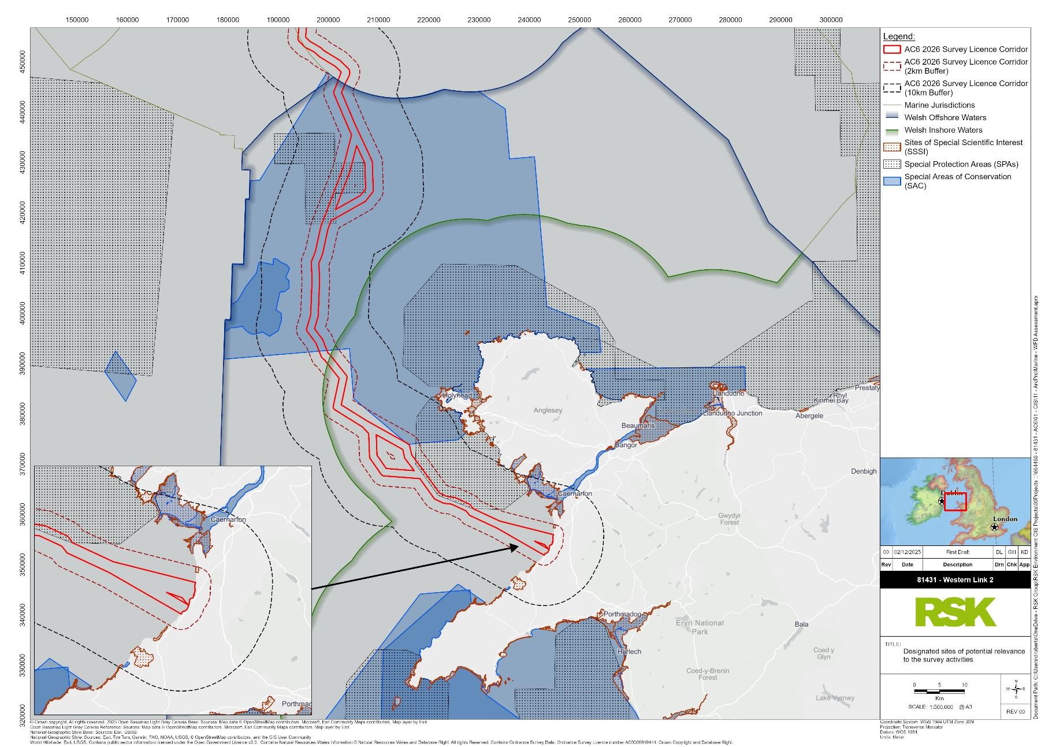
Figure 3.1: Designated sites within proximity to the WL2 survey area

Potential for LSE
The potential pathways for LSE consequent of the survey activities were identified as:
- physical presence of survey vessel(s) and associated underwater noise impacts
- disturbance to the seabed.

Physical presence of vessel(s) and associated underwater noise
Features of the North Anglesey Marine/Gogledd Môn Forol SAC and Anglesey Terns/Morwenoliaid Ynys Môn SPA may be sensitive to vessel presence and associated continuous noise levels.
The North Anglesey Marine/Gogledd Môn Forol SAC directly overlaps with the survey area, as such individuals originating from these sites have the highest potential to be impacted by disturbance from the survey vessels and associated continuous noise. Harbour porpoise may show decreased presence and abundance in relation to increased vessel presence and continuous noise disturbance. Whilst the likelihood of this is considered to be low, the potential for connectivity cannot be ruled out due to direct overlap.
It is considered unlikely for features of the Anglesey Terns/Morwenoliaid Ynys Môn SPA and Irish Sea Front SPA to be impacted via underwater noise impacts; for an impact to occur individuals will be required to be very close to the sound source, which is considered unlikely, hence LSE was ruled out for underwater noise at these sites. In addition, Manx shearwater, the common and Arctic tern possesses low sensitivity to vessel presence due to habituation and low incidences of aggregation around vessels (MMO, 2018), hence LSE for these species can be ruled out. However, LSE cannot be ruled out for sandwich and Roseate tern due to vessel disturbance, consequent of moderate sensitivity to vessel presence (MMO, 2018; Goodship and Furness, 2022). As a result, this site requires further consideration for these species.
With regard to the Afon Gwyrfai a Llyn Cwellyn SAC, the potential for LSE was ruled out. This is based on limited pathways for impacts to associated features. Otters largely utilise the coastal environment in comparison to more offshore areas, of which the survey corridor predominately overlaps. As a result, the likelihood of behavioural responses consequent of vessel presence, is deemed to be limited. In addition, the species are not considered to be as sensitive to underwater noise as they are to airborne noise. Additionally, considering sound source levels associated with vessel presence and temporary nature of the survey, significant impacts to diadromous fish features (i.e., salmon) are not foreseen.

Disturbance to the seabed
The following sites designated for Annex I habitat features were screened out of further assessment:
- Abermanai to Aberffraw Dunes/Y Twyni o Abermenai SAC
- Menai Strait and Conwy Bay/Y Fenai a Bae Conwy SAC
- Anglesey Coast: Saltmarsh/Glannau Mon: Cors Heli SAC
- Holy Island Coast/Glannau Ynys Gybi SAC
- Croker Carbonate Slabs SAC
- Dinas Dinlle SSSI.
The potential for impact pathways to arise on these sites and associated features consequent of the survey activities is considered low due to lack of overlap and sufficient distance, as a result the potential for LSE was ruled out.
The Afon Gwyrfai a Llyn Cwellyn SAC was further screened out for potential LSE due to sufficient dispersion and dilution to negate significant impacts to salmon consequent of sediment mobilisation. The survey will further be limited in duration, minimising the potential for long-term exposure to elevated turbidity levels.

Assessment
Only the North Anglesey Marine/Gogledd Môn Forol SAC designated for harbour porpoise and the Anglesey Terns/Morwenoliaid Ynys Môn SPA for Roseate and sandwich tern required further assessment with respect to vessel presence. This Section aims to satisfy the Report to Inform the Appropriate Assessment (RIAA) for the noted sites.

Physical presence of vessel(s) and associated underwater noise
For features whereby LSE could not be ruled out due to vessel presence and associated underwater noise impacts (for harbour porpoise only), the following measures were considered in order to mitigate LSE.
Though the number and type of vessels to be deployed for the geotechnical survey are yet to be determined, vessels will travel only via predefined survey corridors. Vessels will further travel at a working speed of less than 4 knots with a transit speed of approximately 10 knots. Where appropriate, the Wild Seas Wales (2025) marine code will be adhered to when in Welsh waters as a form of additional mitigation, specifically in relation to the North and West Wales Marine Code in Gwynedd.
Furthermore, marine mammal features are highly mobile individuals spanning across large management unit areas. In addition, the North Anglesey Marine/Gogledd Môn Forol SAC is noted for persistent high-density areas for harbour porpoise in summer months (April to September, Heinänen and Skov, 2015; NRW and JNCC, 2016). However, the survey activities will be of overall limited duration, occurring for only a short timeframe in Welsh waters. Noting this in combination with the proposed mitigation, significant impacts to harbour porpoise are not anticipated.
While bird features associated with Anglesey Terns/Morwenoliaid Ynys Môn SPA are appreciated to be highly sensitive during their breeding season, the survey will only operate for a short time period which may coincide with the breeding season. Specifically, the breeding season for Roseate and sandwich tern falls between mid-May to August and mid-April to mid-September, respectively (NatureScot, 2020). Noting this in combination with the proposed mitigation, significant impacts to bird features are not anticipated.
Therefore, the integrity of the noted sites is not expected to be affected consequent of the survey activities.

EPS consideration
As noted in Section 1.5, there is likely to be limited potential for impacts to EPS, based on survey corridor, associated scope and embedded mitigation.
Where there is potential for impacts to EPS (i.e., vessel disturbance and associated underwater noise impacts), the limited duration of the survey activities alongside the highly localised ZOI, limits the potential for significant impacts to cetaceans and otter. Species with the highest potential to be disturbed are harbour porpoise, however, as noted in the assessment contained within Section 3.5, significant impacts to the species are not foreseen.
As a result, there is considered to be limited potential for interaction of the survey activities with EPS based on the identified impact-pathways and therefore an EPS licence is not considered to be required for the geotechnical survey for the project.

WFD Screening
A WFD assessment is not required if the proposed activity is considered “low risk”. The “Clearing the Waters for All” guidance (EA, 2016) defines low risk activities as follows:
- any self-service marine licence activity or an accelerated marine licence activity that meets specific conditions
- maintenance of pumps at pumping stations if carried out regularly, avoiding low dissolved oxygen levels during maintenance and minimising silt movement when restarting the pumps
- removal of blockages or obstacles like litter or debris within 10 m of an existing structure to maintain flow
- replacement or removal of existing pipes, cables or services crossing over a water body but not including any new structure or supports, or new bed or bank reinforcement
- ‘over water’ replacement or repairs to, for example bridge, pier and jetty surfaces if bank or bed disturbance is minimised
- any activity carried out during 2009 to 2014 (when evidence was collected for the 2015 River Basin Management Plans (RBMP)) that has an existing WFD assessment, does not need repeating unless:
    - there have been changes to how the activity is performed, including method, size or scale, volume, depth, location or timings
    - there’s been a pollution incident since the activity was last carried out.
Since the survey activities do not fall within the above criteria, a WFD scoping assessment and impact assessment for WFD waterbodies, protected areas, and their respective features are provided within this report, to support the Marine Licence application.
Due to the potential for impacts to extend beyond the immediate survey footprint, a precautionary screening radius of 5 km has been employed, this radius incorporates the applied 2 km buffer of the survey area (Figure 5.1), to capture direct and indirect effects on those receptors within scope.

WFD Waterbodies – Baseline information
Screening has identified a total of four WFD water bodies within a 5 km radius of the survey activities site. These include one coastal water body and three surface water river or estuarine bodies. The water bodies are listed in Table 5.1 and shown in Figure 5.1.
Table 5.1: Waterbodies of relevance to the survey activities
Water body Name | ID | Type | Location | Inclusion in Assessment | Summary of Justification
Caernarfon Bay South | GB651010610000 | Coastal | 0 km (intersects) | YES | Survey footprint overlaps this waterbody; full WFD assessment required.
Caernarfon Bay North | GB621010380000 | Coastal | 1.9 km | YES | Hydrologically linked and within 2 km; precautionary inclusion for WFD assessment.
Llifon | GB110065053980 | River | ~0 – 0.1 km | NO | Although hydrologically linked via Caernarfon Bay South, classified as river (not transitional). No plausible impact pathway from marine survey to upstream river status.
Llyfni | GB110065053970 | River | ~0 – 0.1 km | NO | Same basis as Llifon: marine-only activity, negligible risk of deterioration to river WFD elements.
The Caernarfon Bay South coastal water body (GB651010610000) encompasses the survey activities footprint and it is therefore screened in for full WFD assessment. The Caernarfon Bay North coastal water body (GB621010380000) is within 2 km of the proposed survey area and is therefore screened in for a full WFD assessment.
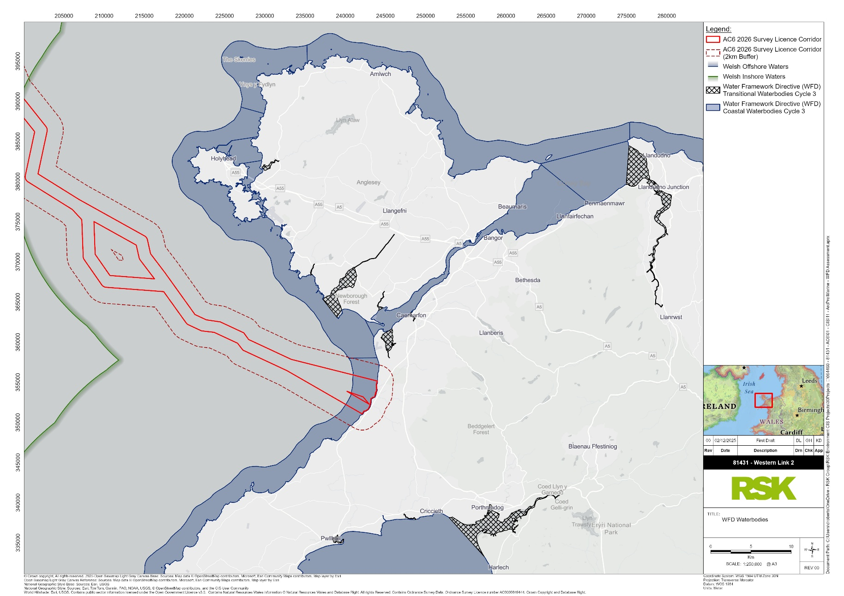
Figure 5.1: WFD waterbodies in proximity to WL2 survey area
Although the Llifon and Llyfni rivers discharge into Caernarfon Bay South and are therefore hydrologically connected to the survey area, the proposed activities are confined to the marine environment and will not interact with riverine channels. Unlike transitional waterbodies such as estuaries, these rivers are classified as freshwater systems and thus do not share sediment or salinity gradients with the marine zone. Consequently, there is no plausible pathway for the survey to alter river hydrology, water quality, or ecological status upstream. On this basis, and considering the temporary, highly localised nature of the survey footprint, the Llifon and Llyfni waterbodies have been appropriately scoped out of further WFD assessment.
Section 5.1 and 5.2, summarise the baseline characteristics of Caernarfon Bay South and Caernarfon Bay North, compiled using data from DataMapWales.

Caernarfon Bay South (GB651010610000) – Baseline information
Table 5.3 provides a summary of information on Caernarfon Bay South water body.
Table 5.2: Caernarfon Bay South Water Body
Water body | Description, notes or more information
WFD water body name | Caernarfon Bay South
Water body ID | GB651010610000
River basin district name | Western Wales
Water body type (estuarine or coastal) | Coastal
Water body total area (ha) | 11579.64
Overall water body status (2021 Cycle 3) | Good
Ecological status | Good
Chemical status | High
Target water body status and deadline | N/A
Hydromorphology status of water body | Natural
Heavily modified water body and for what use | N/A
Higher sensitivity habitats present | N/A
Lower sensitivity habitats present | N/A
Phytoplankton status | Good
History of harmful algae | N/A
WFD protected areas within 2 km | None

Caernarfon Bay North (GB621010380000) – Baseline information
Table 5.3 provides a summary of information on Caernarfon Bay North water body.
Table 5.3: Caernarfon Bay North Water Body
Water body | Description, notes or more information
WFD water body name | Caernarfon Bay North
Water body ID | GB621010380000
River basin district name | Western Wales
Water body type (estuarine or coastal) | Coastal
Water body total area (ha) | 13513.96
Overall water body status (2021 Cycle 3) | Moderate
Ecological status | Moderate
Chemical status | High
Target water body status and deadline | N/A
Hydromorphology status of water body | Natural
Heavily modified water body and for what use | N/A
Higher sensitivity habitats present | N/A
Lower sensitivity habitats present | N/A
Phytoplankton status | N/A
History of harmful algae | N/A
WFD protected areas within 2 km | None
The proposed geotechnical survey activities are located within the Caernarfon Bay South WFD water body, approximately 2 km south of the boundary with the Caernarfon Bay North WFD water body (NRW, 2025). Both waterbodies form part of a high-energy coastal and marine system influenced by tidal currents, wave exposure, and sediment transport processes associated with the wider Irish Sea hydrodynamic regime (NRW, 2015; JNCC, 2025).
Caernarfon Bay South is characterised by strong tidal flows and a mobile sedimentary environment, functioning as a sediment sink where fine material is periodically mobilised and redistributed by tidal and wave-induced currents. These processes maintain extensive shallow sandbank and intertidal systems, supported by hydrodynamic exchange at the entrance to the Menai Strait. The seabed morphology is therefore dynamic, supporting a range of benthic habitats dominated by sands, gravels and mixed sediments, along with intertidal sandflats and mudflats in the nearshore zone (NRW, 2015; EMODnet, 2025; JNCC, 2025). These habitats contribute regionally by supporting benthic invertebrate assemblages, nursery areas for demersal and pelagic fish, and foraging habitat for seabirds (NRW, 2015).
Caernarfon Bay North, although geographically separate from the survey area, shares similar hydrodynamic and geomorphological characteristics. It comprises a heterogeneous coastline with sheltered embayments and exposed open-coast habitats, encompassing ecologically important waters such as Malltraeth Bay and the Cefni Estuary. These areas sustain a diverse assemblage of marine organisms, including commercially important shellfish (e.g., Mytilus spp., Cerastoderma edule) and demersal fish species. The region also provides important feeding and nursery grounds for seabirds and marine mammals such as harbour porpoise (Phocoena phocoena) and grey seal (Halichoerus grypus) (NRW, 2015 & 2025).
The hydrodynamic and sedimentary regimes of both waterbodies promote high natural recovery potential, as the seabed is routinely disturbed and re-worked by tidal currents and storm events. These processes facilitate nutrient exchange, sediment connectivity and habitat renewal, which are fundamental to maintaining the ecological and morphological equilibrium of the broader Caernarfon Bay system (NRW, 2015).

WFD Scoping
This scoping assessment follows the scoping template provided within NRW’s GN078 and OGN 72 guidance. It identifies the potential risks to receptors including hydromorphology, biology (habitats and fish), water quality, protected areas and Invasive non-native species (INNS).
Table 6.1 Summary scoping information
Your activity | Description, notes or more information
Applicant name | National Grid Electricity Transmission Plc.
Application reference number (where applicable)
Name of activity | Western Link 2 Geotechnical Survey
Brief description of activity | This technical note has been prepared by RSK on behalf of NGET (the applicant) in support of their application for a Marine Licence to carry a geotechnical survey campaign (hereafter referred to as the survey activities) to for the Western Link 2 project (the project).
Location of activity (central point XY coordinates or national grid reference) | Coordinates provided as a separate supporting Excel and shapefile.
Footprint of activity (ha) | The disturbance footprint varies by sampling method. Borehole locations will be accessed using a JUB, with indicative sizes anticipating four 0.76 m diameter legs creating a combined direct seabed disturbance footprint of approximately 1.8 m² per borehole, whilst CPT frames will generate a footprint of approximately 9 m². Vibrocore and grab sampling will be limited to<1 m² per sampling event.
Timings of activity (including start and finish dates) | Total geotechnical and benthic survey is expected to be 90 days, anticipating significantly less for the survey confined to Welsh waters (approximately 14 days, though this may be longer).
Extent of activity (for example size, scale frequency, expected volumes of output or discharge) | The survey activities will comprise the geotechnical sampling along a 1500 m survey corridor, spanning multiple jurisdictions, with 172.84 km occurring within Welsh waters
Use or release of chemicals (state which ones) | It is possible that disturbed sediments could contain Environmental Quality Standards Directive (EQSD) list substances and contaminants above Centre for Environment, Fisheries and Aquaculture Science (Cefas) Action Level 1.

Hydromorphology
The survey may result in temporary and highly localised disturbance to seabed morphology due to contact from sampling equipment, including vibrocorers, borehole drilling, CPT frames, grab samplers and JUB.
The disturbance footprint varies by sampling method. Borehole locations will be accessed using a JUB, with indicative sizes anticipating four 0.76 m diameter legs creating a combined direct seabed disturbance footprint of approximately 1.8 m² per borehole, whilst CPT frames will generate a footprint of approximately 9 m². Vibrocore and grab sampling disturbance will be limited to <1 m² per sampling event.
Such activities have minor potential to disturb surface sediments through displacement or compaction but given the dynamic hydrodynamic conditions of Caernarfon Bay which is broadly characterised by strong tidal currents and mobile seabed sediments (NRW, 2015), it is anticipated that any disturbance is to be temporary and fully recoverable.
Given the small-scale footprint and short duration, no measurable changes to seabed depth, sediment structure, or hydrodynamic regime are anticipated within Caernarfon Bay South. Owing to the separation distance and hydrodynamic isolation, the survey activities will also have no hydromorphological influence on Caernarfon Bay North, including no alteration to tidal flows, wave exposure, or coastal morphology.
Accordingly, the proposed benthic and geotechnical surveys are anticipated to pose no risk of deterioration to the hydromorphological quality elements of either WFD water body, and are subsequently scoped out from further assessment, as set out in Table 6.2.
Table 6.2: Hydromorphology risk scoping
Consider if your activity: | Yes | No | Hydromorphology risk issue(s)
Could impact on the hydromorphology (for example morphology or tidal patterns) of a water body at high status | Requires impact assessment | Impact assessment not required | No
Could significantly impact the hydromorphology of any water body | Requires impact assessment | Impact assessment not required | No
Is in a water body that is heavily modified for the same use as your activity | Requires impact assessment | Impact assessment not required | No

Biology: habitats
For the purposes of a WFD assessment, there are predefined higher and lower sensitivity habitats. Higher sensitivity habitats are considered to have a low resistance to, and a low recovery rate from, human pressures, and therefore require inclusion in the impact assessment if located within 500 m of survey activities. Lower sensitivity habitats generally demonstrate medium to high resistance and a greater capacity for recovery and are also assessed where disturbance exceeds threshold levels.

Table 6.3 presents a list of such habitats.
Table 6.3: WFD higher and lower sensitivity habitats
WFD higher sensitivity habitats | WFD lower sensitivity habitats
Chalk reef | Cobbles, gravel and shingle
Clam, cockle and oyster beds | Intertidal soft sediments like sand and mud
Subtidal kelp beds | Rocky shore
Intertidal seagrass | Subtidal boulder fields
Maerl | Subtidal rocky reef
Mussel beds, including blue and horse mussel | Subtidal soft sediments
Polychaete reef | -
Saltmarsh | -
Subtidal seagrass | -
Within 500 m of the survey activities, the following higher sensitivity habitats have been mapped in the wider Caernarfon Bay region (NRW, 2025; JNCC, 2025):
- Polychaete reef (Sabellaria spinulosa)
- Mussel beds (Modiolus modiolus).
Due to their known sensitivity to physical disturbance and smothering, these habitats are carried forward to the WFD impact assessment. While the direct footprint of each sampling station is expected to avoid these features through DDV, the potential for indirect impacts, including sediment resuspension and redeposition, is evaluated to assess whether significant degradation of habitat quality or extent could occur.
Lower sensitivity habitats also present within 500 m of the survey activities (JNCC, 2025), include:
- subtidal soft sediments
- intertidal soft sediments (sand and mud).
The proposed survey activities may result in temporary, localised and minor episodes of suspended sediment; however, the potentially affected area constitutes less than 1% of their total extent within the Caernarfon Bay South water body. Given the temporary nature and limited footprint of the survey activities, effects on these habitats are expected to be short-term and fully recoverable within natural sediment turnover cycles.
The inclusion of both higher and lower sensitivity habitats within the 500 m assessment zone confirms the requirement to carry habitats forward to the WFD impact assessment stage.
Table 6.4 presents the habitats risk scoping for the survey activities

Table 6.4: Habitat risk scoping
Consider if the footprint of your activity is: | Yes | No | Biology habitats risk issue(s)
0.5 km² or larger | Yes to one or more – requires impact assessment | No to all – impact assessment not required | No – footprint of total activity on the seabed is <0.5 m². Footprint of activity on the seabed is anticipated to be <1 m² for individual sampling events (e.g., vibrocore or grab), and to 1.8 m² (boreholes) and 9 m² (CPT).
1% or more of the water body’s area | Yes to one or more – requires impact assessment | No to all – impact assessment not required | No
Within 500 m of any higher sensitivity habitat | Yes to one or more – requires impact assessment | No to all – impact assessment not required | Yes – activity is within 500 m of polychaete reef and mussel beds, including blue and horse mussel.
1% or more of any lower sensitivity habitat | Yes to one or more – requires impact assessment | No to all – impact assessment not required | No – footprint of sample stations covers less than 1% of present lower sensitivity habitat.

Biology: fish
The proposed activities are located within Caernarfon Bay South, within 2 km of Caernarfon Bay North and are not situated within, or adjacent to, estuarine environments.
The temporary and low-intensity nature of benthic and geotechnical sampling means there will be no obstruction to fish migration or movement between Caernarfon Bay North, the Menai Strait, or nearby estuaries, and as such, there is limited risk potential for the activities to delay or prevent fish from entering the estuary or affect their migration.
However, localised and temporary behavioural responses from fish species may occur due to physical disturbance and vessel activity. These impacts are likely to be short-term and confined to the immediate vicinity of the survey.
There geotechnical and benthic sampling activities may result in minor sediment resuspension; however, no changes to dissolved oxygen levels, turbidity, or water chemistry are anticipated that would be sufficient to adversely affect fish health or behaviour beyond the local area. The survey activities do not include activities that could cause entrainment or impingement.
Table 6.5 presents the risk to fish species as a result of the survey activities using the NRW WFD scoping table.

Table 6.5: Fish risk scoping
Consider if your activity: | Yes | No | Biology – Fish risk issue(s)
Is in an estuary and could affect fish in the estuary, outside the estuary but could delay or prevent fish entering it or could affect fish migrating through the estuary | Continue with questions | Go to next section | No
Could impact on normal fish behaviour like movement, migration or spawning (for example creating a physical barrier, noise, chemical change or a change in depth or flow) | Requires impact assessment | Impact assessment not required | The potential for temporary, localised acoustic disturbance from vessel or sampling gear
Could cause entrainment or impingement of fish | Requires impact assessment | Impact assessment not required | No

Water quality
If a proposed activity has the potential to affect water clarity, temperature, salinity, dissolved oxygen levels, nutrient concentrations, or microbial communities continuously for longer than a spring-neap tidal cycle or has the potential to release substances listed under the EQSD or chemical concentrations exceeding Cefas Action Level 1, a detailed WFD impact assessment is required.
Table 6.6 outlines the risk to water quality consequent of the survey activities NRW WFD scoping table.
Table 6.6: Water quality risk scoping
Consider if your activity: | Yes | No | Water quality risk issue(s)
Could affect water clarity, temperature, salinity, oxygen levels, nutrients or microbial patterns continuously for longer than a spring neap tidal cycle (about 14 days) | Requires impact assessment | Impact assessment not required | Yes - Potential temporary, localised and minor changes to turbidity due to interaction with seabed. Survey has the potential to exceed 14 day tidal cycle, although impacts of the survey activities will not last longer than a neap tidal cycle once completed.
Is in a water body with a phytoplankton status of moderate, poor or bad | Requires impact assessment | Impact assessment not required | No – Caernarfon Bay South is designated ‘Good’, whilst Caernarfon Bay North presents a ‘null’ status, which is assumed ‘Good’ as per GN.
Is in a water body with a history of harmful algae | Requires impact assessment | Impact assessment not required | No – no known mention of harmful algae.
If your activity uses or releases chemicals (e.g. through sediment disturbance or building works) consider if: | Yes | No | Water quality risk issue(s)
The chemicals are on the Environmental Quality Standards Directive list | Requires impact assessment | Impact assessment not required | Yes - There is potential for EQSD list substances to be present in the sediment disturbed.
It disturbs sediment with contaminants above Cefas Action Level 1 | Requires impact assessment | Impact assessment not required | Yes - It is possible that disturbed sediments could contain contaminants above Cefas action level 1.
If your activity has a mixing zone (like a discharge pipeline or outfall) consider if: | Yes | No | Water quality risk issue(s)
The chemicals released are on the Environmental Quality Standards Directive list | Requires impact assessment | Impact assessment not required | N/A

WFD protected areas
If a proposed activity is located within 2 km of any designated WFD protected area, that protected area must be included within the WFD impact assessment for the activity. The survey activities are located over 5 km from the nearest WFD Protected Area (e.g. Shellfish Waters, Bathing Waters, Drinking Waters, Nutrient Sensitive Areas) designations. Therefore, these WFD protected areas have been excluded from further assessment.
However, as a conservative measure and to account for mobile qualifying features, designated sites requiring HRA consideration have further been assessed using a conservative 10 km screening distance applied to WFD protected areas (Section 3).
Given the presence of designated sites (SPA, SAC, SSSI, etc) within proximity of the survey activities, these have been scoped in to the assessment, although captured within a separate HRA which was undertaken for the survey activities; this assessment is contained within Section 3. As a conservative measure and to account for mobile fauna, this HRA consideration further employs a 10 km screening distance.
Table 6.7 outlines the risk to WFD protected areas consequent of the survey activities.
Table 6.7: WFD protected area risk scoping
Consider if your activity is: | Yes | No | Protected areas risk issue(s)
Within 2 km of any WFD protected area | Requires impact assessment | Impact assessment not required | Yes – Designated sites scoped in for assessment. These are considered in detail within this technical notes HRA (Section 3)

Invasive, Non-native Species
As there is a risk that the survey activities could introduce or spread INNS via the vessel, mobilisation which may have been used or travelled through other water bodies these receptors will be included within the WFD impact assessment.
Table 6.8 outlines the risk to INNS consequent of the survey activities using the NRW WFD scoping table.
Table 6.8: Invasive, non-native species risk scoping
Consider if your activity could: | Yes | No | INNS risk issue(s)
Introduce or spread INNS | Requires impact assessment | Impact assessment not required | Yes – Potential for INNS to be introduced from the vessel.

Summary
Table 6.9 summarises the scoping assessment to satisfy WFD requirements.

Table 6.9: Summary of the results of the scoping assessment
Receptor | Potential risk to receptor / to be included in Impact Assessment? | Note the risk issue(s) for impact assessment | Impact assessment presented in section
Hydromorphology | No | N/A | N/A
Biology: habitats | Yes | Activity is within 500 m of polychaete reef and mussel beds, including blue and horse mussel. | Section 7.2
Biology: fish | Yes | Potential, temporary and localised acoustic disturbance from vessel or sampling activities. | Section 7.3
Water quality | Yes | Temporary and minor changes to turbidity due to interaction with seabed. There is potential for EQSD list substances to be present in the sediment disturbed. It is possible that disturbed sediments could contain contaminants above Cefas action level 1.  Survey has the potential to exceed 14 day tidal cycle, although impacts of the survey activities will not last longer than a neap tidal cycle once completed. | Section 7.4
Protected areas | Yes | HRA designated sites scoped in for assessment. These are considered in detail within this technical notes HRA (Section 3) | Section 7.5
Invasive non-native species | Yes | Potential for INNS to be introduced from the vessel. | Section 7.6

WFD Impact Assessment

Introduction
This Section focuses on the potential risks to the four receptors (biology – habitats, biology – fish, water quality, and INNS) identified within the scoping assessment (Section 6). The impact assessment determines the pressures on these receptors from the survey activities utilising the pressures-activities database (JNCC, 2022) developed by the JNCC and Natural England. Where necessary, it also identifies ways to avoid or minimise impacts and shows if the survey activities may cause deterioration or jeopardise Caernarfon Bay South or Caernarfon Bay North coastal waterbodies from achieving or maintaining good potential. The overall purpose of a WFD impact assessment is to ascertain whether the proposed activities will cause a significant non-temporary effect on the scoped-in receptors. The proceeding sections provide this assessment alongside consideration of temporary effects to ensure a comprehensive appraisal of environmental impacts and identification of any required mitigation.

Biology: habitats
Caernarfon Bay supports a diverse range of benthic and intertidal habitats, including sandflats, mudflats, mixed sediments, and isolated rocky outcrops. Within 500 metres of proposed sampling stations, higher-sensitivity habitats, specifically polychaete reef (Sabellaria spinulosa) and mussel beds (Modiolus modiolus), have been identified using the publicly available datasets (JNCC, 2025; EMODnet, 2025; NRW, 2025). These habitats are considered ecologically important under the WFD due to their low resistance and slow recovery from physical pressures such as abrasion, penetration, and smothering.
Potential impacts on these high-sensitivity features primarily relate to indirect effects, including temporary sediment resuspension associated with sampling activities. The survey will be of short duration (approximately two weeks), spatially limited, and undertaken in a highly dynamic sedimentary environment influenced by tidal and wave-driven processes that naturally rework the seabed. Any sediment released during sampling is expected to be rapidly dispersed and redeposited within background variability, remaining well below levels associated with ecological disturbance.
The disturbance footprint varies depending on the sampling method. Boreholes undertaken from the JUB will disturb approximately 1.8 m² per location, generated by the four 0.76 m diameter legs. CPT sampling will disturb approximately 9 m². Vibrocore and grab samples will disturb <1 m² per event. Given the limited size of these footprints, the total area disturbed represents a negligible proportion of the Caernarfon Bay South water body (<1%), and will not result in any measurable or lasting deterioration of benthic habitats.
While higher-sensitivity features occur within the wider survey area, no intrusive sampling will be undertaken directly within mapped reef or mussel bed polygons. Sampling locations will be micro-sited using existing habitat datasets and will be verified through pre-survey DDV inspection. If sensitive features are observed during DDV checks, sampling points will be relocated to nearby unconsolidated sediment areas.
Embedded mitigation measures will be implemented to avoid or minimise seabed disturbance, including:
- pre-survey screening and habitat avoidance mapping using the latest spatial datasets
- deployment of lightweight, self-contained equipment with minimal contact area and penetration depth
- controlled lowering and retrieval procedures to prevent dragging or seabed scouring
- limitation of repeat sampling to that required for data reliability.
Temporary sediment displacement during sampling is expected to be rapidly reworked and dispersed within the naturally dynamic hydrological regime of the bay. Natural recovery of the physical substrate and benthic assemblages is likely to occur within days to weeks post-activity, well within a single seasonal cycle.
Although higher-sensitivity habitats are present within 500 metres of some sampling points, the combined effect of micro-siting, limited spatial footprint, short duration, and embedded mitigation ensures that no direct damage or long-term ecological degradation is anticipated. Consequently, the proposed geotechnical and benthic survey activities are not predicted to result in any significant or non-temporary deterioration of the WFD biological quality element for benthic habitats within Caernarfon Bay South or the adjacent Caernarfon Bay North water body.

Biology: fish
The Caernarfon Bay area, within the wider Western Wales River Basin District, supports a diverse community of marine and migratory fish species, many of which are recognised as WFD biological quality elements and species of conservation or commercial importance. These include Atlantic salmon (Salmo salar), sea trout (Salmo trutta), European eel (Anguilla anguilla), river lamprey (Lampetra fluviatilis), and sea lamprey (Petromyzon marinus) (NRW, 2015; NRW, 2022). The bay also provides key nursery and feeding grounds for demersal and pelagic species such as plaice (Pleuronectes platessa), cod (Gadus morhua), and whiting (Merlangius merlangus).
These species depend on the open, well-mixed waters of Caernarfon Bay for critical life stages including foraging, migration, and, for certain species, spawning. Accordingly, the WFD requires consideration of whether marine activities could introduce pressures, such as acoustic disturbance, sediment mobilisation, or water quality degradation, that might temporarily or permanently influence fish behaviour, health, or ecological function.
The geotechnical and benthic survey activities considered within this assessment do not involve piling, dredging, blasting, or the use of high-intensity acoustic equipment. Noise generation is therefore expected to be limited to low-level, continuous mechanical sound from small survey vessels and deck-based operations, which is comparable to ambient vessel traffic in the region. Underwater sound levels associated with these activities are expected to be well below thresholds known to elicit behavioural avoidance or physiological response in fish species (Hawkins & Popper, 2014).
Minor, short-term increases in turbidity may occur during grab sampling, borehole drilling or vibrocore operations as sediments are temporarily resuspended. However, this resuspension will be confined to the immediate vicinity of each sampling location and will dissipate rapidly due to strong tidal mixing. Resultant variations in suspended sediment concentration, dissolved oxygen, salinity, or nutrient levels are expected to remain well within the range of natural background variability for this dynamic coastal system.
Embedded mitigation measures will be implemented to further minimise disturbance to fish populations, including:
- maintaining low vessel speeds and limiting thruster use to reduce propeller wash and noise
- avoiding unnecessary engine idling during stationary sampling operations
- scheduling works to avoid known migratory or spawning periods, where practicable
- implementing standard pollution prevention procedures and adhering to the Marine Pollution Contingency Plan (MPCP) to prevent accidental release of fuels or chemical.
Given the short duration, small spatial extent, and low acoustic output of the proposed activities, combined with the naturally high ambient sound and turbidity levels within Caernarfon Bay, no significant effects on fish migration, spawning, or foraging behaviour are anticipated. The potential for cumulative or synergistic effects with other marine operations is negligible due to the spatial and temporal separation of activities.
Accordingly, the proposed geotechnical and benthic survey activities are not predicted to cause any significant or non-temporary deterioration of the WFD biological quality element for fish within either the Caernarfon Bay South or Caernarfon Bay North waterbodies

Water quality
The Caernarfon Bay South WFD water body is currently classified as Good Ecological Status and High Chemical Status, reflecting a naturally dynamic coastal environment characterised by strong tidal currents and frequent sediment resuspension. These processes result in naturally elevated turbidity, contributing to high natural resilience to localised physical disturbance. The adjacent Caernarfon Bay North water body, located approximately 2 km to the north, holds a classification of Moderate Ecological Status and High Chemical Status. Owing to the small spatial footprint of the proposed activities and the high level of hydrodynamic mixing, any temporary effects arising from the survey are expected to remain confined to Caernarfon Bay South.
The proposed geotechnical and benthic sampling activities may result in short-term and highly localised increases in suspended sediment concentration during seabed contact from grab, vibrocore, or borehole operations. However, the total volume of material disturbed will be minimal when compared to natural background sediment transport in this high-energy coastal setting.
Potential parameters subject to temporary change include turbidity, dissolved oxygen, nutrient availability, and trace contaminant concentrations. Given the small sample sizes and rapid dispersion by tidal currents, any increases in turbidity are expected to remain within the natural range of variability and dissipate within hours of disturbance. No measurable or spatially extensive change in water quality is therefore anticipated.
A low potential exists for disturbance of sediments containing trace contaminants or substances listed under the EQSD or Cefas Action Level 1 contaminants, such as mercury compounds, Polybrominated diphenyl ethers (PBDEs), or hydrocarbons. However, the absence of bulk sediment excavation or discharge, combined with rapid dilution and dispersion, ensures that any release will be short-lived, highly diluted, and undetectable beyond the immediate sampling area.
To minimise potential water quality effects, the survey will employ several embedded mitigation measures, including:
- pre-sampling DDV surveys to confirm seabed conditions and avoid sensitive habitats
- implementation of NRW marine pollution prevention guidance during vessel operations, and
- use of controlled sampling techniques to minimise sediment disturbance and resuspension.
Additional standard marine pollution prevention controls will be implemented, including:
- onboard spill-prevention equipment (containment kits, drip trays) and strict refuelling protocols
- adherence to the project-specific MPCP, and
- timing of works to avoid forecast storm events or peak turbidity periods where practicable.
These measures will minimise sediment disturbance and any associated mobilisation of nutrients or contaminants. Any material resuspended during sampling will be rapidly diluted and dispersed within the well-flushed coastal system, preventing any persistent changes to key water quality parameters. Any minor water quality impacts will therefore be temporary in nature and are not envisaged to have a significant non-temporary effect on any WFD water quality elements.
Given the limited scale and duration of the survey activities, the comprehensive mitigation measures in place, and the natural resilience of Caernarfon Bay South, no measurable or non-temporary deterioration in water quality is predicted. Any minor and transient increases in turbidity or contaminant release will dissipate rapidly and will not affect the chemical or ecological status of either the Caernarfon Bay South or Caernarfon Bay North WFD waterbodies.

Protected sites
Protected Areas have been scoped into this assessment owing to the proximity of UK National Site Network sites to the proposed survey area. Whilst WFD protected sites, such as Bathing and Shellfish waters, are not present within the 2 km screening distance, these sites overlap in purpose with the UK National Site Network, encompassing designations such as SACs, SPAs, and SSSIs, many of which contribute directly to the ecological objectives of WFD coastal waterbodies (NRW, 2022; Defra, 2021).
Potential effects on the qualifying habitats and species of these designated areas, including disturbance, sediment resuspension, and temporary changes to water quality, have been comprehensively assessed in the HRA provided in Section 3 of this Technical Note. That assessment considered all relevant designated sites within the screening and assessment zones, including the North Anglesey Marine SAC, Anglesey Terns SPA, and other nearby marine conservation sites.
The HRA concluded that the proposed geotechnical and benthic sampling activities will not result in any significant adverse effects on the integrity or conservation objectives of any designated sites. This conclusion was reached based on the temporary, localised, and fully recoverable nature of seabed and water column disturbance, coupled with the implementation of embedded mitigation measures such as pre-survey habitat screening, micro-siting, and adherence to marine pollution prevention protocols.
Accordingly, this WFD assessment signposts to the HRA for the detailed evaluation of potential effects on designated and protected areas. No duplication of assessment is required, as both the spatial extent of the proposed activities and the risk pathways have been comprehensively addressed under the HRA process.
It is therefore concluded that no deterioration of WFD Protected Area status is anticipated as a result of the proposed survey activities. The activities are compliant with the environmental objectives of the WFD and consistent with the Habitats Regulations (2017, as amended), ensuring continued protection of designated marine habitats and species.

Invasive, Non-native Species
The introduction or spread of INNS is a risk for any project, when vessels and equipment have been used in other waterbodies. Species can be transferred between work sites and be “harmful and invasive in locations where they do not naturally occur” and “where material used in the development originates from outside of the site, organisms within the substrate may be introduced into the site” (JNCC, 2022). Natural England’s evidence standards advise that the pressure will increase with the spatial/temporal scale and intensity of survey activities.
Mobilisation of survey vessels and equipment between waterbodies has the potential to introduce or spread INNS. Common marine INNS in the region include Didemnum vexillum (carpet sea squirt) and Crepidula fornicata (slipper limpet), both of which can be transferred via hull fouling or contaminated sampling equipment (Payne, Hall-Spencer & Moore, 2015). Any vessels used as part of the survey programme will not be mobilised from international waters.
Although the risk of INNS introduction is considered low, standard biosecurity protocols will be implemented, consistent with the Check, Clean, Dry guidance and NRW’s Marine Biosecurity Planning Toolkit. These include:
- thorough inspection and cleaning of vessels and sampling gear prior to mobilisation
- containment and disposal of waste material at licensed facilities
- documentation of vessel origin and previous operating locations.
Like many other areas of the UK’s coastline, INNS are already present within the survey corridor. There are numerous ways in which INNS can arrive in UK waters including being carried in ballast water tanks and on the hulls of vessels traveling from one international harbour to another. It is therefore reasonable to assume that some INNS may already be present within the survey corridor.
With embedded biosecurity procedures and adherence to best practice, the risk of introducing or spreading INNS is negligible. The proposed survey activities are not expected to cause any deterioration in the biological status of the water body with respect to non-native species.

Conclusion
This technical report has been prepared to satisfy the requirements laid out within the Habitats Directive and Water Framework Directive.
In relation to HRA, a total of 10 sites were identified within the conservative screening boundary. Of these, it was concluded that there was no potential for LSE for nine of the designated sites, including for common and Arctic tern associate with the Anglesey Terns/Morwenoliaid Ynys Môn SPA. The North Anglesey Marine/Gogledd Môn Forol SAC and Anglesey Terns/Morwenoliaid Ynys Môn SPA (for sandwich and Roseate tern) was carried forward for further assessment due to potential LSE from vessel presence and associated underwater noise impacts (harbour porpoise only). It was determined, as part of the RIAA, that the integrity of the noted species would not be affected consequent of the survey activities.
It was further determined negligible disturbance to EPS is expected, and on this basis an EPS Licence is not required.
With regard to the Water Framework Directive, this assessment concluded that no significant or non-temporary effects on the Caernarfon Bay South water body are predicted as a result of the proposed geotechnical and benthic survey activities, provided that standard best practice environmental controls are implemented to limit sediment resuspension and prevent pollution incidents. The assessment also considered potential, highly localised effects on Caernarfon Bay North arising from the proximity of the survey activities, but the spatial separation, small footprint of the survey and natural dispersion processes mean no measurable transboundary deterioration is anticipated.
Caernarfon Bay South is currently classified as having Good Ecological Status and Good Chemical Status. The proposed survey activities are temporary, spatially restricted and will be conducted in a well-flushed, high-energy marine environment that supports rapid dispersion of suspended material and minimises the potential for accumulation or long-term impact.
The WFD receptors scoped in for detailed assessment were biology (habitats), biology (fish), water quality and invasive non-native species). Hydromorphology was scoped out due to the temporary, highly localised nature of the survey activities and there is no anticipated modification of seabed form, tidal patterns or sediment transport at a scale relevant to WFD hydromorphological quality elements.
Potential pressures that were assessed under the WFD are temporary seabed disturbance from grab and vibrocore sampling, temporary localised increases in turbidity, possible mobilisation of trace sediment-bound contaminants and the potential for INNS transfer via vessel and equipment movement. All identified pressures are expected to be low magnitude, short term and reversible. Embedded mitigation measures and project controls will be implemented to further reduce risk. These measures include pre-sampling habitat verification using DDV, avoidance of mapped sensitive features, controlled sampling techniques, closed-system borehole drilling with recovery of cuttings, pollution prevention procedures and a project biosecurity plan consistent with current best practice.
Collectively, given the temporary nature of the survey activities, the very limited seabed footprint per sampling location, the strong natural dispersion and reworking in Caernarfon Bay South, and the embedded mitigation measures, no measurable or non-temporary deterioration of any WFD quality element is predicted for the Caernarfon Bay South water body or the adjacent Caernarfon Bay North. No deterioration of any nearby WFD Protected Areas is expected. The survey activities therefore do not conflict with, and will not compromise, the objectives of the Water Framework Directive for the waterbodies assessed.
It can therefore be concluded that the survey activities will not cause a deterioration in the current WFD classification of the named waterbodies, nor will they compromise the ability of the waterbodies to achieve Good Status by 2027.
The survey activities are therefore considered compliant with the objectives and requirements of the Water Framework Directive and Habitats Directive.

References
Defra (2021), The Water Framework Directive (Standards and Classification) Directions (England and Wales) 2015 – Updated Guidance. Department for Environment, Food and Rural Affairs. Available at: https://www.gov.uk/government/publications/water-framework-directive-standards-and-classification
EMODnet (2025), Seabed Habitats Map Viewer (Version 2023). European Marine Observation and Data Network. Available at: https://emodnet.ec.europa.eu/en/seabed-habitats
Environment Agency (EA) (2016), ‘Water Framework Directive assessment: estuarine and coastal waters’. Guidance. Available from: https://www.gov.uk/guidance/water-framework-directive-assessment-estuarine-and-coastal-waters
Goodship, N.M. and Furness, R.W. (2022), ‘Disturbance Distances Review: An updated literature review of disturbance distances of selected bird species’. NatureScot Research Report 1283.
Hawkins, A. D. & Popper, A. N. (2014), Assessing the Impact of Underwater Sounds on Fishes and Other Forms of Marine Life. Acoustics Today, 10 (2), 30–41. Available at: https://acousticstoday.org/issues/
Heinänen, S. and Skov, H. (2015), ‘The identification of discrete and persistent areas of relatively high harbour porpoise density in the wider UK marine area’. Joint Nature Conservation Committee.
Joint Nature Conservation Committee (2025), JNCC Marine Habitat Web Mapper. Joint Nature Conservation Committee. Available at: https://jncc.gov.uk/our-work/marine-habitat-mapper/
Joint Nature Conservation Committee (2022), ‘Marine Activities and Pressures Evidence (PAD) v1.5’. Available online: https://hub.jncc.gov.uk/assets/97447f16-9f38-49ff-a3af-56d437fd1951
Marine Management Organisation (2018), ‘Displacement and habituation of seabirds in response to marine activities (MMO 1139)’. May 2018
Natural Resources Wales (NRW) (2025), DataMapWales – Marine and Coastal Datasets (including WFD waterbodies, habitats and designations). Available at: https://datamap.gov.wales/ (Accessed November 2025).
Natural Resources Wales (NRW) (2024), ‘GN078 WFD Assessment Guidance Notes’.
Natural Resources Wales (NRW) (2018), ‘Guidance for assessing activities and projects for compliance with the Water Framework Directive’. OGN 72 Guidance Note, Version 2. October 2020’.
Natural Resources Wales (NRW) (2015), Marine Character Areas – MCA 11: Caernarfon Bay. Natural Resources Wales, Cardiff. Available at: https://cdn.naturalresources.wales/674518/mca-11-caernarfon-bay_final.pdf
Natural Resources Wales (NRW) (2022) Western Wales River Basin Management Plan 2021–2027: Summary. Available at: https://cdn.cyfoethnaturiol.cymru/695227/western-wales-rbmp-2021_2027-summary.pdf
Natural Resources Wales (NRW) and Joint Nature Conservation Committee (JNCC) (2016), ‘Inshore and Offshore Special Area of Conservation (SAC): North Anglesey Marine / Gogledd Môn Forol, SAC Selection Assessment Document’. January 2016.
NatureScot (2020), ‘Seasonal Periods for Birds in the Scottish Marine Environment’, Short
Payne, R. D., Hall-Spencer, J. M. & Moore, P. G. (2015), Marine Biosecurity Planning – Guidance for Producing Site and Operation-Based Plans for Preventing the Introduction and Spread of Invasive Non-Native Species in England and Wales. Natural England & Natural Resources Wales. Available at: https://naturalresources.wales/media/681171/marine_biosecurity_planning_guidance_for_wales_and_england_november_2015.pdf
Welsh Government (2021), ‘Habitats Regulations Assessments: Protecting a European Site’.
Welsh Parliament Senedd Research (2022), ‘The Planning Series: 16 – Habitats Regulations Assessment’.
Wild Seas Wales (2025), ‘Wild Seas Wales, Respect. Available online: https://wildseas.wales/respect/?location=gwynedd (accessed November 2025)

Formerly European sites, now part of the UK National Site Network.
Wetlands of International Importance, designated under the Ramsar Convention.
Sturgeon and marine turtle are not considered relevant in relation to the survey corridor and wider area due to a lack of noted sightings. Marine turtles are additionally only occasional visitors to UK waters, hence these species are not considered further.
https://hub.jncc.gov.uk/assets/e2a46de5-43d4-43f0-b296-c62134397ce4
This source has been used a proxy in the absence of comparable literature for Wales, it is acknowledged that there may be slight variation in the arrival and departure of species at Welsh sites.
Natural Resources Wales (NRW) (2024), ‘GN078 WFD Assessment Guidance Notes’.
Natural Resources Wales (NRW) (2018), ‘Guidance for assessing activities and projects for compliance with the Water Framework Directive’. OGN 72 Guidance Note, Version 2. October 2020’.
This has been used in absence of Welsh specific guidance

