PAN-031797 My Map Report:
Application maps
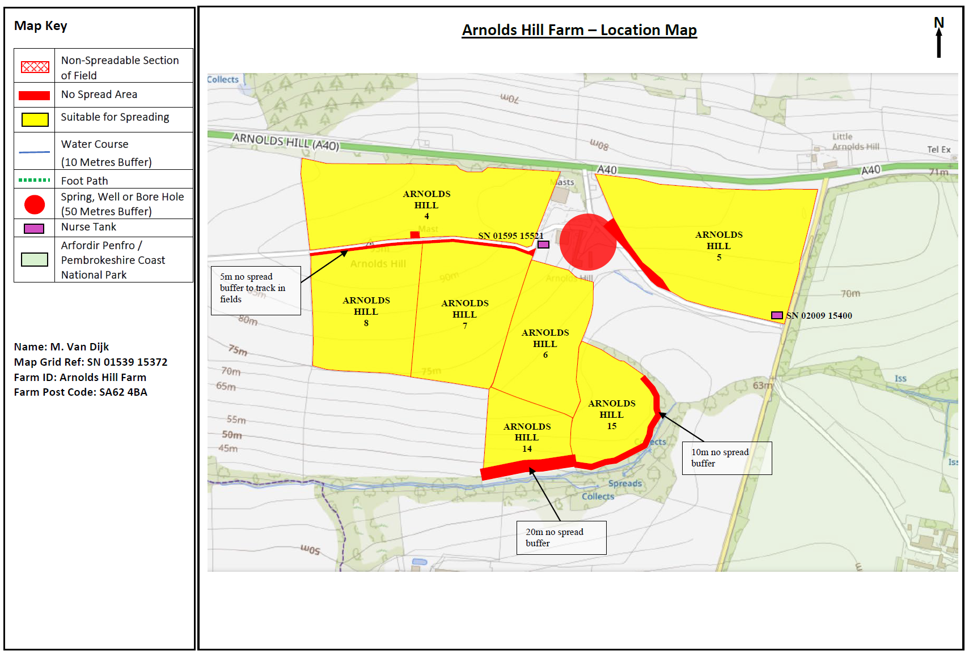
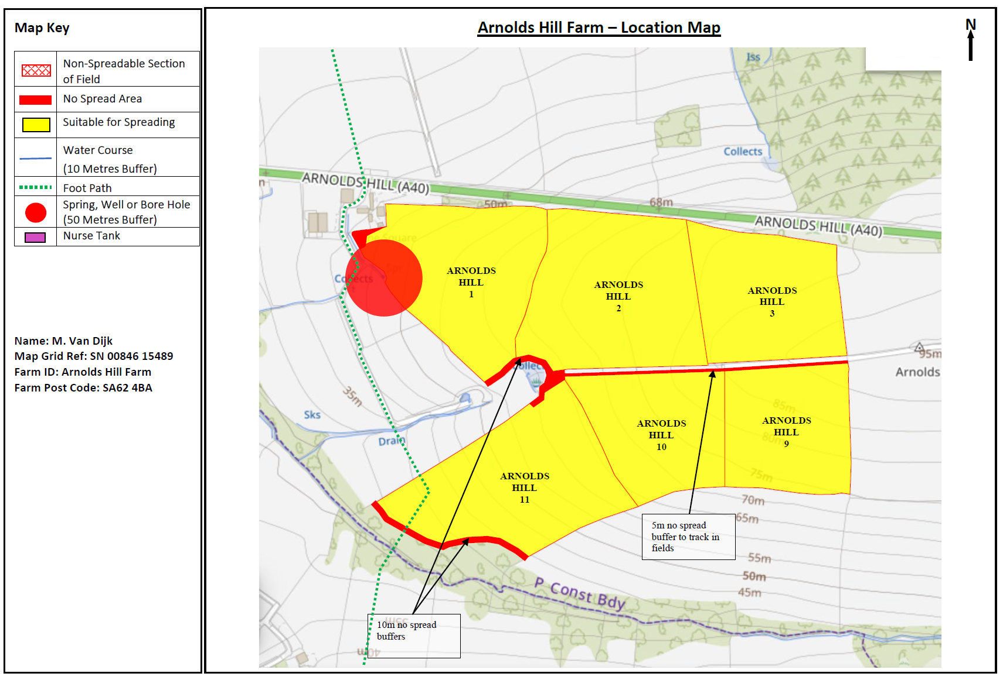
Deployment Boundaries and storage
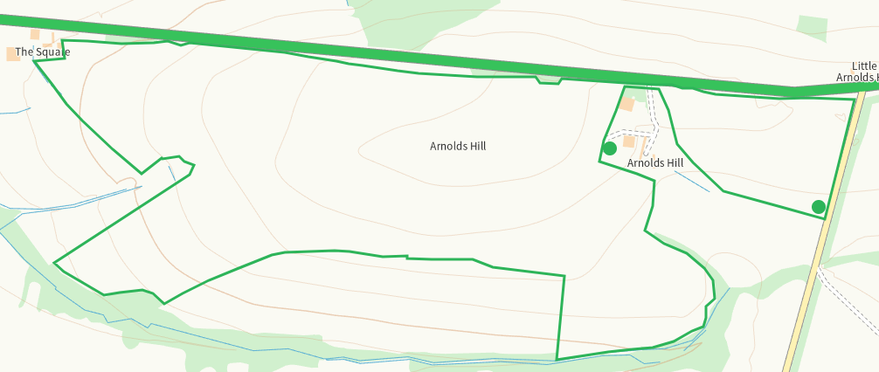
Detailed river network 10m
Watercourse within 1 on app map and buffered
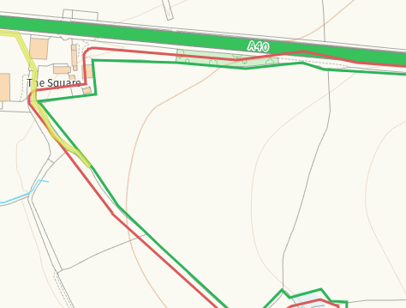
Watercourse at 11 on app map and buffered
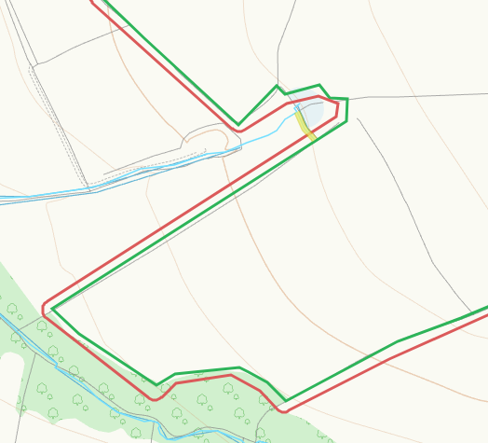
Watercourse at 14,15 on app map and buffered
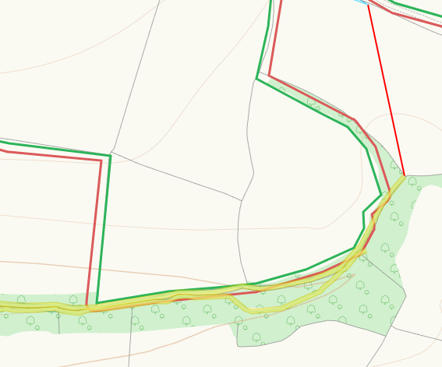
None at other fields
Groundwater source protection zones
None
Any well, spring (or issue) or borehole used for the supply of water for human consumption including from a private water supply or supplies within 50m.
Spring within 1 on app map and buffered
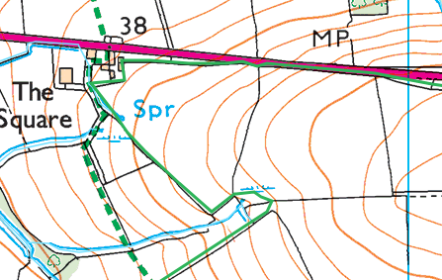
Well adjacent to 5 on app map and buffered
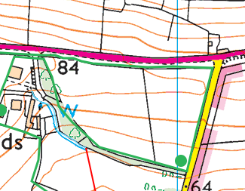
Any well, spring (or issue) or borehole used for the supply of water for human consumption including from a private water supply or supplies within 250m.
None
Within Groundwater Safeguard Zone
none
European designated sites- Natura 2000 (SPA, pSPA, SAC or cSAC) or Ramsar- or SSSI within 500m
none
Other protected sites within 500m:
- Protected Species-
Some within range, nil risk from the activity.
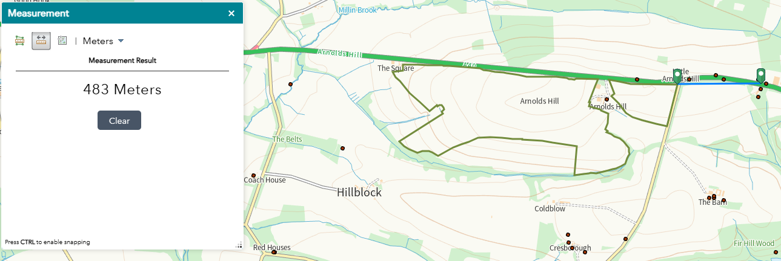

- Protected Habitats-
Nil risk
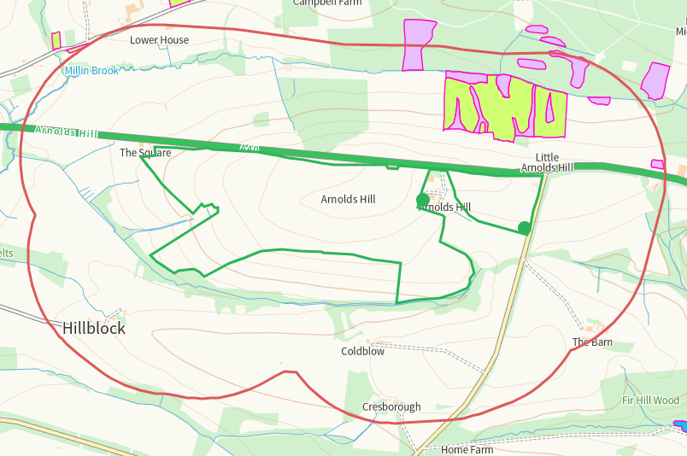

- Scheduled Ancient Monument- none
- Local Nature Reserve- none
- National Nature Reserve- none
- Ancient Woodlands-
Nil risk
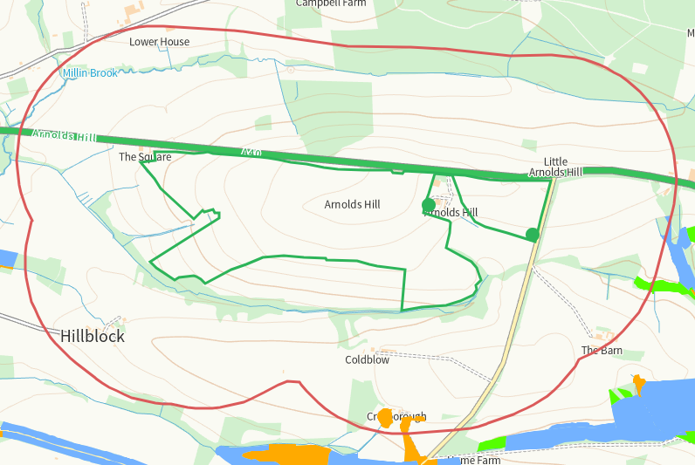
- Local Wildlife Sites (SINC)- none
- National Park-
Arfordir Penfro / Pembrokeshire Coast, on app map, nil risk
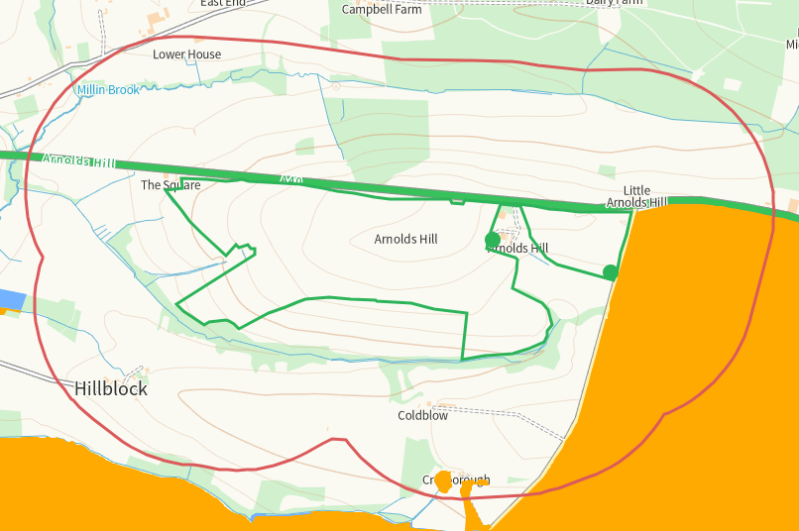

- Nitrate Vulnerable Zone (NVZ)- ALL Wales
- Groundwater Safeguard Zone- none

Flood risk
none
Public rights of way
Within 11, shown on application map.
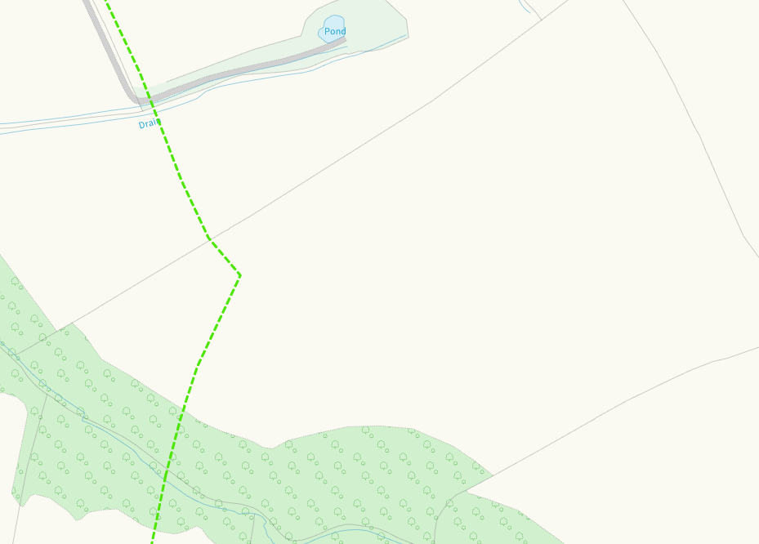
None at other fields
Distance from Main Farm Address
Adjacent
Slope Map
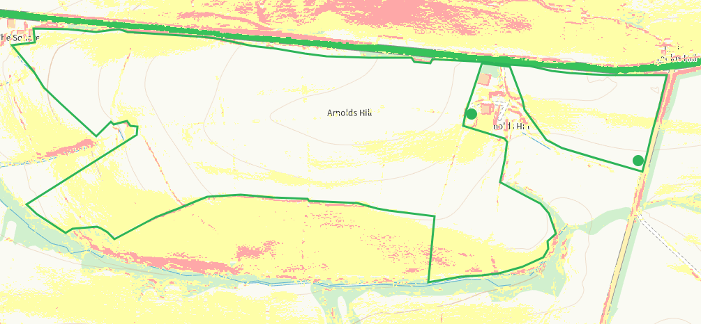
END

