PAN-031595 My Map Report:
Application maps
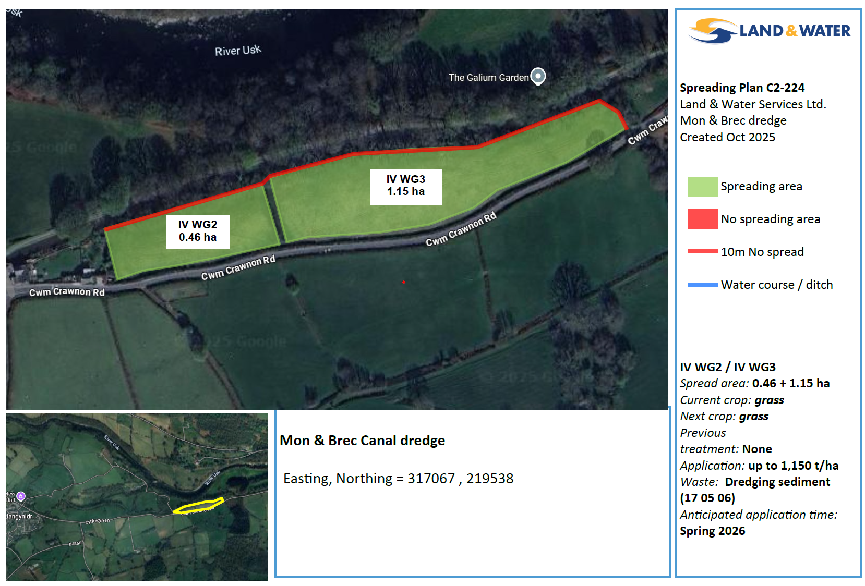
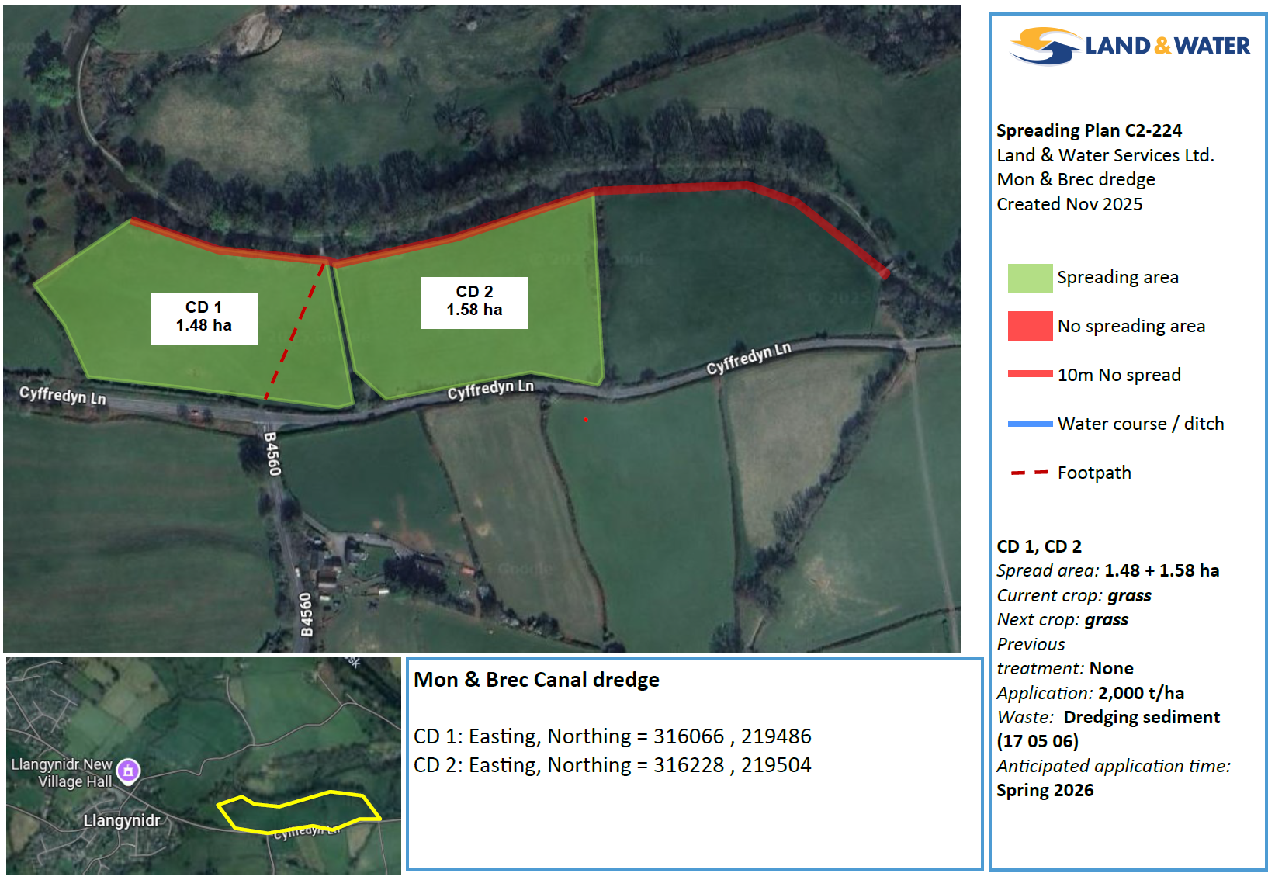
Deployment Boundaries
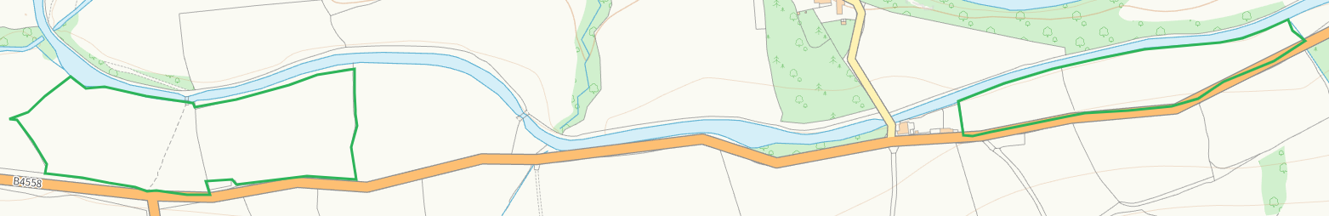

Detailed river network 10m
Monmouthshire and Brecon Canal adjacent N to all fields, watercourse adjacent NE of WG3 buffered on app map
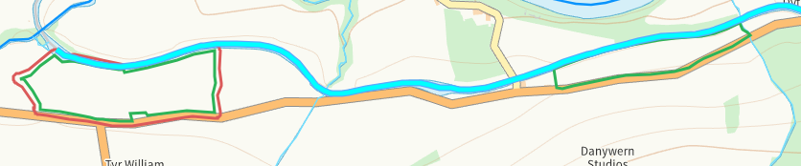
Groundwater source protection zones
none
Any well, spring (or issue) or borehole used for the supply of water for human consumption including from a private water supply or supplies within 50m.
none
Any well, spring (or issue) or borehole used for the supply of water for human consumption including from a private water supply or supplies within 250m.
none
Within Groundwater Safeguard Zone
none
European designated sites- Natura 2000 (SPA, pSPA, SAC or cSAC) or Ramsar- or SSSI within 500m
SSSI River Usk (Upper Usk) / Afon Wysg (Wysg Uchaf)
SAC River Usk / Afon Wysg
N of all fields and within range approx. 60-390 metres.
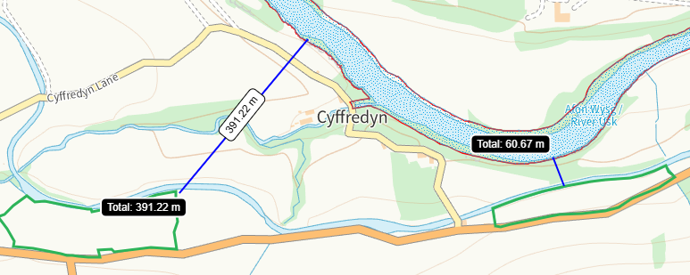
Other protected sites within 500m:
- Protected Species-
Multiple within range but nil risk from the activity
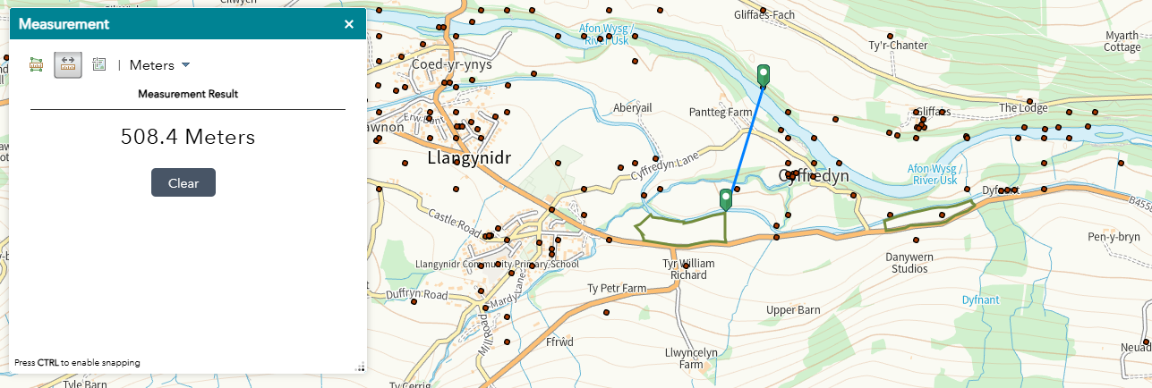

- Protected Habitats-
Buffers in place where adjacent to fields
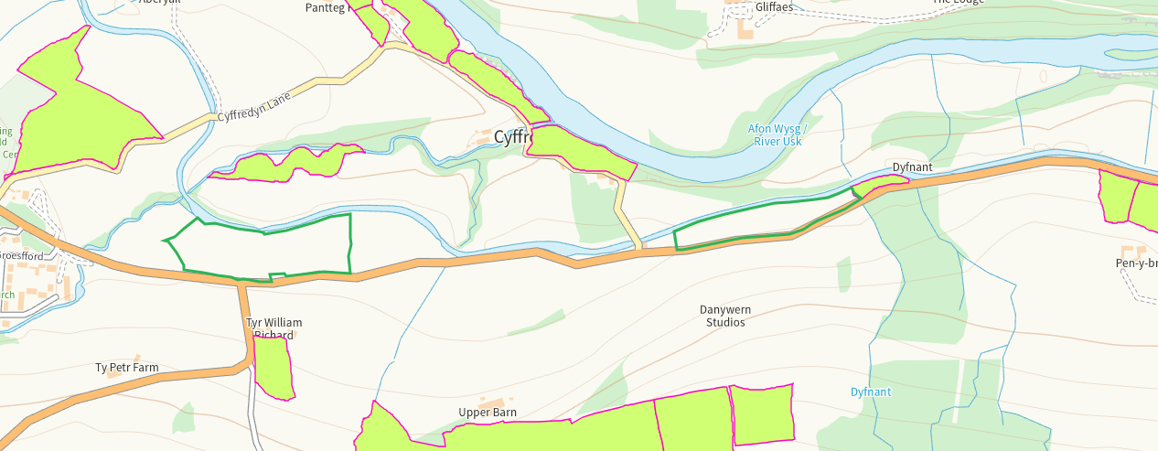
- Scheduled Ancient Monument- none
- Local Nature Reserve- none
- National Nature Reserve- none
- Ancient Woodlands-
Nil risk from the activity
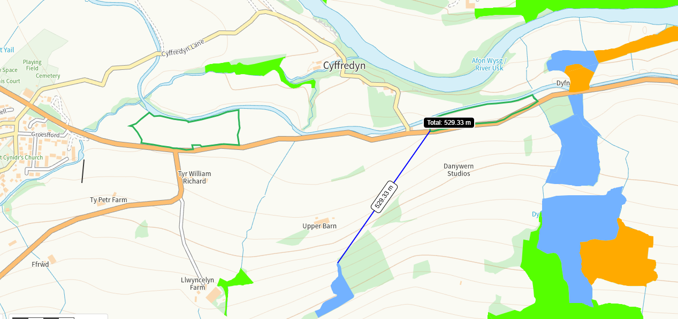
- Local Wildlife Sites (SINC)- none
- National Park-
All fields within Bannau Brycheiniog / Brecon Beacons nil risk from the activity
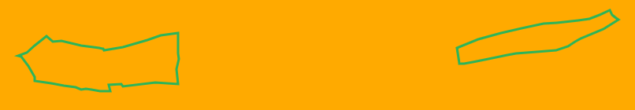

- Nitrate Vulnerable Zone (NVZ)- ALL Wales
- Groundwater Safeguard Zone- none

Flood risk
Risk to the N boundary of all fields, buffered on application map
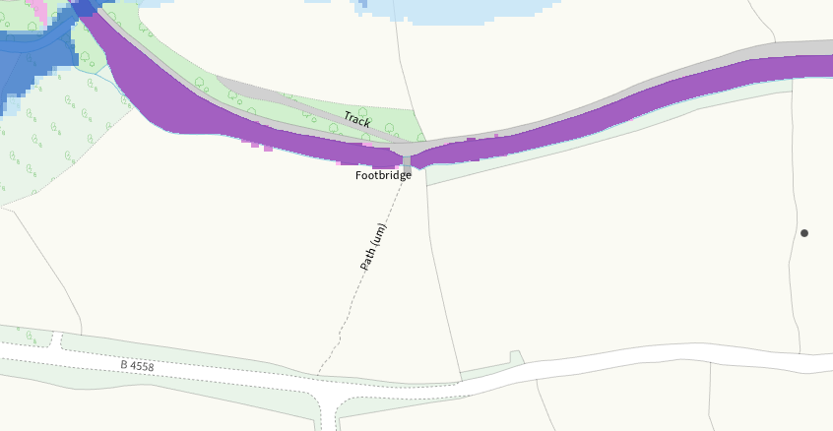
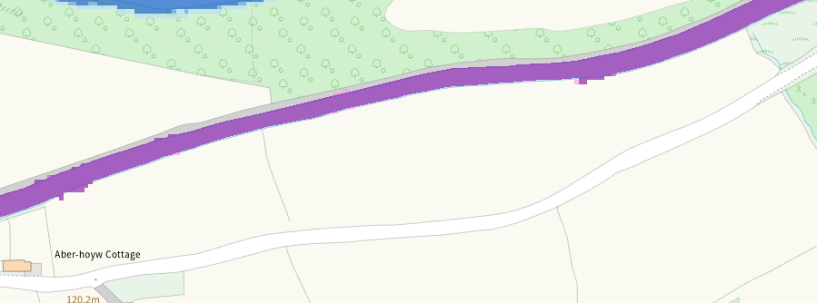
Public rights of way
Right of way marked as Path on image below is shown on app map. The PRoW shown in light green is not on app map RFI
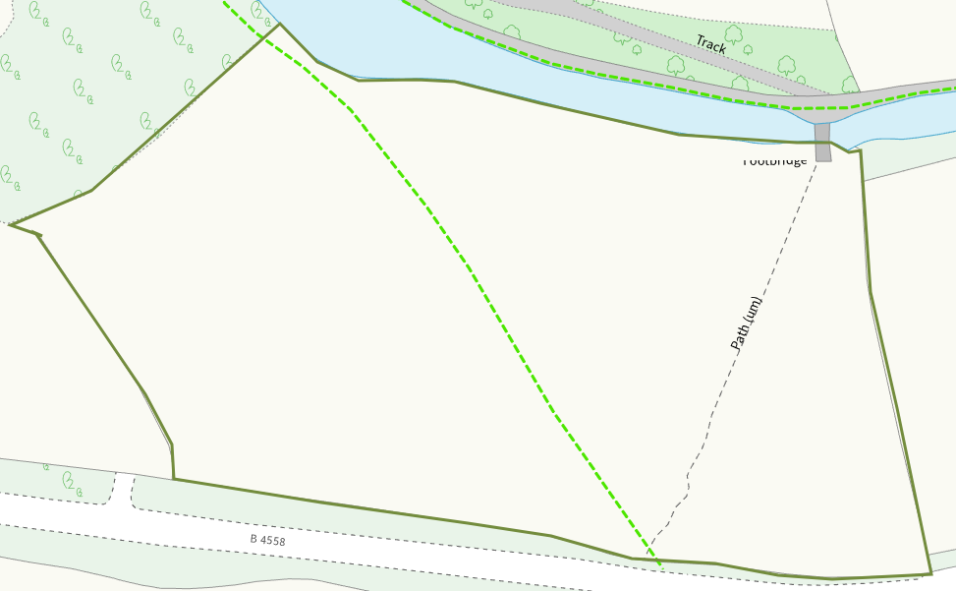
None at other fields
Distance from Main Farm Address
Adjacent, postcode matches although grid reference is incorrect RFI
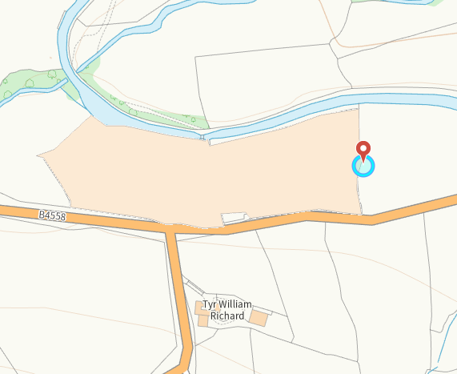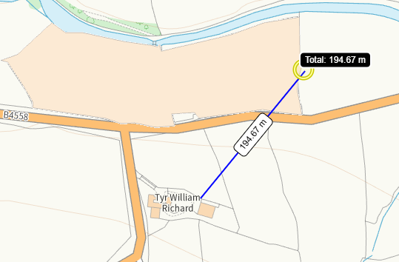
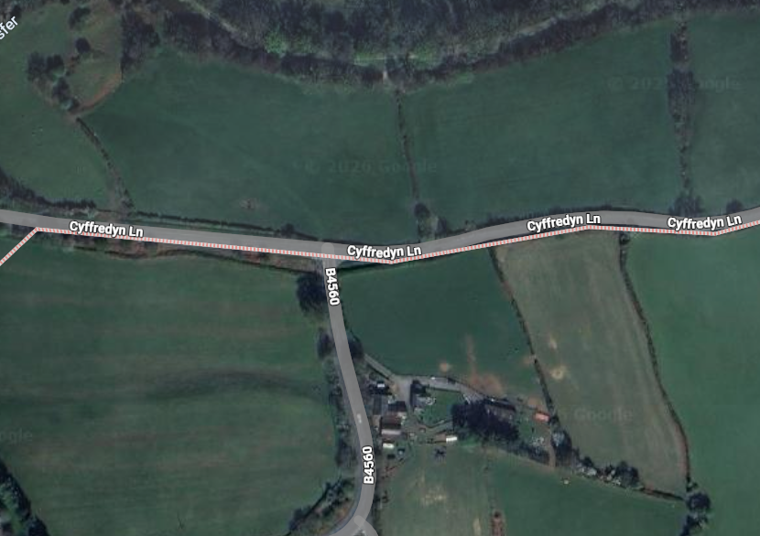
Slope Map
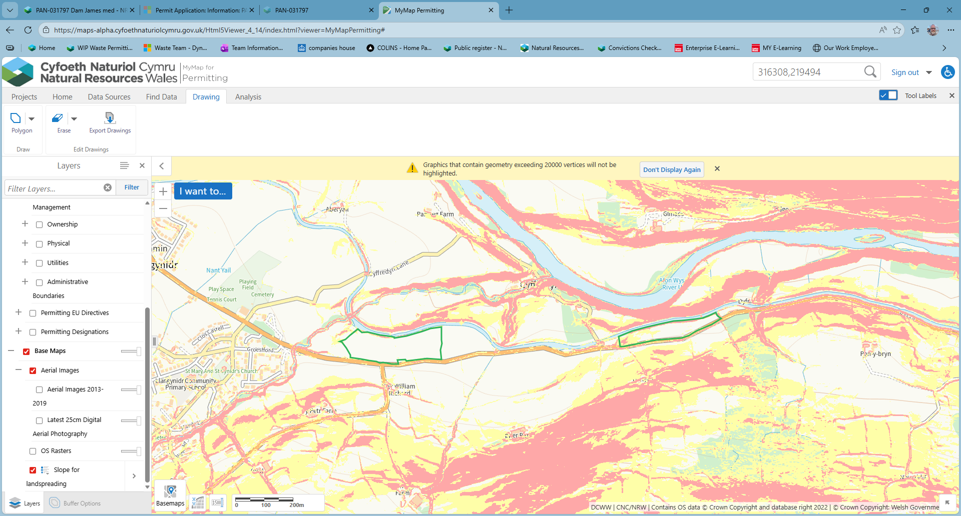
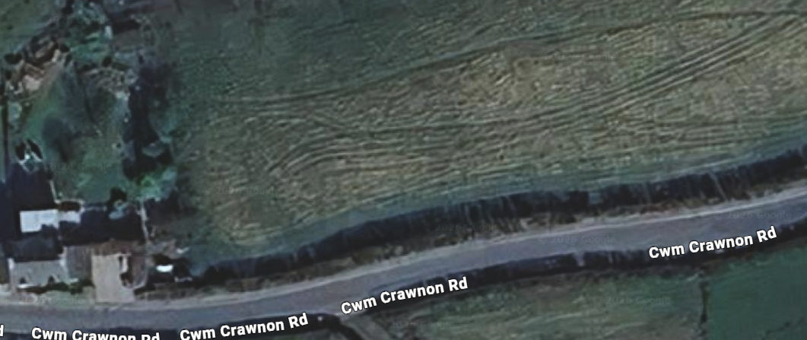
END

