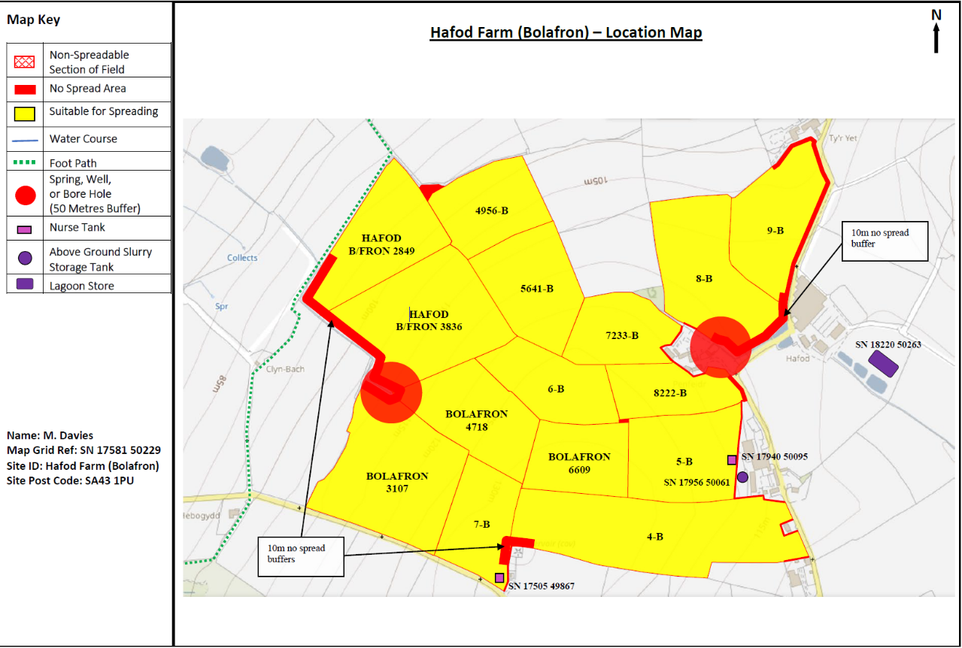
PAN-031796 My Map Report:

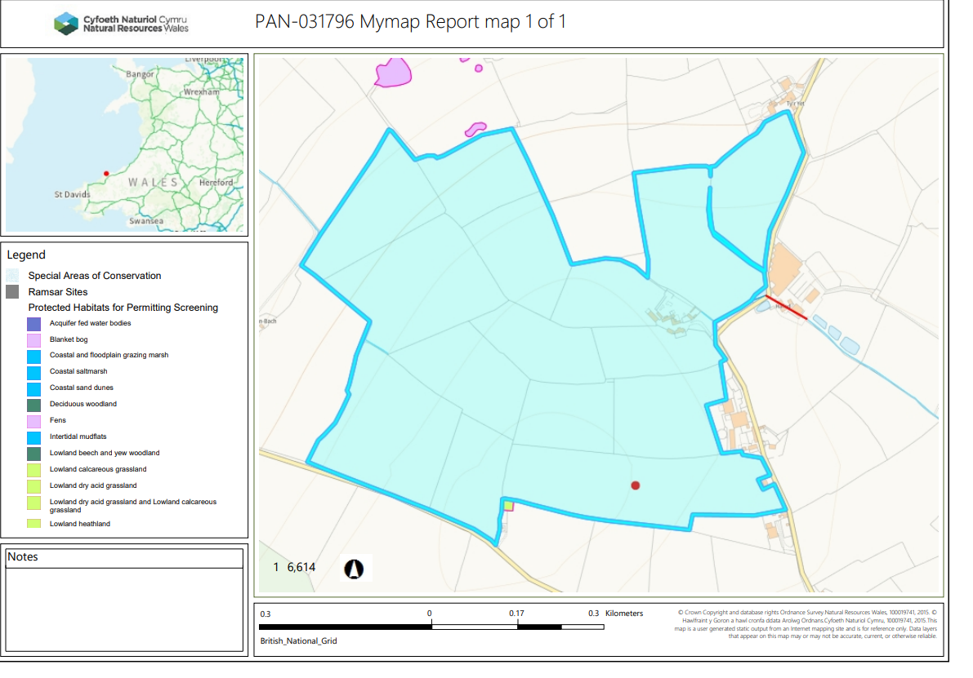
My Map summary map:

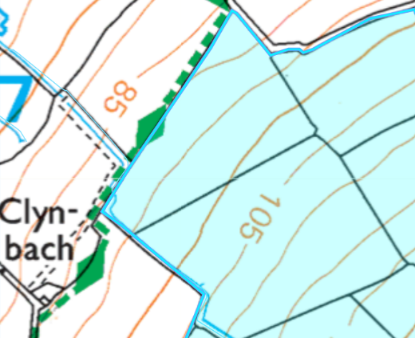
Detailed river network:
Field Hafod B/Fron 2849 & 3836 border a water course. The boundary of this field contains a 10 meter no spread buffer zone to mitigate the risk of nutrients from entering the watercourse in compliance with SR2010n04. No action needed.

Groundwater protection zones (source) - None in range.

Wells, springs or boreholes used for the supply of water for human consumption including from a private water supply or supplies None in range.

any springs wells or boreholes not used to supply water for domestic or food production purposes within 50m None in range.

European designated sites- Natura 2000 (SPA, pSPA, SAC or cSAC) or Ramsar- or SSSI within 500m
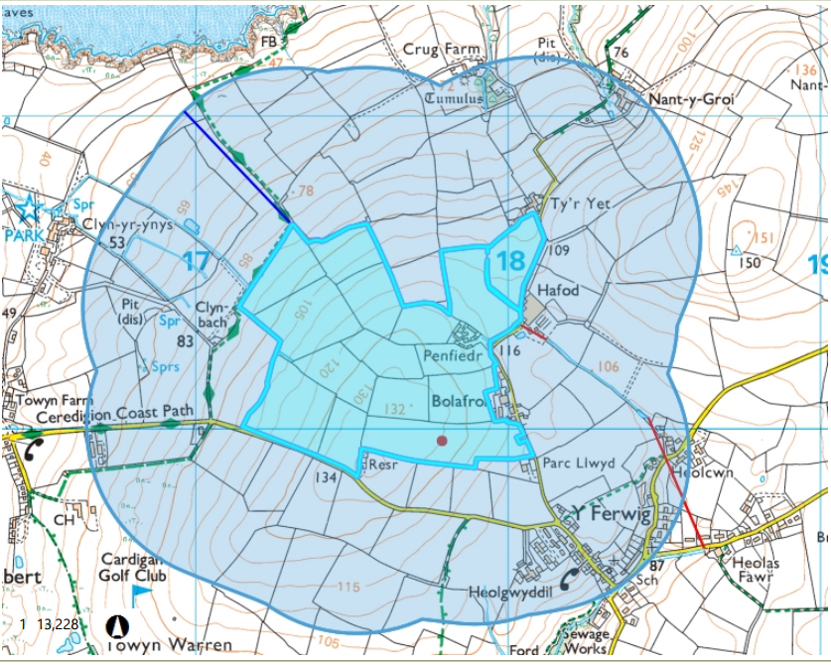
European designated sites- Natura 2000 (SPA, pSPA, SAC or cSAC) or Ramsar- or SSSI – none in range of 500 meters.

Other protected sites:
- Protected Species- None in range.

- Protected Habitats- None in range.

- Scheduled Ancient Monument- None in range.

- Local Nature Reserve- None in range.

- National Nature Reserve- None in range.

- Ancient Woodlands- None in range.

- Local Wildlife Sites (SINC)- None in range.

- National Park- None in range.

- Public rights of way - None in range.

- Groundwater Safeguard Zone- None in range.

- Hedges- nothing of concern

- Ditches- see slope map below.

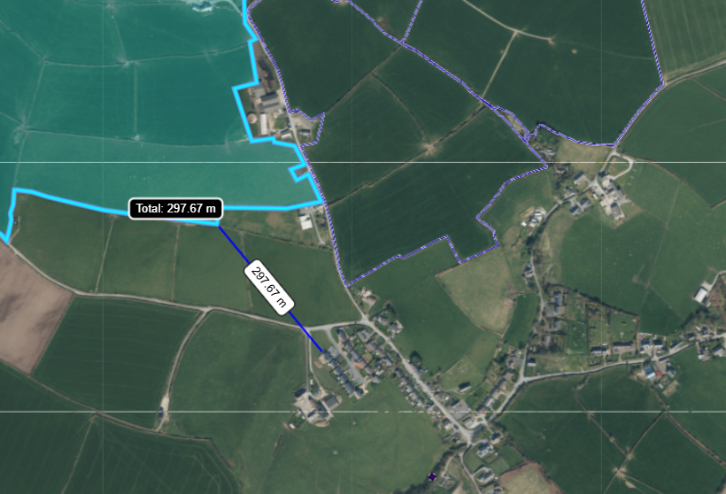
- Local residents, Housing, schools, Workplaces & Recreational facilities
Field 4-B is located 298 meters from a hamlet called Ferwig.

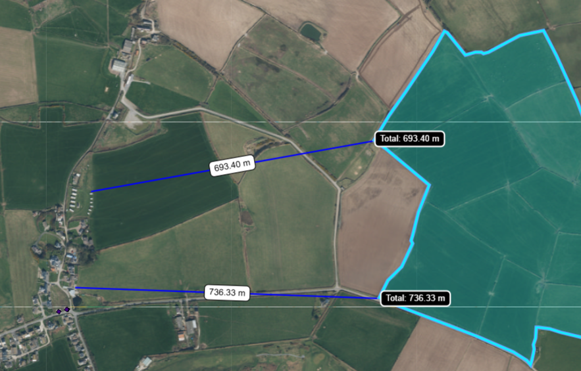
Field B/FRON 2849 is located 693 meters from Gwbert Glamping site.
Field BOLAFRON 3107 is located 736 meters from a hamlet called Gwbert.

This deployment application contains an odour management plan due to the proposed deployment spreading EWC 02 05 02 (dairy wastes) TGN 8.01 states this waste stream is likely to cause odour issues and an OMP should be provided. From reviewing the nearby sensitive odour receptor NRW agrees an odour management plan was required. The odour management plan has been assessed as part of this application and NRW conclude odour risk from EWC 02 05 02 (dairy wastes) can be effectively managed/ mitigated if spreading and storage prodecures are followed as wrote in the OMP to the nearby sensitive receptors.

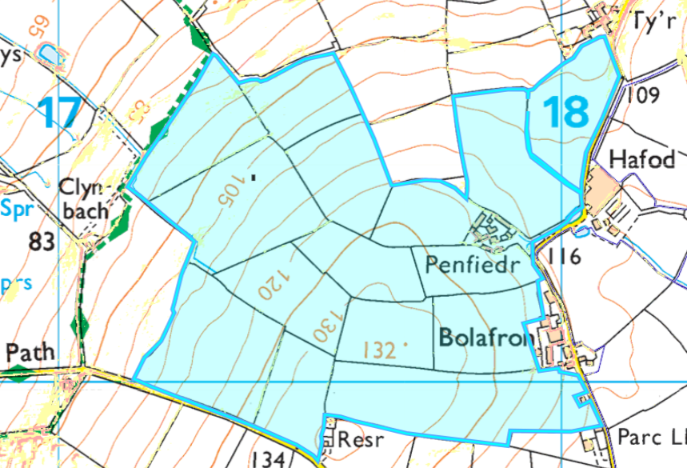
Slope Map
All fields in this deployment are located on flat to gently sloping land (0-7º).
The wastes will be applied to the fields via dribble bar which is an appropriate spreading method for the waste types (non-stackable sludge). In addition to this The maximum application rate for each field over 50t/ha will be split into multiple applications and will not exceed 50t/ha in any one application to a field. In conclusion the surface runoff risk has been determined as low.

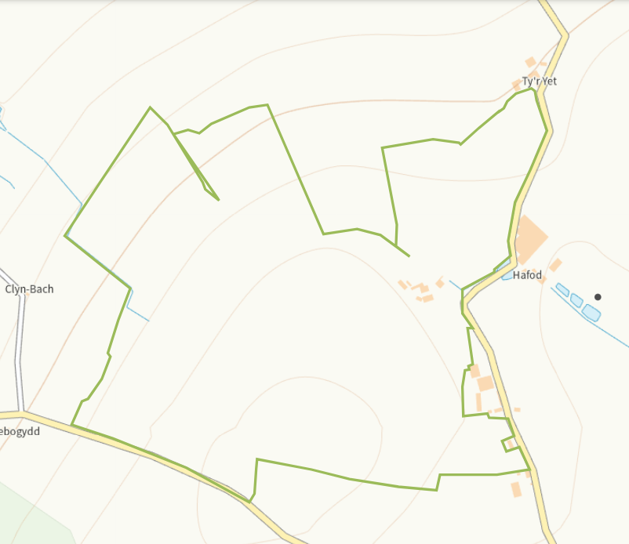
Flood risk
All fields in this deployment are located on areas of land not prone to flooding from rivers, seas and small water courses. Therefore there is not a flood risk for this deployment application.

